**Brain Waves and Binaural Beats: A Gateway to Higher Consciousness, Enhanced Learning and Brain Function**

[Print Friendly or Save as PDF](http://www.printfriendly.com/print?headerImageUrl=&headerTagline=&pfCustomCSS=&imageDisplayStyle=right&disableClickToDel=1&disablePDF=0&disablePrint=0&disableEmail=0&hideImages=0&url=https%3A%2F%2Fwakeup-world.com%2F2017%2F02%2F17%2Fbrain-waves-and-binaural-beats-a-gateway-to-higher-consciousness-enhanced-learning-and-brain-function%2F&source=wp)

[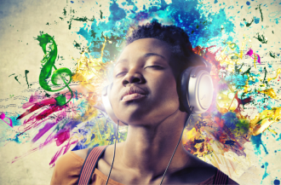](https://wakeup-world.com/wp-content/uploads/2017/02/Brain-Waves-and-Binaural-Beats-A-Gateway-to-Higher-Consciousness-and-Enhanced-Brain-Function-4.png)

February 17th, 2017

By [Carolanne Wright](https://wakeup-world.com/category/contributing-writers/carolanne-wright/)

Contributing writer for [Wake Up World](https://wakeup-world.com/2017/02/17/brain-waves-and-binaural-beats-a-gateway-to-higher-consciousness-enhanced-learning-and-brain-function/)

I have to admit, I’ve always had a fascination with shortcuts to higher levels of consciousness and have shamelessly embraced technology to this end. A veteran in all manner of brain wave entrainment soundtracks, I’ve found some work better than others for increasing creativity, focus and learning; supporting meditation and calming an overactive mind, as well as promoting sound sleep.

For those who are new to brain synchronization technology, [binaural beats](http://www.mindfithypnosis.com/about-binaural-beats/) are sound patterns that, when listened to through headphones, encourage synchronization of the left and right brain hemispheres. Depending on the speed of the binaural beats — gamma, beta, alpha, theta or delta brain waves are enhanced, each with their own beneficial characteristics. Production of brain chemicals — like DHEA, GABA, endorphins, serotonin, melatonin and growth hormone — is also triggered, while the stress hormone cortisol is lowered.

**Ultimate Brain Power**

To understand how binaural and brain synchronization works, we first have to look at the different levels of brain wave patterns, which fall into five categories:

**Gamma:** The fastest brain wave frequency, gamma brain waves measure between 25 and 100 Hz (cycles per minute) — with 40 Hz the most typical for humans. Peak concentration, exceptionally high levels of cognitive functioning and being in “the zone” are the most prominent characteristics of gamma brain waves. People with high levels tend to exhibit extraordinary intelligence and compassion, strong memory and incredible self-control. Seasoned meditators, like monks and nuns, often have elevated gamma brain wave activity. Compassion and loving-kindness practices appear to yield the highest level of gamma waves.

**Beta:** A rapid pattern that falls between 15Hz and 40Hz, beta is associated with alertness, arousal, cognition and concentration. Beta waves represent our normal waking consiousness and logic. At higher levels, beta waves can trigger stress, anxiety and restlessness. Most adults operate at the beta level throughout the day.

**Alpha:** Slower waves ranging from 9 to 14 Hz, this pattern is one of deep relaxation and the twilight state between sleep and waking. Alpha waves also encourage increased serotonin production. Meditation and access to the unconscious mind fall within the alpha realm. The higher end of alpha results in a relaxed, yet focused state with increased intuition.

**Theta:** Ranging between 5 and 8 Hz, dreaming (REM sleep), increased creativity, super-learning and heightened memory are all characteristic of theta waves. They also encourage the production of *catecholamines*, which are crucial for memory and learning. Trance, deep meditation, access to the unconscious mind and a feeling of deep spiritual connection all belong to theta.

**Delta:** The slowest frequency, delta waves fall below 4 Hz and are a pattern of deep, dreamless sleep with loss of body awareness. However, some research indicates that we may [remain alert in a very deep trance-like, non-physical state](http://www.centerpointe.com/articles/articles-research). Our brains trigger large quantities of the healing growth hormone during the delta cycle. Access to the unconscious and collective unconscious mind happens during the delta state.

[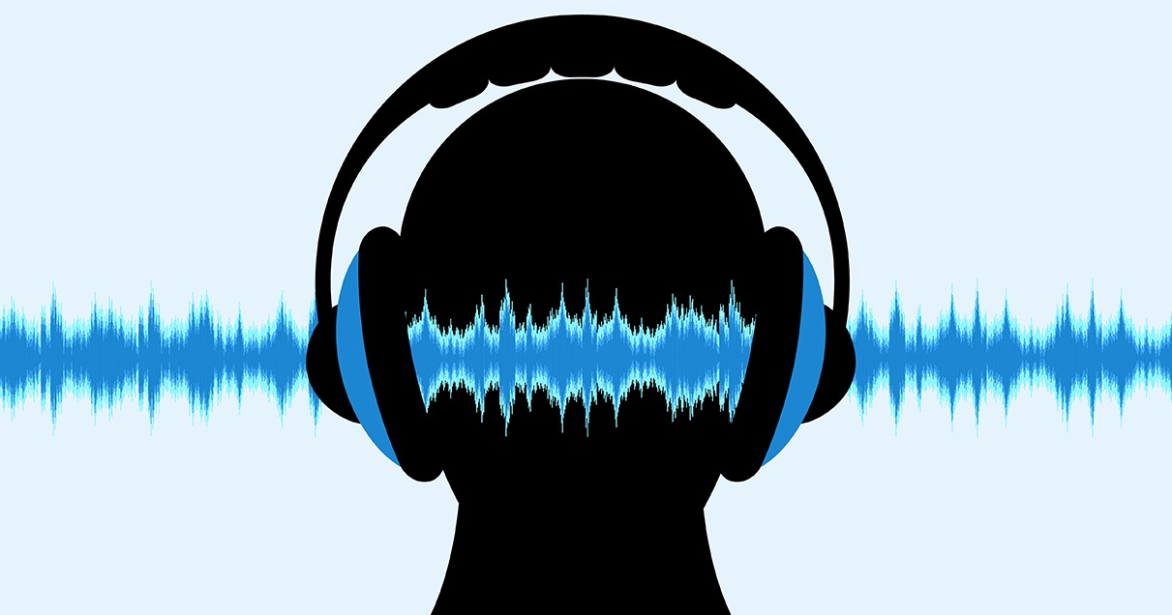](https://wakeup-world.com/wp-content/uploads/2017/02/Brain-Waves-and-Binaural-Beats-A-Gateway-to-Higher-Consciousness-and-Enhanced-Brain-Function-FB.jpg)

**Benefits of Brain Wave Entrainment**

Robert Monroe of the Monroe Institute found that using binaural beats to induce brain wave patterns resulted in “[focusing of attention, suggestibility, problem solving, creativity, memory, and learning… sleep induction, pain control… and enhanced learning](http://www.centerpointe.com/articles/articles-research)”. Other researchers have noted that slower brain wave patterns are accompanied by feelings of deep tranquility, flashes of creative insight, enhanced learning abilities and euphoria.

Dr. Lester Fehmi, director of the Princeton Biofeedback Research Institute, has this to say about brain hemispheric synchronization:

“[It represents] the maximum efficiency of information transport through the whole brain” and “[it] is correlated experientially with a union with experience, and ‘into-it-ness.’ Instead of feeling separate and narrow-focused, you tend to feel more into it—that is, unified with the experience, you are the experience—and the scope of your awareness is widened a great deal, so that you’re including many more experiences at the same time. There’s a whole-brain sensory integration going on, and it’s as if you become less self-conscious and you function more intuitively.”

Brain wave entrainment radically increases the capacity for learning as well. Back in the late 1960s and early 1970s, Bulgarian psychiatrist Georgi Lozanov was able to induce alpha waves in his students, which resulted in “super-learning.” He discovered that when in an alpha state, students “[learned over five times as much information with less study time per day, with greater long-term retention](http://www.centerpointe.com/articles/articles-research).” Some learned up to *thirty* times as much information.

Alpha waves aren’t the only pattern beneficial for learning and retention. Sustained theta waves have been found to allow for “a broader and deeper processing of the information provided by the teacher… [and] increases… focus of attention and creates a mental set of open receptivity,” observes speech-language pathologist, Suzanne Evans Morris, Ph.D.

She also notes that the use of binaural beat signals in the classroom “improved focus of attention” and “a greater openness and enthusiasm for learning.” And adds, “One of the by-products of hemispheric synchronization appears to be a highly focused state of attending. The ability to reduce ‘mind chatter’ and focus the attention is critical for efficient learning.”

Just like we need exercise to keep our bodies healthy and strong, we also need to exercise our brain. Says pharmaceutics and biomedical engineering authority, Robert Cosgrove, Jr., Ph.D., M.D.:

“… with appropriately selected stimulation protocols [have] been observed by us to be an excellent neuro-pathway exerciser. As such we believe it has great potential for use in promoting optimal cerebral performance… Furthermore, the long-term effects of regular use… on maintaining and improving cerebral performance throughout life and possibly delaying for decades the deterioration of the brain traditionally associated with aging is very exciting.”

For those interested in experimenting with binaural beats, I’ve found [OmHarmonics](http://www.omharmonics.com), [Genius Brain Power](http://www.geniusbrainpower.com) and [EquiSync](http://eocinstitute.org/meditation/) to be quite effective. You can also find more information in the following articles:

* [Sound Healing: The Power of Sound (Binaural Beats Meditation Included!)](https://wakeup-world.com/2015/09/26/sound-healing-the-power-of-sound-binaural-beats-meditation-included/)
* [Riding the Waves of Change – How Altering Your Brainwaves Can Change Your Life](https://wakeup-world.com/2016/08/12/riding-the-waves-of-change-how-altering-your-brainwaves-can-change-your-life/)
* [7 Health Benefits of Vibroacoustic (Sound & Vibration) Therapy](https://wakeup-world.com/2016/03/18/7-health-benefits-of-vibroacoustic-sound-vibration-therapy/)

**Article sources:**

* [www.scientificamerican.com/…/what-is-the-function-of-t-1997-12-22](https://www.scientificamerican.com/article/what-is-the-function-of-t-1997-12-22/)
* [www.centerpointe.com/…/articles-research](http://www.centerpointe.com/articles/articles-research)
* [www.immramainstitute.com/…/binaural-beats-and-how-they-affect-your-brain](http://www.immramainstitute.com/brainwave-technology-for-health-wellness/binaural-beats-and-how-they-affect-your-brain/)
* [www.amadeux.net/…/G.OsterAuditoryBeatsintheBrain.pdf](http://www.amadeux.net/sublimen/documenti/G.OsterAuditoryBeatsintheBrain.pdf) [PDF]
* [www.brainisohertz.it/…Auditory%20Beats%20in%20the%20Brain.pdf](http://www.brainisohertz.it/p/G%20Oster%20-%20Auditory%20Beats%20in%20the%20Brain.pdf) [PDF]
* [www.omharmonics.com/blog/gamma-brain-waves](http://www.omharmonics.com/blog/gamma-brain-waves/)
* [www.finerminds.com/mind-power/brain-waves](http://www.mindvalleyacademy.com/blog/mind/brain-waves)

**About the author:**

[](https://wakeup-world.com/wp-content/uploads/2014/02/Carolanne-Wright.jpg)Carolanne Wright enthusiastically believes if we want to see change in the world, we need to *be*the change. As a nutritionist, natural foods chef and wellness coach, Carolanne has encouraged others to embrace a healthy lifestyle of organic living, gratefulness and joyful orientation for over 13 years.

Through her website [Thrive-Living.net](http://www.thrive-living.net/), she looks forward to connecting with other like-minded people from around the world who share a similar vision. You can also follow Carolanne on [Facebook](http://www.facebook.com/pages/Thrive-Living/499578863433146), [Twitter](http://www.twitter.com/Thrive_Living) and [Pinterest](https://www.pinterest.com/thriveliving/).

**Recommended articles by Carolanne Wright:**

* [Psychiatric Industry Corruption: 6-Year-Old Boy Committed to a Psych Ward for Throwing a Temper Tantrum at School](https://wakeup-world.com/2017/01/29/psychiatric-industry-corruption-6-year-old-boy-committed-to-a-psych-ward-for-throwing-a-temper-tantrum-at-school/)
* [Renowned Harvard Psychologist Says ADHD is Largely a Fraud](https://wakeup-world.com/2016/09/09/renowned-harvard-psychologist-says-adhd-is-largely-a-fraud/)
* [Plastic Waste in the Ocean Will Outnumber Fish by 2050](https://wakeup-world.com/2016/04/11/plastic-waste-in-the-ocean-will-outnumber-fish-by-2050/)
* [Plastic-Eating Mushroom Discovered in the Amazon Rainforest — A Solution for Our Trash Saturated World?](https://wakeup-world.com/2015/10/18/plastic-eating-mushroom-discovered-in-the-amazon-rainforest-a-solution-for-our-trash-saturated-world/)
* [Over 100 Scientific Studies Agree: Cannabis Annihilates Cancer](https://wakeup-world.com/2015/05/17/over-100-scientific-studies-agree-cannabis-annihilates-cancer/)
* [Why Every Parent Should Consider Unschooling](https://wakeup-world.com/2015/05/11/why-every-parent-should-consider-unschooling/)
* [First U.S. City Produces More Electricity Than It Uses — With 100% Renewable Technology](https://wakeup-world.com/2015/03/10/first-u-s-city-produces-more-electricity-than-it-uses-with-100-renewable-technology/)
* [If You Care About Animals and the Earth, Here’s Why You Need to Boycott Palm Oil Immediately](https://wakeup-world.com/2016/06/25/if-you-care-about-animals-and-the-earth-heres-why-you-need-to-boycott-palm-oil-immediately/)

# Sound Healing: The Power of Sound (Binaural Beats Meditation Included!)

[Print Friendly or Save as PDF](http://www.printfriendly.com/print?headerImageUrl=&headerTagline=&pfCustomCSS=&imageDisplayStyle=right&disableClickToDel=1&disablePDF=0&disablePrint=0&disableEmail=0&hideImages=0&url=https%3A%2F%2Fwakeup-world.com%2F2015%2F09%2F26%2Fsound-healing-the-power-of-sound-binaural-beats-meditation-included%2F&source=wp)

[](https://wakeup-world.com/wp-content/uploads/2015/09/Sound-healing.-The-power-of-sound-.jpg)

By [Peter Paul Parker](https://peterpaulparker.wordpress.com/author/peterpaulparker/)

Guest Writer for [Wake Up World](https://wakeup-world.com/2015/09/26/sound-healing-the-power-of-sound-binaural-beats-meditation-included/)

In the beginning was the word and the word was God. The Hebrew translation for word can also been interpreted as sound. There are ancient mystics and sages who believe that the sound Aum or Om is the sound of creation. So, if the word of God was a sound, could that be the reason for this material creation?

Back in the 1960’s Swiss scientist Dr. Hans Jenny researched the Cymatic frequencies and how they influence physical form. His exploration of the effects of Cymatic frequencies on matter came up with some breathtaking results, and I have included the links at the end of this article. As Cymatics shows us, sound creates form and [really does affect our physical condition](https://wakeup-world.com/2015/04/07/6-evidence-based-ways-drumming-heals-body-mind-and-soul/?doing_wp_cron=1471352828.6618139743804931640625) in many ways. Sound also has the power to heal, and this is what I aim to explore with this article.

Jonathan Reid is another Cymatic researcher, who is a musician and a scientist. Jonathan was researching these Cymatic patterns within the walls of the Kings chamber inside the Great Pyramid. He was experiencing great back pain while conducting the experiments, and later realised that the pain had disappeared and never came back, and it was the culmination of the sound frequencies that healed his back. We do use sound for healing in hospitals today in the form of ultrasound, which is used to heal tissue, can decrease swelling and gives a gentle massage to the affected area. So we already use sound in today’s modern world for healing and health, but all the possibilities have not been explored as yet. Let us go back in history and see where this was used then.

## ****Pythagoras and Sound Healing****

Pythagoras has been credited as being the Father of Mathematics, Geometry and Music. Pythagoras was actually a sound healer. He worked out that music is mathematics and he would perform what he called ‘soul adjustments’ with this music. Pythagoras used intervals, including the Fibonacci series, as a medicine for the body and the emotions.

[](https://wakeup-world.com/wp-content/uploads/2015/09/Sound-healing.-The-power-of-sound-fibonacci-sequence.jpg)

The Fibonacci Sequence is evident in nature.

The Fibonacci series of numbers can be found everywhere in nature, and are looked upon as the building blocks of life. If we look at the scale of western music, a scale comprises of 8 notes, and the chord sequence of that note is the third and fifth note.

The Fibonacci series starts at the beginning, which is zero, and then the next number is 1. Add zero and one together and you get one. Add one to that and you get two. Add one to two and you get three. Add two and three and you get five. Add three and five and you get eight and it goes up like that. So the numbers go up like this 0, 1, 1, 2, 3, 5, 8, 13, 21, 34, 55, 89, 144, 233 and so on.

The Fibonacci series gives perfect balance in growth and movement, so therefore you get a balanced expansion. So now can you see that the first note, the third note, the fifth note and the octave (eighth note) is all part of the Fibonacci series in relation to a musical scale.

## ****Tuning Your Chakras****

Another researcher into Sound healing is Jonathan Goldman. He also has researched heavily into the use of sound by the ancients and has made many great discoveries. He also realised while working in an anechoic chamber that the nervous system has a sound, and that sound could be affected by tuning forks. Einstein spoke about the Universal Energy Field and explained that this is the only reality.

[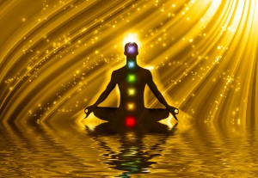](https://wakeup-world.com/wp-content/uploads/2012/05/chakras.jpg)

In modern life today we are being detuned from that field and we all need to find ways to tune us back up. Sound healing is a great way of doing this.

We have seven energy vortex points that run up the spine of the body, known in Eastern philosophies as the chakra system and these can all be opened and tuned by tuning folks. The tuning of the chakra system simply runs up the C scale in musical terms. C, D, E, F, G, A and B. C is the root chakra, D is the sacral chakra, E is the solar plexus chakra, F is the heart chakra, G is the throat chakra, A is the third eye chakra and B is the crown chakra.

Once you start to work with these chakras and sound, your reality starts to look different. I found this to be an amazing journey.

## ****Binaural Beats and the Fibonacci Sequence****

Another way to affect the human condition through sound is the use of [*binaural beats*](https://wakeup-world.com/?s=binaural+beats&category=&year=&month=&format=&go=&sortby=DESC). Binaural beats are created by playing two different tones in each headphone, no less than 1 Hz and no more than 30 Hz, and the brain will process these two beats by filling in the difference between the two frequencies. If you have 400 Hz in one earpiece and 410 Hz in the other earpiece, you are creating a binaural beat of 10 Hz in your brain. The five cognitive states your brain operates in are Gamma (over 40 Hz), Beta (13 – 39 Hz), Alpha (7 – 13 Hz), Theta (4 – 7 Hz) and Delta (<4 Hz). As the frequencies decrease, cognitive focus and alertness decrease. You will start to move to more meditative states depending on what Binaural beat you are listening to.

[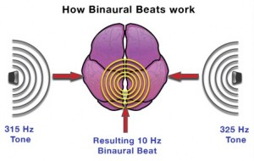](https://wakeup-world.com/wp-content/uploads/2015/09/Sound-healing.-The-power-of-sound-Binaural-Beats-.jpg)

I have been working with [Dr. Tomasz Kopec](http://www.openfocusattentiontraining.com/), who is known for his research into [Open Focus Theory](https://wakeup-world.com/2015/02/26/the-open-focus-theory-diffuse-attention-unify-reality/), and we have come up with an exercise that is designed to help you get into a meditation state very easily. We have combined one of Tomasz’s exercises with music tuned to the relative chakra with a binaural beat placed in the background. So while being guided by the exercise, you will have the binaural beat also working to get you into the desired state, and some music to ease you through the gaps in the exercise. You may get it the first time, or it may take a few attempts, but you should feel refreshed and relaxed after the exercise.

## ****The Schumann Pulse****

We have four exercises in this series. The first exercise is just a general exercise and the binaural beat is based on the pulse of the earth, the Schumann pulse, which is 7.8 Hz. This is also the frequency of the Alpha state for the brain, which is wakeful relaxation. It is the desired frequency for rest and digest, which is a human state this modern world doesn’t seem to allow us to visit very much.

Here is a very simple exercise you can use daily for your body to get into that healing zone. The first exercise has been designed by [Dr. Tomasz Kopec](http://www.openfocusattentiontraining.com/) to diffuse your attention. The other three exercises are designed to go up the chakra system, so the second exercise is the sacral chakra, the third exercise is the heart chakra and the fourth exercise is the third eye chakra. These exercises with the relevant binaural beat and sounds used for the tuning of the chakra will enable you to open up the three most powerful chakras in your system and release the full potential of you as a human being.

Our world is becoming more and more obsessed with the physical body. We are being dragged into this material world by the meme we live in, and by choosing to wake up your energy body, you will be making a great change for yourself. You will start to wake up the senses, see the mad world for what it is and start to realise that you need to wake up, pay attention and do something about changing yourself, and changing the world around you. More and more people are starting to take these steps, and the results are wonderful to see. Here is the link to the first free exercise below.

## ****Change Your Energy****

Our energy body, or you may have heard of it as a “light body”, can carry the physical body. Indeed it does especially in the Western world with our bad diet, additions and habits. When you begin to wake up to your energy or light body, you understand that if you want to work at an optimum, these two bodies should work in tandem with each other. So both of these bodies need good fuel, exercise and the proper rest to work properly. Our exercises will help you to rest and you may not notice the change in you at first, but, with time, I am sure you will start to feel the difference.

This world is a wonder and if we all start to experience it from that understanding, then things will change automatically for the better. We all need love. We all want to avoid suffering. We all want a better world. So rather than staying in systems that do not serve humanity as a whole, let us rid the ones that no longer work that are being controlled from the shadows, and make the ones stronger that do.

[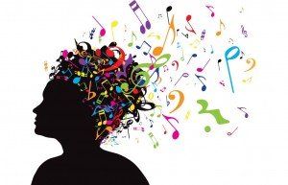](https://wakeup-world.com/wp-content/uploads/2015/03/How-Music-Affects-the-Brain-for-the-Better-Copy.jpg)

The first steps are easy really. Choose love or choose fear. We believe these exercises will help you make steps to find the real you inside, where you can now start to build the life you want, and then start to help others build the life they want around you. So what is good for me is good for you. It is a very simple principle in theory, so why not put it into practice?

The time is now and a new world is waiting for us when we reach the numbers to make the true change this world is crying out for. Turn on, tune in and chill out. Yeah!!!!!!

## Diffusing Your Attention with Music

[This exercise](http://www.openfocusattentiontraining.com/product/diffusing-attention-with-music-one/) will let you experience what happens when you diffuse your attention. I hope you will realise that many types of meditation and relaxation techniques are based on simply changing your attention style from focusing to diffusing. Once you know how to do it you can get into the ‘zone’ a lot quicker.

[Click here to get started.](http://www.openfocusattentiontraining.com/product/diffusing-attention-with-music-one/)

## Binaural Beats Meditation Exercise — Shumann Resonance 7.38 Hz

This is a meditation exercise that includes a binaural beat at the shumman resonance of 7.38 Hz which will help to get your brain into the alpha frequency.

**Cymatics links:**

* [www.youtube.com/watch?v=05Io6lop3mk](https://www.youtube.com/watch?v=05Io6lop3mk)
* [www.youtube.com/watch?v=ahJYUVDY5ek](https://www.youtube.com/watch?v=ahJYUVDY5ek)
* [www.youtube.com/watch?v=I4jUMWFKPTY](https://www.youtube.com/watch?v=I4jUMWFKPTY)

**Related articles** **by Dr. Tomasz Kopec:**

* [Diffuse Your Attention](http://www.openfocusattentiontraining.com/2015/09/04/diffuse-your-attention/)
* [The Open Focus Theory – Diffuse Attention, Unify Reality](https://wakeup-world.com/2015/02/26/the-open-focus-theory-diffuse-attention-unify-reality/)

**Previous articles by Peter Paul Parker:**

* [Can Looking Back Help Humanity Move Forward?](https://wakeup-world.com/2014/08/09/can-looking-back-help-humanity-move-forward/)
* [Clearing Blocked Energy Pathways with Ancient Remedies](https://wakeup-world.com/2013/10/22/ancient-remedies-for-clearing-blocked-energy-pathways/)
* [Open Your focus. Hear The Silence.](https://wakeup-world.com/2013/03/31/open-your-focus-hear-the-silence/)

**About the author:**

[](https://wakeup-world.com/wp-content/uploads/2015/09/Peter-Paul-Parker-.jpg)

Peter Paul Parker has been a musician for most of his career. He started as a bass player and moved on to become a producer and writer of music and songs. Peter has also now moved into the health arena and is a [Bach flower advisor](http://www.bachcentre.com/), a sound healer, a vegan and health consultant, and was partly responsible for setting up the [Ministry Of Health](http://www.ministryofhealth.org.uk/) in the UK, a non-government organization comprised of experts in the field of non-pharmaceutical health. Peter is also an [activist and writer](http://www.peterpaulparker.co.uk/), highlighting the challenges our world faces and how we can regain our humanity.

Peter wrote and produced the album ‘Wild Child’ by The Spoken X and his own album, ‘Stepping Up’, both released by Metro Publishing. He also wrote and produced his recent album [Anahata, Earth Echoes](https://newworldmusic.com/uk/downloads/anahata-earth-echoes/) as an expression of love for his conscious awakening, released by New World Music.

Peter is currently working with [Dr. Tomasz Kopec](http://www.openfocusattentiontraining.com/) on a series of meditation exercises, incorporating his music, binaural beats and tones of the chakras in the mixes.

Connect with Peter at [www.peterpaulparker.co.uk](http://www.peterpaulparker.co.uk/), [www.brightbeings.co.uk](http://www.brightbeings.co.uk/)

## Anahata, Earth Echoes

[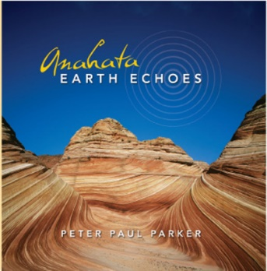](https://newworldmusic.com/uk/downloads/anahata-earth-echoes/)In addition to his work with the Ministry of Health, seeker, activist and writer Peter Paul Parker is also an accomplished musician. His album ‘[Anahata, Earth Echoes](https://newworldmusic.com/uk/downloads/anahata-earth-echoes/)’ is available on the label New World Music. Anahata is the fourth chakra at the center of the luminous auric body, and is considered a gateway to higher consciousness.

In creating ‘Anahata, Earth Echoes’, Peter was inspired by learning about the chakras and experiencing the togetherness of ancient tribes like the Aborigines, the Fijians and the Native Americans he met travelling around the world as a child. The first seven tracks are tuned to the seven chakras, from the base to the seventh chakra, to help you meditate on your chakras — Peter’s small way of helping to raise the vibrations on our planet.

**To learn more, visit**[**www.newworldmusic.com/uk/anahata-earth-echoes**](https://newworldmusic.com/uk/downloads/anahata-earth-echoes/)