**Coconut Chia Seed Pudding**

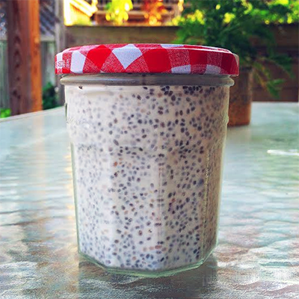

**Recipe Courtesy of Meredith Dykstra**

* 1/4 cup chia seeds
* 1/2 a can full-fat, organic coconut milk
* 1 tsp vanilla extract
* Pinch of sea salt
* 2 Tbs cacao nibs (optional)
* Optional Toppings: Walnuts and/or fresh or frozen berries

1. In a small bowl or jar add chia seeds, coconut milk, nibs, vanilla, salt and mix well.
2. Place in the refrigerator for at least two hours, but preferably overnight.
3. Top with berries or nuts and enjoy!