Coconut Milk & Tumeric Recipe To Detox Organs & Fight Inflammation Quickly

March 31, 2016

|

FettleBotanical.com

Turmeric Curcumin is the main ingredient in this recipe. Turmeric has curcumin, the component known because of its primary active ability to exhibit over 150 potentially therapeutic actions, including antioxidant, anti-inflammatory,anti-depressant, anti-cancer properties.

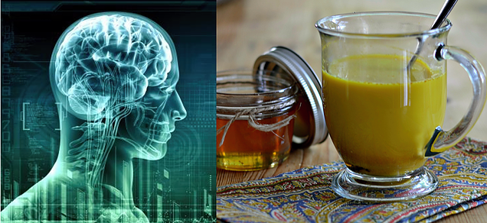

**Additional benefits:**

* -Helps Reduce High blood pressure.
* -Various skin ailments.
* -Neurological disorders.
* -Lowers Triglycerides
* -Anti-inflammatory, anti-oxidant, antiseptic, analgesic.
* -Increases immune system effectiveness.
* -Anti-carcinogenic.
* -Helps maintain good cholesterol levels.
* -Promotes digestive health.
* -Memory and brain function.
* -Liver detoxifier.
* Has Anti-Depressant mechanisms
* -Regulates metabolism and weight management.

Mixing black pepper with tumerics or adding fish oils or peppercorns improves curcumin’s bioavailability by up to 2000% , because of the black pepper’s exclusive property called piperine. Yes, with combining turmeric and black pepper together, you will increase your body’s absorption of the turmeric curcumin by 2000%!

**Golden Milk**

* Step 1: Turmeric Paste:

**Ingredients:**

* 1/4 cup of turmeric powder
* 1/2 cup of filtered water
* 1/2 teaspoon of ground pepper

**Directions:**

Mix the ingredients  thoroughly in a small pan. Turn the heat to medium and mix non stop until you get a thick paste. This doesn’t take too long so don’t walk  away from the pan.

Let this mixture cool and then keep it in a small jar in the fridge.

**Golden Milk**

* Step 2

**Ingredients:**

* 1 cup of Coconut milk (hemp or Almond Milk are also good options)
* 1/4 teaspoon or more of turmeric paste
* 1 teaspoon coconut oil
* Add Honey or Natural low glycemic Agave

**Directions:**

Mix the ingredients, except honey/agave in a small pan. Turn the heat to medium, stir non stop while heating. Don’t allow the mixture to boil. In the end add the honey for a sweeter taste.