[](http://www.littlethings.com/bucket-of-water-vacuum-seal/)

[](http://www.littlethings.com/dresser-goodwill-masterpiece/)

[](http://www.littlethings.com/10-simple-gardening-hacks/)

**[](http://www.littlethings.com/)**

Top of Form

Bottom of Form

[](http://www.littlethings.com/)

Dying Woman Throws A Party For 30 Guests And Kills Herself At The End

LIFE

**Dying Woman Throws A Party For 30 Guests And Kills Herself At The End**

[*[](http://www.littlethings.com/author/barbara-diamond/)Barbara Diamond*](http://www.littlethings.com/author/barbara-diamond/)

Advertisement

Advertisement

In July 2016, Betsy Davis invited 30 of her closest friends and family to a weekend party at a house in southern California.

The invitation read: *These circumstances are unlike any party you have attended before, requiring emotional stamina, centeredness, and openness.*

She also noted the party’s one firm rule: No crying in front of her.

You see, in 2013, the 41-year-old artist was diagnosed with ALS, or Lou Gehrig’s disease. [ALS is incurable](http://www.littlethings.com/als-one-thousand-for-a-thousand/) and affects nerve cells in the brain and the spinal cord. Betsy was losing all control of her body as it gradually shut down — and so, she decided to hold this gathering as a joyous way to say goodbye before becoming one of the first Californians to take a lethal dose of drugs.

Yes, this two-day party would be full of fun and laughter, but would culminate in Betsy’s suicide.

The idea was hard to grasp for Betsy’s loved ones, but as you’ll see below, Betsy was about to give her “final performance” just the way she wanted to.

*Credit: Niels Alpert* [*Website*](http://littlethings.us/MpTHtQ) */* [*Instagram*](http://littlethings.us/0JtoFg)

Like our Page http://cdn5.littlethings.com/app/themes/littlethings/img/arrow-gray.png

[Share on Facebook](http://www.littlethings.com/betsy-davis-party/)



Niels Alpert

In July 2016, Betsy Davis, 41, emailed 30 friends and family members to invite them to a two-day party. “These circumstances are unlike any party you have attended before, requiring emotional stamina, centeredness, and openness,” the invitation read.

The party had one rule, and one rule only: No crying in front of Betsy.

That’s because the talented artist was diagnosed with ALS, also known as Lou Gehrig’s disease, and her body was shutting down. The planned weekend was a way for Betsy to say goodbye before taking a lethal dose of drugs as prescribed by her doctor.

Betsy shared the weekend’s detailed schedule with her guests, along with the precise hour she planned to slip into a coma.



Niels Alpert

It was a difficult decision to attend the party, as you can imagine, but Betsy’s loved ones wouldn’t have missed it for the world.

More than 30 people came from all across the country to spend two days at a gorgeous mountainside home in southern California.

Guests played instruments, they imbibed, they ate pizza from Betsy’s favorite restaurant, and watched screenings of her favorite movies.

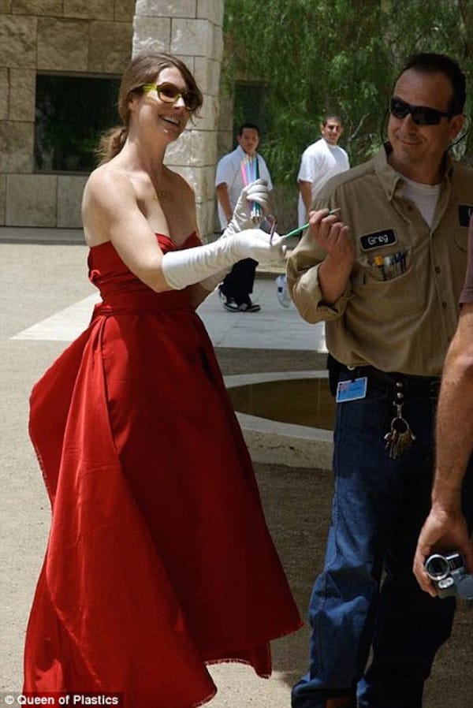

[Queen of Plastics](http://www.queenofplastics.com/)

Loved ones say the painter and performance artist, pictured above at a 2006 Getty Center staging, turned her death into a “final performance.”

After gradually losing control of her body, Davis felt a rush of empowerment. She spent months planning her final exit.

She would become one of the first residents of California to take a lethal dose of drugs under the state’s new doctor-assisted suicide law for the terminally ill.



Niels Alpert

During the party, Betsy’s caretakers translated her speech for the guests, as it was slurred because of her condition.

But Betsy was able to roll her electric wheelchair throughout the house, making sure to spend quality time with each of her guests.

Guests were also invited to take home a “Betsy souvenir,” like a piece of artwork, accessory, or beauty product. Her sister placed sticky notes on each item, explaining their significance.



Niels Alpert

Niels Alpert, a cinematographer from NYC, was also at the party. He snapped these photos to capture the precious moments. “For me and everyone who was invited, it was very challenging to consider, but there was no question that we would be there for her,” he said.

“In the background of the lovely fun, smiles, and laughter that we had, that weekend was the knowledge of what was coming.”



Niels Alpert

At the end of the weekend, everyone gathered for a photo and said their goodbyes. Betsy was wheeled out to a canopy bed on the hillside, wearing a kimono she bought in 2013 after being diagnosed.

At 6:45 p.m., Betsy watched her last sunset and took a lethal combination of drugs prescribed by her doctor. She was surrounded by her caretaker, doctor, massage therapist, and sister.

Four hours later, Betsy died.

“What Betsy did gave her the most beautiful death that any person could ever wish for,” said one of her friends. “By taking charge, she turned her departure into a work of art.”

It’s no wonder people all over the country are touched by Betsy’s life *and* death. Please **SHARE** this with your friends on Facebook.

Like our Page http://cdn5.littlethings.com/app/themes/littlethings/img/arrow-gray.png

[Share on Facebook](http://www.littlethings.com/betsy-davis-party/)

[Share on Facebook](http://www.littlethings.com/betsy-davis-party/)

Popular In the Community

[Student Has Violation Put On Permanent Record When She Wears Cardigan To Class](https://traffic.spot.im/v2" \l "to_url%3Dhttp%253A%252F%252Fwww.littlethings.com%252Fdress-code%253Fspot_im_comment_id%253Dsp_6Md8natL_dress-code_c_yAjQDf%26from_spot%3Dsp_6Md8natL%26to_spot%3Dsp_6Md8natL%26source%3Drecommendations)

[Cyan Quill 2](https://traffic.spot.im/v2" \l "to_url%3Dhttp%253A%252F%252Fwww.littlethings.com%252Fdress-code%253Fspot_im_comment_id%253Dsp_6Md8natL_dress-code_c_yAjQDf%26from_spot%3Dsp_6Md8natL%26to_spot%3Dsp_6Md8natL%26source%3Drecommendations)

[Her outfit was completely appropriate,  and the cardigan and top were meant to be worn together.  She was acting responsible and respectful with her choices.  Many female outfits have two layers,  which also can make a person, female or male, feel more flattered by the ensemble and less exposed than a single top.  This is ridiculous, and the teacher is picking on her. Save it for the kids pushing the limits.](https://traffic.spot.im/v2" \l "to_url%3Dhttp%253A%252F%252Fwww.littlethings.com%252Fdress-code%253Fspot_im_comment_id%253Dsp_6Md8natL_dress-code_c_yAjQDf%26from_spot%3Dsp_6Md8natL%26to_spot%3Dsp_6Md8natL%26source%3Drecommendations)

[Man Has The Best Reaction To Seeing His Mom For The First Time In 10 Years](https://traffic.spot.im/v2" \l "to_url%3Dhttp%253A%252F%252Fwww.littlethings.com%252Fjeffrey-reunion-brother-mom%253Fspot_im_comment_id%253Dsp_6Md8natL_jeffrey-reunion-brother-mom_c_vQbezl%26from_spot%3Dsp_6Md8natL%26to_spot%3Dsp_6Md8natL%26source%3Drecommendations)

[Blue Lamp 4](https://traffic.spot.im/v2" \l "to_url%3Dhttp%253A%252F%252Fwww.littlethings.com%252Fjeffrey-reunion-brother-mom%253Fspot_im_comment_id%253Dsp_6Md8natL_jeffrey-reunion-brother-mom_c_vQbezl%26from_spot%3Dsp_6Md8natL%26to_spot%3Dsp_6Md8natL%26source%3Drecommendations)

[Ok this had me in tears.  I lost my mom a year ago. What I would give to see her again. This was awesome. Love this man and his family. God bless you all!](https://traffic.spot.im/v2" \l "to_url%3Dhttp%253A%252F%252Fwww.littlethings.com%252Fjeffrey-reunion-brother-mom%253Fspot_im_comment_id%253Dsp_6Md8natL_jeffrey-reunion-brother-mom_c_vQbezl%26from_spot%3Dsp_6Md8natL%26to_spot%3Dsp_6Md8natL%26source%3Drecommendations)

[Doctors Are Urging Parents Everywhere To Keep Their Kids’ Baby Teeth](https://traffic.spot.im/v2" \l "to_url%3Dhttp%253A%252F%252Fwww.littlethings.com%252Fkeeping-baby-teeth%253Fspot_im_comment_id%253Dsp_6Md8natL_keeping-baby-teeth_c_n5ukde%26from_spot%3Dsp_6Md8natL%26to_spot%3Dsp_6Md8natL%26source%3Drecommendations)

[Red Apple 2](https://traffic.spot.im/v2" \l "to_url%3Dhttp%253A%252F%252Fwww.littlethings.com%252Fkeeping-baby-teeth%253Fspot_im_comment_id%253Dsp_6Md8natL_keeping-baby-teeth_c_n5ukde%26from_spot%3Dsp_6Md8natL%26to_spot%3Dsp_6Md8natL%26source%3Drecommendations)

[just one more thing to take people's money that most people don't have.](https://traffic.spot.im/v2" \l "to_url%3Dhttp%253A%252F%252Fwww.littlethings.com%252Fkeeping-baby-teeth%253Fspot_im_comment_id%253Dsp_6Md8natL_keeping-baby-teeth_c_n5ukde%26from_spot%3Dsp_6Md8natL%26to_spot%3Dsp_6Md8natL%26source%3Drecommendations)

[Dad Confronts 2 Women As They Attempt To Steal His Family’s Beach Gear](https://traffic.spot.im/v2" \l "to_url%3Dhttp%253A%252F%252Fwww.littlethings.com%252Fdad-confronts-thieves%253Fspot_im_comment_id%253Dsp_6Md8natL_dad-confronts-thieves_c_UiUajg%26from_spot%3Dsp_6Md8natL%26to_spot%3Dsp_6Md8natL%26source%3Drecommendations)

[lcjynx134 8](https://traffic.spot.im/v2" \l "to_url%3Dhttp%253A%252F%252Fwww.littlethings.com%252Fdad-confronts-thieves%253Fspot_im_comment_id%253Dsp_6Md8natL_dad-confronts-thieves_c_UiUajg%26from_spot%3Dsp_6Md8natL%26to_spot%3Dsp_6Md8natL%26source%3Drecommendations)

[Hey peeps, this video is OVER two years old. The women's names are Kathleen Duffy and Linda Duffy Kelly. They tried to sue Fox News for portraying them as thieves. They failed.  Just thought I'd let ya all know.](https://traffic.spot.im/v2" \l "to_url%3Dhttp%253A%252F%252Fwww.littlethings.com%252Fdad-confronts-thieves%253Fspot_im_comment_id%253Dsp_6Md8natL_dad-confronts-thieves_c_UiUajg%26from_spot%3Dsp_6Md8natL%26to_spot%3Dsp_6Md8natL%26source%3Drecommendations)

More Stories **from LittleThings**

[Dad Has Alzheimer’s And Can’t Remember, But ‘Comes Back’ When He Sings With His Son](http://www.littlethings.com/son-sings-with-dad-alzheimers/)

[Hungry Dog Is Ignored In The Streets Every Day — Then A Stranger Decides To Take Him Home](http://www.littlethings.com/ojitos-transformation/)

[Son Comes Up With A Brilliant Way To Surprise His Blindfolded Parents](http://www.littlethings.com/blindfolded-parents-surprise/)

[Supermom Delivers Healthy Quintuplets At University Of Utah Hospital](http://www.littlethings.com/garcia-all-five/)

[Cheetah Mom Gives Birth To Five Cubs At The Metro Richmond Zoo](http://www.littlethings.com/cheetah-gives-birth-5-cubs/)

[Bride Gives Her Bouquet To The Maid Of Honor For An Impromptu Surprise Proposal](http://www.littlethings.com/maid-of-honor-surprise-proposal/)

[Widow Returns Home During Holiday, Only To Get A Huge Light Show Surprise](http://www.littlethings.com/chelsea-holiday-help/)

[Mom And Dad Get A Huge Surprise On The Day Of Their Son’s Delivery](http://www.littlethings.com/baby-name-reveal-surprise/)

[View More Stories](http://www.littlethings.com/betsy-davis-party/)

* [About Us](http://www.littlethings.com/about.html)
* [Advertising](http://www.littlethings.com/advertising.html)
* [Partnerships](http://www.littlethings.com/partnerships.html)
* 
* [Team](http://www.littlethings.com/team.html)
* [Careers](http://www.littlethings.com/careers.html)
* [Contact Us](http://www.littlethings.com/contact.html)
* [Press](http://www.littlethings.com/press.html)

[news](http://www.littlethings.com/category/lifestyle-2/news-2/)[Privacy Policy](http://www.littlethings.com/privacy/)[Terms Of Service](http://www.littlethings.com/terms-of-service/)[DMCA REMOVAL](http://www.littlethings.com/dmca-removal/)

Copyright 2014 - 2016 LittleThings Inc.