**Keep Avocados Fresh That Most People Don’t Know About**

**  April 13, 2016 | **  [Fruits](http://www.healthyfoodhouse.com/category/fruits/), [General](http://www.healthyfoodhouse.com/category/general/) | **  0 | **  admin

|  |
| --- |
|  |
|  |
|  |
|  |
| [share](http://techxt.com/?) |

Avocados are the favorite fruit of numerous of people, but they are also extremely nutritious and provide extremely important health benefits. Namely, they are rich in healthy raw fat, which [can help in weight loss](http://www.healthyfoodhouse.com/eat-this-protein-packed-breakfast-to-reduce-inflammation-and-your-waistline/) and ca provide many other advantages.

[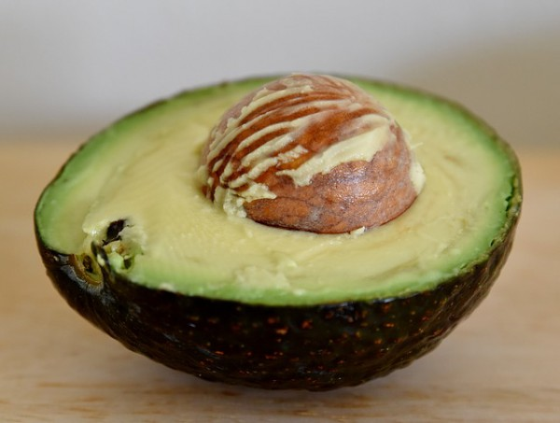](http://a3145z1.americdn.com/wp-content/uploads/2016/04/surprising-way-keep-avocados-fresh-people-dont-know.jpg)

Avocados are abundant in 20 essential nutrients, including:

* Vitamin E
* Fiber
* B-vitamins
* Potassium (Avocados have twice the amount of potassium found in a banana)
* Magnesium
* Iron
* Sodium
* Calcium
* Boron
* Folic acid

Furthermore, these beneficial fruits are rich in [cancer-fighting](http://www.healthyfoodhouse.com/scientists-approved-herb-powerful-medicine-cancer/) carotenoids.

The California Avocado Commission, in 2010, provided guidelines for peeling the avocado properly in order to be able to get the most benefits of it.

*“California-grown avocados contain 11 carotenoids. According to USDA’s Agricultural Research Service, avocados contain a complex package of phytonutrients, including carotenoids that may provide numerous health benefits.*

*Carotenoids appear to protect humans against certain cancers, heart disease, and age-related macular degeneration. The UCLA research showed that in California avocados, the greatest concentration of beneficial carotenoids is in the dark green fruit of the avocado closest to the peel.”*

Avocados have strong antifungal and antibacterial properties which strengthen the immune system. In addition, these healthy fruits will boost the ability of the body to absorb fat-soluble nutrients from other vegetables and fruits, like lutein, and alpha and beta-carotene.

Avocados are also abundant in the amino acid lecithin, which improves the function of the brain, prevents liver overload, and promotes body weight balance.

Therefore, [the consumption of avocados](http://www.healthyfoodhouse.com/10-surprising-reasons-eat-avocado-everyday/) can be of great benefit for the health. However, only a few people know how to keep them fresh.

Namely, as soon as the cut surface of the fruit comes into contact with oxygen, it almost immediately turns brown, which makes them difficult to store for a longer period of time I the fridge. This is due to the enzyme known as polyphenol oxidase.

Hence, you should put the avocado in an airtight container with a piece of onion and you will keep it fresh longer. This is what to do:

You should cut the onion in bigger chunks, and place them in the fridge. Then, place the avocado on the top of them, but you should make sure it touches them. They will release gasses that will prevent oxidation and you will succeed to keep the cut avocado fresh in the fridge.

It can stay there up to 5-7 days.

Source: [livingtraditionally.com](http://livingtraditionally.com/the-surprising-way-to-keep-avocados-fresh-that-most-people-dont-know-about/)  
Other included sources linked in Living Traditionally’s article:  
[www.sciencedaily.com](http://www.sciencedaily.com/releases/2012/04/120422162217.htm)  
[www.eurekalert.org](http://www.eurekalert.org/pub_releases/2012-04/foas-aot041712.php)