**Tea for gum disease: How To Grow Equisetum Hyemale Buy starts on Amazon**

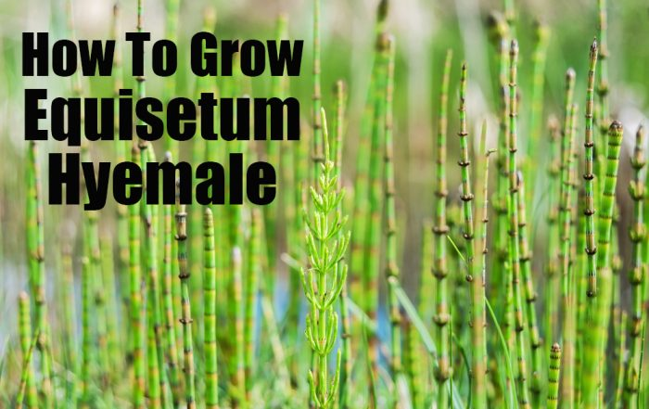

53

*Equisetum hyemale* is commonly called scouring rush or rough horsetail. Equisetum is not a rush, fern, or reed. This horsetail is a non-flowering, rush-like, perennial, which is native to Europe, North America, and Asia, and is invasive in most places. It is very easy to grow *Equisetum Hymale*!

It is a single surviving genus that dates back 350 million years. Its name comes from the Latin word *equus* meaning “a horse” and *seta* meaning “a bristle.”

**The stems**

It occurs in wet woods, moist hillsides, and the edges of lakes, rivers, and ponds. This species has rigid, rough, hollow, jointed-and-segmented, bamboo-like, dark green stems that are about 1/2 inch in diameter at the base.

**Photosynthesis** happens in the stems of this plant. Fertile stems bear pine cone-like fruiting heads about 1-inch long, which contain a lot of spores.

If you live in an area that is frost-free, the evergreen stems are pretty in winter.

*The stems are also high in silica and were used by early Americans for polishing pots and pans.* (1)

**The leaves**

Tiny, scale-like leaves attached to the stem and fuse into an ash-gray sheath, which is a 1/4-inch long. The leaves end in a fringe of teeth marks at each stem *node* (joint). During the growing season, these teeth shed.

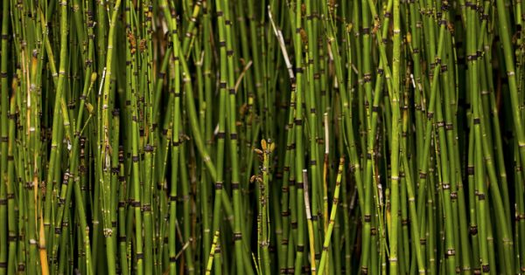

**Grow Equisetum Hyemale**

This ancient plant spreads by *rhizomes (underground stem that acts like a root)*. It is commonly called **horsetail** or **winter scouring rush**, but there are several varieties. This particular species is one that has been used for centuries for **tooth and gum care**.

**In your landscape**

Horsetail reeds (*Equisetum hyemale*) is a great addition to the edges of backyard ponds and water features. The **reeds thrive where soils are moist**, but the plant remains above water. Depending on where you live, it can be invasive. This species of horsetail multiplies in a “thicket.”

The reeds may stay green where frost is not a concern. The reeds are typically grown only as a potted plant, because they spread quickly via underground rhizomes. It grows to a **height of 2 feet to 4 feet**.

**Soil**

*Equisetum Hyemale* tolerates a wide-range of moist soils It will even grow in up to 4 inches of standing water. A large colony of reeds forms in the wild. *Equisetum Hyemale* is a very aggressive plant, which needs to be restrained by a pot. Once established, it can be challenging to remove because the rhizomes spread wide and deep. Any small section of rhizome left behind will sprout a new plant. In water gardens, plant in pots, or it will choke out other plants.

This horsetail species likes a slightly acidic soil with a clay, loam, sand mix. It particularly likes wet sites. It is perfect for a bog garden, containers, or water gardens.

**Light**

Grow *Equisetum Hyemale* in full sun, partial sun, or partial shade depending on your particular climate.

**Climate**

This species of horsetail grows well in Zones 4 through 9.

[**Click here to find your hardiness zone.**](http://planthardiness.ars.usda.gov/PHZMWeb/)

**Maintenance**

Indoors or outside, be sure to cut off any rhizomes growing out of the pot. This will keep the horsetail from spreading into the pond or surrounding soil.

Place the pot so the rim is above the water surface, near the edge of a pond or water feature is perfect.

*Prune the dead stems after they turn brown in winter.* Provide some winter interest by leaving the stems in place until new stems emerge.

**Watering**

Water horsetail reeds twice-a-week or more, so the soil stays moist, almost wet. Pots sitting in water need less watering. Water pond plants only if the potting soil surface looks dry.

**Pests**

*Equisetum Hyemale* does not have any serious insect or disease problems. **The only problem is its very aggressive and spreading nature.**

**Fertilizer**

When the reed is **actively growing in spring and summer** or every two months, apply a fertilizer made for pond or bog plants. Follow the recommended applications on the fertilizer bag.

Here are [**35 Homemade Organic Fertilizers**](http://thegrownetwork.com/cheap-organic-fertilizer/) to try!

**Grow *Equisetum Hyemale* Indoors**

Although a bog plant, horsetail reeds **are low-maintenance** and do well in pots on your patio, too. Plant *Equisetum Hyemale* in a **non-perforated, 1-gallon pot** with drainage holes.

Lift the pot once-a-month to examine the drainage holes. **Cut back any rhizomes that are trying to escape.**

Indoors, grow *Equisetum Hyemale* in moist soil and with a lot of light. A sunny window is perfect.

Use a potting soil that works best for bog and water garden plants. Set the pot in water that is no more than 4-inches deep.

**Will you be growing *Equisetum Hyemale*? Tell us your thoughts in the comments below.**

Research:

1 Missouri Botanical Garden. [http://www.missouribotanicalgarden.org/PlantFinder/PlantFinderDetails.aspx?kempercode=c670]