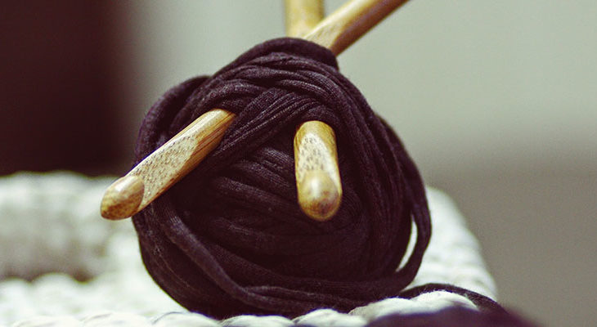

**What is the importance of respecting each other’s differences?**

Posted October 9, 2017

Back in the early 70’s my audiences were all between 15 and 25 years old. They wore white, they all had flowers in their hair, and they all smiled a lot, and we would meet so that we could review the maps for our inner journeys.

So one night I was lecturing to my constituents, and in the front row was a women about 70 years old with a hat with strawberries and cherries on it. She had a black patent leather bag and a print dress and solid black oxford shoes. I looked at her and thought, “This is not an ‘acid head’, what is she doing here?” I figured somebody brought her for some reason and how bizarre. I started to talk, and talk about these very far out places of the mind and everywhere I went, she’d be going like this (nodding), and I got absolutely obsessed with her, you know. I tried saying different things, and she’d be going along.

At the end I couldn’t stand it and I kind of “willed” her up to me, you know how you smile at somebody, and you just kind of feel compelled to come up. You know about that stuff, and so she just came up to me and she said, “Thank you. That’s just the way I know the way the world to be.” I said, “How do you know? I mean like, what have you done to know this?” and she leaned forward and said very conspiratorially, “I crochet.”

Now, you’ve got to realize there are marked individual differences in people, and that a lot of people flip into these planes of consciousness during their period, during sex, during a traumatic moment, when their motorcycle’s going off the road, when they lose a lover, when they get poisoned with something they eat, it can happen when a leaf falls.

I mean, under the right conditions you really see there are marked individual differences. Other people, you can take them into the highest place, and in a moment, it’s like a tire that has a big hole in it, it’ll go flat again and again and again, and you learn to really respect individual differences, and realize each person has their own journey and one’s not better than another. It’s a big circle anyway, and nothing’s happening you see, because when you get out of time, nothing’s happening anyway.

-Ram Dass