Photo by Analiese Trimber

If you haven’t zoodled yet in life, you are seriously missing out. I mean let’s be honest, who knew that slicing zucchini into noodle form and sautéing it briefly would taste good. While zoodles are definitely not the same as pasta, they are a perfectly suitable and [**guilt-free way to indulge**](https://thebaconprincess.wordpress.com/2014/02/06/lemon-spaghetti-squash-sauteed-veggies-and-bacon/) in a one-pot meal of creamy deliciousness.

**Level:** Easy

**Prep Time:** 10minutes  
**Cook Time:** 10 minutes  
**Total Time:** 20 minutes

**Servings:** 1 (or 2 if you eat like a rabbit)

**Ingredients:**  
2 tablespoons olive oil  
2 cloves garlic, finely diced  
2 medium zucchini or squash  
Juice from 1 lemon  
1 ½ tablespoons corn starch (or tapioca starch if you want to make it Paleo)  
¼ cup water  
Any veggies or toppings you’d like—you can see I added some sweet potato and asparagus  
Salt and pepper, to taste  
½ tablespoon dill

**Directions:**

1. Using a [**spiralizer**](http://mcgill.spoonuniversity.com/2015/01/29/spiralizers-vegetable-noodles/), slice zucchini and squash into noodle form. If you don’t have a spiralizer, you can use a mandolin, super sharp knife, or vegetable peeler to slice the squash thinly, and then cut into noodle-sized width from there.

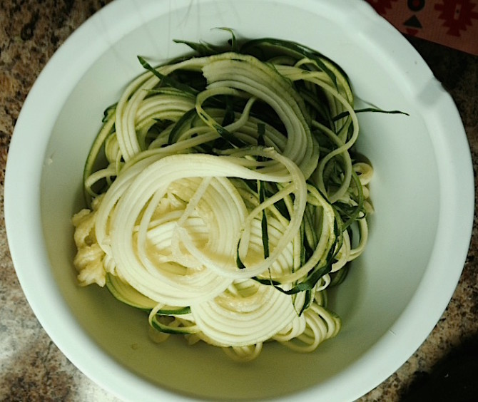

* [Share](http://www.facebook.com/sharer.php?u=http://spoonuniversity.com/uncategorized/zoodle-recipe-will-make-forget-real-pasta-exists/?utm_source=buzzfeed&utm_medium=referral&utm_campaign=content-partnerships)
* [Pin It](http://pinterest.com/pin/create/button?url=http://spoonuniversity.com/uncategorized/zoodle-recipe-will-make-forget-real-pasta-exists/?utm_source=buzzfeed&utm_medium=referral&utm_campaign=content-partnerships&media=http://1ej8x43yl3fdbkhft1np5ch2.wpengine.netdna-cdn.com/wp-content/themes/spoon/images/loading.svg)

Photo by Jen Berger

2. In a medium-sized frying pan, heat the olive oil and garlic over medium heat.

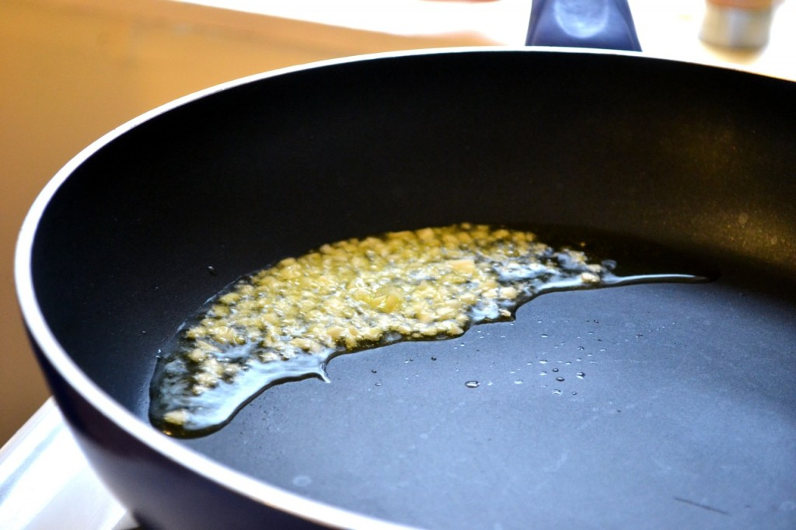

* [Share](http://www.facebook.com/sharer.php?u=http://spoonuniversity.com/uncategorized/zoodle-recipe-will-make-forget-real-pasta-exists/?utm_source=buzzfeed&utm_medium=referral&utm_campaign=content-partnerships)
* [Pin It](http://pinterest.com/pin/create/button?url=http://spoonuniversity.com/uncategorized/zoodle-recipe-will-make-forget-real-pasta-exists/?utm_source=buzzfeed&utm_medium=referral&utm_campaign=content-partnerships&media=http://1ej8x43yl3fdbkhft1np5ch2.wpengine.netdna-cdn.com/wp-content/themes/spoon/images/loading.svg)

Photo by Kelda Baljon

3. Add whatever veggies you’d like to the pan and cook for 5-10 minutes or until nearly cooked.

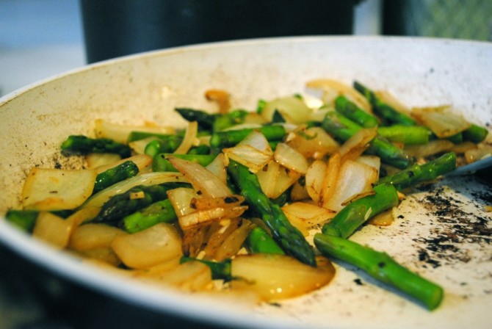

* [Share](http://www.facebook.com/sharer.php?u=http://spoonuniversity.com/uncategorized/zoodle-recipe-will-make-forget-real-pasta-exists/?utm_source=buzzfeed&utm_medium=referral&utm_campaign=content-partnerships)
* [Pin It](http://pinterest.com/pin/create/button?url=http://spoonuniversity.com/uncategorized/zoodle-recipe-will-make-forget-real-pasta-exists/?utm_source=buzzfeed&utm_medium=referral&utm_campaign=content-partnerships&media=http://1ej8x43yl3fdbkhft1np5ch2.wpengine.netdna-cdn.com/wp-content/themes/spoon/images/loading.svg)

Photo by Kelda Baljon

4. Add the zucchini noodles and lemon juice and sauté for another 5-10 minutes or until soft.

5. In a small bowl or cup, combine corn starch and water and stir until fully incorporated. Add to pan and stir everything constantly until the mixture starts to thicken.