[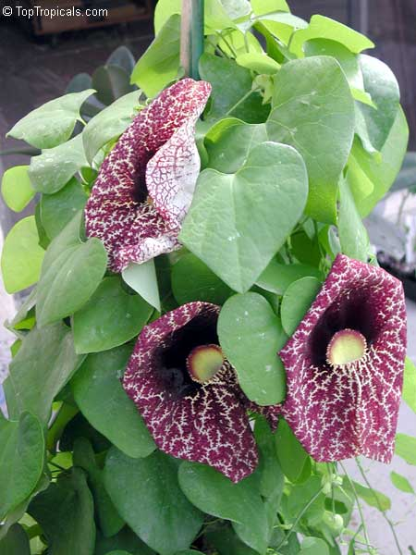](https://toptropicals.com/catalog/uid/Aristolochia_gigantea.htm)[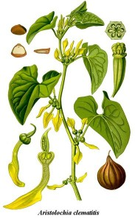](https://www.google.co.in/url?sa=i&rct=j&q=&esrc=s&source=images&cd=&ved=0ahUKEwiClN-4_YPXAhXKL48KHQDXB1EQjRwIBw&url=https%3A%2F%2Fwww.decodedscience.org%2Faristolochic-acid-its-history-and-use-in-chinese-herbal-medicines%2F35466&psig=AOvVaw1mshSvgWD_oO95u9Jtiglt&ust=1508752973417814)

**A common herbal medicine may cause liver cancer mutations**

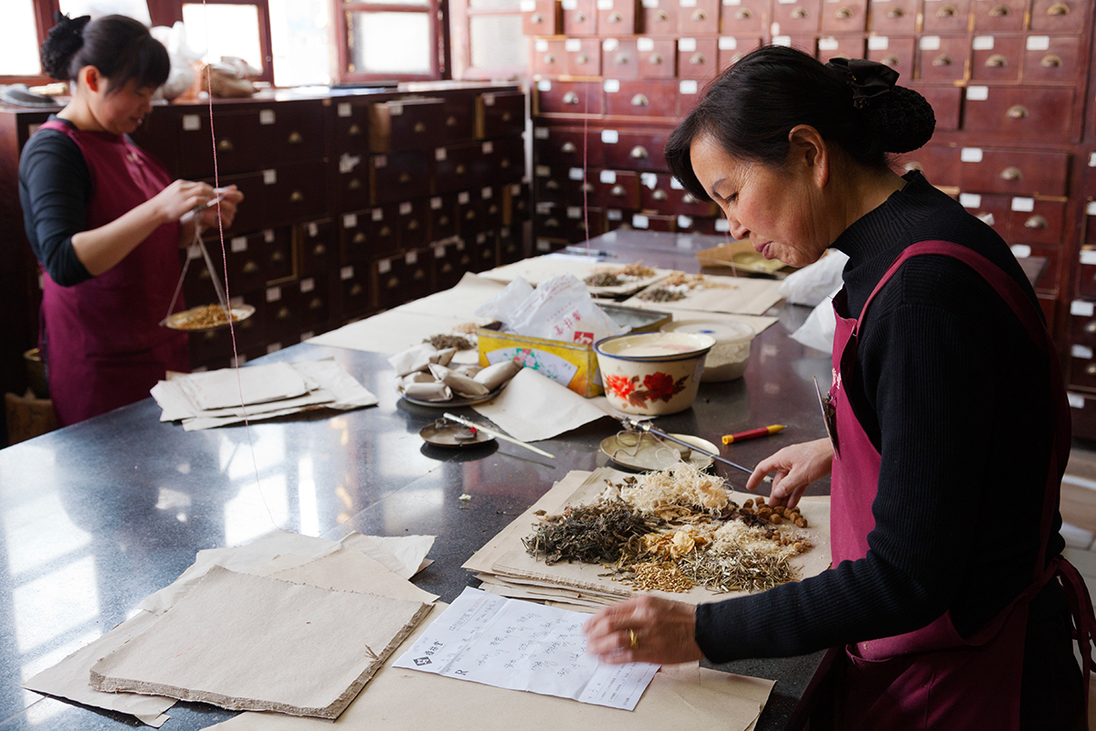

Hard to regulate

Katie Garrod/Getty

By Jessica Hamzelou

A commonly-used herbal medicine causes mutations that are linked to liver cancer, according to research in Taiwan. Extracts taken from plants of the genus *Aristolochia*, which are used in traditional Chinese medicine to treat a wide range of conditions, may be responsible for many liver cancers in Asia.

There are over 500 species of *Aristolochia*, around 100 of which have been used in [herbal medicines](https://www.newscientist.com/article/mg20126903-200-medicinal-plants-on-verge-of-extinction/). “They have very beautiful, trumpet-shaped flowers,” says [Steven Rozen](https://www.duke-nus.edu.sg/content/rozen-steve) at Duke-NUS Medical School in Singapore. This has led to them being given names like “Dutchman’s pipe”.

Extracts of the plants – taken from the flowers, root or stem, for example – have long been used in herbal medicine. But fears over their safety were raised in the 1990s, when women who were given trial weight loss drugs containing *Aristolochia* extracts developed [kidney failure](https://www.ncbi.nlm.nih.gov/pubmed/25446374). Since then, the plant extracts have also been linked to [Balkan nephropathy](http://www.pnas.org/content/104/29/12129.long) – a kidney disease affecting people in Bosnia, Bulgaria, Croatia, Romania and Serbia.

In 2013, researchers found that a compound in the plants, known as aristolochic acid, seems to cause gene mutations by [targeting the base adenine](http://stm.sciencemag.org/content/5/197/197ra101), a component of DNA’s genetic code. “It attacks any part of the genome with equal opportunity,” says Rozen.

**Cases worldwide**

When a member of Rozen’s team spotted the same type of mutation occurring in [liver cancer](https://www.newscientist.com/article/dn23154-liver-cancer-survival-time-tripled-by-virus/), the group wondered if plants that contain aristolochic acid might increase a person’s chances of developing the disease.

The team looked for the mutation in 98 liver tumour samples taken at two hospitals in Taiwan. *Aristolochia* plants are used widely in herbal treatments in this country.

“I was dumbstruck to find the evidence of exposure to aristolochic acid in 78 per cent of cases,” says Rozen. “This indicates strongly that aristolochic acid was one of the causes of these cancers.”

Analysing genetic cancer data from other countries, Rozen’s team found a link between adenosine mutations and liver cancer in many cases from China, Japan and Korea. The same mutation appeared to be linked to 10 per cent of cases in North America, and 5 per cent of liver cancers in the UK. However, aristolochic acid may not be the only cause of the cancer-linked mutation, so it’s unclear how many of these cases were caused by herbal medicine.

Extracts from some *Aristolochia* species have already been banned in countries like Taiwan, but many others are widely available, and even banned ones can be found online, says Rozen. “It’s quite difficult to regulate,” he says. “We need to warn people of the dangers of aristocholic acid.”