*Recipe courtesy of Doris Choi*

**Ingredients:**

2 pounds cauliflower florets, riced  
1 egg, beaten  
1/3 cup soft goat cheese (chevre)  
1 teaspoon dried oregano  
pinch of salt

*\*Tip: For a faster and less labor-intensive method, check out* [*my new cookbook*](http://www.amazon.com/gp/product/1607747227?ie=UTF8&camp=1789&creativeASIN=1607747227&linkCode=xm2&tag=dtx04-20)*. You can completely skip the cauliflower cooking process, avoid burning your hands, and get fantastic results! It’s the method I use exclusively now.*

**Directions:**

Preheat your oven to 400F, then get to work on your crust.

**Step 1: Begin by making your cauliflower “rice.”**

Simply pulse batches of raw cauliflower florets in a food processor, until a rice-like texture is achieved.

[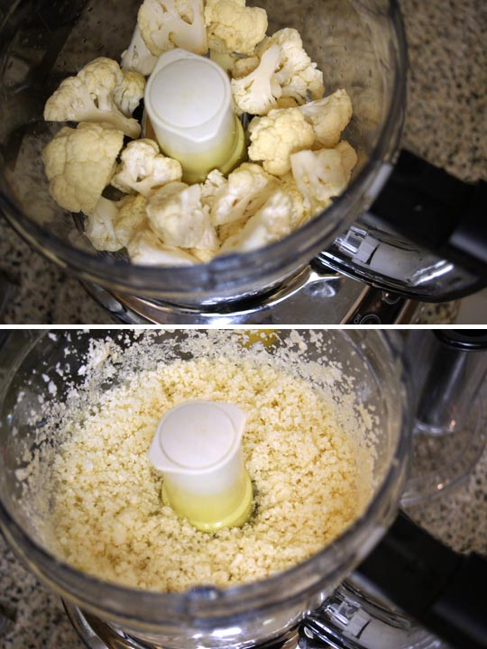](http://detoxinista.com/wp-content/uploads/2012/01/rice.jpg)**—**

**Step 2: Cook & Strain the rice.**

Fill a large pot with about an inch of water, and bring it to a boil. Add the “rice” and cover; let it cook for about 4-5 minutes. Drain into a fine-mesh strainer.

*Now here comes the secret:*

Once you’ve strained the rice, transfer it to a clean, thin dishtowel.

[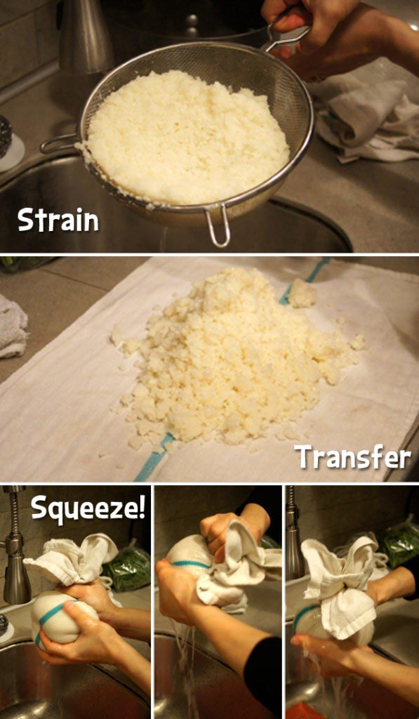](http://detoxinista.com/wp-content/uploads/2012/01/Strain-rice.jpg)Wrap up the steamed rice in the dishtowel, twist it up, then SQUEEEEEEEZE all the excess moisture out! (Be careful not to burn your hands!)

It’s amazing how much liquid will be released, which will leave you with a nice and dry pizza crust.

—

**Step 3: Make & Shape the dough.**

In a large bowl, mix up your strained rice, beaten egg, goat cheese, and spices.

Don’t be afraid to use your hands! You want it very well mixed.

[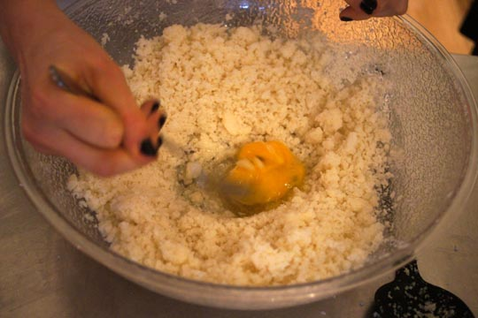](http://detoxinista.com/wp-content/uploads/2012/01/DSC06633.jpg)It won’t be like any pizza dough you’ve ever worked with, but don’t worry– it’ll hold together!

Press the dough out onto a baking sheet lined with parchment paper. (It’s important that it’s lined with parchment paper, which is not to be confused with WAX paper– they’re very different!)

[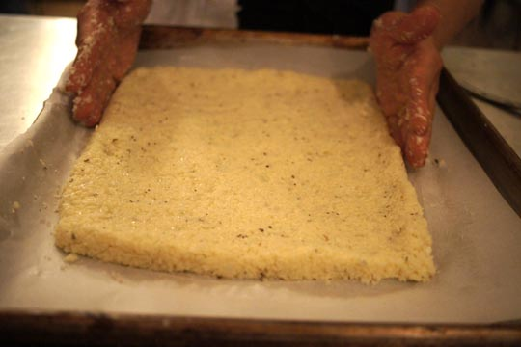](http://detoxinista.com/wp-content/uploads/2012/01/DSC06662.jpg)Keep the dough about 1/3″ thick, and make the edges a little higher for a “crust” effect, if you like.

—

**Step 4: Bake!**

Bake for 35-40 minutes at 400F.

[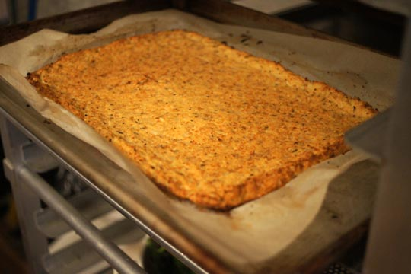](http://detoxinista.com/wp-content/uploads/2012/01/DSC06681.jpg)The crust should be firm, and golden brown when finished.

—

**Step 5: Load on the Toppings!**

Now’s the time to add all your favorites– sauce, cheese, and any other toppings you like.

[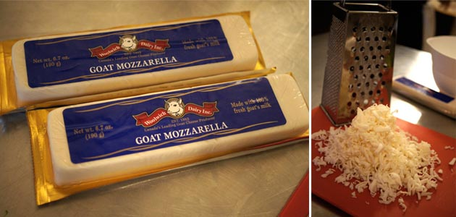](http://detoxinista.com/wp-content/uploads/2012/01/cheese.jpg)This goat mozzarella is ridiculously good, without a “goat-y” flavor.

[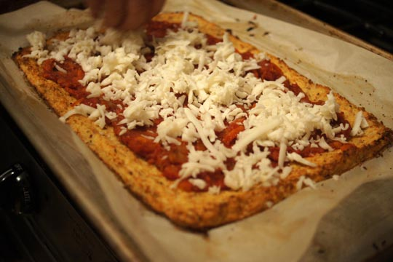](http://detoxinista.com/wp-content/uploads/2012/01/DSC06702.jpg)

*Time-Saving Tip: I recommend making a double-batch of cauliflower pizza crusts–> make one for now, and save one for later. After baking the crusts and adding the toppings, wrap up the whole pizza in foil, and FREEZE it for a quick “frozen pizza” to enjoy another night! Simply thaw and bake at 400F, as directed below, until the cheese is hot and bubbly.*

Return the pizza to the 400F oven, and bake an additional 5-10 minutes, just until the cheese is hot and bubbly.

Then slice and serve immediately!

[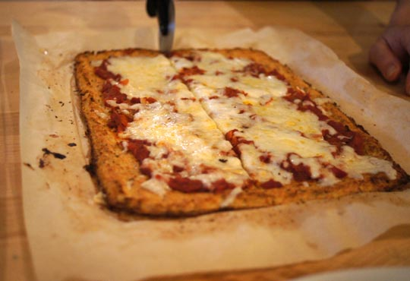](http://detoxinista.com/wp-content/uploads/2012/01/DSC06772.jpg)Enjoy!

*\*Tip: If you need to avoid eggs or dairy, try making my* [*Vegan Cauliflower Pizza Crust*](http://detoxinista.com/2014/02/vegan-cauliflower-pizza-crust/) *instead!*

4.8 from 162 reviews

[Print](http://detoxinista.com/easyrecipe-print/7122-0/)

The Secret To Perfect Cauliflower Pizza Crust

Author: Detoxinista.com

Serves: 2-4

A grain-free alternative to traditional pizza crust, that you can pick up with your hands!

Ingredients

* 2 pounds cauliflower florets, riced
* 1 egg, beaten
* ⅓ cup soft goat cheese (chevre)
* 1 teaspoon dried oregano
* pinch of salt

Instructions

1. Preheat your oven to 400F.
2. To make the cauliflower rice, pulse batches of raw cauliflower florets in a food processor, until a rice-like texture is achieved.
3. Fill a large pot with about an inch of water, and bring it to a boil. Add the "rice" and cover; let it cook for about 4-5 minutes. Drain into a fine-mesh strainer.
4. THIS IS THE SECRET: Once you've strained the rice, transfer it to a clean, thin dishtowel. Wrap up the steamed rice in the dishtowel, twist it up, then SQUEEZE all the excess moisture out! It's amazing how much extra liquid will be released, which will leave you with a nice and dry pizza crust.
5. In a large bowl, mix up your strained rice, beaten egg, goat cheese, and spices. (Don't be afraid to use your hands! You want it very well mixed.) It won't be like any pizza dough you've ever worked with, but don't worry-- it'll hold together!
6. Press the dough out onto a baking sheet lined with parchment paper. (It's important that it's lined with parchment paper, or it will stick.) Keep the dough about ⅓" thick, and make the edges a little higher for a "crust" effect, if you like.
7. Bake for 35-40 minutes at 400F. The crust should be firm, and golden brown when finished.
8. Now's the time to add all your favorites-- sauce, cheese, and any other toppings you like. Return the pizza to the 400F oven, and bake an additional 5-10 minutes, just until the cheese is hot and bubbly.
9. Slice and serve immediately!

Notes

Time-Saving Tip: I recommend making a double-batch of cauliflower pizza crusts--&amp;gt; make one for now, and save one for later. After baking the crusts, wrap up the extra pizza crust in foil, and FREEZE it for a quick "frozen pizza" to enjoy another night! All you need to do is add toppings and bake at 400F, until the cheese is hot and bubbly.

—

Hope you try this the next time a pizza-craving strikes!