[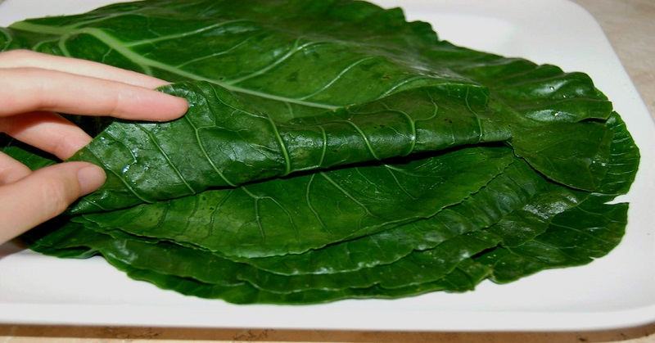](http://expand-your-consciousness.com/wp-content/uploads/2015/05/step_6-850x573.jpg)There may not be a perfect gluten-free tortilla, but whether you care about gluten-free or not, using blanched collard leaves in place of tortillas (or bread) is a fun and super healthy thing to do. The nutrient density of collard leaves versus tortillas, bread, burger buns, hot dog buns and the like doesn’t even compare.

Try blanching a couple of bunches in advance and store them in your fridge so that you don’t have to think about it, you can just grab and wrap!