The human body can effectively maintain a [balance of the pH levels](http://www.healthyfoodhouse.com/how-to-balance-your-ph-levels-and-find-out-if-you-are-too-acidic/). However, if it is in a too acidic state, this function is impeded.

In order to be healthy, the pH levels of the body should range from 7.35 to 7.45.  If these levels are elevated, they disturb the digestion system and upset the stomach. The maximum amount of the pH levels that is allowed is 7.36. Therefore, you need to check them in order to preserve your health.

[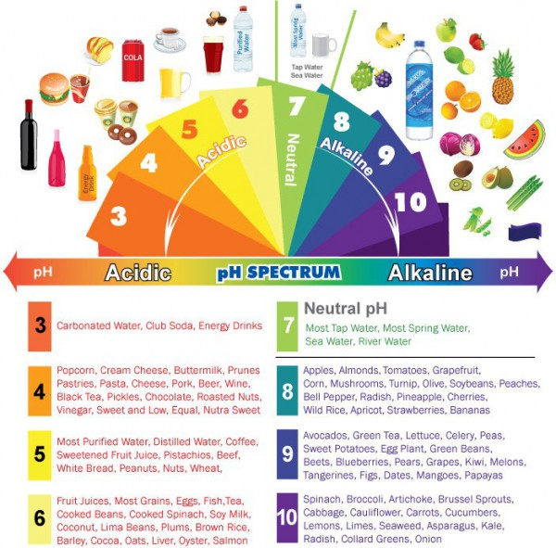](http://a3145z1.americdn.com/wp-content/uploads/2016/03/17-signs-body-acidic-9-ways-quickly-alkalize1.jpg)

**Here is a list of health issues caused by poor pH balance:**

* Inflamed or sensitive gums and cavities
* Poor immunity
* Heart issues, arrhythmia, tachycardia
* Yeast proliferation
* Lack of energy and chronic fatigue
* Respiratory issues, shortness of breath, coughing
* Cardiovascular damage, such as tightening of blood vessels and decrease in oxygen supply
* Premature aging
* Weight gain, obesity and diabetes
* Bladder and kidney infections
* Allergies, acne
* Increased free radical damage
* Sciatica, lumbago, stiff neck
* Nausea, vomiting, diarrhea
* Osteoporosis, weak brittle bones, hip fractures, and bone spurs
* Headaches, confusion, sleepiness
* Joint pain, aching muscles and lactic acid accumulation

However, in order to maintain a [healthy balance of the pH levels](http://www.healthyfoodhouse.com/baking-soda-the-nightmare-of-the-pharmaceutical-industry/), you need to eat a proper diet, as it is a key to preventing acidity. According to Ann Wigmore, founder of the renowned Hippocrates Health Institute *“The food you eat can either be the safest and most powerful form of medicine or the slowest form of poison.”*

Therefore, you should avoid dairy products, sugars, grains, and meat, and consume fruits, sea vegetables and greens. In this way, you will [successfully alkalize the body](http://www.healthyfoodhouse.com/alkaline-food-list-the-most-effective-alkalizing-foods-to-reset-alkaline-balance-and-prevent-cancer/) and enjoy your health.

Namely, even though you may consider lemons to be acidic, they are in fact alkaline, just like sodium, potassium, iron, calcium and magnesium. Moreover, if a product can be both, alkaline and acidic, you should choose the one which is high in minerals.

In the 1case of a dominant organism type, it is advised to consume proteins in order to reduce acidity and be alkaline, and avoid vegetables and fruits. On the other hand, fewer proteins and lots of vegetables and fruits are advised in the case of an organism dominant to the autonomic system (ANS).

**Hence, in order to effectively alkalize your body, you should do the following:**

* frequently control the pH levels
* avoid acidic foods
* drink lots of alkaline water
* avoid soda, coffee and sugar
* do not consume processed foods
* Often consume green salads, such as collard greens and lettuce leaves
* drink green drinks, herbal coffee, herbal teas, almond and coconut milk and smoothies

To conclude, it is of utmost importance to be aware of the effects of acidity on your health, and constantly maintain a healthy balance of your body in order to prevent all kinds of illnesses and health conditions.

Alkalizing the organism is of extreme benefit for your health, so even though it may require some time to get used to the new, healthy diet, eventually, it will result in a healthy and strong body.

Sources:  
[theheartysoul.com](http://theheartysoul.com/how-to-alkalize/)[www.collective-evolution.com](http://www.collective-evolution.com/2015/09/10/signs-your-body-is-too-acidic-how-to-correct-it/)  
[www.healthyfoodteam.com](http://www.healthyfoodteam.com/17-signs-your-body-is-too-acidic-and-9-ways-to-quickly-alkalize-it/)