Chemical Nature of the Amino Acids
All peptides and polypeptides are polymers of alpha-amino acids. There are 20 α-amino acids that are relevant to the make-up of mammalian proteins (see below). Several other amino acids are found in the body free or in combined states (i.e. not associated with peptides or proteins). These non-protein associated amino acids perform specialized functions. Several of the amino acids found in proteins also serve functions distinct from the formation of peptides and proteins, e.g., tyrosine in the formation of thyroid hormones or glutamate acting as a neurotransmitter.
The α-amino acids in peptides and proteins (excluding proline) consist of a carboxylic acid (-COOH) and an amino (-NH₂) functional group attached to the same tetrahedral carbon atom. This carbon is the α-carbon. Distinct R-groups, that distinguish one amino acid from another, also are attached to the alpha-carbon (except in the case of glycine where the R-group is hydrogen). The fourth substitution on the tetrahedral α-carbon of amino acids is hydrogen.

Table of α-Amino Acids Found in Proteins
Amino Acid | Symbol | Structure* | pK₁  (COOH) | pK₂  (NH₂) | pK R Group
Amino Acids with Aliphatic R-Groups
Glycine | Gly - G | 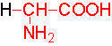 | 2.4 | 9.8
Alanine | Ala - A | 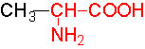 | 2.4 | 9.9
Valine | Val - V | 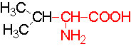 | 2.2 | 9.7
Leucine | Leu - L | 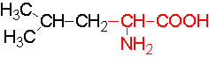 | 2.3 | 9.7
Isoleucine | Ile - I | 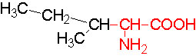 | 2.3 | 9.8
Non-Aromatic Amino Acids with Hydroxyl R-Groups
Serine | Ser - S | 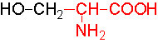 | 2.2 | 9.2 | ~13
Threonine | Thr - T | 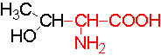 | 2.1 | 9.1 | ~13
Amino Acids with Sulfur-Containing R-Groups
Cysteine | Cys - C | 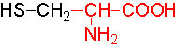 | 1.9 | 10.8 | 8.3
Methionine | Met-M | 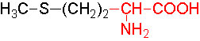 | 2.1 | 9.3
Acidic Amino Acids and their Amides
Aspartic Acid | Asp - D | 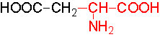 | 2.0 | 9.9 | 3.9
Asparagine | Asn - N | 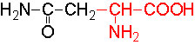 | 2.1 | 8.8
Glutamic Acid | Glu - E | 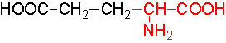 | 2.1 | 9.5 | 4.1
Glutamine | Gln - Q | 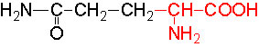 | 2.2 | 9.1
Basic Amino Acids
Arginine | Arg - R | 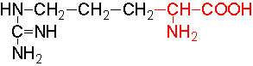 | 1.8 | 9.0 | 12.5
Lysine | Lys - K | 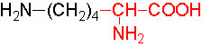 | 2.2 | 9.2 | 10.8
Histidine | His - H | 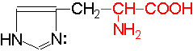 | 1.8 | 9.2 | 6.0
Amino Acids with Aromatic Rings
Phenylalanine | Phe - F | 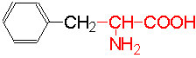 | 2.2 | 9.2
Tyrosine | Tyr - Y | 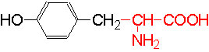 | 2.2 | 9.1 | 10.1
Tryptophan | Trp-W | 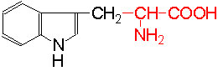 | 2.4 | 9.4
Imino Acids
Proline | Pro - P | 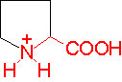 | 2.0 | 10.6
*Backbone of the amino acids is red, R-groups are black

