The Human Gastrointestinal (GI) Tract
Index to this page
- Ingestion
- The stomach
  - Parietal cells
  - Hydrochloric acid (HCl)
  - Intrinsic factor
  - Chief Cells
- The liver
  - The hepatic portal system
- The pancreas
- The small intestine
- The large intestine

The strategy
Humans (and most animals) digest all their food extracellularly; that is, outside of cells.
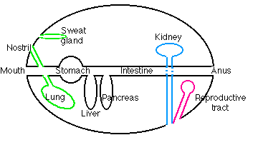
- Digestive enzymes are secreted from cells lining the inner surfaces of various exocrine glands.
- The enzymes hydrolyze the macromolecules in food into small, soluble molecules that can be
- absorbed into cells.

The topology
The diagram shows the major topological relationships in the body. The linings of all
- exocrine glands, including digestive glands,
- nasal passages, trachea, and lungs,
- kidney tubules, collecting ducts, and bladder,
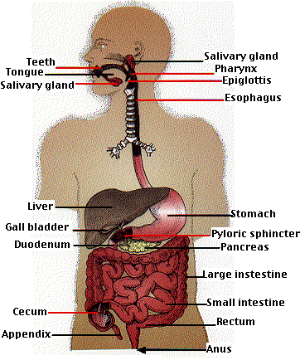
- reproductive structures like the vagina, uterus, and fallopian tubes
are all continuous with the surface of the body. Anything placed within their lumen is, strictly speaking, outside the body. This includes
- the secretions of all exocrine glands (in contrast to the secretions of endocrine glands, which are deposited in the blood).
- Any indigestible material placed in the mouth which will appear, in due course, at the other end.

Ingestion
Food placed in the mouth is
- ground into finer particles by the teeth,
- moistened and lubricated by saliva (secreted by three pairs of salivary glands)
- small amounts of starch are digested by the amylase present in saliva
- the resulting bolus of food is swallowed into the esophagus and
- carried by peristalsis to the stomach.

The stomach
The wall of the stomach is lined with millions of gastric glands, which together secrete 400-800 ml of gastric juice at each meal. Three kinds of cells are found in the gastric glands
- parietal cells
- "chief" cells
- mucus-secreting cells

Parietal cells
Parietal cells secrete
- hydrochloric acid
- intrinsic factor

Hydrochloric acid (HCl)
Parietal cells contain a H⁺ ATPase. This transmembrane protein secretes H⁺ ions (protons) by active transport, using the energy of ATP. The concentration of H⁺ in the gastric juice can be as high as 0.15 M, giving gastric juice a pH somewhat less than 1. With a concentration of H⁺ within these cells of only about 4 x 10⁻⁸ M, this example of active transport produces more than a million-fold increase in concentration. No wonder that these cells are stuffed with mitochondria and are extravagant consumers of energy.

Intrinsic factor
Intrinsic factor is a protein that binds ingested vitamin B₁₂ and enables it to be absorbed by the intestine. A deficiency of intrinsic factor causes pernicious anemia.

"Chief" Cells
The "chief" cells synthesize and secrete pepsinogen, the precursor to the proteolytic enzyme pepsin.
Pepsin cleaves peptide bonds, favoring those on the C-terminal side of tyrosine, phenylalanine, and tryptophan residues. Its action breaks long polypeptide chains into shorter lengths.
Secretion by the gastric glands is stimulated by the hormone gastrin. Gastrin is released by endocrine cells in the stomach in response to the arrival of food.

Absorption in the stomach
Very little occurs. However, some water, certain ions, and such drugs as aspirin and ethanol are absorbed from the stomach into the blood (accounting for the quick relief of a headache after swallowing aspirin and the rapid appearance of ethanol in the blood after drinking alcohol).
As the contents of the stomach become thoroughly liquefied, they pass into the duodenum, the first segment (about 10 inches long) of the small intestine.
Two ducts enter the duodenum:
- one draining the gall bladder and hence the liver
- the other draining the exocrine portion of the pancreas.

The liver
The liver secretes bile. Between meals it accumulates in the gall bladder. When food, especially when it contains fat, enters the duodenum, the release of the hormone cholecystokinin (CCK) stimulates the gall bladder to contract and discharge its bile into the duodenum.
Bile contains:
- bile acids. These amphiphilic steroids emulsify ingested fat. The hydrophobic portion of the steroid dissolves in the fat while the negatively-charged side chain interacts with water molecules. The mutual repulsion of these negatively-charged droplets keeps them from coalescing. Thus large globules of fat (liquid at body temperature) are emulsified into tiny droplets (about 1 µm in diameter) that can be more easily digested and absorbed.
- bile pigments. These are the products of the breakdown of hemoglobin removed by the liver from old red blood cells. The brownish color of the bile pigments imparts the characteristic brown color of the feces.

The hepatic portal system
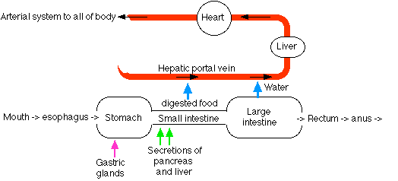
The capillary beds of most tissues drain into veins that lead directly back to the heart. But blood draining the intestines is an exception. The veins draining the intestine lead to a second set of capillary beds in the liver. Here the liver removes many of the materials that were absorbed by the intestine:
- Glucose is removed and converted into glycogen.
- Other monosaccharides are removed and converted into glucose.
- Excess amino acids are removed and deaminated.
  - The amino group is converted into urea.
  - The residue can then enter the pathways of cellular respiration and be oxidized for energy.
- Many nonnutritive molecules, such as ingested drugs, are removed by the liver and, often, detoxified.
The liver serves as a gatekeeper between the intestines and the general circulation. It screens blood reaching it in the hepatic portal system so that its composition when it leaves will be close to normal for the body.
Furthermore, this homeostatic mechanism works both ways. When, for example, the concentration of glucose in the blood drops between meals, the liver releases more to the blood by
- converting its glycogen stores to glucose (glycogenolysis)
- converting certain amino acids into glucose (gluconeogenesis).

The pancreas
The pancreas consists of clusters if endocrine cells (the islets of Langerhans) and exocrine cells whose secretions drain into the duodenum.
Pancreatic fluid contains:
- sodium bicarbonate (NaHCO₃). This neutralizes the acidity of the fluid arriving from the stomach raising its pH to about 8.
- pancreatic amylase. This enzyme hydrolyzes starch into a mixture of maltose and glucose.
- pancreatic lipase. The enzyme hydrolyzes ingested fats into a mixture of fatty acids and monoglycerides. Its action is enhanced by the detergent effect of bile.
In April 1999, the FDA approved orlistat as a treatment for obesity. Orlistat inactivates pancreatic lipase. About one-third of ingested fats fails to be broken down into absorbable fatty acids and monoglycerides and simply passes out in the feces.
- 4 "zymogens" - proteins that are precursors to active proteases. These are immediately converted into the active proteolytic enzymes:
  - trypsin. Trypsin cleaves peptide bonds on the C-terminal side of arginines and lysines.
  - chymotrypsin. Chymotrypsin cuts on the C-terminal side of tyrosine, phenylalanine, and tryptophan residues (the same bonds as pepsin, whose action ceases when the NaHCO₃ raises the pH of the intestinal contents).
  - elastase. Elastase cuts peptide bonds next to small, uncharged side chains such as those of alanine and serine.
Trypsin, chymotrypsin, and elastase are members of the family of serine proteases. Link to discussion.
  - carboxypeptidase. This enzyme removes, one by one, the amino acids at the C-terminal of peptides.
- nucleases. These hydrolyze ingested nucleic acids (RNA and DNA) into their component nucleotides.
The secretion of pancreatic fluid is controlled by two hormones:
- secretin, which mainly affects the release of sodium bicarbonate, and
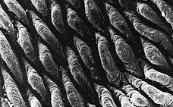
- cholecystokinin (CCK), which stimulates the release of the digestive enzymes.

The small intestine
Digestion within the small intestine produces a mixture of disaccharides, peptides, fatty acids, and monoglycerides. The final digestion and absorption of these substances occurs in the villi, which line the inner surface of the small intestine.
This scanning electron micrograph (courtesy of Keith R. Porter) shows the villi carpeting the inner surface of the small intestine.
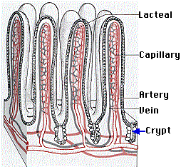
The crypts at the base of the villi contain stem cells that continuously divide by mitosis producing
- more stem cells
- cells that migrate up the surface of the villus while differentiating into
  - columnar epithelial cells (the majority). They are responsible for digestion and absorption.
  - goblet cells, which secrete mucus;
  - endocrine cells, which secrete a variety of hormones;
Link to Gut Hormones.
- Paneth cells, which secrete antimicrobial peptides [Link to discussion] that sterilize the contents of the intestine.
All of these cells replace older cells that continuously die by apoptosis.
The villi increase the surface area of the small intestine to many times what it would be if it were simply a tube with smooth walls. In addition, the apical (exposed) surface of the epithelial cells of each villus is covered with microvilli (also known as a "brush border"). Thanks largely to these, the total surface area of the intestine is almost 200 square meters, about the size of the singles area of a tennis court and some 100 times the surface area of the exterior of the body.
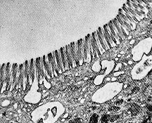
The electron micrograph (courtesy of Dr. Sam L. Clark) shows the microvilli of a mouse intestinal cell.
Incorporated in the plasma membrane of the microvilli are a number of enzymes that complete digestion:
- aminopeptidases attack the amino terminal (N-terminal) of peptides producing amino acids.
- disaccharidasesThese enzymes convert disaccharides into their monosaccharide subunits.
  - maltase hydrolyzes maltose into glucose.
  - sucrase hydrolyzes sucrose (common table sugar) into glucose and fructose.
  - lactase hydrolyzes lactose (milk sugar) into glucose and galactose.
Fructose simply diffuses into the villi, but both glucose and galactose are absorbed by active transport.
- fatty acids and monoglycerides. These become resynthesized into fats as they enter the cells of the villus. The resulting small droplets of fat are then discharged by exocytosis into the lymph vessels, called lacteals, draining the villi.

The large intestine (colon)
The large intestine receives the liquid residue after digestion and absorption are complete. This residue consists mostly of water as well as materials (e.g. cellulose) that were not digested. It nourishes a large population of bacteria (the contents of the small intestine are normally sterile). Most of these bacteria (of which one common species is E. coli) are harmless. And some are actually helpful, for example, by synthesizing vitamin K. Bacteria flourish to such an extent that as much as 50% of the dry weight of the feces may consist of bacterial cells.
How one harmless species avoids attack by its host's immune system.
Reabsorption of water is the chief function of the large intestine. The large amounts of water secreted into the stomach and small intestine by the various digestive glands must be reclaimed to avoid dehydration. If the large intestine becomes irritated, it may discharge its contents before water reabsorption is complete causing diarrhea. On the other hand, if the colon retains its contents too long, the fecal matter becomes dried out and compressed into hard masses causing constipation.
Welcome&Next Search

Cellular Respiration
Cellular respiration is the process of oxidizing food molecules, like glucose, to carbon dioxide and water. The energy released is trapped in the form of ATP for use by all the energy-consuming activities of the cell.
Index to this page
- Mitochondria
- The Citric Acid Cycle
- The Respiratory Chain
- Chemiosmosis in Mitochondria
- How many ATPs?
- Mitochondrial DNA (mtDNA)
The process occurs in two phases:
- glycolysis, the breakdown of glucose to pyruvic acid
- the complete oxidation of pyruvic acid to carbon dioxide and water
In eukaryotes, glycolysis occurs in the cytosol. (Link to a discussion of glycolysis). The remaining processes take place in mitochondria.

Mitochondria
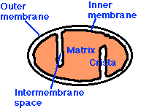
Mitochondria are membrane-enclosed organelles distributed through the cytosol of most eukaryotic cells. Their main function is the conversion of the potential energy of food molecules into ATP. Mitochondria have:
- an outer membrane that encloses the entire structure
- an inner membrane that encloses a fluid-filled matrix
- between the two is the intermembrane space
- the inner membrane is elaborately folded with shelflike cristae projecting into the matrix.
- a small number (some 5-10) circular molecules of DNA

The Outer Membrane
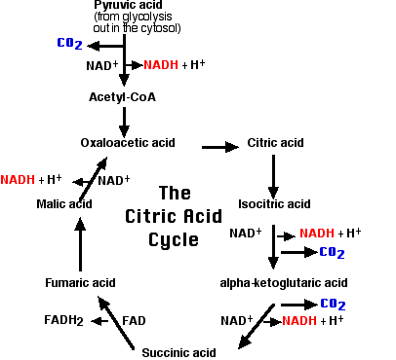
The outer membrane contains many complexes of integral membrane proteins that form channels through which a variety of molecules and ions move in and out of the mitochondrion.

The Inner Membrane
The inner membrane contains 5 complexes of integral membrane proteins:
- NADH dehydrogenase
- succinate dehydrogenase
- cytochrome c reductase(also known as the cytochrome b-c₁ complex)
- cytochrome c oxidase
- ATP synthase

The Matrix
The matrix contains a complex mixture of soluble enzymes that catalyze the respiration of pyruvic acid and other small organic molecules.
Here pyruvic acid is
- oxidized by NAD⁺ producing NADH + H⁺
- decarboxylated producing a molecule of
  - carbon dioxide (CO₂) and
  - a 2-carbon fragment of acetate bound to coenzyme A forming acetyl-CoA

The Citric Acid Cycle
- This 2-carbon fragment is donated to a molecule of oxaloacetic acid.
- The resulting molecule of citric acid (which gives its name to the process) undergoes the series of enzymatic steps shown in the diagram.
- The final step regenerates a molecule of oxaloacetic acid and the cycle is ready to turn again.
Summary:
- Each of the 3 carbon atoms present in the pyruvate that entered the mitochondrion leaves as a molecule of carbon dioxide (CO₂).
- At 4 steps, a pair of electrons (2e⁻) is removed and transferred to NAD⁺ reducing it to NADH + H⁺.
- At one step, a pair of electrons is removed from succinic acid and reduces FAD to FADH₂.
The electrons of NADH and FADH₂ are transferred to the respiratory chain.

The Respiratory Chain
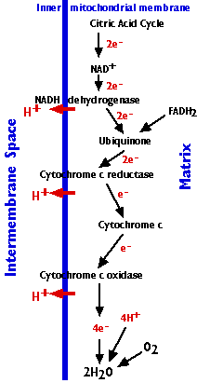
The respiratory chain consists of 3 complexes of integral membrane proteins
- the NADH dehydrogenase complex
- the cytochrome c reductase complex
- the cytochrome c oxidase complex
and two freely-diffusible molecules
- ubiquinone
- cytochrome c
that shuttle electrons from one complex to the next.
The respiratory chain accomplishes:
- the stepwise transfer of electrons from NADH (and FADH₂) to oxygen molecules to form (with the aid of protons) water molecules (H₂O);
(Cytochrome c can only transfer one electron at a time, so cytochrome c oxidase must wait until it has accumulated 4 of them before it can react with oxygen.)
- harnessing the energy released by this transfer to the pumping of protons (H⁺) from the matrix to the intermembrane space.
- Approximately 20 protons are pumped into the intermembrane space as the 4 electrons needed to reduce oxygen to water pass through the respiratory chain.
- The gradient of protons formed across the inner membrane by this process of active transport forms a miniature battery.
- The protons can flow back down this gradient, reentering the matrix, only through another complex of integral proteins in the inner membrane, the ATP synthase complex (as we shall now see).

Chemiosmosis in mitochondria
The energy released as electrons pass down the gradient from NADH to oxygen is harnessed by the three enzyme complexes of the respiratory chain to pump protons (H⁺) against their concentration gradient from the matrix of the mitochondrion into the intermembrane space (an example of active transport). 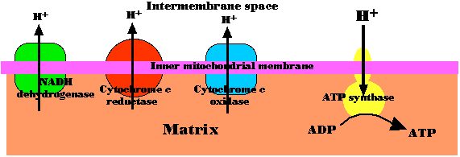
As their concentration increases there (which is the same as saying that the pH decreases), a strong diffusion gradient is set up. The only exit for these protons is through the ATP synthase complex. As in chloroplasts, the energy released as these electrons flow down their gradient is harnessed to the synthesis of ATP. The process is called chemiosmosis and is an example of facilitated diffusion.
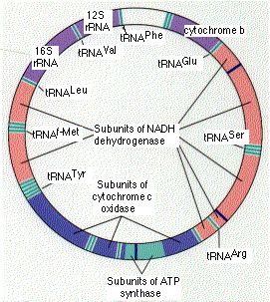
One-half of the 1997 Nobel Prize in Chemistry was awarded to Paul D. Boyer and John E. Walker for their discovery of how ATP synthase works.

How many ATPs?
It is tempting to try to view the synthesis of ATP as a simple matter of stoichiometry (the fixed ratios of reactants to products in a chemical reaction). But (with 3 exceptions) it is not.
Most of the ATP is generated by the proton gradient that develops across the inner mitochondrial membrane. The number of protons pumped out as electrons drop from NADH through the respiratory chain to oxygen is theoretically large enough to generate, as they return through ATP synthase, 3 ATPs per electron pair (but only 2 ATPs for each pair donated by FADH₂).
With 12 pairs of electrons removed from each glucose molecule,
- 10 by NAD⁺ (so 10x3=30); and
- 2 by FADH₂ (so 2x2=4),
this could generate 34 ATPs.
Add to this the 4 ATPs that are generated by the 3 exceptions and one arrives at 38.
But
- The energy stored in the proton gradient is used for a number of other mitochondrial functions such as the active transport of a variety of essential molecules and ions through the mitochondrial membranes.
- NADH is also used as reducing agent for many cellular reactions.
So the actual yield of ATP as mitochondria respire varies with conditions. It probably seldom exceeds 30.

The three exceptions
A stoichiometric production of ATP does occur at:
- one step in the citric acid cycle yielding 2 ATPs for each glucose molecule. This step is the conversion of alpha-ketoglutaric acid to succinic acid.
- at two steps in glycolysis yielding 2 ATPs for each glucose molecule.

Mitochondrial DNA (mtDNA)
The human mitochondrion contains 5-10 identical, circular molecules of DNA. Each consists of 16,569 base pairs carrying the information for 37 genes which encode:
- 2 different molecules of ribosomal RNA (rRNA)
- 22 different molecules of transfer RNA (tRNA) (at least one for each amino acid)
- 13 polypeptides
The rRNA and tRNA molecules are used in the machinery that synthesizes the 13 polypeptides.
The 13 polypeptides are subunits of the protein complexes in the inner mitochondrial membrane, including subunits of NADH dehydrogenase, cytochrome c oxidase, and ATP synthase. However, each of these protein complexes also requires subunits that are encoded by nuclear genes, synthesized in the cytosol, and imported from the cytosol into the mitochondrion.

Mutations in mtDNA cause human diseases.
A number of human diseases are caused by mutations in genes in our mitochondria:
- cytochrome b
- 12S rRNA
- ATP synthase
- subunits of NADH dehydrogenase
- several tRNA genes
Although many different organs may be affected, disorders of the brain and muscles are the most common. Perhaps this reflects the great demand for energy of both these organs.
Some of these disorders are inherited in the germline. In every case, the mutant gene is received from the mother because none of the mitochondria in sperm survives in the fertilized egg. Other disorders are somatic; that is, the mutation occurs in the somatic tissues of the individual.

Example: exercise intolerance
A number of humans who suffer from easily-fatigued muscles turn out to have a mutations in their cytochrome b gene. Curiously, only the mitochondria in their muscles have the mutation; the mtDNA of their other tissues is normal. Presumably, very early in their embryonic development, a mutation occurred in the cytochrome b gene in a cell destined to produce their muscles.

Why do mitochondria have their own genome?
Many of the features of the mitochondrial genetic system resemble those found in prokaryotes like bacteria. This has strengthened the theory that mitochondria are the evolutionary descendants of a prokaryote that established an endosymbiotic relationship with the ancestors of eukaryotic cells early in the history of life on earth. However, many of the genes needed for mitochondrial function have since moved to the nuclear genome.
The recent sequencing of the complete genome of Rickettsia prowazekii has revealed a number of genes closely related to those found in mitochondria. Perhaps rickettsias are the closest living descendants of the endosymbionts that became the mitochondria of eukaryotes.
Further discussion of the evolutionary implications of mtDNA.

Welcome&Next Search

1 March 2003

Nitric Oxide (NO)
Index to this page
- Blood Flow
  - Kidney Function
  - Penile Erection
- Other Actions on Smooth Muscle
  - Peristalsis
  - Birth
- Effects on Secretion
- NO and the Nervous System
  - Autonomic Nervous System
  - Medulla Oblongata
  - Brain
- NO and fertilization
- Killing Pathogens
- Mechanisms of NO Action
- Fireflies Use NO To Turn On their Flashes
- Plants Also Use NO
Nitric oxide is a gas. It is highly reactive; that is, it participates in many chemical reactions. (It is one of the nitrogen oxides ("NO_{x}") in automobile exhaust and plays a major role in the formation of photochemical smog [Link].)
But NO also has many physiological functions.
They share these features:
- NO is synthesized within cells by an enzyme NO synthase (NOS).
- The human (and mouse) genome contains 3 different genes encoding NO synthases.
  - nNOS (or NOS-1): found in neurons (hence the "n").
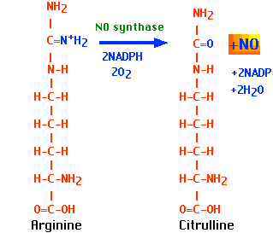
  - iNOS (or NOS-2): found in macrophages. (the "i" stands for "inducible". Whereas the levels of nNOS and eNOS are relatively steady, expression of iNOS genes awaits an appropriate stimulus (e.g., ingestion of a parasite).
  - eNOS (or NOS-3): found in the endothelial (hence the "e") cells that line the lumen of blood vessels.
- All types of NOS produce NO from arginine with the aid of molecular oxygen and NADPH.
- NO diffuses freely across cell membranes.
- There are so many other molecules with which it can interact, that it is quickly consumed close to where it is synthesized.
- Thus NO acts in a paracrine or even autocrine fashion - affecting only cells near its point of synthesis.
This page examines some of the functions of NO.

Blood Flow
NO relaxes the smooth muscle in the walls of the arterioles. At each systole, the endothelial cells that line the blood vessels release a puff of NO. This diffuses into the underlying smooth muscle cells causing them to relax and thus permit the surge of blood to pass through easily. Mice whose genes for the NO synthase found in endothelial cells (eNOS) has been "knocked out" suffer from hypertension.
Nitroglycerine, which is often prescribed to reduce the pain of angina, does so by generating nitric oxide, which relaxes the walls of the coronary arteries and arterioles.
Three of the pioneers in working out the biological roles of NO shared a Nobel Prize in 1998 for their discoveries. The award to one of them, Ferid Murad, honored his discovery that nitroglycerine works by releasing NO. This seems particularly appropriate because Alfred Nobel's fortune came from his invention of making dynamite from nitroglycerine!
NO also inhibits the aggregation of platelets and thus keeps inappropriate clotting from interfering with blood flow.

Kidney Function
Release of NO around the glomeruli of the kidneys increases blood flow through them thus increasing the rate of filtration and urine formation.
Link to discussion of kidney function.

Penile Erection
The erection of the penis during sexual excitation is mediated by NO released from nerve endings close to the blood vessels of the penis. Relaxation of these vessels causes blood to pool in the blood sinuses producing an erection.
The popular prescription drug sildenafil citrate ("Viagra") inhibits the breakdown of NO and thus enhances its effect.
Recent evidence suggests that NO's job in reproduction is not finished with producing an erection. At the moment of contact, release of NO by the acrosome of the sperm activates the egg to complete meiosis II and the other steps of fertilization.

Other Actions on Smooth Muscle

Peristalsis
The wavelike motions of the gastrointestinal tract are aided by the relaxing effect of NO on the smooth muscle in its walls.

Birth
NO also inhibits the contractility of the smooth muscle wall of the uterus. As the moment of birth approaches, the production of NO decreases.
Nitroglycerine has helped some women who were at risk of giving birth prematurely to carry their baby to full term.

Effects on Secretion
NO affects secretion from several endocrine glands.
For examples, it stimulates
- the release of Gonadotropin-releasing hormone (GnRH) from the hypothalamus;
- the release of pancreatic amylase from the exocrine portion of the pancreas;
- the release of adrenaline from the adrenal medulla.

NO and the Nervous System

NO and the Autonomic Nervous System
Some motor neurons of the parasympathetic branch of the autonomic nervous system release NO as their neurotransmitter. The actions of NO on penile erection and peristalsis are probably mediated by these nerves.

NO and the Medulla Oblongata
Hemoglobin transports NO at the same time it carries oxygen [Link to discussion]. When it unloads oxygen in the tissues, it also unloads NO.
In severe deoxygenation, NO-sensitive cells in the medulla oblongata respond to this release by increasing the rate and depth of breathing.

NO and the Brain
In laboratory animals (mice and rats), NO is released by neurons in the CA1 region of the hippocampus and stimulates the NMDA receptors there that are responsible for long-term potentiation (LTP) - a type of memory (and learning).
Link to discussion of LTP.
The ease with which NO diffuses away from the synapse where it is generated enables it to affect nearby synapses. So what may have begun as a localized action becomes magnified.
Laboratory rats treated with inhibitors of NOS synthesis fail to develop and/or retain learned responses such as the conditioned response.
Mice whose genes for nNOS have been knocked out are healthy but display abnormal behavior, e.g., they kill other males and try to mate with nonreceptive females.

NO and fertilization
The acrosome at the tip of sperm heads activates its NO synthase when it enters the egg. The resulting release of NO in the egg is essential (at least in sea urchins) for triggering the next steps in the process :
- blocking the entry of additional sperm and
- orienting the pronuclei for fusion.
[Link]

Killing Pathogens
NO aids in the killing of engulfed pathogens (e.g., bacteria) within the lysosomes of macrophages.
Mice whose genes for the NO synthase found in macrophages (iNOS) have been knocked out are more susceptible to infections by intracellular bacteria like Listeria monocytogenes.
Th1 cells, the ones responsible for an inflammatory response against invaders secrete NO.
Harmless bacteria, living as commensals at the rear of our throat, convert nitrates in our food into nitrites. When these reach the stomach, the acidic gastric juice (pH ~1.4) generates NO from them. This NO kills almost all the bacteria that have been swallowed in our food.
(Since the dawn of recorded human history, nitrites have been used to preserve meat from bacterial spoilage.)

Mechanisms of NO Action
The signaling functions of NO begin with its binding to protein receptors on or in the cell. The binding sites can be either:
- a metal ion in the protein or
- one of its S atoms (e.g., on cysteine.
In either case, binding triggers an allosteric change in the protein which, in turn, triggers the formation of a "second messenger" within the cell. The most common protein target for NO seems to be guanylyl cyclase, the enzyme that generates the second messenger cyclic GMP (cGMP)

Fireflies Use NO To Turn On their Flashes
Link to a discussion.

Plants Also Use NO
Plants also employ NO as a weapon against invading pathogens. Infection of the plant triggers the formation of a NOS, that like the animal versions, makes NO from arginine.
Release of NO by the infected cell induces a number of defense responses; some of these involving enhanced gene transcription mediated by cGMP as a second messenger.
Welcome&Next Search

22 December 2001

