Mitochondrial regeneration:
MitoBoost I & II™..
(Inside every cell are structures known as mitochondria, the energy powerhouses of cells. Mitochondrial problems occur when cells lack sufficient energy (ATP) for normal functioning. An energy shortage in the tissues can cause muscle weakness, fatigue and problems in the heart, kidneys, eyes and endocrine system. A malfunction in the respiratory chain of mitochondria generates excessive amounts of free radical molecules, which may cause further damage to unique DNA found only in mitochondria. This creates a vicious cycle of damage and free radical production that damage cells and causes aging disorders. Vitamin Research Products has developed a two-formula system to protect and restore proper mitochondrial functioning. Energy Substrate Fuel, a drink mix, is specially formulated to increase the supply of ATP from mitochondria for energy. Respiratory Chain Optimizer is specially formulated to protect mitochondrial DNA and cells against free radical damage, enabling the respiratory chain to run more smoothly. This system supports the health of individuals with the following conditions: energy-related dysfunction and defective ATP production, chronic fatigue, chronic pain or fatigue of the muscles, modest muscle pain following exercise, oxidative and neuronal stress, and other symptoms of mitochondrial disorders.
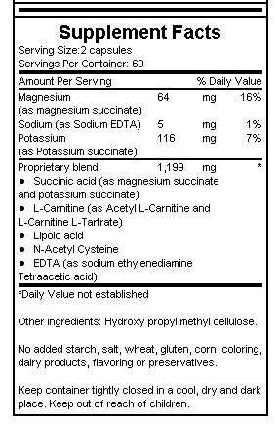
Feeling fatigued? The real culprit behind your lack of energy could be a decline in the efficiency of intracellular powerhouses known as mitochondria. Mitochondrial energy production is an absolute necessity for physical strength, energy, stamina, and life itself. Even the slightest drop in mitochondrial energy output, no matter how subtle, can lead to weakness, fatigue and cognitive difficulties. In fact, researchers have found mitochondrial abnormalities in patients suffering from fatigue.
Studies have shown that certain nutrients—combined with diet and exercise— restore mitochondrial energy-producing processes to more youthful levels. Sodium succinate, for instance, triggered dramatic improvements in a patient who had mitochondrial encephalomopathy. In studies, N-Acetyl Cysteine (NAC) has protected the mitochondria and maintained levels of the important mitochondrial antioxidant, glutathione. D-Ribose, Creatine, EDTA, Niacinamide (Vitamin B3), and Taurine also are known to benefit mitochondria. Taking a combination of these and other mitochondria-enhancing nutrients (found in VRP’s Mito Boost I & II) ensures the most complete mitochondrial protection.
Furthermore, people suffering from fatigue have reported increased energy levels and mental clarity after supplementing with mitochondria-boosting nutrients.
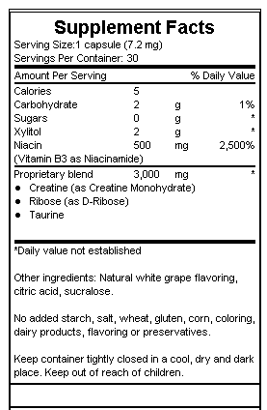

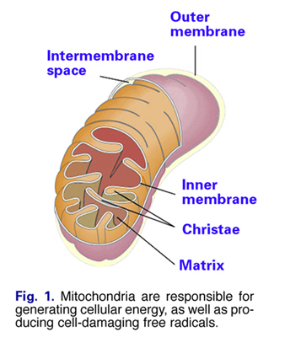
Restoring Mitochondrial Function and Bio-Energetics:

by Ward Dean, MD
In 1956 Denham Harman, MD, introduced his groundbreaking paper on the Free Radical Theory of Aging. Over the years a number of scientists have elaborated on Dr. Harman's original work, striving to establish a direct link between free radical damage and human aging, and age-related diseases. Several of these mitochondrial-related theories of aging have been summarized in previous issues of Vitamin Research News (Vol. 16, No.10, and Vol. 16, No.11).
Mitochondrial damage is one of the main causes of the age-related decline of cellular energy production ("bioenergetic decline"). In addition to being the principal source of energy for all cells, mitochondria (Fig. 1) are also the primary site of free radical production. Free radicals are highly reactive molecules that damage cellular structures such as membranes, proteins, and both nuclear and mitochondrial DNA. Due to their proximity to the inner mitochondrial respiratory chain (Fig 2)—which is also a primary source of free radical production—and their limited capacity for self-protection and repair, mitochondrial DNA are particularly susceptible to free radical damage. Mitochondrial dysfunction is now well recognized as a cause of a number of diseases (Table 1), as well as aging itself.
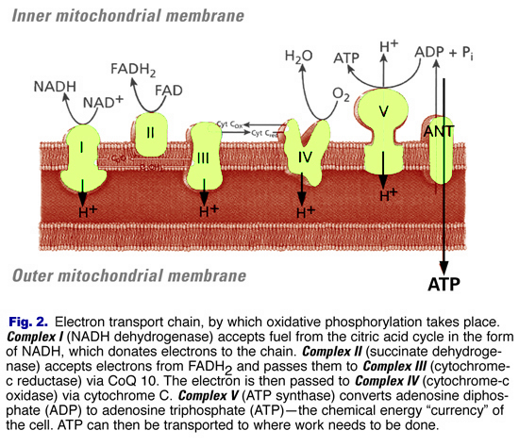
As evidence implicating mitochondrial dysfunction in the aging process continues to accumulate, the question becomes: What—if anything—can we do about it?

Improving Mitochondrial Function
Fortunately, a growing body of research suggests that a number of interventionist strategies may help to reduce mitochondrial damage, enhance mitochondrial repair, and restore mitochondrial energy-producing processes to more youthful levels. These strategies include lifestyle changes, such as diet and exercise, as well as supplementation with nutritional and pharmaceutical substances that may minimize age-related mitochondrial changes and enhance mitochondrial function.
- Alzheimer's disease
- Parkinson's disease
- Essential hypertension
- Cardiomyopathy
- Congenital muscular dystrophy
- Immune (HyperThyroid)
- Fatigue & Exercise intolerance
- Huntington's chorea
- Longevity (Aging)
- MELASL (Mitochondrial Encephalomopathy, Lactic Acidosis, and Stroke-Like episodes)
- Deafness
- Diabetes
- Multiple symmetric lipomatosis
- Myalgias
- Myoglobinuria
- Myopathy syndromes
- Neoplasms (Cancer)
- Optic atrophy
- Rhabdomyolysis: mtDNA
- Sudden infant death (SIDS)
- Wilson's disease
Table 1. Diseases due to mitochondrial dysfunction.
CoQ10
Coenzyme Q10 is probably the most widely used cofactor for treating mitochondrial-related diseases. CoQ10 functions as the electron carrier in the inner mitochondrial membrane, transferring electrons from complexes I and II to complex III. In addition to increasing biosynthesis of ATP (the universal energy molecule), and acting as a potent free radical scavenger, CoQ10 also reduces lactic acid levels, improves muscle strength, and decreases muscle fatigability. (1)
Idebenone
Idebenone is a CoQ10 analog that, while sharing some of CoQ10's properties, offers unique mitochondrial-protective benefits of its own. Idebenone is a powerful mitochondrial free radical quencher that reduces the ever-increasing damage to mitochondrial DNA that occurs with age. Idebenone has also been shown to be more effective than CoQ10 in the electron transport chain. Studies show that when cellular oxygen levels are low—a condition that may occur periodically over a lifetime— idebenone is actually superior to CoQ10 for preventing free radical damage while helping cells maintain relatively normal ATP levels—a property that is especially beneficial to brain and heart cells that may be rapidly damaged during low ATP production due to poor tissue oxygenation. (2)
Acetyl-L-Carnitine
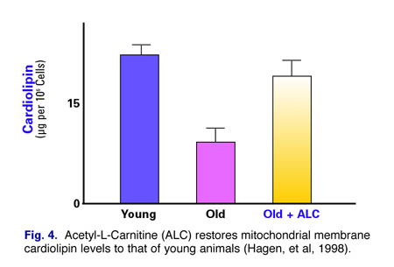
Mitochondrial changes that occur with age include alteration of mitochondrial membrane potential (mitochondrial membrane potential of old rats is known to decline by about 40 percent compared with young animals); (3) a reduction in membrane levels of cardiolipin (an important phospholipid that serves as a cofactor for a number of critical mitochondrial transport proteins); a reduction in Coenzyme Q10 levels (an important factor in the electron transport chain); and a decrease in the concentration of carnitine (an important factor in the beta-oxidation of fatty acids). (4)
Dr. Tory Hagen, in the Molecular and Cell Biology Laboratory of Dr. Bruce Ames at the University of California, proposed that dietary supplementation might reverse some of these age-related mitochondrial changes. Dr. Hagen and his associates demonstrated that ALC restores mitochondrial membrane potential (Fig. 3) and cardiolipin levels (Fig. 4) of old mice to that of young animals, facilitates fatty acid transport into mitochondria, and increases overall cellular respiration. The researchers also noted that ALC enhances cognitive performance, increased production of neurotransmitters, and restores levels of certain hormone receptors to more youthful levels. They concluded that ALC reverses many aspects of age-related cellular dysfunction, principally through maintenance of mitochondrial function. (5)
N-Acetyl Cysteine
As previously noted, a major cause of mitochondrial dysfunction is due to changes that take place in the respiratory chain where oxidative phosphorylation occurs (explained in detail in Vitamin Research News, Vol. 16 No. 11). A team of researchers in the Department of Bio-chemistry and Biophysics at the University of Kalyani in India studied the effects of N-Acetyl Cysteine (NAC) on key elements of the respiratory chain. (6) They administered NAC to mature (40 week-old) rats. After 20 weeks of treatment they found that the activities of Complex I, IV and V were significantly higher in the treated rats compared to the controls. NAC also helped to maintain levels of the important mitochondrial antioxidant, glutathione, as well as prevented cell death in in vitro studies. (7) In other in vitro studies, NAC protected cells from "programmed cell death" (PCD)—also known as apoptosis—by promoting oxidative phosphorylation, mitochondrial membrane integrity, and mitochondrial homeostasis. (8)
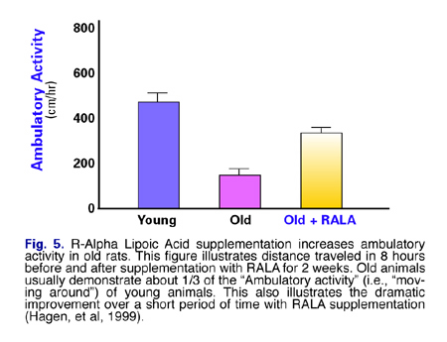
(R) Alpha Lipoic Acid
Dr. David Horrobin's group at Trinity College, Dublin, Ireland, found that a diet supplemented with alpha-lipoic acid reversed a number of age-related changes in the brains of rats. (9) These changes included: (1) increased activity of the anti-oxidant enzymes, superoxide dismutase (SOD), catalase, and glutathione peroxidase (GSH px); and (2) decreased production of free radicals.
Dr. Tory Hagen and associates at the University of California evaluated the mitochondrial-resuscitating properties of an even more effective form of lipoic acid—(R)-alpha lipoic acid. They gave (R)-alpha lipoic acid to young and old rats for two weeks, and found that mitochondrial oxygen consumption of the old rats treated with (R)-alpha lipoic acid was completely restored to the level of young, unsupplemented rats. The researchers also found that (R)-alpha lipoic acid, like ALC, increased mitochondrial membrane potential of old rats by up to 50 percent, compared to unsupplemented old rats.
In addition, they found that animals treated with (R)-alpha lipoic acid demonstrated twice the activity of the untreated old animals—again, demonstrating a partial reversal of age-associated changes (Fig. 5).
(R)-alpha lipoic acid supplementation also increased mitochondrial glutathione and vitamin C in old animals to levels higher than those of young animals (Fig. 6), indicating (R)-alpha lipoic acid's ability to reverse the age-associated decline in low molecular weight antioxidants, therefore reducing the risk for oxidative damage that occurs with aging. (10) (10)

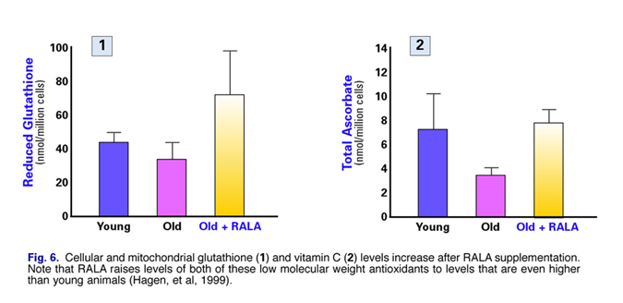
Hagen and his colleagues concluded that (R)-alpha lipoic acid supplementation improves mitochondrial function in old rats, alleviates some of the age-related loss of metabolic activity, increases ATP synthesis and aortic blood flow, and increases glucose uptake. Furthermore, (R)-alpha lipoic acid appears to be about ten times more potent than the more commonly available form of lipoic acid. The researchers further concluded that (R)-alpha lipoic acid supplementation may be a safe and effective means to improve general metabolic activity and increase antioxidant status.
Omega Three Fatty Acids
Mitochondrial calcium levels increase and mitochondrial membrane cardiolipin content decreases with aging. Scientists at the National Institute on Aging found that omega-3 fatty acids from fish oils are cardio-protective in aging animals, in that they minimized the increase in mitochondrial calcium content, prevented the decrease in cardiolipin content, and increased levels of phosphatidylcholine. (11)
Dr. Salvatore Pepe of the Alfred Hospital Cardiac Surgical Research Unit in Melbourne, Australia, reported similar findings. Dr. Pepe demonstrated that an omega-3 rich diet directly increases mitochondrial membrane cardiolipin concentrations, increases the ratio of mitochondrial membrane omega-3 to omega-6, and increases tolerance of the heart to ischemia and reperfusion. (12)
Niacinamide (Vitamin B3)
Drs. Christopher Driver and Angela Georgiou of the National Aging Research Institute in Australia tested the efficacy of niacinamide to re-energize the bioenergy system of old fruit flies. After administering niacinamide (250 mcg/ml of water) to the flies, they determined that niacinamide ameliorated age-related changes in bioenergy and extended the lifespan of the flies by 15 percent. (13)
Thiamine (Vitamin B1)
Large doses of thiamine (vitamin B1) have been used to stimulate NADH, which then augments oxidative phosphorylation at Complex I. Doses of 300 mg/day in patients with chronic external ophthalmoplegia (CPEO), resulted in normalization of blood levels of lactate and pyruvate. (14)
Riboflavin (Vitamin B2)
Riboflavin (vitamin B2) functions as a cofactor in Complex I and II. Riboflavin in a dose of 100 mg/day improved exercise capacity in a patient with a mitochondrial myopathy due to a Complex I dysfunction. (15)
Exercise
Elderly subjects tend to use more glucose and less fat during exercise than young subjects. However, endurance training increases muscle respiratory capacity, decreases glucose production and oxidation, and increases fat oxidation, thereby correcting or compensating to some degree the age-related alterations in substrate oxidation and energy production. (16)
One argument that is propounded by some scientists as an excuse for their sedentary lifestyles is the fact that exercise increases the production of free radicals. However, scientists at the Guang-zhou Institute of Physical Education in Canton, China, showed that endurance training actually increases the production of mitochondrial manganese superoxide dismutase (MnSOD) and glutathione peroxidase (GSH px), resulting in an overall increase in antioxidant activity and decrease in lipid peroxidation. (16)
Ginkgo Biloba
Ginkgo biloba extract has been found by scientists in Spain to protect mitochondrial DNA (MtDNA) against oxidative damage and oxidation of mitochondrial glutathione. (17) The Spanish researchers found that Ginkgo biloba extract also prevents age-related morphological changes in mitochondria of the brain and liver. They concluded that "mitochondrial aging may be prevented by antioxidants," and that "certain antioxidants are also able to prevent the impairment in physiological performance, particularly motor coordination, that occurs with aging."
Succinate
Succinate is a tricarboxylic acid (Krebs') cycle intermediate that donates electrons directly to Complex II. Succinates have been widely used for their alleged ability to enhance athletic performance—especially in Russia. (18) Dilman believed succinic acid was a non-specific cell receptor sensitizer. Several studies reported improvement in clinical conditions using six grams per day of sodium succinate. One patient with respiratory failure and a known mitochondrial defect of Complex I, IV, and V completely resolved on a regimen of 300 mg CoQ10 per day, and six grams of sodium succinate. (19) Another patient with Mitochondrial encephalomopathy, lactic acidosis, and stroke-like episodes (MELAS) improved dramatically when treated with six grams of sodium succinate alone. (20) I think the use of succinates is even more effective when a balance of several salts is used—especially combinations of magnesium and potassium.
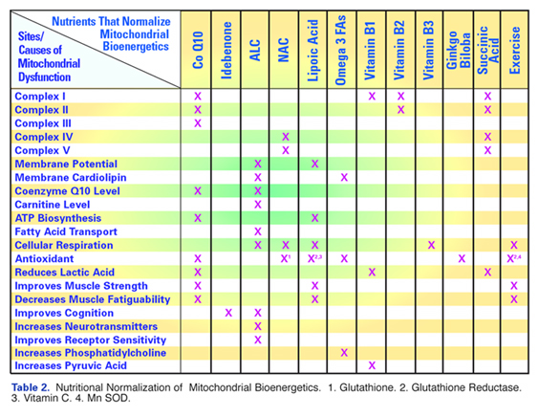
Conclusion:
Mitochondrial dysfunction has been identified as one of the principal causes of age-related bioenergetic decline. Although there is no single "silver bullet" or even combination of substances that will unfailingly resuscitate all aspects of aging mitochondria, anti-aging physicians and scientists have discovered a number of nutrients and prescription substances that alleviate or completely restore many aspects of mitochondrial failure. Some of these substances have been discussed in this article, and their sites of action and specific mitochondrial-resuscitating properties are summarized in Table II. Combinations of these nutrients, acting on multiple targets, may normalize mitochondrial function, increase cellular and systemic energy production, alleviate mitochondrial-related disease, and delay age-related decline in many organs and systems of the body.

