,Core Energy Surgery for the Electromagnetic Body
by Jon Whale. PhD Cumbria
Part 1 of 3
Gravity and magnetism are examples of force and energy fields that our lives depend on, yet the eye can't see them. Radio waves, Infrared, ultra violet, X-rays and gamma rays are all invisible waves that make up the Frequency Spectrum. The human eye is sensitive to a narrow band of frequencies called light.
Surrounding every living person is a vibrating Energy Field. It is an egg shaped pressure field that contains and characterises our individual consciousness as distinct from that of others and the universe at large. Other descriptions are, the human aura or electromagnetic body. Some scientists call it the unified field.
Fortunately, this field has a very bright, high energy spot on it that the trained eye can 'see'. This spot is the 'Stationary Assemblage Point'.
For most healthy people, the idea that, 'How we behave and how we feel' is beyond our rational control, is preposterous. For those of us, who have experienced a serious physical accident, disease, fever, tragedy, violent intimidation, drug overdose, acute stress or depression, this idea is acceptable. Under such circumstances many people undergo a personality change, often accompanied by unfamiliar physical symptoms and illness.
Suffers experience that 'something' deep inside them has changed. Although they can remember how they behaved and felt before the incident, it is impossible for them to return to their former self. That indescribable 'something' deep inside all of us that can suddenly shift, changing our whole perception of reality including our physical health is the 'Assemblage Point'.
The Assemblage Point is the vortex of high energy in the Electromagnetic Body. It is the location of the Assemblage Point that 'dictates' how we behave, how we feel and how we 'see' the world. Its location influences our conscious reality and greatly affects physical and mental health.
Inside the Core or the energy body are seven major energy vortexes or meridians. Acupuncture and Ayurvedic Medicine call them Chakras. The locations of these energy vortexes coincide with seven major glands and organs inside the body. The vibrational rate and the energy levels of the chakras influence the functioning and efficiency of their associated organs and glands. Chakras directly influence physical and mental health. A prime requirement before all seven chakras can open or function properly is; correct location and alignment of the Assemblage Point to the physical body.
Every one of us has an Assemblage Point and it is very easy to locate. The procedure for locating and correcting it is quick, simple and painless. Manipulation of the location of the Assemblage Point can change our state of consciousness, increase our biological energy levels and improve general health. Familiarity with its location and performing regular adjustments to it can accelerate personal development and improve mental and physical efficiency.
Correct alignment of the Energy Body with the physical body are vital for our physical and mental well-being. Figure 1 shows the correct alignment.
Violence, intimidation, bereavement, shock, accidents, trauma, drugs, toxins and illness can easily dislocate the energy body's alignment.
Depending on the severity and direction of the misalignment, various psychological and physical symptoms will be present.
Gross misalignment of the Energy Body is present in depression, various psychotic and psychological disorders. Drugs and alcohol addiction, toxicity, leukaemia, cancer, AIDS, ME, MS, schizophrenia, epilepsy, alzheimer's, coma, Parkinson's etc.
It is a simple matter to find out the alignment of a person's Energy Body by locating the Assemblage Point.
For optimum health and vitality, energies in the left and right sides of the brain are equal, and the Electromagnetic Field equally distributed about the bodies central meridian line. The ideal location for the Stationary Assemblage Point is the central position, shown in Fig 1. In this position balanced biological energy flows around the central nervous system and the many organs and glands function in harmony.
This ideal alignment is rare. With most people the Assemblage Point will be found entering on the right side of the chest's central meridian line. This is due to excessive left brain activity, demanded by today's stressful life style.
Brain Rhythm Frequency Range State of Consciousness
High Beta  Beta  Alpha  Theta  Delta | above 25 HZ  14 25 HZ  7.8 14 HZ  3.2 7.8 HZ  0.1 3.2 HZ | Anxiety, Panic, Anger, Psychosis  Attention focused on external affairs  Relaxed, attention divided internal and external  Dreaming, Trance, Hypnosis, internal attention  Unconscious, deep sleep, coma
Drugs, Toxins, Illness, accidents and emotional trauma are the most common causes of misalignment. Once misalignment has occurred, it is very difficult to re-establish the original position by one's own efforts.
Neither orthodox nor complementary medicine has the knowledge or procedures to correct Electromagnetic Body alignment. Realignment is a simple procedure that takes about one minute to execute.
Misalignment causes mild to serious imbalances of energy distribution in the brain and nervous system, upsetting endocrine and hormone functions. The symptoms directly relate to the location and entry angle as in Fig 2. The further the location is outside the shaded area in Fig 2, the more acute the listed symptoms. The symptoms experienced will vary according to the location and the angle of entry. Severe misalignment causes acute disturbances in the functioning of the organs and glands. Eventually biological damage can occur.
Today, neither psychiatrists, psychologists nor counsellors can correct gross misalignment. The alignment of the Electromagnetic Body controls the way we feel, think, and our perception of reality. Correcting alignment is not possible by talking, thinking or, in acute cases with medication. Therefore the usual method is to employ drugs to relieve or mask the symptoms caused by misalignment.
Shifting the location of the Assemblage Point and adjusting the angle will alter the state of human consciousness.

The Human Electromagnetic Energy Field
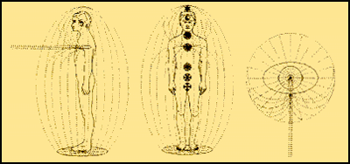
Fig 1 The vortex of the energy field is called THE STATIONARY ASSEMBLAGE POINT. The position shown is the location and alignment for optimum mental and physical health (organ and glandular synergy). Large deviations from this location can cause serious health problems.

The Stationary Assemblage Point (SAP)
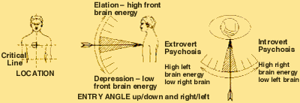
Fig 2
1 The shaded area is the location and entry angle for a healthy balanced person
2 Large deviations from the shaded are accompanied with the symptoms listed
3 Locations close to the Critical Line cause acute unease and discomfort
4 When it drops below the Critical Line the energy field collapses and death occurs
reminder
Left brain controls right body functions
Left brain is associated with thinking and extrovert activity
Right brain controls left body functions
Right brain is associated with dreaming and introvert activity
Assemblage Point Shift to the Right
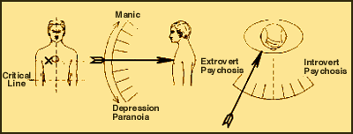
Fig 3 Panic, anxiety, anger, violence and sexual deviation
Assemblage Point Shift Below (Right Side)
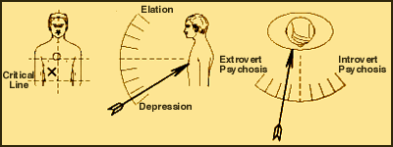
Fig 4 Acute physical distress and mental depression
Assemblage Point Shift to the Left
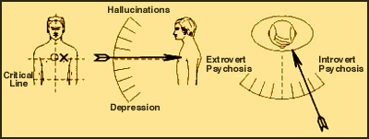
Fig 5 Melancholia, Fantasy, Delusions, Dreaming
Assemblage Point Shift Below (Left Side)
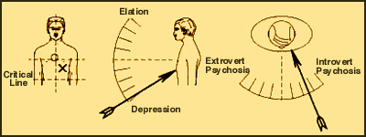
Fig 6 Dementia, Alzheimers, Autism, Downs Syndrome, Etc.
Assemblage Point location affects brain energy levels and its predominant operating frequencies. The brain frequencies and states of consciousness are: -
1. Assemblage Point locations on the right side of the body (Fig.3) reflect an increase in left brain activity and Beta brain frequencies (extrovert attention).
2. Conversely, locations on the left body side (Fig 5) reflect in an increase in right brain activity and Theta frequencies (introvert attention).
3. The Central location (Fig 1) reflects as balanced brain activity and Alpha [relaxed internal and external attention].
4. Low locations (Fig 4 & 6) reflect in low frontal brain energy and low Alpha and Theta frequencies (right=depression left=catatonia).
5. High locations reflect in an increase in frontal brain energy and high Beta frequencies (right=psychosis left=hallucinations).
The Assemblage Point Location and its angle of alignment affect the state of the patient's consciousness. Manually shifting the Assemblage Point is the fast way back to normality, high biological energy, improved mental and physical health. Realignment should be done as soon as possible to minimise the possibility of physical damage and disease manifesting as a result of long term imbalance in biological energy distribution.
The shift to the right
This is the most commonly found misalignment, symptoms are compulsive mental and physical activity. The medical diagnosis for this location is STRESS. Excessive feelings of anxiety, panic or anger, are indicators of this location. These are associated with high beta brain-wave frequencies in the left brain. The Assemblage Point moves to the right side of the chest as shown in Fig 3. In Paranoia the location and angle are to the right and down. In mania the location is high right and the angle is upwards. Manic depression and schizophrenia are associated with oscillations and splits in the Assemblage Point location.
Intimidation, worry, overwork, insomnia, Cocaine, LSD, amphetamines, antidepressants, excessive caffeine can drive the stationary assemblage point to the far right. In this position various physical symptoms medically connected with stress will appear. Energy demands are high and sleep will be problematic. High Beta activity is present. The attention is external and the awareness of the physical body is absent. Locations further to the right cause psychotic behaviour that can include violence and sexual deviations. Left brain energy will be high, right brain low.
From this position, drugs, illness or emotional trauma can cause complete exhaustion of the nervous system. The Assemblage Point then drops down towards the critical line as shown in Fig 4. ME is a disease with this location.
Shifting the Assemblage Point to the centre will give immediate back to normal, reducing dependence on drugs.
The shift below
From this location it is virtually impossible to recover without realignment of the Electromagnetic Field.
This a dangerous, uncomfortable, distressing location. The indications are very low mental and physical energy with acute psychological instability and physiological disturbances. Impaired functions of endocrine glands and organs may develop. Frontal brain energy will be low.
With this location serious psychiatric or physical illness will often be present. Diseases associated are AIDS, cancer, ME, meningitis, cerebral thrombosis, apoplexy, clinical depression. As the Assemblage Point moves towards the critical line the symptoms worsen. Beta activity will mostly be absent. Distressing feelings and emotions are prevalent. Sympathy, placation or chastisement does not help.
Toxic material, heavy metals, chemotherapeutic drugs, poisoning, head injury, drugs, attempted suicide, solvent abuse, violent intimidation, physical shock, electric shock, long term exposure to strong electromagnetic and high voltage electrostatic fields, anoxia, infections and disease can drive the Assemblage Point to this location. Antidepressants will not correct this location.
Shifting the location up and over to the centre will immediately alleviate the symptoms. Vibrational levels will increase, more energy will be available even if physiological disease is present. The natural healing process will accelerate.
The shift to the left
Irrational preoccupation with daydreaming, fantasy, hallucinations and melancholia are the most common indicators for this location. LSD and other hallucinogenic drugs can cause a shift to the left. Pseudo religious cult brainwashing methods unconsciously shift the location to the left side (Fig 5).
Shifting the Assemblage point to right of the centre will return normal behaviour. It will increase left brain energy, Beta frequencies and rationality.
Senile dementia, alzheimer's, autism, downs syndrome, coma, are examples where the location will be around the area shown in Fig 6. In the early stages of these diseases regular checks and correction of the Assemblage Point may slow the progress. Astute doctors and clinicians of the future will reverse these diseases by combining Assemblage Point realignment with other therapies.
Death occurs when the Electromagnetic Field collapses, while the Assemblage is above the navel line then there is hope. At the navel there is a weak area, or Gap in the field. By preventing the Assemblage Point from dropping to the Gap, it should be possible to postpone death.
Bibliography
Becker, R. O. M.D. Cross Currents, The Perils of Electropollution The Promise of Electromedicine. Tarcher.
Becker, R.O. M.D. and Gary Selden. The Body Electrical.
Electromagnetism and the Foundation of Life.
Bhattacharya, A. K. Dr. Power in a Magnet to Heal. Shatri Villa. Naihati. West Bengal. India.
Castaneda, Carlos. PhD. The Fire From Within. Black Swan.
Castaneda, Carlos. PhD. The Art Of Dreaming. Harper Collins.
Castaneda, Carlos. PhD. The Eagle's Gift. Hodder and Stoughton.
Castaneda, Carlos. PhD. The Power Of Silence. Black Swan.
Hutchinson, Michael. Megabrain. Beech Tree Books.
Ros, Frank MD. The Lost Secrets of Ayurvedic Acupuncture. Lotus Press.
Harner, Michael. The Way of the Shaman. Bantam Books.
Study by UCLA, Electronic Evidence Of Auras and Chakras, Mind Brain Bulletin, Vol 3, No 9, March 1978
Swiftdeer. H. Ph.D. Medicine Wheel Handbook. Deer Tribe. PO Box 8204. Lacrescenta. CA. 91214

Locating the Assemblage Point

by Jon Whale, Ph.D.
Part II of a 3 part series
The ability to change how we 'feel' and how we 'behave' by adjusting or correcting our Energy Body alignment is nothing short of miraculous. The medical, political and economic benefits are enormous. Once we are familiar with our own Assemblage Point location and that of others, the idea that there is more to a human being than flesh and bone becomes an absolute certainty.
The law of energy conservation states that energy can neither be created nor destroyed. It can only be changed in form. When we are alive, we have 'life' energy in our body. When we are dead that energy is gone. Physics says it doesn't cease to be; it can only change form. Therefore there is a part of us, the energy part that exists beyond the flesh body.
Locating and experiencing our Assemblage Point provides us with personal proof that we all have an Energy Body as well as a physical body.
Working with the Energy Body is not a trivial affair, the Assemblage Point in particular, is a very personal matter, directly connected to the 'Life Force' or spirit of the individual.
Assemblage point description
The Assemblage Point is not part of the physical body. It is an integral component of the Energy Body that surrounds the physical body. It is a large indentation of energy lines which pierce the physical body. Fig. 7 is exaggerated for clarity. Its entry position is 'fixed' or 'stationary'.
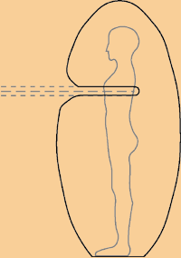
Figure 7 – Energy lines which pierce
the body (exaggerated for clarity)
The average diameter of the bundle of energy lines is 1 centimetre. It causes a sausage-shaped indentation in the Energy Field. There is an energy 'potential' both along the length of the lines and across their diameter. Where the bundle of lines enters the physical body, they induce a tender or very sensitive area of skin of the same diameter. This tenderness can be quite uncomfortable and can often penetrate through to the shoulder blade.
Where to look
The location of a woman's Assemblage point is generally, but not always, several centimetres higher than a man's. Broadly speaking, a woman's vibrational rate, her behaviour, the way she feels and her view of the world is quite different to that of a man. Therefore, female and male locations tend to be different. These differences also reflect in the efficiency of the chakras in the central core. Women are more efficient on the higher chakras, men doing better on the lower ones. Fig. 8 illustrates commonly found locations for a woman and a man. Finding the precise location and entry angle of the average, healthy, balanced person is a very quick and simple affair.
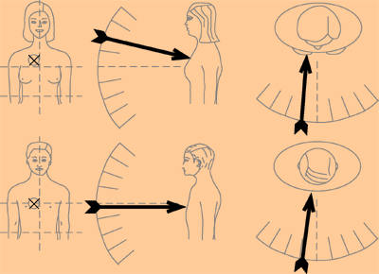
Figure 8 – Women's locations is higher than men's
Subjects with a bright and energetic disposition [high vibrational rate] will have a high location and elevated entry angle. Depressed and lethargic patients such as those suffering from ME or post natal depression will have a low location and descending entry angle. Finding the location and entry angle of patients with mental or physical health problems can be difficult, but gets easier with experience. Often their symptoms, posture, tone of voice will suggest where to look. The 'Off Centre Map', Fig. 9, give a general overview of locations for specific symptoms, there are rare exceptions.
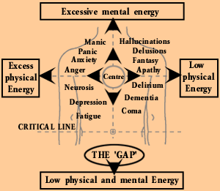
Figure 9 – The "Off Center Map"
Investigators of the Intuitive or Feeling (Jungian) type will not experience any difficulties in locating Assemblage Points. Rational and practical personality types will find difficulties with the feeling and seeing methods listed below. Confidence will develop with experience. Therefore, it is best to work in a small team and compare results. Maintain good records for each subject. Note their medication, symptoms, age, sex, and profession. When shifting Assemblage Points, make a drawing of the location and entry angle for future reference.
The following methods and procedures for locating the Assemblage Point will be quickly confirmed and improved on by other investigators. Photographic and electronic evidence of the Assemblage Point will follow.
Feeling the location
1 The subject should stand upright, looking ahead at the horizon. The investigator should stand facing the subject right-hand body side. Fig. 10.

Figure 10
2 Form your left-hand into a cup shape, Fig 11. Use it to 'feel' for the sausage shaped end of the subject's Assemblage Point in the area of the shoulder blades. Fig. 11
3 Form the fingers and thumb of your right-hand into a tight, concentrated point. Fig 11. Use this hand to 'feel' for the bundle of energy lines entering the subject.
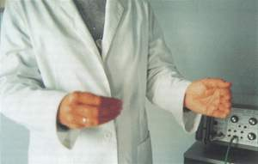
Figure 11
4 Hold both of your arms wide apart. Hold your left-hand behind the subject and your right-hand in front. Standing relaxed, be keenly aware of your physical feelings and your weight on the floor. It helps to close your eyes or look away. Slowly bring your hands towards the subject feeling for the maximum energy. Allow the subject's energy to control your arm muscles.
5 The difference in energy potential along the bundle of lines of the Assemblage Point makes it easy to distinguish. When your cupped hand and pointed fingers are lined up with the subject's bundle of energy lines, you will experience an energy surge. This will pass through your arms and chest. Sensitive subjects will also feel this surge.
6 Bring your hands together feeling for the maximum power and connection with your subject. Allow your hands to touch the subjects back and chest at the points of maximum energy connection.
7 Move your right-hand fingers back and forth across the Assemblage Point. Most subjects will feel a 'pulling' sensation deep inside the chest. Use small, adhesive labels to mark these positions back and front.
Kinesiology
This procedure is not suitable for frail or exhausted patients.
1 Stand facing the subject. With your left arm, use the standard muscle test on the subject's right arm as in Fig 12.
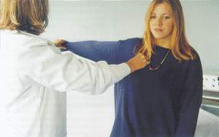
Figure 12
Investigators of the Intuitive or Feeling (Jungian) type will not experience any difficulties in locating Assemblage Points. Rational and practical personality types will find difficulties with the feeling and seeing methods listed below. Confidence will develop with experience. Therefore, it is best to work in a small team and compare results. Maintain good records for each subject. Note their medication, symptoms, age, sex, and profession. When shifting Assemblage Points, make a drawing of the location and entry angle for future reference.
The following methods and procedures for locating the Assemblage Point will be quickly confirmed and improved on by other investigators. Photographic and electronic evidence of the Assemblage Point will follow.
Feeling the location
1 The subject should stand upright, looking ahead at the horizon. The investigator should stand facing the subject right-hand body side. Fig. 10.
Figure 10
2 Form your left-hand into a cup shape, Fig 11. Use it to 'feel' for the sausage shaped end of the subject's Assemblage Point in the area of the shoulder blades. Fig. 11
3 Form the fingers and thumb of your right-hand into a tight, concentrated point. Fig 11. Use this hand to 'feel' for the bundle of energy lines entering the subject.
Figure 11
4 Hold both of your arms wide apart. Hold your left-hand behind the subject and your right-hand in front. Standing relaxed, be keenly aware of your physical feelings and your weight on the floor. It helps to close your eyes or look away. Slowly bring your hands towards the subject feeling for the maximum energy. Allow the subject's energy to control your arm muscles.
5 The difference in energy potential along the bundle of lines of the Assemblage Point makes it easy to distinguish. When your cupped hand and pointed fingers are lined up with the subject's bundle of energy lines, you will experience an energy surge. This will pass through your arms and chest. Sensitive subjects will also feel this surge.
6 Bring your hands together feeling for the maximum power and connection with your subject. Allow your hands to touch the subjects back and chest at the points of maximum energy connection.
7 Move your right-hand fingers back and forth across the Assemblage Point. Most subjects will feel a 'pulling' sensation deep inside the chest. Use small, adhesive labels to mark these positions back and front.
Kinesiology
This procedure is not suitable for frail or exhausted patients.
1 Stand facing the subject. With your left arm, use the standard muscle test on the subject's right arm as in Fig 12.
Figure 12
2 Grouping the fingers to a point as before, move your right hand across the subject's chest. Keep the hand at a distance of 5 centimetres away from the chest. The subject's arm will drop when you move across the location.
3 Check the entry angle by testing the subject's arm muscle strength further away from the chest. Drawing your fingers in an out along the Assemblage Point Lines will reflect in the subjects arm muscle tone.
4 Touching the chest at the entry location will weaken the subject's arm muscles.
Biofeedback
Touching or pushing the Assemblage Point with a finger will stimulate a stress/arousal response in the subject's body. This arousal response will cause the subject's skin resistance to change. This change can be detected by many of the biofeedback devices available to day. Clinicians working with the more expensive, electronic biofeedback systems will probably be able to offer scientific proof of the Assemblage Point's existence and location.
The skin at the point of entry on the chest has different electrical properties from the surrounding skin. These differences are measurable with sensitive electronic instrumentation. However, this is a very sensitive area of the body and prolonged experimentation with testmeters or other equipment could be irritating to the subject.
Seeing the location
This method is the most difficult to describe and comprehend, yet ironically, the simplest and least obtrusive way to locate assemblage points. The method, although totally subjective, is most useful in assessment and diagnosis. If you can 'see' your patient's alignment, it becomes possible, with experience, to describe to your patient his symptoms and experiences before being told about them.
Always look for the Assemblage Point before you use any of the above methods to locate it. Confirming the location by using the other methods will develop your confidence and accuracy in 'seeing' it.
Realise the truth that what we see 'outside' is not the actual object but a hologram or mental construct of it 'inside' our mind. Whilst intensely observing your subject, suspend all thinking and judgements. Perceive the space surrounding your subject as charged with energy.
Try to see the energy as effervescent particles. Look for a concentration of these particles in front of and on the surface of your subject. Where the particles are most concentrated you will find the assemblage point location. These particles may be bright or dull. Look for lines of flux, flowing to a small concentrated bright spot or even a shadow on the subject. Note the location and angle.
Confirming the location
At the location, the skin is less resilient and more painful to the touch. The skin is often blemished or marked in some way, sometimes by a reddish spot. Touching or pushing the spot with your finger, will causes the skin to redden more than skin elsewhere on the chest. The spot is tender, sore or uncomfortable. Pushing it causes the subject a feeling of slight unease. The feeling passes deep into the chest, often right through to the shoulder blade.
Patients' consideration
Patients with low locations will often react physically when their assemblage point is found. For example, they may start to tremble or shake as you move your right hand across their Assemblage Point. Sometimes they complain of a long-standing pain in their back where your left hand is. Therefore, do not practice on patients, learn the methods with your friends and colleagues first. When you are confident you can locate them efficiently, then progress to work with patients.
Shadows and splits
From time to time, in the clinical setting, patients can present a shadow or split Assemblage Point. These are most often associated with patients suffering from schizophrenia and manic depression. In several cases of schizophrenia, two locations of the Assemblage Point have been observed on each patient. One shadow location, high up, near the patient's right collar bone and a second brighter location lower down on the same side. Diagnosed manic depressive patients often have two locations, one strong and active and a second shadow location. The locations are generally lower and not so far to the right side, as with diagnosed schizophrenic patients.
It seems that these patients can, by some means not clear to us, shift their location. This in turn changes their behaviour and the way they feel. In this way the patient oscillates between two locations. Split locations can be reunited and shifted across to a more central and stable location for the patient. From a central position the patient's mental and physical health will stabilise.
Babies and children
The Assemblage Point on babies and young children has no fixed location. It is unstable and can move freely. As a child's personality and internal dialogue develops, its' Assemblage Point location begins to be fixed. Given a stable environment, most children's location will becomes fixed when they are around six years of age, or slightly later. Ideally, adolescents and juveniles should be allowed to develop and fix their own location, without interference other than the normal family and educational procedures.
As with adults, children with serious misalignment of their Assemblage Point do not find it easy to integrate with their peers. Youngsters who have experienced accident, intimidation, drug abuse, illness, or psychological problems are likely to have misalignment problems. In such cases, any educational or therapeutic methods that will stabilise and centralise their Assemblage Point will help their development. Children over 10 years of age, with health problems or symptoms caused by misalignment can gain substantial benefits from the shifting and realignment procedures.
The investigator's experience
Ms Doreen B. London University Lecturer. 'I asked Jon about spiritual matters, especially reincarnation. Handing me two powerful therapeutic magnets, he said "the eye cannot see magnetic waves, but we can experience their effects." Then he instructed me to place one magnet in each hand, to bring my hands slowly together. Suddenly the magnet in my left hand jumped out and across several inches to crash against the second magnet in my right hand. The magnetic power was too strong for me to physically control.
He then said, "enveloping every living person is a strong energy field that is visible only under special circumstances." He emphasised that just as I had experienced the power of the magnets, I could, any time I liked, experience the power of the human energy field.
As a practising Christian, I felt great doubt, but also curiosity and took up his challenge. Following instructions, I brought my hands towards his chest and upper back. As my right hand came within twelve inches of his chest a 'power' took over and I could not control my arms. I felt strong tingling sensations pass up my right arm and across my chest, connecting to my left hand at his back. My hands automatically came into and touched the centre of his chest and back. I admit I was frightened. Something beyond me, a field of energy, took control of my hands and arms.
Over the next two weeks I became very aware of my own Assemblage Point location. I was aware of a curved energy line entering my upper right chest through to my shoulder blade. This energy line seemed connected to a kindred spirit 'out there'. The next time I saw Jon, I asked him if he would confirm my location. He told me the precise location and angle of entry, then came over to me and touched the exact spot. Becoming aware of my own Assemblage Point, has confirmed my belief that we all have a 'spirit energy' outside or above the physical body that dies. My discovery complements my Christian faith.'
Part 3 – final part of this series Shifting Assemblage Points

CORE ENERGY

Shifting the Assemblage Point

by Jon Whale, Ph.D.
Part III of a 3 part series
Clinically depressed patients such as M.E. sufferers will have a dropped, or low Assemblage Point location. Patients with anxiety or panic symptoms will have a high location. Shifting the patient's Assemblage Point to the central position will relieve the symptoms. Observing patients recover as their Assemblage Point stabilises in a new location provides the final proof. It proves that:-
Surrounding every human being is an energy field. It puts the patient and the clinician in touch with the 'unseen self'.
• Misalignment of the Energy Body and dislocation of the Assemblage Point adversely affect the way we think, feel and behave.
• Centralised Assemblage Point location has a beneficial influence on our biological energy levels and physical health.
• The central location is beneficial for mental health. It directly influences our interactions with others and the world at large and can improve our fortune.
Those of us who are fortunate and possess a stable, centrally aligned Assemblage Point prosper in health, performance and success. The average person's location is to the right of central. Many retired people maintain a good high location and by doing so remain active and happy, well into old age.
People with unstable or misaligned Assemblage Points do not get the best from life. Misalignment detrimentally affects physical and mental performance. Dropped Assemblage Points, in particular, cause unnecessary suffering and are a tragic waste of human potential and resources. Long-term gross misalignment can cause serious physiological and psychological symptoms. It is often reflected in a hunched or slumped body posture.
Shifting the Assemblage Point will change the patient's complexion, posture and medication requirements. For some patients, for example, those who are suicidal, the shifting procedures can be life saving. Before diagnosing and prescribing any treatment, the clinician's first consideration should be the assessment and correction of their patient's Assemblage Point location. In many cases, medication will not be required after correction.
Locating and shifting the Assemblage Point takes about 5 minutes. The procedures are painless and the experience can be exhilarating, stabilising or a profound relief, depending on the direction of the shift. The procedures are compatible with most therapies. The medical and financial benefits for the patient and the health services are enormous.
Accelerating personal development
Regular central shifting of the Assemblage Point will significantly improve mental and physical efficiency. It also improves reflex times, muscular coordination, posture, confidence and assertiveness. The central location will increase performance in employment or a profession, sports, team sports, marshal arts, dancing, singing, yoga, meditation.
Esoteric disciplines like Tai Chi, Kundalini, Raja, Chakra and Tantra yogas all use special techniques to increase psychic powers and control vital life force energies. The Energy Body and Assemblage Point extends beyond the physical body as an energy field. The field can influence other people and events. Paying close attention to the Assemblage Point location will speed up and enhance results from these disciplines. Psychic abilities are acquired by gaining control of the Assemblage Point location and by increasing the efficiency of the seven Chakras in the central core of the Energy Body.
The Shaman's blow
It is possible for a trained person to shift the Assemblage Point without any aids or tools: –
'With that blow they made their apprentices enter into a state of heightened, keenest, most impressionable awareness. . . . The force of the push creates a dent in the cocoon and it is felt like a blow to the right shoulder blade, a blow that knocks all the air out of the lungs.'
(C Castaneda. The Fire From Within)
This somewhat frightening account talks about the right shoulder blade. Most people's Assemblage Point enters the right side of the chest and penetrates through to the right shoulder blade. This is the 'Rear Location' or 'Pivot Point', see Fig. 13 below. The rear location must be found to shift the Assemblage Point (refer to Part II in Issue 16 of Positive Health).
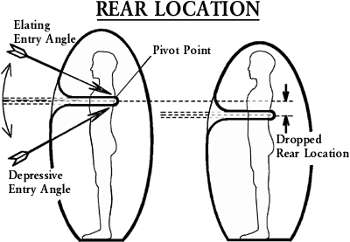
Figure 13
A trained and strongly 'centred' person can shift and centralise anyone's Assemblage Point by shoving the rear location using the heal of the right hand. The clenched left hand is placed on the centre of the subject's chest. The technique requires great mental concentration and personal energy, as well as the full cooperation of the person receiving the shift.
Native medicine men can shift Assemblage Points with a single blow, catching their apprentices by surprise. The Shaman fixes the direction and location of the shift using his 'unbending intent'. These types of shifting techniques although effective and spectacular are not suitable for clinical work. They are too abrupt and require too much personal energy and self-discipline to be effective. In a clinical setting patients frequently have a low location and poor health. In such cases a softer approach, using the special techniques and tools recommended below is called for.
Shifting Tools
To undo or tighten a nut or bolt, we use a spanner. Precision realigning and shifting of Assemblage Points are best done with a special quartz crystal. The crystal should weigh 200 grams or more, have a length of a least 18 centimetres and a diameter of 3 centimetres or more. The crystal must have a ground and polished convex or domed end. It should be as clear as possible, although it could also be of Amethyst or Rose Quartz. It must have a well-defined point. The point should have at least 3 perfect triangles among its 6 facets, Fig. 14 below shows examples.
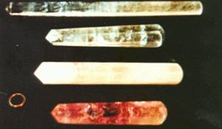
Figure 14 Assemblage point shifting crystals
The crystal must be 'alive' or active. To check this, hold the crystal with your right hand and direct the point at the palm of your left hand. You should feel a breeze of cool tingling energy penetrating the skin of your left hand.
Charging a crystal with your 'Chi' energy will increase its activity. To do this hold the crystal tight in your right hand, as you would a screwdriver, breath in and out, slowly and very deeply three times. Hold the third breath, contract your sphincter muscles and swallow simultaneously, direct your Chi energy up your body and down your right arm into the crystal. This will increase the energy emitted from the point.
Sliding Shift
Shifting the Assemblage Point by sliding it from one location to another is the easiest and most straight-forward method. It is the preferred method for training purposes and best practised with friends and colleagues or in a group situation. This method has disadvantages in a clinical setting. The subject must be bare chested. It can be difficult to use on female patients where the location has dropped below the breast.
To use this method of realignment, the subject or patient must cooperate.
1 Locate the subject's Assemblage Point as instructed in part 2. Mark the locations on his chest and back with a marking pen.
2 Instruct the subject to stand upright, head up and chin back, looking straight ahead.
3 You must stand facing the subject's left side. Hold the quartz crystal in your left hand, place the domed end on the subject's Assemblage Point. Use the palm of your right hand to cover and slide the rear location around the shoulder blade area. See Fig. 16 below.
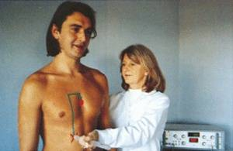
Figure 16 Photograph of sliding shift
4 Instruct your subject to take three deep breaths, slowly in through the nose and out of the mouth.
5 On the third breath, when the chest is expanded and the lungs are full with air, tell your subject to hold the breath in. Next instruct him to contract his sphincter and other muscles in the anus and genital area and keep them contracted. Then instruct him to swallow and close the throat a the same time (head upright and chin back).
6 This effectively closes the upper and lower exit and entry gateways to the body. With the retained breath and closed gateways, pressure builds up and pushes or loosens the subject's Energy Field from his physical body. This situation will allow you to slide the Assemblage Point to the central location using a quartz crystal. Most subjects can hold their breath for 5 or 10 seconds and this is sufficient time.
7 Using the quartz crystal, slide your subject's Assemblage Point to the centre of the chest. Use the palm of your right hand to drag the rear location into the centre between the shoulder blades. Twist the crystal half a turn and remove it from his chest. Simultaneously, tap him lightly on his head with the palm of your right hand and tell him to breathe normally.
The shift should be in the directions shown in Fig. 17 below. Never shift in a diagonal direction. It helps to lubricate the domed end of the crystal with vegetable oil or lubricating jelly. It can then slide easily over the skin.
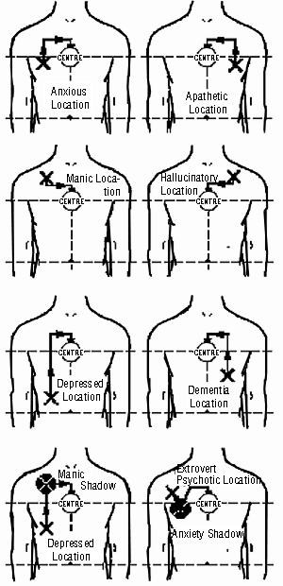
Figure 17 Shifting direction
Sometimes the subject will forget to swallow or lets his breath go. When this happens the shift may be lost, then the Assemblage Point must be relocated and the procedure repeated.
Clinical Shifting
Shifting and realignment of pathological Assemblage Point must be backed up with professional patient management and should only be carried out by professionally qualified personnel. Clinical shifting associated with physiological and psychological health problems requires two experienced professionals attending. At least one of them should be qualified in the psychological field. One is required to locate the Assemblage Point and the second to do the shifting. Each will double-check the other's work.
The sliding method is not normally used, except perhaps for patients with breathing problems, heart problems or a pacemaker. With the following method, the patient keeps his clothes on. Instead of sliding the Assemblage point towards the centre, shifting is done in several stages (see Fig. 18).
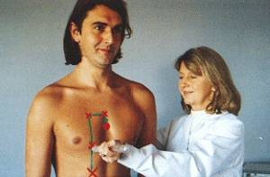
Figure 18 Photograph of stage shifting
The rear location or pivot point is dislodged with a firm push to Patient's back. Normally, the heal of the right hand is used to deliberately thump the pivot point. Shifts of a short distance require only one stage and two pushes. Large distances may require three stages and four pushes to shift it to the centre. The rest of the procedure is the same as for the sliding method above.
A) Use two small adhesive labels to mark the front and rear Assemblage Point locations. Plan the number of stages you will use to move the Assemblage Point to the centre, normally not more than four.
B) Use your left hand and position the crystal on first stage. Firmly instruct the patient through steps 2 to 6 above. When the patient is holding his breath and ready, with the heal of your right hand, give a firm push to the patient's Assemblage Point rear location. The Assemblage Point will jump and relocate at the crystal. Note: Large strong willed subjects often require a firm shove or thump.
C) Rapidly move the crystal to the stage two, again push the rear location. Long shifts may require a third stage, so push the rear location again to shift the Assemblage Point to the third stage. The patient must continue to hold his breath throughout. You only have a few seconds before he will need to breathe again, therefore you must be practised and swift.
D) When you arrive at the centre give a final firm push between the shoulder blades and remove the crystal from patient's chest with a half twist. Simultaneously, using your right hand, tap the patient lightly on the head and instruct him to breathe normally.
Allow the patient a few moments to rest. Always recheck his location, making sure that the Assemblage Point has not been left behind at one of the stages. If necessary, repeat the procedure. After the shift, get the patient to lie down, breath freely and relax for about 15 minutes. This helps to 'fix' the new location.
Psychiatric patients suffering from schizophrenia or manic depression often present with 'energy shadows' and 'split' Assemblage Point locations. The dominant Assemblage Point must be located and shifted to the secondary location or shadow. Both are then picked up with the crystal and shifted to the centre. Examples are shown in Figure 21 below.
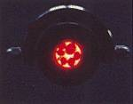  Fig 21 Hot Ruby Rays | 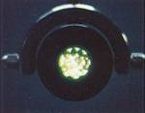  Fig 22 Cold Emerald Rays
Dropped rear locations, (see Figure 13) adversely affect muscular coordination and mobility. Several patients on long term drug management have presented with Parkinson type symptoms. Their rear location was below the shoulder blades. In each case, shifting their Assemblage Point up to the centre stopped the symptoms. This suggests that rear brain energy levels and activity may fall as the Assemblage Point drops towards the navel.
Shifting with Energy Medicine
The Assemblage Point can be shifted by more subtle and pleasurable means. Assemblage Points move around in trance and dream states of consciousness. The dominant brain frequencies in trance and dreaming states are Theta i.e. 3.2 to 7.8 HZ (cycles per second). Theta states of consciousness can be extremely pleasant. Slow Theta brain waves unite both halves of the brain. They are especially beneficial for de-stressing and physical healing. The Shaman enters the trance state, assisted by the sound of drums and rattles at rhythms of around 3.3 HZ. Clairvoyants and mystics utilise Theta trance states for their work. Most people experience Theta states during sleep. It is a dreamy, pleasurable state of semi-consciousness.
Electronic Gem Therapy can induce Theta states of consciousness. The procedure is called 'Samadhi Therapy' and it is often used to 'fix' the patient's Assemblage Point after a manual shift. Blue Sapphire emits a soft, pleasurable, calming energy. It is used in two violet filtered Lamps. Sometimes Diamonds are added to the Sapphire. The lamps are directed at each side of the head as in Figure 22 above. The patient is kept warm, fully relaxed and comfortable in quiet surroundings. The sapphires are electronically pulsed at 3.3 HZ. Most patients will quickly enter a dream state of consciousness. The heart beat and blood pressure will fall and stabilise. This treatment induces pleasurable bodily sensations. The Lamps are adjusted to balance the patient's Energy Field and alignment. Maximum body and mind integration occurs with the centre location.
In old age the Energy Body's vibrational rate slows and the Assemblage Point falls. The Energy Body can be realigned by energising and balancing the seven major chakras. Chakras are associated with the endocrine glands. Energising under-active or calming over-active chakras promotes a profound feeling of wellbeing (Figures 19 & 20 below). It is also accompanied with higher levels of physical and mental energy. This type of energy medicine will shift the Assemblage Point Location and raise the vibrational frequency of the Energy Body which is reflected in patient's attitude and complexion.
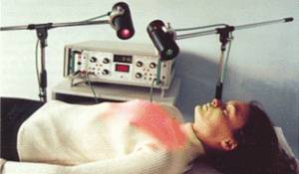
Figure 19 Photography of Chakra Therapy
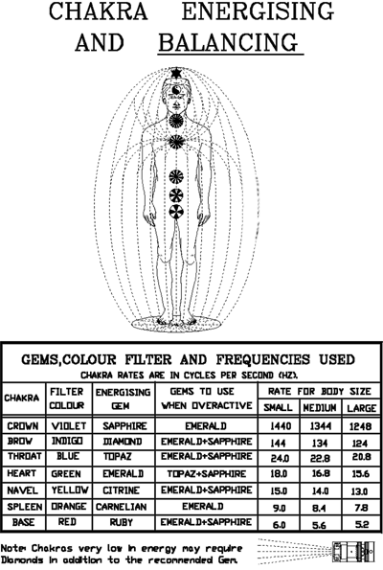
Figure 20 Chakra Energising and Balancing
Confirming the new location
It is helpful to familiarise the patient with his original location and his new position after the shift. Touching or pushing the spot with your finger, will causes the skin to redden more than skin elsewhere on the chest. The spot is often tender, sore or uncomfortable. Pushing it causes the subject a feeling of slight unease. The feeling passes deep into the chest, often right through to the shoulder blade. Helping patients take conscious note of the new position allows them to keep track of their Assemblage Point and arrange to have it corrected when necessary.
Frequency of Shifting
For personal and group development purposes the Assemblage Point can be shifted monthly. It can also be centralised before important meetings or after stressful events. Sports and other teams can benefit, since all members can be given the same alignment.
Patients should be reassessed and their Assemblage Point corrected within 10 to 14 days of their first shift. It should then be corrected monthly until their location stabilises. Patients taking antidepressants or tranquilliser and other types of drugs, may require lower dosages or a different type of drug after realignment. Patients withdrawing from non-prescribed drugs or alcohol may require shifting daily for a week or more until their system adjusts and stabilises.
In the final part of this ground-breaking series, Dr Jon Whale describes how to shift Assemblage Points. Instructions regarding how to locate Assemblage Points, pre-requisite to actually shifting them, are found in Issues 15 and 16.
NOTE: Under no circumstances should these manipulations be carried out without full training and prior supervision of therapists qualified and insured to carry out these manoeuvres.
About the Author
For further information regarding the therapeutic manipulation of Assemblage Points, please communicate directly with Dr Whale:
He can be contacted at: www.whalemedical.com or www.theassemblagepoint.com
About the Author
Jon Whale is an electronic design and development engineer working exclusively on medical applications. He is also a graphologist, transactional analyst and teaches and lectures internationally.
Jon lives in England's Lake District area where he continues his research and design work in electronic and preventive medicine. Currently he is researching the effects of the energy body. (Unified Field or Aura) on psychological and physiological diseases combined with Ayurvedic Medicine and Electronic Gem Therapy.
He can be contacted at: www.whalemedical.com or www.theassemblagepoint.com

