Interleukins | Principal Source | Primary Activity
IL1-α and -β | macrophages and other antigen presenting cells (APCs) | costimulation of APCs and T cells, inflammation and fever, acute phase response, hematopoiesis
IL-2 | activated TH₁ cells, NK cells | proliferation of B cells and activated T cells, NK functions
IL-3 | activated T cells | growth of hematopoietic progenitor cells
IL-4 | TH₂ and mast cells | B cell proliferation, eosinophil and mast cell growth and function, IgE and class II MHC expression on B cells, inhibition of monokine production
IL-5 | TH₂ and mast cells | eosinophil growth and function
IL-6 | activated TH₂ cells, APCs, other somatic cells | acute phase response, B cell proliferation, thrombopoiesis, synergistic with IL-1 and TNF on T cells
IL-7 | thymic and marrow stromal cells | T and B lymphopoiesis
IL-8 | macrophages, other somatic cells | chemoattractant for neutrophils and T cells
IL-9 | T cells | hematopoietic and thymopoietic effects
IL-10 | activated TH₂ cells, CD8⁺ T and B cells, macrophages | inhibits cytokine production, promotes B cell proliferation and antibody production, suppresses cellular immunity, mast cell growth
IL-11 | stromal cells | synergisitc hematopoietic and thrombopoietic effects
IL-12 | B cells, macrophages | proliferation of NK cells, INF-γ production, promotes cell-mediated immune functions
IL-13 | TH₂ cells | IL-4-like activities
Interferons | Principal Source | Primary Activity
INF-α and -β | macrophages, neutrophils and some somatic cells | antiviral effects, induction of class I MHC on all somatic cells, activation of NK cells and macrophages
INF-γ | activated TH₁ and NK cells | induces of class I MHC on all somatic cells, induces class II MHC on APCs and somatic cells, activates macrophages, neutrophils, NK cells, promotes cell-mediated immunity, antiviral effects

Cytokines regulate the intensity and duration of the immune response by stimulating or inhibiting the activation, proliferation, and/or differentiation of various cells and by regulating the secretion of antibodies or other cytokines.
COMPARISON OF HORMONES & CYTOKINES
Because cytokines share many properties with hormones and growth factors, the distinction between these three classes of mediators is becoming blurred. For example, growth hormone is considered by many to be a cytokine because the growth hormone receptor is similar to Class I cytokine receptors.
Any classification of cytokines represents a somewhat arbitrary arrangement on the part of the individual(s) doing the grouping to some extent. Abbas et al group the most common cytokines on the basis of their general properties.
Cytokines that mediate and regulate innate immunity
Type I interferons
Tumor necrosis factor-a
Interleukins 1, 6, 10, 12, and 15
Chemokines
Cytokines that mediate and regulate specific immunity
Interleukins 2, 4, 5, 13, 16, and 17
Interferon-g
TGF-ß
Lymphotoxin
Cytokines that stimulate hematopoiesis
c-kit ligand
Interleukins 3, 7, 9, 11
Colony stimulating factors

Transforming Growth Factors-β (TGFs-β)
TGF-b was originally characterized as a protein (secreted from a tumor cell line) that was capable of inducing a transformed phenotype in non-neoplastic cells in culture. This effect was reversible, as demonstrated by the reversion of the cells to a normal phenotype following removal of the TGF-b. Subsequently, many proteins homologous to TGF-b have been identified. The four closest relatives are TGF-b-1 (the original TGF-b) through TGF-b-5 (TGF-b-1 = TGF-b-4). All four of these proteins share extensive regions of similarity in their amino acids. Many other proteins, possessing distinct biological functions, have stretches of amino-acid homology to the TGF-b family of proteins, particularly the C-terminal region of these proteins.
The TGF-b-related family of proteins includes the activin and inhibin proteins. There are activin A, B and AB proteins, as well as an inhibin A and inhibin B protein. The Mullerian inhibiting substance (MIS) is also a TGF-b-related protein, as are members of the bone morphogenetic protein (BMP) family of bone growth-regulatory factors. Indeed, the TGF-b family may comprise as many as 100 distinct proteins, all with at least one region of amino-acid sequence homology.
There are several classes of cell-surface receptors that bind different TGFs-b with differing affinities. There also are cell-type specific differences in receptor sub-types. Unlike the EGF, PDGF and FGF receptors, the TGF-b family of receptors all have intrinsic serine/threonine kinase activity and, therefore, induce distinct cascades of signal transduction.
TGFs-b have proliferative effects on many mesenchymal and epithelial cell types. Under certain conditions TGFs-b will demonstrate anti-proliferative effects on endothelial cells, macrophages, and T- and B-lymphocytes. Such effects include decreasing the secretion of immunoglobulin and suppressing hematopoiesis, myogenesis, adipogenesis and adrenal steroidogenesis. Several members of the TGF-b family are potent inducers of mesodermal differentiation in early embryos, in particular TGF-b and activin A.
back to the top

Transforming Growth Factor-a (TGF-a)
TGF-a, like the b form, was first identified as a substance secreted from certain tumor cells that, in conjunction with TGF-b-1, could reversibly transform certain types of normal cells in culture. TGF-a binds to the EGF receptor, as well as its own distinct receptor, and it is this interaction that is thought to be responsible for the growth factor's effect. The predominant sources of TGF-a are carcinomas, but activated macrophages and keratinocytes (and possibly other epithelial cells) also secrete TGF-a. In normal cell populations, TGF-a is a potent keratinocyte growth factor; forming an autocrine growth loop by virtue of the protein activating the very cells that produce it.
back to the top

Erythropoietin (Epo)
Epo is synthesized by the kidney and is the primary regulator of erythropoiesis. Epo stimulates the proliferation and differentiation of immature erythrocytes; it also stimulates the growth of erythoid progenitor cells (e.g. erythrocyte burst-forming and colony-forming units) and induces the differentiation of erythrocyte colony-forming units into proerythroblasts. When patients suffering from anemia due to kidney failure are given Epo, the result is a rapid and significant increase in red blood cell count.
back to the top

Insulin-Like Growth Factor-I (IGF-I)
IGF-I (originally called somatomedin C) is a growth factor structurally related to insulin. IGF-I is the primary protein involved in responses of cells to growth hormone (GH): that is, IGF-I is produced in response to GH and then induces subsequent cellular activities, particularly on bone growth. It is the activity of IGF-I in response to GH that gave rise to the term somatomedin. Subsequent studies have demonstrated, however, that IGF-I has autocrine and paracrine activities in addition to the initially observed endocrine activities on bone. The IGF-I receptor, like the insulin receptor, has intrinsic tyrosine kinase activity. Owing to their structural similarities IGF-I can bind to the insulin receptor but does so at a much lower affinity than does insulin itself.
back to the top

Insulin-Like Growth Factor-II (IGF-II)
IGF-II is almost exclusively expressed in embryonic and neonatal tissues. Following birth, the level of detectable IGF-II protein falls significantly. For this reason IGF-II is thought to be a fetal growth factor. The IGF-II receptor is identical to the mannose-6-phosphate receptor that is responsible for the integration of lysosomal enzymes (which contain mannose-6-phosphate residues) to the lysosomes.

Interleukin-1 (IL-1)
IL-1 is one of the most important immune response-- modifying interleukins. The predominant function of IL-1 is to enhance the activation of T-cells in response to antigen. The activation of T-cells, by IL-1, leads to increased T-cell production of IL-2 and of the IL-2 receptor, which in turn augments the activation of the T-cells in an autocrine loop. IL-1 also induces expression of interferon-g (IFN-g) by T-cells. This effect of T-cell activation by IL-1 is mimicked by TNF-a which is another cytokine secreted by activated macrophages. There are 2 distinct IL-1 proteins, termed IL-1-a and -1-b, that are 26% homologous at the amino acid level. The IL-1s are secreted primarily by macrophages but also from neutrophils, endothelial cells, smooth muscle cells, glial cells, astrocytes, B- and T-cells, fibroblasts and keratinocytes. Production of IL-1 by these different cell types occurs only in response to cellular stimulation. In addition to its effects on T-cells, IL-1 can induce proliferation in non-lymphoid cells.
back to the top

Interleukin-2 (IL-2)
IL-2, produced and secreted by activated T-cells, is the major interleukin responsible for clonal T-cell proliferation. IL-2 also exerts effects on B-cells, macrophages, and natural killer (NK) cells. The production of IL-2 occurs primarily by CD4+ T-helper cells. As indicated above, the expression of both IL-2 and the IL-2 receptor by T-cells is induced by IL-1. Indeed, the IL-2 receptor is not expressed on the surface of resting T-cells and is present only transiently on the surface of T-cells, disappearing within 6-10 days of antigen presentation. In contrast to T-helper cells, NK cells constitutively express IL-2 receptors and will secrete TNF-a, IFN-g and GM-CSF in response to IL-2, which in turn activate macrophages.
back to the top

Interleukin-6 (IL-6)
IL-6 is produced by macrophages, fibroblasts, endothelial cells and activated T-helper cells. IL-6 acts in synergy with IL-1 and TNF-( in many immune responses, including T-cell activation. In particular, IL-6 is the primary inducer of the acute-phase response in liver. IL-6 also enhances the differentiation of B-cells and their consequent production of immunoglobulin. Glucocorticoid synthesis is also enhanced by IL-6. Unlike IL-1, IL-2 and TNF-a, IL-6 does not induce cytokine expression; its main effects, therefore, are to augment the responses of immune cells to other cytokines.
back to the top

Interleukin-8 (IL-8)
IL-8 is an interleukin that belongs to an ever-expanding family of proteins that exert chemoattractant activity to leukocytes and fibroblasts. This family of proteins is termed the chemokines. IL-8 is produced by monocytes, neutrophils, and NK cells and is chemoattractant for neutrophils, basophils and T-cells. In addition, IL-8 activates neutrophils to degranulate.
back to the top

Tumor Necrosis Factor-a (TNF-a)
TNF-a (also called cachectin), like IL-1 is a major immune response-- modifying cytokine produced primarily by activated macrophages. Like IL-1, TNF-a induces the expression of other autocrine growth factors, increases cellular responsiveness to growth factors and induces signaling pathways that lead to proliferation. TNF-a acts synergistically with EGF and PDGF on some cell types. Like other growth factors, TNF-a induces expression of a number of nuclear proto-oncogenes as well as of several interleukins.
back to the top

Tumor Necrosis Factor-b (TNF-b)
TNF-b (also called lymphotoxin) is characterized by its ability to kill a number of different cell types, as well as the ability to induce terminal differentiation in others. One significant non-proliferative response to TNF-b is an inhibition of lipoprotein lipase present on the surface of vascular endothelial cells. The predominant site of TNF-b synthesis is T-lymphocytes, in particular the special class of T-cells called cytotoxic T-lymphocytes (CTL cells). The induction of TNF-b expression results from elevations in IL-2 as well as the interaction of antigen with T-cell receptors.
back to the top

Interferon-g (INF-g)
IFN-a, IFN-b and IFN-w are known as type I interferons: they are predominantly responsible for the antiviral activities of the interferons. In contrast, IFN-g is a type II or immune interferon. Although IFN-g, has antiviral activity it is significantly less active at this function than the type I IFNs. Unlike the type I IFNs, IFN-g is not induced by infection nor by double-stranded RNAs. IFN-g is secreted primarily by CD8+ T-cells. Nearly all cells express receptors for IFN-g and respond to IFN-g binding by increasing the surface expression of class I MHC proteins, thereby promoting the presentation of antigen to T-helper (CD4+) cells. IFN-g also increases the presentation of class II MHC proteins on class II cells further enhancing the ability of cells to present antigen to T-cells.

Cytokines in Allergic Disease
The immune system is unique in that it can very selectively discriminate between self and nonself, leaving self alone while rapidly processing and destroying nonself (foreign) antigens in a primary immune response. In addition, a functioning immune system remembers previous encounters with these foreign antigens, resulting in a more vigorous and rapid secondary response (called immunologic memory). These responses depend on both T cells (dependent on the thymus gland for function) and, when specific antibody is made, B cells (which ultimately differentiate into antibody secreting plasma cells). These cells are present in bone marrow, lymphoid organs (i.e. thymus, lymph nodes, tonsils, spleen, etc) and peripheral blood. Many of these lymphoid cells look alike when viewed under a microscope. They can be categorized by the presence of specific cell surface markers called clusters of differentiation (CD). Each CD marker is given a specific number and is found on certain cell types. Thus the function of a cell can often be predicted by the specific CD marker present. For example, all mature human T cells have CD3 on their cell surface (thus they are CD3+). In contrast, human B cells are CD19+ but CD3-. CD3+ T cells can further be divided by function. T cells capable of killing target cells (called cytotoxic T cells- CTL) and/or downregulating immune responses (called suppressor T cells) are CD8+. T cells that help B cells make antibody or other T cells (such as CTL) become active are called helper T cells (TH) and are CD4+.
While it has been appreciated for many years that TH cells existed, it was unclear how helper cells worked until recent studies showed that soluble peptides secreted by activated TH could turn on selective portions of the immune response. Initially, these glycoproteins produced by lymphocytes were called lymphokines. It is now known that many different cell types can produce these immune mediators. The current , more accurate term now used is cytokine.
Cytokines
All cytokines have certain properties in common. They are all small molecular weight peptides or glycopeptides. Many are produced by multiple cell types such as lymphocytes, monocytes/macrophages, mast cells, eosinophils, even endothelial cells lining blood vessels. Each individual cytokine can have multiple functions depending upon the cell that produces it and the target cell(s) upon which it acts (called pleiotropism). Also, several different cytokines can have the same biologic function (called redundancy). Cytokines can exert their effect through the bloodstream on distant target cells (endocrine), on target cells adjacent to those that produce them (paracrine) or on the same cell that produces the cytokine (autocrine). Physiologically it appears that most cytokines exert their most important effects in a paracrine and/or autocrine fashion. Their major functions appear to involve host defense or maintenance and repair of the blood elements (Table 1).
Cytokines are categorized by their major specific function(s). There are four major categories of cytokines (Table 2). Interferons are so named because they interfere with virus replication. There are three major types based upon the source of the interferon. Interferon alpha (IFNa) is produced by the buffy coat layer from white blood cells and is used in treatment of a variety of malignant and immune disorders. Interferon beta (IFNb) is produced by fibroblasts and is currently being evaluated in the treatment of multiple sclerosis. Interferon gamma (IFNg) is produced by activated T cells and is an important immunoregulatory molecule, particularly in allergic diseases.
The colony stimulating factors are so named because they support the growth and differentiation of various elements of the bone marrow. Many are named by the specific element they support such as granulocyte colony stimulating factor (G-CSF), macrophage colony stimulating factor (M-CSF), and granulocyte-macrophage colony stimulating factor (GM-CSF). Other CSFs include Interleukin (IL) -3, which can stimulate a variety of hematopoietic precursors and is being evaluated as a therapy in aplastic anemia and bone marrow transplantation; and c-Kit ligand (stem cell factor) which has recently been demonstrated as a cytokine necessary to cause the differentiation of bone marrow stem cells into their various precursor elements for eventual differentiation into RBC, WBC and megakaryocytes (platelets).
The tumor necrosis factors (TNF) are so called because injecting them into animals causes a hemorrhagic necrosis of their tumors. TNFa is produced by activated macrophages and TNFb is produced by activated T cells (both TH and CTL). These molecules appear to be involved in the pathogenesis of septic shock and much research is aimed at trying to inhibit their activity in septic patients. Attempts have also been made to use the TNFs clinically to treat human tumors. Because of their extremely narrow therapeutic window (efficacy vs toxicity), few view this as a useful stand-alone cancer therapy.
The largest group is the interleukins, so named because their fundamental function appears to be communication between (inter-) various populations of white blood cells (leucocytes -leukin). Interleukins (IL) are given numbers. They are produced by a variety of cell types such as monocytes/macrophages, T cells, B cells and even non-leucocytes. The major interleukins currently of greatest interest to allergists are IL-4, IL-5, IL-10 and IFNg. IL-4 causes a switch to IgE production by differentiating B cells. IFNg can inhibit that switch and prevent the production of specific IgE. IL-10 can actually inhibit the activity of IFNg, allowing the original IL-4 to proceed in the IgE cascade. Thus, an allergic response can be viewed as an allergen-specific production of excess IL-4 and/or IL-10 , lack of adequate IFNg production or both. Eosinophilic inflammation, a major component of allergic reactions, is under control of IL-5 and TNFa
The Allergic Response
There are three fundamental components of allergic reactions:
- formation of allergen-specific IgE ;
- activity of mast cells caused by allergen reexposure, which crosslinks IgE on the surface of mast cells, activating them to cause the signs and symptoms of an immediate hypersensitivity reaction ; and
- allergic inflammation, mediated primarily by recruitment and activation of eosinophils.
Each of these events involve cellular recruitment to the reaction site (called chemotaxis) along with activation of these cells to produce their products and altered cellular traffic to gather the cells together in an optimal fashion to promote the allergic reaction. Remember, the host mistakenly believes this is a protective reaction. A group of proteins called adhesion molecules can be stimulated on both inflammatory cell surfaces as well as target cells (i.e. endothelial lining of blood vessels, lung tissue, etc.). These molecules function to "localize" the inflammatory reaction at the site of tissue injury and/or antigen deposition. In addition, certain adhesion molecules likely have a role in inflammatory cell activation, further enhancing allergic inflammation.
IgE is one of five isotypes of antibody formed in humans. The cell responsible (B cell) starts with an IgM molecule on its surface that is specific for the antigen (or in the case on an allergic response, an allergen). T helper (TH2) cells assist B cells in making antibody by producing cytokines. One particular cytokine (IL-4) is responsible for causing the isotype switch from IgM to IgE. Although necessary, IL-4 is not in and of itself sufficient to cause a switch to IgE. A second signal, which can come from a variety of sources, is needed to complete the switch. Once formed, IgE seeks to bind to either the inciting allergen or to IgE receptors located on a variety of cell types. Mast cells have high affinity IgE receptors.
Of note, other cytokines are active in the regulation of IgE production. IFNg, produced by TH1 helper cells, can antagonize the ability of IL-4 to induce IgE production Recent studies have shown that T cells from nonatopic patients, when stimulated in vitro by specific allergen, produces primarily IFNg while T cells from atopic patients produce allergen-induced IL-4. Further, TH2 cells can produce IL-10, which can inhibit the production of cytokines such as IFNg. Thus IgE could be the prevalent antibody if TH2 rather than TH1 helper cells are stimulated in an atopic individual.
Once allergen-specific IgE is generated and bound to mast cells, subsequent allergen exposure causes crosslinking of mast cell-bound IgE resulting in degranulation. This process takes only a matter of minutes and releases a variety of mediators, including histamine. Histamine binds to target receptors in the nose, lung, skin, gastrointestinal tract and near blood vessels via specific histamine receptors, especially H1 receptors. This activates a series of events leading to increased vascular permeability and dilation, stimulation of nerve fibers and initiation of inflammatory cascades that are collectively responsible for the signs and symptoms of immediate hypersensitivity - itching, sneezing, increased mucus secretion (i.e. rhinorrhea, etc.), bronchospasm and, if enough vascular tissue is involved, hypotension.
Mast cells themselves both respond to and produce cytokines. IL-3 is a mast cell growth factor. Mast cells make IL-4 when stimulated. This may be particularly important in the propagation of IgE- producing B cells as well as the differentiation of T helper cells to the TH2 pathway (both necessary for IgE production). In addition, IL-4 appears to be a secondary but important growth factor for mast cells. Mast cells also make and secrete TNFa. This cytokine has important inflammatory properties that are consistent with the known proinflammatory activities of mast cells.
Eosinophils both respond to and manufacture certain cytokines. IL-5 appears to be a major growth factor for eosinophils. IL-5 is also produced by TH2 cells, further supporting the developing allergic cascade. Eosinophils can secrete many cytokines such as IL-3,GM-CSF, TNFa and IL-1 when activated. Any or all of these cytokines serve to enhance and sustain the allergic inflammatory process by mast cell activation (IL-3), further eosinophil recruitment (TNFa), altering the target tissue (IL-1) and even direct tissue damage. The activated eosinophils also produce and secrete multiple basic proteins and lipid mediators associated with allergic inflammation.
Inflammation has three major components: recruitment , where the inflammatory cells are drawn from the circulation under direct a chemical influence called chemotaxis; altered traffic, where the inflammatory cells are held at the site of developing inflammation; and activation, where the inflammatory cells exert their influence , e.g. producing cytokines, lytic enzymes, phagocytosis, etc. In allergic inflammation, a combination of TH2 cell and mast cell activity appear to be most responsible for the initiation of the eosinophilic activities.
A major source of chemotactic molecules is the activated mast cell. TNFa is a major proinflammatory cytokine whose activities include chemotaxis. Activated mast cell secrete TNFa and therefore may directly influence recruitment of eosinophils. Once activated, eosinophils are themselves a source of secreted TNFa which may serve to continue the recruitment of new eosinophils to the site of inflammation.
Altered traffic also involves changing how the inflammatory cells migrate through tissue. Most leucocytes migrate into tissue from the circulation. This process involves sticking to the endothelial lining of the blood vessel and movement (called diapedesis) between adjacent cells of the blood capillary endothelium to the site of developing inflammation in the tissue. Fundamental to this process is. the expression of adhesion molecules on both the leucocytes and endothelial target tissue. These adhesion molecules are necessary to keep the inflammatory cell at the target tissue site as well as , in certain cases, participate in the cellular activation process.
Cytokines play a fundamental role in adhesion molecule expression. IL-1 can act on the endothelial cell to increase the expression of several adhesion molecules such as ELAM-1(endothelial leucocyte adhesion molecule) , ICAM-1 (intercellular adhesion molecule) and VCAM-1 (vascular cell adhesion molecule). The specific biochemical properties of these molecules is a subject for future discussion. It appears that VCAM-1 expression may be most important in allergic (eosinophilic) inflammation . Another adhesion molecule of special importance in allergic reactions is VLA-4. This molecule is expressed on activated lymphocytes, mast cells and eosinophils. Thus , expression of VCAM-1 on endothelium (of , say, the nose or lung) and VLA-4 on activated mast cells and eosinophils are necessary steps for eosinophilic infiltration of these organs in allergic late phase reactions. This has become particularly significant with the discovery that IL-4 induces the expression of both VCAM-1 on endothelial surfaces and VLA-4 on eosinophils. TNFa further enhances IL-4-induced VCAM-1 expression.
Thus, the cytokine influences on allergic inflammatory reactions can be summarized into three major components:
- Induction of allergen-specific IgE
  - IL-4 upregulates IgE production ,
  - Gamma IFN downregulates IgE production,
  - IL-10 inhibits the production/activity of gamma IFN
- Mast cell activation
  - IL-3, IL-4 - mast cell growth factors,
  - TNF alpha - proinflammatory, chemotactic,
  - IL-4
    - Th2 differentiation,
    - VCAM-1, VLA-4 induction
- Eosinophil inflammation -
  - IL-5 - eosinophilic growth factor,
  - IL-3 - supports mast cell growth,
  - GM-CSF - proinflammatory effects
It follows that excess, allergen-specific TH2 activity could produce activation of each component of the allergic cascade. It is reasonable to hypothesize that allergic disease is characterized by animbalance between allergen- specific TH1 and TH2 activities.
Therapeutic Potentials of Cytokines in Allergic Diseases
This knowledge provides possibilities of new targets for therapeutic activity. Many therapeutic modalities have been examined for their effects on these TH subpopulations . Several have been demonstrated to have significant activities on this arm of the immune response. Currently, the most extensively used antiinflammatory agents, in various topical and systemic formulations, are the corticosteroids. While steroids have direct activities on inflammatory cells such as mast cells and eosinophils, they also exert a regulatory effect on cytokine production.
Recall that the immune reaction that leads to IgE production involves antigen presenting cells(APC- usually macrophages), T cells and B cells. The APC produces IL-1, TNFa and IL-6, all proinflammatory cytokines. In addition, IL-1 activates helper T cells to produce IL-2 (and other cytokines) which activates the immune cascade. Corticosteroids have a fundamental effect on IL-1 secretion and, thus, the ultimate production of IL-2 and resulting T cell activity. Further, mast cells produce their own cytokines including proinflammatories such as TNFa. These are also downregulated in the presence of corticosteroids
Perhaps most exciting is recent data from several investigators that address the effects of allergen immunotherapy (AIT) on cytokine production. What has been appreciated for many years is the positive clinical effects of AIT on symptoms of allergic diseases such as rhinitis and asthma. Until recently, the mechanisms were largely unknown. Now we are beginning to understand that the process of AIT can selectively change allergen-specific cytokine profiles. That is, when an atopic patient's peripheral blood lymphocytes (PBL) are stimulated in vitro with allergen, they produce mostly IL-4. In contrast, PBL from patients who were highly atopic but treated with AIT did not produce IL-4 but rather produced large amounts of IFNg. In other words, it appears that successful AIT is characterized by a switch from allergen-specific TH2 to TH1 expression. The effect appears to be durable and related to length of AIT. It correlates reasonably well with symptom improvement.
The fact that successful AIT takes several years to achieve and the still controversial positions about duration of therapy suggests that we are not yet at the definitive stage for allergy therapy that we desire. This raises the possibility of new therapeutic modalities that can achieve clinical control of allergic inflammation with the rapidity of corticosteroids and specificity of AIT. Such modalities could include cytokines themselves or pharmacologic agents that can modulate specific cytokine profiles.
Recombinant cytokines are being studied in a variety of clinical conditions such as malignant, infectious, autoimmune and allergic/asthmatic diseases. What is apparent is the limited use of these recombinant cytokines for three reasons: (a) they are extremely expensive, something not viewed kindly in the new age of managed health care; (b) they are extremely toxic, causing various systemic symptoms such as fever, chills, muscle aches and fatigue. In higher doses they are potentially life threatening by their effects on causing hypotension; and (c) since these immune-based diseases (particularly allergic/asthmatic) are most likely an imbalance of "good" and "bad" cytokines, giving large pharmacologic doses of recombinant cytokines may create other imbalances in the host that could create other disease entities.
With those concerns, several studies have provided promising results in diseases such as atopic dermatitis (AD). IFNg has been shown to clinically improve children with severe AD and can be steroid-sparing. It is still extremely expensive and can make the children ill. IFNg is also being el\valuated in topical form in asthma.
Finally, there are new immunomodulators being studied that can selectively activate cytokine production in a positive way at the inflammatory site. While not of themselves antigen-specific, they tend to be more effective in networks that are already antigen (or allergen)-activated. This may in part explain the long known observation that, in certain patients, treatment with AIT that does not involve a specific allergen (i.e. animal dander) provides relief of documented symptoms after successful therapy for pollens. Microenvironmental production of IFNg to pollens may act on the animal dander-specific TH2 clone to downregulate its activity. Such a hypothesis remains to be verified.
The understanding of the allergen-specific TH1/TH2 functional ration and its importance in the pathophysiology of allergic diseases may also have utility in clinical monitoring situations. It is provocative to consider clinically useful laboratory assays that could establish the TH2 nature of a specific response and then monitor response to therapy such as AIT by watching for the change to a normal balance. This could also be useful in evaluating therapeutic agents to determine dose and duration of therapy. Such concepts are currently being investigated as research related to allergic inflammation and cytokines continues to move steadily from bench to bedside.

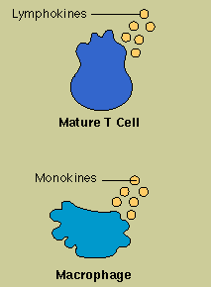
Cytokines
Cytokines are diverse and potent chemical messengers secreted by the cells of the immune system—and the chief tool of T cells.
Lymphocytes, including both T cells and B cells, secrete lymphokines, while monocytes and macrophages secrete monokines.
Binding to specific receptors on target cells, cytokines recruit many other cells and substances to the field of action. Cytokines encourage cell growth, promote cell activation, direct cellular traffic, and destroy target cells—including cancer cells. Because they serve as a messenger between white cells, or leukocytes, many cytokines are also known as interleukins.

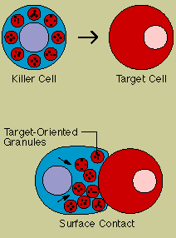
Natural Killer Cells
At least two types of lymphocytes are killer cells—cytotoxic T cells and natural killer cells.
To attack, cytotoxic T cells need to recognize a specific antigen, whereas natural killer or NK cells do not. Both types contain granules filled with potent chemicals, and both types kill on contact. The killer binds to its target, aims its weapons, and delivers a burst of lethal chemicals.
To attack, cytotoxic T cells need to recognize a specific antigen, whereas natural killer or NK cells do not. Both types contain granules filled with potent chemicals, and both types kill on contact. The killer binds to its target, aims its weapons, and delivers a burst of lethal chemicals.

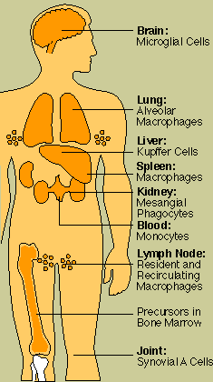
Phagocytes and Granulocytes
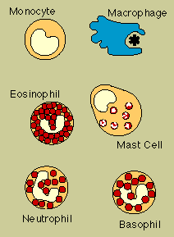
Phagocytes are large white cells that can engulf and digest foreign invaders.
They include monocytes, which circulate in the blood, and macrophages, which are found in tissues throughout the body, as well as neutrophils, cells that circulate in the blood but move into tissues where they are needed. Macrophages are versatile cells; they act as scavengers, they secrete a wide variety of powerful chemicals, and they play an essential role in activating T cells.
Neutrophils are not only phagocytes but also granulocytes: they contain granules filled with potent chemicals. These chemicals, in addition to destroying microorganisms, play a key role in acute inflammatory reactions. Other types of granulocytes are eosinophils and basophils. Mast cells are granule-containing cells in tissue.

Phagocytes in the Body
Specialized phagocytes are found in organs throughout the body.

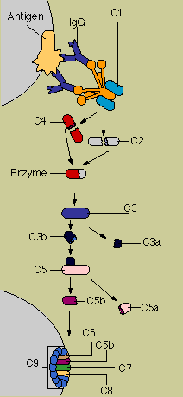
Complement
The complement system consists of a series of proteins that work to "complement" the work of antibodies in destroying bacteria.
Complement proteins circulate in the blood in an inactive form. The so-called "complement cascade" is set off when the first complement molecule, C1, encounters antibody bound to antigen in an antigen-antibody complex. Each of the complement proteins performs its specialized job in turn, acting on the molecule next in line. The end product is a cylinder that punctures the cell membrane and, by allowing fluids and molecules to flow in and out, dooms the target cell.

Mounting an Immune Response
Microbes attempting to get into the body must first get past the skin and mucous membranes, which not only pose a physical barrier but are rich in scavenger cells and IgA antibodies.
Next, they must elude a series of nonspecific defenses—cells and substances that attack all invaders regardless of the epitopes they carry. These include patrolling scavenger cells, complement, and various other enzymes and chemicals.
Infectious agents that get past the nonspecific barriers must confront specific weapons tailored just for them. These include both antibodies and cells. Almost all antigens trigger both nonspecific and specific responses.

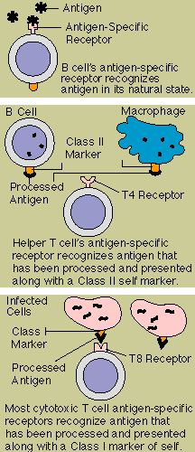
Antigen Receptors
Both B cells and T cells carry customized receptor molecules that allow them to recognize and respond to their specific targets.
The B cell's antigen-specific receptor is a sample of the antibody it is prepared to manufacture; it recognizes antigen in its natural state.
The T cell receptor system is more complex. A T cell can recognize an antigen only after the antigen is processed and presented to it by a so-called antigen-presenting cell, in combination with a special type of cell marker.
The T4 T cell's receptor looks for an antigen that has been broken down by an immune system cell such as a macrophage or a B cell and combined with a marker, known as a class II protein, carried by immune cells. The T8 T cell's receptor recognizes an antigen fragment produced within the cell, combined with a class I protein; class I proteins are found on virtually all body cells.
This complicated arrangement assures that T cells act only on precise targets and at close range.

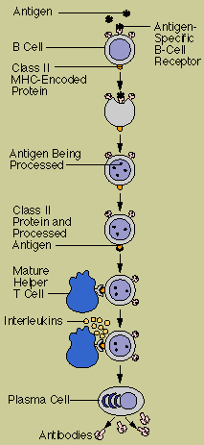
Activation of B Cells to Make Antibody
The B cell uses its receptor to bind a matching antigen, which it proceeds to engulf and process.
Then it combines a fragment of antigen with its special marker, the class II protein. This combination of antigen and marker is recognized and bound by a T cell carrying a matching receptor. The binding activates the T cell, which then releases lymphokines—interleukins—that transform the B cell into an antibody- secreting plasma cell.

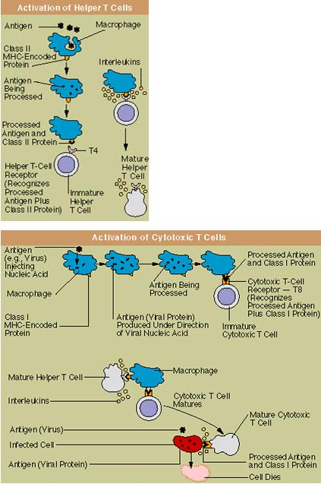
Activation of T Cells: Helper and Cytotoxic

After an antigen-presenting cell such as a macrophage has ingested and processed an antigen, it presents the antigen fragment, along with a class II marker protein, to a matching helper T cell with a T4 receptor.
The binding prompts the macrophage to release interleukins that allow the T cell to mature.
A cytotoxic T cell recognizes antigens such as virus proteins,which are produced within a cell, in combination with a class I self-marker protein. With the cooperation of a helper T cell, the cytotoxic T cell matures. Then, when the mature cytotoxic T cell encounters its specific target antigen combined with a class I marker protein—for instance, on a body cell that has been infected with a virus—it is ready to attack and kill the target cell.

Disorders of the Immune System: Allergy
When the immune system malfunctions, it can unleash a torrent of disorders and diseases.
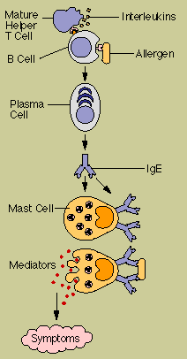
One of the most familiar is allergy. Allergies such as hay fever and hives are related to the antibody known as IgE. The first time an allergy-prone person is exposed to an allergen—for instance, grass pollen—the individual's B cells make large amounts of grass pollen IgE antibody. These IgE molecules attach to granule-containing cells known as mast cells, which are plentiful in the lungs, skin, tongue, and linings of the nose and gastrointestinal tract. The next time that person encounters grass pollen, the IgE-primed mast cell releases powerful chemicals that cause the wheezing, sneezing, and other symptoms of allergy.

Disorders of the Immune System: Autoimmune Disease
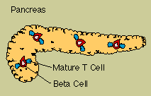
Sometimes the immune system's recognition apparatus breaks down, and the body begins to manufacture antibodies and T cells directed against the body's own cells and organs.
Such cells and autoantibodies, as they are known, contribute to many diseases. For instance, T cells that attack pancreas cells contribute to diabetes, while an autoantibody known as rheumatoid factor is common in persons with rheumatoid arthritis.

Disorders of the Immune System: Immune Complex Disease
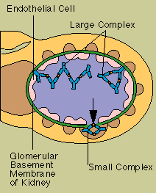
Immune complexes are clusters of interlocking antigens and antibodies.
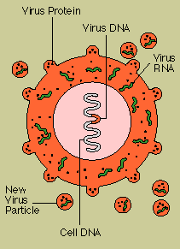
Normally they are rapidly removed from the bloodstream. In some circumstances, however, they continue to circulate, and eventually they become trapped in and damage the tissues of the kidneys, as seen here, or in the lungs, skin, joints, or blood vessels.

Disorders of the Immune System: AIDS
When the immune system is lacking one or more of its components, the result is an immunodeficiency disorder.
These can be inherited, acquired through infection, or produced as an inadvertent side effect of drugs such as those used to treat cancer or transplant patients.
AIDS is an immunodeficiency disorder caused by a virus that destroys helper T cells and that is harbored in macrophages as well as helper (T4) T cells. The AIDS virus splices its DNA into the DNA of the cell it infects; the cell is thereafter directed to churn out new viruses.

Immunity and Cancer
When normal cells turn into cancer cells, some of the antigens on their surface change.
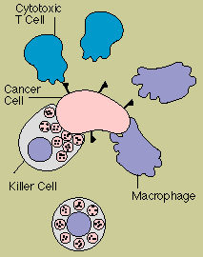
These new or altered antigens flag immune defenders, including cytotoxic T cells, natural killer cells, and macrophages. According to one theory, patrolling cells of the immune system provide continuing bodywide surveillance, spying out and eliminating cells that undergo malignant transformation. Tumors develop when the surveillance system breaks down or is overwhelmed.

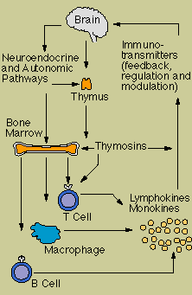
The Immune System and the Nervous System
Biological links between the immune system and the central nervous system exist at several levels.
Hormones and other chemicals such as neuropeptides, which convey messages among nerve cells, have been found also to "speak" to cells of the immune system—and some immune cells even manufacture typical neuropeptides. In addition, networks of nerve fibers have been found to connect directly to the lymphoid organs.
The picture that is emerging is of closely interlocked systems facilitating a two-way flow of information. Immune cells, it has been suggested, may function in a sensory capacity, detecting the arrival of foreign invaders and relaying chemical signals to alert the brain. The brain, for its part, may send signals that guide the traffic of cells through the lymphoid organs.

