Acu-Vac Coils & Feedback Loop
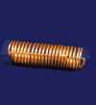
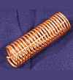
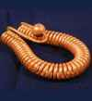
Functional Art Forms based on the principles of the Light-Life Rings, with the addition of controlled polarity and flow.
The Acu-Vac Coil acts like a vacuum cleaner for pain. In skin contact or non-contact modes, it has been demonstrated to achieve states of relaxation in a few minutes, as monitored by bio-feedback equipment, which would normally require weeks or months of training to achieve.
As an aid to meditation, it may be applied to each chakra to cleanse and energize: The suction end first, to cleanse for one minute, and the positive, output end for one minute to energize and balance.
A few highly skilled and intuitive practitioners report cases of broken bones knit in as little as twenty minutes with the Coil. Other lay practitioners report reduction of swelling and bone knitting in as little as one hour with a combination of Acu-Vac Coil, Light-Life Ring, and Feedback Loop, plus a wet towel wrap (under field conditions far from civilization).
Chronic lower back pain classically is relieved very significally in 45 minutes to 1-1/2 hours in a session, with the client standing.

The Harmonizer: A Functional Art Form
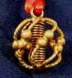
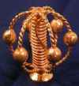
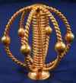
The Harmonizer was developed experimentally from three Light-Life Rings and a Coil. Initially we sought to provide an art form, that would give relief from the "electro-smog" in the modern environment for those who are sensitive to that area of modern day pollution; it worked.
The extraordinary clairvoyants who joined in this early research easily defined the field radius at 100 feet in all directions! With a 200-foot spherical "comfort zone," an Environmental Harmonizer will nicely reduce the electro-smog discomfort in even a large home.
Subsequent verification by high-tech electronics, "low-tech" dowsing, and direct observation has confirmed the original clairvoyants' descriptions of the spherical field.
In the spring of 1994, we discovered that by applying specific sound frequency patterns from a nearby set of earphones or a common "boom box" portable radio-cassette player, the spherical radius of the field could be expanded to a 15-mile radius, and the indoor and outdoor air in that radius smelled distinctly of the natural ozone produced by a mountain meadow in the spring — for hours and even days.

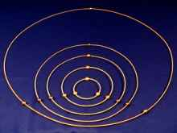
Light-Life Rings
A Functional Art Form based on the principle of sacred geometry measure; superconductivity, and harmonic frequencies of light. Used to remove energetic blockages for healing in chiropractic, massage, homeopathic, Reiki, Jin Shin, Therapeutic Touch, water therapy, and rejuvenation practices by professionals and lay practitioners.
It is an independent development of a discovery made in 1991 and recently found to have its roots in ancient Africa/Egypt, some 3000+ years ago (Interview with Credo Mutlaw, last of the Zulu tribal Scholar / Prophet/ Holy Man/ Sangomas; May 2000, Johannesburg).

