Co enzyme Q-10
Human studies confirm Morganics Co-Q-10 300X delivers 300% more serum levels than any other Co-Enzyme-Q-10 available.
Co-enzyme Q-10 is a fat soluble vitamin-like substance that is found in minute amounts in a variety of foods and although it is synthesized in all tissues, it is found in greater percentages in the heart muscle.
The biosynthesis of Co-Q-10 from the amino acid Tyrosine, is a multi-stage process requiring B-Complex vitamins and several trace minerals. Co-enzymes are co-factors upon which large and complex enzymes absolutely depend for their function.
Co-Q-10 is the Co-enzyme for at least three mitochondrial enzymes, (mitochondria are the power-plants of cells) as well as enzymes in other parts of the cell. Mitochondrial enzymes are essential for the production of the high-energy phosphate, adenosine triphosphate (ATP), upon which all cellular functions depend. Co-Q-10 is critical in the Electron and Proton transfer function, fundamental to all life forms - animals, plants and bacteria.
Helps | 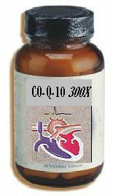 | Benefits
- Support Cardiac Function  - Manage High Blood Pressure  - Strengthen The Heart Muscle  - Immune System Stimulation  - Produce Cellular Energy (ATP)  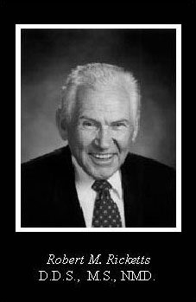 |  | - Helps Prevent Oxidation of LDL Cholesterol  - Protects Mitochondria of Cells From Oxidation Damage  - Plasma Levels Exceeing 3.0mcg/ml Achieved In Only 21 Days
  Click here for more information

CO-ENZYME Q-10 DEFICIENCY

Normal blood and tissue levels of Co-Q-10 have been well established by numerous investigators around the world. Significantly decreased levels of Co-Q-10 have been noted in a wide variety of diseases in both animals and human studies. Co-Q-10 deficiency may be caused by insufficient dietary Co-Q-10, impairment in Co-Q-10 biosynthesis, excessive utilization of Co-Q-10 by the body, or a combination of the three. Dr. Karl Folkers takes the position that the dominant source of Co-Q-10 in Man is biosynthesis. This complex 17 step process using all the B-Complex vitamins including several trace elements, is, by its nature, highly vulnerable. Dr. Folkers argues that average ìnormalî levels of Co-Q-10 are really sub-optimal and the very low levels observed in advanced disease states, represent on the tip of the deficiency "ice berg".

HEART DISEASE AND CO-Q-10
Drugs used to treat elevated cholesterol levels, also block the biosynthesis of Co-Q-10 in the heart muscle, where it is needed most.
Co-Q-10 is known to be highly concentrated in heart muscle cells due to the high energy requirements of this cell type. For the past 14 years, the great bulk of clinical work with Co-Q-10 has focused on heart disease. Specifically congestive heart failure has been strongly correlated with significantly low blood and tissue levels of Co-Q-10. The severity of heart failure correlates with the severity of Co-Q-10 deficiency. This deficiency of Co-Q-10 appears to be a major treatable factor in the progression of heart failure.
According to Dr. Julian Whitaker, Co-Q-10 is the most powerful treatment of cardiomyopathy available. He states that it increases the survival rate of cardiomyopathy patients tenfold, compared to the combined therapy of ACE inhibitors, diuretics and digitalis drugs. Several trials showed the gradual and sustained improvement in the blood pumped out of the heart as well as improvement in fatigue, chest pain and palpitations.
Co-Q-10 ESSENTIAL TO ALL CELLS
Since Co-Q-10 is necessary for optimal function of all cells, it is not surprising to learn of the diverse number of diseases which respond favorably to Co-Q-10.
Disease states that involve immune dysfunction, have been recognized to have low levels of Co-Q-10. Q-10 is a powerful antioxidant and can greatly reduce oxidative damage to tissues as well as inhibit oxidation of LDL cholesterol. Co-Q-10 protects the mitochondria, the power-house of the cell, from free radical damage. Co-Q-10 is LIFE FORCE.
RELATIVE BIOAVAILABILITY
Co-Q-10 Formulation Influences Bioavailability
Summary: The relative bioavailability of typical commercially available forms of Co-Enzyme Q-10 including other softgels, was compared with Morganics Q-GelÆ Biosolvô Co-Q-10, a new form of Co-Q-10, in human subjects in two separate trials, performed at the new York Medical College. The data from both trials show that Q-Gel, delivers 300% greater plasma levels of Co-Q-10 compared to all other Co-enzyme Q-10 products. This means that much lower doses of Q-Gel are required to rapidly reach and maintain adequate blood Q-10 values. A primary reason for the elevated blood plasma levels, is due to Q-Gel's 100% dissolution, thereby allowing superior absorption and assimilation.

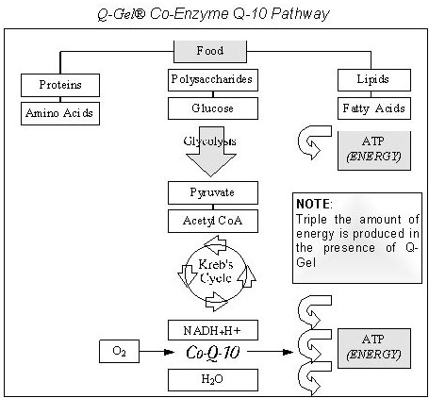
Bromelain is a proteolytic enzyme found in raw pineapple that stimulates protein manufacture and repair. It dissolves damaged protein (scar tissue) and speeds the healing rate of bruises. It reduces pain and swelling after oral surgery and aids in the digestion of protein rich foods. Papain, another protein dissolving enzyme like bromelain, is one of the main ingredients found in meat tenderizers.
Bromelain For Tendonitis
Over the past twenty years, I have had tendonitis in various parts of my body. Participation in racquet sports, weightlifting, and other body pounding activities such as running and other aerobic activities are considered main causes. Tendonitis is inflammation of the tendon and/or the insertion point of tendon to muscle or bone caused by excessive pounding activities. The traditional medical establishment (doctors and the like) mainly suggest ibuprofen (or any other pain killer) for the pain. They also recommend staying away from the activities responsible for the problem for long periods of time. Most of us are not happy with conventional wisdom.
In December 1993, I developed severe wrist tendonitis (the kind that keeps you awake at night). I have been playing/teaching racquetball and tennis since 1976. I wasn't about to be side-lined and had a feeling (due to research in natural/alternative medicine) there was/is a cure. At this point in my life, I had found many solutions to virus and disease that was seemingly being hidden from us by the traditional medical establishment. My research led me to sources stating that bromelain is a natural anti-inflammatory and digestive aid for protein. In short, I surmised, based on all evidence discovered that tendonitis created an internal wound resulting in scar tissue (fibrous material composed of calcium ions and protein). I then theorized that tendonitis could be cured by ingesting bromelain, but couldn't find how much to take. I became my own guinea pig for this project too (at this point in my life I had already conquered skin cancer, bunions, arthritis, hemorrhoids, frequent colds and flu, and low energy naturally).
I began taking 750 mg per day in divided doses and felt a bit of relief after a week. The 750 mg dose helped with the pain and mobility but not completely. At that point, I decided to increase the dose to 1,500 mg/day/divided doses. It worked completely. Since the discovery, I've always recommended 1,500 mg per day to others who contract the ailment. There appears to be approximately an eighty percent success rate. Factors that may account for the other twenty percent are:
- mis-diagnosis (they may have carpal tunnel syndrome or arthritis of which there are different treatment methods)
- low levels of co-nutrients in their system
The combination of anti-inflammatory action and protein dissolving abilities enables bromelain to do its job. It appears significant amounts of vitamins C, E, beta-carotene, bioflavonoids, and zinc, (similar to the amounts found in Life Extension Mix -- LEM) are necessary for bromelain to be effective -- Life Extension, pg. 237, Encyclopedia of Natural Medicine, pg. 513, Hiroshima Journal of Medical Science, 1975, 24:185, and Medical Hypothesis, 1960, 6:99. Most people do not take a high quality multi-formula (commercial and multi-level varieties) containing the amounts of co-nutrients needed to aid bromelain. This could be a part of the explanation for the 20% who do not find relief.

