

How Your Eyes Work
by Dr. Carl Bianco, M.D.
It’s no accident that the main function of the sun at the center of our solar system is to provide light. Light is what drives life. It’s hard to imagine our world and life without it.
The sensing of light by living things is almost universal. Plants use light through photosynthesis to grow. Animals use light to hunt their prey or to sense and escape from predators. Some say that it is the development of stereoscopic vision, along with the development of the large human brain and the freeing of hands from locomotion, that have allowed humans to evolve to such a high level.
In this edition of HowStuffWorks Fitness, you will learn about the amazing inner workings of the human eye!
Basic Anatomy
Although small in size, the eye is a very complex organ. The eye is approximately 1 inch (2.54 cm) wide, 1 inch deep and 0.9 inches (2.3 cm) tall.
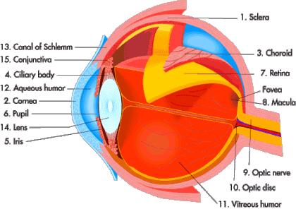
The tough, outermost layer of the eye is called the sclera. It maintains the shape of the eye. The front sixth of this layer is clear and is called the cornea. All light must first pass through the cornea when it enters the eye. Attached to the sclera are the muscles that move the eye, called the extraocular muscles.
The choroid (or uveal tract) is the second layer of the eye. It contains the blood vessels that supply blood to structures of the eye. The front part of the choroid contains two structures:
- The ciliary body - The ciliary body is a muscular area that is attached to the lens. It contracts and relaxes to control the size of the lens for focusing.
- The iris - The iris is the colored part of the eye. The color of the iris is determined by the color of the connective tissue and pigment cells. Less pigment makes the eyes blue; more pigment makes the eyes brown. The iris is an adjustable diaphragm around an opening called the pupil.
The iris has two muscles: The dilator muscle makes the iris smaller and therefore the pupil larger, allowing more light into the eye; the sphincter muscle makes the iris larger and the pupil smaller, allowing less light into the eye. Pupil size can change from 2 millimeters to 8 millimeters. This means that by changing the size of the pupil, the eye can change the amount of light that enters it by 30 times.
The innermost layer is the retina -- the light-sensing portion of the eye. It contains rod cells, which are responsible for vision in low light, and cone cells, which are responsible for color vision and detail. In the back of the eye, in the center of the retina, is the macula. In the center of the macula is an area called the fovea centralis. This area contains only cones and is responsible for seeing fine detail clearly.
The retina contains a chemical called rhodopsin, or "visual purple." This is the chemical that converts light into electrical impulses that the brain interprets as vision. The retinal nerve fibers collect at the back of the eye and form the optic nerve, which conducts the electrical impulses to the brain. The spot where the optic nerve and blood vessels exit the retina is called the optic disk. This area is a blind spot on the retina because there are no rods or cones at that location. However, you are not aware of this blind spot because each eye covers for the blind spot of the other eye.
When a doctor looks at the back of your eye through an ophthalmoscope, here's the view:
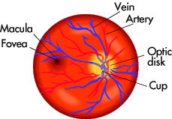
Inside the eyeball there are two fluid-filled sections separated by the lens. The larger, back section contains a clear, gel-like material called vitreous humor. The smaller, front section contains a clear, watery material called aqueous humor. The aqueous humor is divided into two sections called the anterior chamber (in front of the iris) and the posterior chamber (behind the iris). The aqueous humor is produced in the ciliary body and is drained through the canal of Schlemm. When this drainage is blocked, a disease called glaucoma can result.
The lens is a clear, bi-convex structure about 10 mm (0.4 inches) in diameter. The lens changes shape because it is attached to muscles in the ciliary body. The lens is used to fine-tune vision.
Covering the inside surface of the eyelids and sclera is a mucous membrane called the conjunctiva, which helps to keep the eye moist. An infection of this area is called conjunctivitis (also called pink eye).
The eye is unique in that it is able to move in many directions to maximize the field of vision, yet is protected from injury by a bony cavity called the orbital cavity. The eye is embedded in fat, which provides some cushioning. The eyelids protect the eye by blinking. This also keeps the surface of the eye moist by spreading tears over the eyes. Eyelashes and eyebrows protect the eye from particles that may injure it.
Tears are produced in the lacrimal glands, which are located above the outer segment of each eye. The tears eventually drain into the inner corner of the eye, into the lacrimal sac, then through the nasal duct and into the nose. That is why your nose runs when you cry.
There are six muscles attached to the sclera that control the movements of the eye. They are shown here:
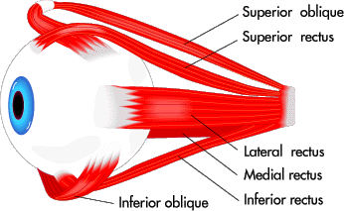

Muscle | Primary Function
Medial rectus | moves eye towards nose
Lateral rectus | moves eye away from nose
Superior rectus | raises eye
Inferior rectus | lowers eye
Superior oblique | rotates eye
Inferior oblique | rotates eye
In the next section, you'll learn how the eye perceives light.
Perceiving Light
When light enters the eye, it first passes through the cornea, then the aqueous humor, lens and vitreous humor. Ultimately it reaches the retina, which is the light-sensing structure of the eye. The retina contains two types of cells, called rods and cones. Rods handle vision in low light, and cones handle color vision and detail. When light contacts these two types of cells, a series of complex chemical reactions occurs. The chemical that is formed (activated rhodopsin) creates electrical impulses in the optic nerve. Generally, the outer segment of rods are long and thin, whereas the outer segment of cones are more, well, cone shaped. Below is an example of a rod and a cone:
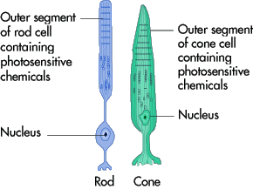
The outer segment of a rod or a cone contains the photosensitive chemicals. In rods, this chemical is called rhodopsin; in cones, these chemicals are called color pigments. The retina contains 100 million rods and 7 million cones. The retina is lined with black pigment called melanin -- just as the inside of a camera is black -- to lessen the amount of reflection. The retina has a central area, called the macula, that contains a high concentration of only cones. This area is responsible for sharp, detailed vision.
When light enters the eye, it comes in contact with the photosensitive chemical rhodopsin (also called visual purple). Rhodopsin is a mixture of a protein called scotopsin and 11-cis-retinal -- the latter is derived from vitamin A (which is why a lack of vitamin A causes vision problems). Rhodopsin decomposes when it is exposed to light because light causes a physical change in the 11-cis-retinal portion of the rhodopsin, changing it to all-trans retinal. This first reaction takes only a few trillionths of a second. The 11-cis-retinal is an angulated molecule, while all-trans retinal is a straight molecule. This makes the chemical unstable. Rhodopsin breaks down into several intermediate compounds, but eventually (in less than a second) forms metarhodopsin II (activated rhodopsin). This chemical causes electrical impulses that are transmitted to the brain and interpreted as light. Here is a diagram of the chemical reaction we just discussed:
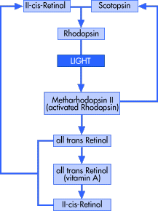
Activated rhodopsin causes electrical impulses in the following way:
- The cell membrane (outer layer) of a rod cell has an electric charge. When light activates rhodopsin, it causes a reduction in cyclic GMP, which causes this electric charge to increase. This produces an electric current along the cell. When more light is detected, more rhodopsin is activated and more electric current is produced.
- This electric impulse eventually reaches a ganglion cell, and then the optic nerve.
- The nerves reach the optic chasm, where the nerve fibers from the inside half of each retina cross to the other side of the brain, but the nerve fibers from the outside half of the retina stay on the same side of the brain.
- These fibers eventually reach the back of the brain (occipital lobe). This is where vision is interpreted and is called the primary visual cortex. Some of the visual fibers go to other parts of the brain to help to control eye movements, response of the pupils and iris, and behavior.
Eventually, rhodopsin needs to be re-formed so that the process can recur. The all-trans retinal is converted to 11-cis-retinal, which then recombines with scotopsin to form rhodopsin to begin the process again when exposed to light.
Color Vision
The color-responsive chemicals in the cones are called cone pigments and are very similar to the chemicals in the rods. The retinal portion of the chemical is the same, however the scotopsin is replaced with photopsins. Therefore, the color-responsive pigments are made of retinal and photopsins. There are three kinds of color-sensitive pigments:
- Red-sensitive pigment
- Green-sensitive pigment
- Blue-sensitive pigment
Each cone cell has one of these pigments so that it is sensitive to that color. The human eye can sense almost any gradation of color when red, green and blue are mixed.
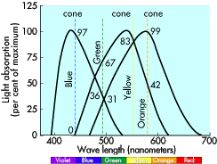
In the diagram above, the wavelengths of the three types of cones (red, green and blue) are shown. The peak absorbancy of blue-sensitive pigment is 445 nanometers, for green-sensitive pigment it is 535 nanometers, and for red-sensitive pigment it is 570 nanometers.
Color Blindness
Color blindness is the inability to differentiate between different colors. The most common type is red-green color blindness. This occurs in 8 percent of males and 0.4 percent of females. It occurs when either the red or green cones are not present or not functioning properly. People with this problem are not completely unable to see red or green, but often confuse the two colors.
This is an inherited disorder and affects men more commonly since the capacity for color vision is located on the X chromosome. (Women have two X chromosomes, so the probability of inheriting at least one X with normal color vision is high; men have only one X chromosome to work with. Click here for more on chromosomes.). The inability to see any color, or seeing only in different shades of gray, is very rare.
For more on color blindness, click here.
Vitamin A Deficiency
When severe vitamin A deficiency is present, then night blindness occurs.
Vitamin A is necessary to form retinal, which is part of the rhodopsin molecule. When the levels of light-sensitive molecules are low due to vitamin A deficiency, there may not be enough light at night to permit vision. During daylight, there is enough light stimulation to produce vision despite low levels of retinal.
Refraction
When light rays reach an angulated surface of a different material, it causes the light rays to bend. This is called refraction. When light reaches a convex lens, the light rays bend toward the center:
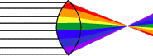
When light rays reach a concave lens, the light rays bend away from the center:
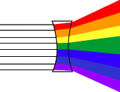
The eye has multiple angulated surfaces that cause light to bend. These are:
- The interface between the air and the front of the cornea
- The interface between the back of the cornea and the aqueous humor
- The interface between the aqueous humor and the front of the lens
- The interface between the back of the lens and the vitreous humor
When everything is working correctly, light makes it through these four interfaces and arrives at the retina in perfect focus.
Normal Vision
Vision or visual acuity is tested by reading a Snellen eye chart at a distance of 20 feet. By looking at lots of people, eye doctors have decided what a "normal" human being should be able to see when standing 20 feet away from an eye chart. If you have 20/20 vision, it means that when you stand 20 feet away from the chart you can see what a "normal" human being can see. (In metric, the standard is 6 meters and it's called 6/6 vision). In other words, if you have 20/20 vision your vision is "normal" -- a majority of people in the population can see what you can see at 20 feet.
If you have 20/40 vision, it means that when you stand 20 feet away from the chart you can only see what a normal human can see when standing 40 feet from the chart. That is, if there is a "normal" person standing 40 feet away from the chart, and you are standing only 20 feet away from the chart, you and the normal person can see the same detail. 20/100 means that when you stand 20 feet from the chart you can only see what a normal person standing 100 feet away can see. 20/200 is the cutoff for legal blindness in the United States.
You can also have vision that is better than the norm. A person with 20/10 vision can see at 20 feet what a normal person can see when standing 10 feet away from the chart.
Hawks, owls and other birds of prey have much more acute vision than humans. A hawk has a much smaller eye than a human being but has lots of sensors (cones) packed into that space. This gives a hawk vision that is eight times more acute than a human's. A hawk might have 20/2 vision!
Errors of Refraction
Normally, your eye can focus an image exactly on the retina:
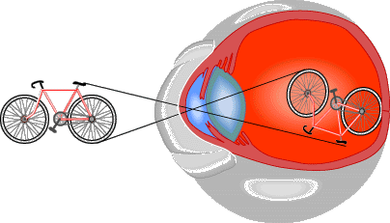
Nearsightedness and farsightedness occur when the focusing is not perfect.
When nearsightedness (myopia) is present, a person is able to see near objects well and has difficulty seeing objects that are far away. Light rays become focused in front of the retina. This is caused by an eyeball that is too long, or a lens system that has too much power to focus. Nearsightedness is corrected with a concave lens. This lens causes the light to diverge slightly before it reaches the eye, as seen here:
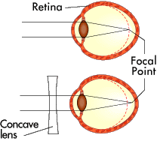
When farsightedness (hyperopia) is present, a person is able to see distant objects well and has difficulty seeing objects that are near. Light rays become focused behind the retina. This is caused by an eyeball that is too short, or by a lens system that has too little focusing power. This is corrected with a convex lens, as seen here:
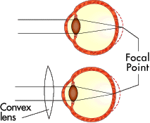
See How Refractive Vision Problems Work and How Corrective Lenses Work for details.
Astigmatism
Astigmatism is an uneven curvature of the cornea and causes a distortion in vision. To correct this, a lens is shaped to correct the unevenness.
Why does vision worsen as we age?
As we grow older, the lens becomes less elastic. It loses its ability to change shape. This is called presbyopia and is more noticeable when we try to see things that are close up, because the ciliary body must contract to make the lens thicker. The loss of elasticity prevents the lens from becoming thicker. As a result, we lose the ability to focus on close objects.
At first, people begin holding things farther away in order to see them in focus. This usually becomes noticeable when we reach our mid-forties. Eventually, the lens is unable to move and becomes more or less permanently focused at a fixed distance (which is different for each person).
To correct this, bifocals are required. Bifocals are a combination of a lower lens for close vision (reading) and an upper lens for distance vision.
Depth Perception
The eye uses three methods to determine distance:
- The size a known object has on your retina - If you have knowledge of the size of an object from previous experience, then your brain can gauge the distance based on the size of the object on the retina.
- Moving parallax - When you move your head from side to side, objects that are close to you move rapidly across your retina. However, objects that are far away move very little. In this way, your brain can tell roughly how far something is from you.
- Stereo vision - Each eye receives a different image of an object on its retina because each eye is about 2 inches apart. This is especially true when an object is close to your eyes. This is less useful when objects are far away because the images on the retina become more identical the farther they are from your eyes.
Blindness
Legal blindness is usually defined as visual acuity less than 20/200 with corrective lenses. Now that you have learned some anatomy of the eye and how it functions, it becomes easier to understand how the following conditions can lead to blindness:
- Cataracts - This is a cloudiness in the lens that blocks light from reaching the retina. It becomes more common as we age, but babies can be born with a cataract. As it worsens, it can require surgery to remove the lens and place an intraocular lens.
- Glaucoma - If the aqueous humor does not drain out correctly, then pressure builds up in the eye. This causes the cells and nerve fibers in the back of the eye to die. This can be treated with medications and surgery.
- Diabetic retinopathy - Persons with diabetes can get blockage of blood vessels, leakage of blood vessels and scarring that can lead to blindness. This can be treated with laser surgery.
- Macular degeneration - In some persons, the macula (which is responsible for fine detail in the center of vision) can deteriorate with age for unknown reasons. This causes loss of central vision. This can sometimes be helped with laser surgery.
- Trauma - Direct trauma or chemical injuries can cause enough damage to the eyes to prevent adequate vision.
- Retinitis pigmentosa - This is an inherited disease that causes a degeneration of the retina and excess pigment. It first causes night blindness and then tunnel vision, which often gradually progresses to total blindness. There is no known treatment.
- Trachoma - This is an infection caused by an organism called Chlamydia trachomatis. It is a common cause of blindness worldwide but is rare in the United States. It can be treated with antibiotics.
There are many other causes of blindness, such as vitamin A deficiency, tumors, strokes, neurological diseases, other infections, hereditary diseases and toxins. For more information, check out the links on the next page.
Lots More Information
Related HowStuffWorks Fitness Articles
- How Refractive Vision Problems Work
- How Corrective Lenses Work
- How LASIK Works
- Why do people have red eyes in some flash photographs?
- Why does it take my eyes several minutes to get used to darkness?
- Will reading in low light hurt my eyes?
- How Guide Dogs Work
More Great Links!
- Eye Resources on the Internet
- National Institutes of Health: National Eye Institute
- Gallery of Illusions
- UC Davis: Neurological Eye Simulator
About the Author
Carl Bianco, M.D., is an emergency physician practicing at Dorchester General Hospital in Cambridge, Maryland. Dr. Bianco attended medical school at Georgetown University School of Medicine and received his undergraduate degree from Georgetown University with majors in nursing and pre-med. He Completed an internship and residency in emergency medicine at Akron City Hospital in Akron, Ohio.
Dr. Bianco lives near Baltimore with his wife and two children.

Home | Search | Privacy Statement | Terms of Use | About Us | Contact Us
Copyright © 1998-2002 Howstuffworks, Inc. All rights reserved.

