The pentose pathway:
The pentose phosphate pathway is primarily an anabolic pathway that utilizes the 6 carbons of glucose to generate 5 carbon sugars and reducing equivalents. However, this pathway does oxidize glucose and under certain conditions can completely oxidize glucose to CO₂ and water. The primary functions of this pathway are:
- 1. To generate reducing equivalents, in the form of NADPH, for reductive biosynthesis reactions within cells.
- 2. To provide the cell with ribose-5-phosphate (R5P) for the synthesis of the nucleotides and nucleic acids.
- 3. Although not a significant function of the PPP, it can operate to metabolize dietary pentose sugars derived from the digestion of nucleic acids as well as to rearrange the carbon skeletons of dietary carbohydrates into glycolytic/gluconeogenic intermediates
Enzymes that function primarily in the reductive direction utilize the NADP⁺/NADPH cofactor pair as co-factors as opposed to oxidative enzymes that utilize the NAD⁺/NADH cofactor pair. The reactions of fatty acid biosynthesis and steroid biosynthesis utilize large amounts of NADPH. As a consequence, cells of the liver, adipose tissue, adrenal cortex, testis and lactating mammary gland have high levels of the PPP enzymes. In fact 30% of the oxidation of glucose in the liver occurs via the PPP. Additionally, erythrocytes utilize the reactions of the PPP to generate large amounts of NADPH used in the reduction of glutathione (see below). The conversion of ribonucleotides to deoxyribonucleotides (through the action of ribonucleotide reductase) requires NADPH as the electron source, therefore, any rapidly proliferating cell needs large quantities of NADPH.
back to the top

Reactions of the Pentose Phosphate Pathway
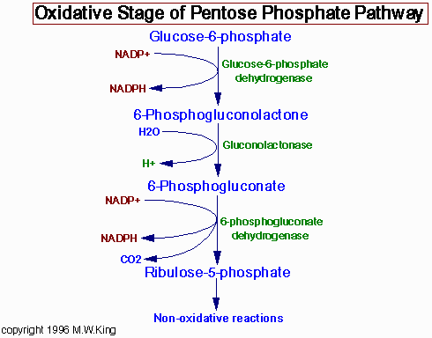
The reactions of oxidative portion of the pentose phosphate pathway are shown. The enzymes are in green.

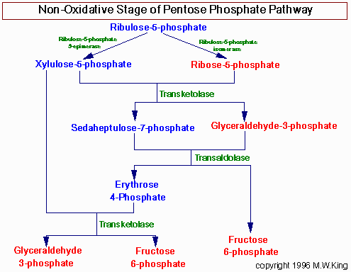
The reactions of the non-oxidative portion of the pentose phosphate pathway are shown. Enzymes are in green. Relevant carbohydrate intermediates of this portion of the pathway are in red.
The reactions of the PPP operate exclusively in the cytoplasm. From this perspective it is understandable that fatty acid synthesis (as opposed to oxidation) takes place in the cytoplasm. The pentose phosphate pathway has both an oxidative and a non-oxidative arm. The oxidation steps, utilizing glucose-6-phosphate (G6P) as the substrate, occur at the beginning of the pathway and are the reactions that generate NADPH. The reactions catalyzed by glucose-6-phosphate dehydrogenase and 6-phosphogluconate dehydrogenase generate one mole of NADPH each for every mole of glucose-6-phosphate (G6P) that enters the PPP.
The non-oxidative reactions of the PPP are primarily designed to generate R5P. Equally important reactions of the PPP are to convert dietary 5 carbon sugars into both 6 (fructose-6-phosphate) and 3 (glyceraldehyde-3-phosphate) carbon sugars which can then be utilized by the pathways of glycolysis.
The primary enzymes involved in the non-oxidative steps of the PPP are transaldolase and transketolase.
- Transketolase functions to transfer 2 carbon groups from substrates of the PPP, thus rearranging the carbon atoms that enter this pathway. Like other enzymes that transfer 2 carbon groups, transketolase requires thiamine pyrophosphate (TPP) as a co-factor in the transfer reaction.
- Transaldolase transfers 3 carbon groups and thus is also involved in a rearrangement of the carbon skeletons of the substrates of the PPP. The transaldolase reaction involves Schiff base formation between the substrate and a lysine residue in the enzyme.
The net result of the PPP, if not used solely for R5P production, is the oxidation of G6P, a 6 carbon sugar, into a 5 carbon sugar. In turn, 3 moles of 5 carbon sugar are converted, via the enzymes of the PPP, back into two moles of 6 carbon sugars and one mole of 3 carbon sugar. The 6 carbon sugars can be recycled into the pathway in the form of G6P, generating more NADPH. The 3 carbon sugar generated is glyceraldehyde-3-phsphate which can be shunted to glycolysis and oxidized to pyruvate. Alternatively, it can be utilized by the gluconeogenic enzymes to generate more 6 carbon sugars (fructose-6-phosphate or glucose-6-phosphate).
Metabolic Disorders Associated with the
Pentose Phosphate Pathway
Oxidative stress within cells is controlled primarily by the action of the peptide, glutathione, GSH. See Specialized Products of Amino Acids for the synthesis of GSH.
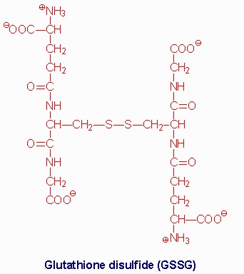
Glutathione (GSH) is a tripeptide composed of γ-glutamate, cysteine and glycine. The sulfhydryl side chains of the cysteine residues of two glutathione molecules form a disulfide bond (GSSG) during the course of being oxidized in reactions with various oxides and peroxides in cells. Reduction of GSSG to two moles of GSH is the function of glutathione reductase, an enzyme that requires coupled oxidation of NADPH.
Glutathione is the tripeptide γ-glutamylcysteinylglycine. The cysteine thiol plays the role in reducing oxidized thiols in other proteins. Oxidation of 2 cysteine thiols forms a disulfide bond. Although this bond plays a very important role in protein structure and function, inappropriately introduced disulfides can be detrimental. Glutathione can reduce disulfides nonenzymatically. Oxidative stress also generates peroxides that in turn can be reduced by glutathione to generate water and an alcohol, or 2 waters if the peroxide were hydrogen peroxide.
Regeneration of reduced glutathione is carried out by the enzyme, glutathione reductase. This enzyme requires the co-factor NADPH when operating in the direction of glutathione reduction which is the thermodynamically favored direction of the reaction.
It should be clear that any disruption in the level of NADPH may have a profound effect upon a cells ability to deal with oxidative stress. No other cell than the erythrocyte is exposed to greater oxidizing conditions. After all it is the oxygen carrier of the body.
back to the top

Erythrocytes and the Pentose Phosphate Pathway
The predominant pathways of carbohydrate metabolism in the red blood cell (RBC) are glycolysis, the PPP and 2,3-bisphosphoglycerate (2,3-BPG) metabolism (refer to discussion of hemoglobin for review of role of 2,3-BPG). Glycolysis provides ATP for membrane ion pumps and NADH for re-oxidation of methemoglobin. The PPP supplies the RBC with NADPH to maintain the reduced state of glutathione. The inability to maintain reduced glutathione in RBCs leads to increased accumulation of peroxides, predominantly H₂O₂, that in turn results in a weakening of the cell wall and concomitant hemolysis. Accumulation of H₂O₂ also leads to increased rates of oxidation of hemoglobin to methemoglobin that also weakens the cell wall. Glutathione removes peroxides via the action of glutathione peroxidase. The PPP in erythrocytes is essentially the only pathway for these cells to produce NADPH. Any defect in the production of NADPH could, therefore, have profound effects on erythrocyte survival.
Several deficiencies in the level of activity (not function) of glucose-6-phosphate dehydrogenase have been observed to be associated with resistance to the malarial parasite, Plasmodium falciparum, among individuals of Mediterranean and African descent. The basis for this resistance is the weakening of the red cell membrane (the erythrocyte is the host cell for the parasite) such that it cannot sustain the parasitic life cycle long enough for productive growth.

Glutathione Functions
Glutathione (abbreviated GSH) is a tripeptide composed of glutamate, cysteine and glycine that has numerous important functions within cells. It serves as a reductant, is conjugated to drugs to make them more water soluble, is involved in amino acid transport across cell membranes (the γ-glutamyl cycle), is a part of the peptidoleukotrienes, serves as a cofactor for some enzymatic reactions and as an aid in the rearrangement of protein disulfide bonds.
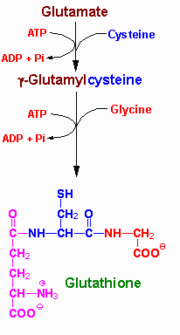
Synthesis of glutathione (GSH) | Structure of GSSG
The role of GSH as a reductant is extremely important particularly in the highly oxidizing environment of the erythrocyte. The sulfhydryl of GSH can be used to reduce peroxides formed during oxygen transport. The resulting oxidized form of GSH consists of two molecules disulfide bonded together (abbreviated GSSG). The enzyme glutathione reductase utilizes NADPH as a cofactor to reduce GSSG back to two moles of GSH. Hence, the pentose phosphate pathway is an extremely important pathway of erythrocytes for the continuing production of the NADPH needed by glutathione reductase. In fact as much as 10% of glucose consumption, by erythrocytes, may be mediated by the pentose phosphate pathway.
Several mechanisms exist for the transport of amino acids across cell membranes. Many are symport or antiport mechanisms that couple amino acid transport to sodium transport. The γ-glutamyl cycle is an example of a group transfer mechanism of amino acid transport. Although this mechanism requires more energy input, it is rapid and has a high capacity. The cycle functions primarily in the kidney, particularly renal epithelial cells. The enzyme γ-glutamyl transpeptidase is located in the cell membrane and shuttles GSH to the cell surface to interact with an amino acid. Reaction with an amino acid liberates cysteinylglycine and generates a γ-glutamyl-amino acid which is transported into the cell and hydrolyzed to release the amino acid. Glutamate is released as 5-oxoproline and the cysteinylglycine is cleaved to its component amino acids. Regeneration of GSH requires an ATP-dependent conversion of 5-oxoproline to glutamate and then the 2 additional moles of ATP that are required during the normal generation of GSH.
Nitric Oxide Synthesis and Function
Vasodilators, such as acetylcholine, do not exert their effects upon the vascular smooth muscle cell in the absence of the overlying endothelium. When acetylcholine binds its receptor on the surface of endothelial cells, a signal cascade, coupled to the activation phospholipase C-γ (PLCγ), is initiated. The PLCγ-mediated release of inositol trisphosphate, IP₃ (from membrane associated phosphatidylinositol-4,5-bisphosphate, PIP₂), leads to the release of intracellular stores of Ca²⁺. In turn, the elevation in Ca²⁺ leads to the liberation of endothelium-derived relaxing factor (EDRF) which then diffuses into the adjacent smooth muscle. Within smooth muscle cells, EDRF reacts with the heme moiety of a soluble guanylyl cyclase, resulting in activation of the latter and a consequent elevation of intracellular levels of cGMP. The net effect is the activation of cGMP-responsive enzymes which lead to smooth muscle cell relaxation. The coronary artery vasodilator, nitroglycerin, acts to increase intracellular release of EDRF and thus of cGMP.
Quite unexpectedly, EDRF was found to be the free radical diatomic gas, nitric oxide, NO. NO is formed by the action of NO synthase, (NOS) on the amino acid arginine.
arginine -----> citrulline + NO
Nitric oxide is involved in a number of other important cellular processes in addition to its impact on vascular smooth muscle cells. Events initiated by NO that are important for blood coagulation include inhibition of platelet aggregation and adhesion and inhibition of neutrophil adhesion to platelets and to the vascular endothelium. NO is also generated by cells of the immune system and as such is involved in non-specific host defense mechanisms and macrophage-mediated killing. NO also inhibits the proliferation of tumor cells and microorganisms. Additional cellular responses to NO include induction of apoptosis (programmed cell death), DNA breakage and mutation.
NOS is a very complex enzyme, employing five redox cofactors: NADPH, FAD, FMN, heme and tetrahydrobiopterin. NO can also be formed from nitrite, derived from vasodilators such as glycerin trinitrate during their metabolism. The half-life of NO is extremely short, lasting only 2-4 seconds. This is because it is a highly reactive free radical and interacts with oxygen and superoxide. NO is inhibited by hemoglobin and other heme proteins which bind it tightly.
Chemical inhibitors of NOS are available and can markedly decrease production of NO. The effect is a dramatic increase in blood pressure due to vasoconstriction. Another important cardiovascular effect of NO is exerted through the production of cGMP, which acts to inhibit platelet aggregation.

Tryptophan-Derived Neurotransmitters
Tryptopan serves as the precursor for the synthesis of serotonin (5-hydroxytryptamine, 5-HT, see also Biochemistry of Nerve Transmission) and melatonin (N-acetyl-5-methoxytryptamine).
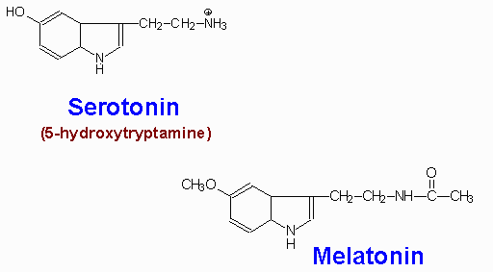
Serotonin is synthesized through 2-step process involving a tetrahydrobiopterin-dependent hydroxylation reaction (catalyzed by tryptophan-5-monooxygenase) and then a decarboxylation catalyzed by aromatic L-amino acid decarboxylase. The hydroxylase is normally not saturated and as a result, an increased uptake of tryptophan in the diet will lead to increased brain serotonin content.
Serotonin is present at highest concentrations in platelets and in the gastrointestinal tract. Lesser amounts are found in the brain and the retina. Serotonin containing neurons have their cell bodies in the midline raphe nuclei of the brain stem and project to portions of the hypothalamus, the limbic system, the neocortex and the spinal cord. After release from serotonergic neurons, most of the released serotonin is recaptured by an active reuptake mechanism. The function of the antidepressant, Prozac is to inhibit this reuptake process, thereby, resulting in prolonged serotonin presence in the synaptic cleft.
The function of serotonin is exerted upon its interaction with specific receptors. Several serotonin receptors have been cloned and are identified as 5HT₁, 5HT₂, 5HT₃, 5HT₄, 5HT₅, 5HT₆, and 5HT₇. Within the 5HT₁ group there are subtypes 5HT_{1A}, 5HT_{1B}, 5HT_{1D}, 5HT_{1E}, and 5HT_{1F}. There are three 5HT₂ subtypes, 5HT_{2A}, 5HT_{2B}, and 5HT_{2C} as well as two 5HT₅ subtypes, 5HT_{5a} and 5HT_{5B}. Most of these receptors are coupled to G-proteins that affect the activities of either adenylate cyclase or phospholipase Cγ (PLCγ). The 5HT₃ class of receptors are ion channels.
Some serotonin receptors are presynaptic and others postsynaptic. The 5HT_{2A} receptors mediate platelet aggregation and smooth muscle contraction. The 5HT_{2C} receptors are suspected in control of food intake as mice lacking this gene become obese from increased food intake and are also subject to fatal seizures. The 5HT₃ receptors are present in the gastrointestinal tract and are related to vomiting. Also present in the gastrointestinal tract are 5HT₄ receptors where they function in secretion and peristalsis. The 5HT₆ and 5HT₇ receptors are distributed throughout the limbic system of the brain and the 5HT₆ receptors have high affinity for antidepressant drugs.
Melatonin is derived from serotonin within the pineal gland and the retina, where the necessary N-acetyltransferase enzyme is found. The pineal parenchymal cells secrete melatonin into the blood and cerebrospinal fluid. Synthesis and secretion of melatonin increases during the dark period of the day and is maintained at a low level during daylight hours. This diurnal variation in melatonin synthesis is brought about by norepinephrine secreted by the postganglionic sympathetic nerves that innervate the pineal gland. The effects of norepinephrine are exerted through interaction with β-adrenergic receptors. This leads to increased levels of cAMP, which in turn activate the N-acetyltransferase required for melatonin synthesis. Melatonin functions by inhibiting the synthesis and secretion of other neurotransmitters such as dopamine and GABA

Tyrosine-Derived Neurotransmitters
The majority of tyrosine that does not get incorporated into proteins is catabolized for energy production. One other significant fate of tyrosine is conversion to the catecholamines. The catecholamine neurotransmitters are dopamine, norepinephrine, and epinephrine (see also Biochemistry of Nerve Transmission).
Norepinephrine is the principal neurotransmitter of sympathetic postganglionic endings. Both norepinephrine and the methylated derivative, epinephrine are stored in synaptic knobs of neurons that secrete it, however, epinephrine is not a mediator at postganglionic sympathetic endings.
Tyrosine is transported into catecholamine-secreting neurons and adrenal medullary cells where catechaolamine synthesis takes place. The first step in the process requires tyrosine hydroxylase, which like phenylalanine hydroxylase requires tetrahydrobiopterin as cofactor. The hydroxylation reaction generates DOPA (3,4-dihydrophenylalanine). DOPA decarboxylase converts DOPA to dopamine, dopamine β-hydroxylase converts dopamine to norepinephrine and phenylethanolamine N-methyltransferase converts norepinephrine to epinephrine. This latter reaction is one of several in the body that uses SAM as a methyl donor generating S-adenosylhomocysteine. Within the substantia nigra and some other regions of the brain, synthesis proceeds only to dopamine. Within the adrenal medulla dopamine is converted to norepinephrine and epinephrine.
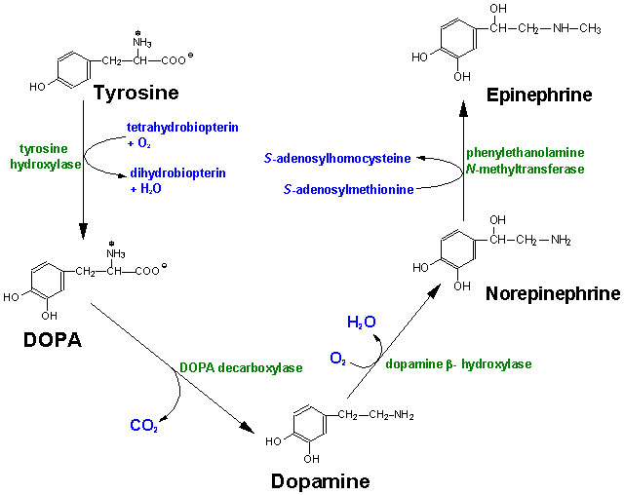
Synthesis of the catecholamines from tyrosine.
Once synthesized, dopamine, norepinephrine and epinephrine are packaged in granulated vesicles. Within these vesicles, norepinephrine and epinephrine are bound to ATP and a protein called chromogranin A.
Metabolism of the catecholemines occurs through the actions of catecholamine-O-methyltransferase, (COMT) and monoamine oxidase, (MAO). Both of these enzymes are widley distributed throughout the body. However, COMT is not found in nerve endings as is MAO.

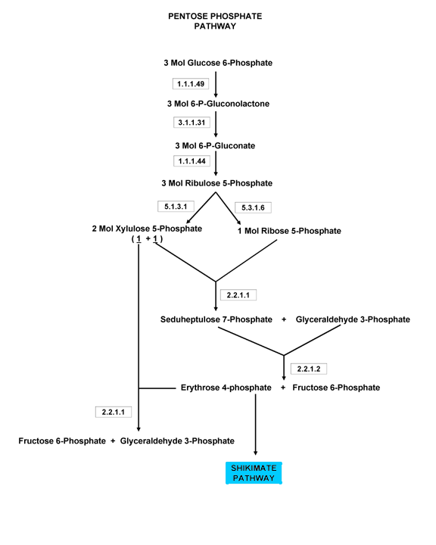

Enzymatic control of metabolic pathways

Regulation of glycolysis
Metabolic flow through glycolysis can be regulated at three key points:
- hexokinase: is inhibited by glucose-6-P (product inhibition)
- phosphofructokinase: is inhibited by ATP and citrate (which signals the abundance of citric acid cycle intermediates). It is also inhibited by H⁺, which becomes important under anaerobiosis (lactic fermentation produces lactic acid, resulting on a lowering of the pH ). Probably this mechanism prevents the cell from using all its ATP stock in the phosphofrutokinase reaction, which would prevent glucose activation by hexokinase. It is stimulated by its substrate (fructose-1,6-bisphosphate), AMP and ADP (which signal the lack of available energy), etc.
- pyruvate kinase: inhibited by ATP and acetyl-CoA

Regulation of gluconeogenesis
Flow is regulated in the gluconeogenesis-specific reactions. Pyruvate carboxilase is activated by acetyl-CoA, which signals the abundance of citric acid cycle intermediates, i.e., a decreased need of glucose.

Regulation of the citric acid cycle
The citric acid cycle is regulated mostly by substrate availability, product inhibition and by some cycle intermediates.
- pyruvate dehydrogenase: is inhibited by its products, acetyl-CoA and NADH
- citrate synthase: is inhibited by its product, citrate. It is also inhibited by NADH and succinyl-CoA (which signal the abundance of citric acid cycle intermediates).
- isocitrate dehydrogenase and α-ketoglutarate dehydrogenase: like citrate synthase, these are inhibited by NADH and succinyl-CoA. Isocitrate dehydrogenase is also inhibited by ATP and stimulated by ADP. All aforementioned dehydrogenases are stimulated by Ca²⁺. This makes sense in the muscle, since Ca²⁺ release from the sarcoplasmic reticulum triggers muscle contraction, which requires a lot of energy. This way, the same "second messenger" activates an energy-demanding task and the means to produce that energy.

Regulation of the urea cycle
Carbamoyl-phosphate sinthetase is stimulated by N-acetylglutamine, which signals the presence of high amounts of nitrogen in the body.

Regulation of glycogen metabolism
Liver contains a hexokinase (hexokinase D or glucokinase)with low affinity for glucose which (unlike "regular" hexokinase) is not subject to product inhibition. Therefore, glucose is only phosphrylated in the liver when it is present in very high concentrations (i.e. after a meal). In this way, the liver will not compete with other tissues for glucose when this sugar is scarce, but will accumulate high levels of glucose for glycogen synthesis right after a meal.

Regulation of fatty acids metabolism
Acyl-CoA movement into the mitochondrion is a crucial factor in regulation. Malonyl-CoA (which is present in the cytoplasm in high amounts when metabolic fuels are abundant) inhibits carnitine acyltransferase, thereby preventing acyl-CoA from entering the mitochondrion. Furthermore, 3-hydroxyacyl-CoA dehydrogenase is inhibited by NADH and thiolase is inhibited by acetyl-CoA, so that fatty acids wil not be oxidized when there are plenty of energy-yielding substrates in the cell.

Regulation of the pentose phosphate pathway
Metabolic flow through the pentose phosphate pathway is controled by the activity of glucose-6-phosphate dehydrogenase, which is controlled by NADP⁺ availability.

One form of chemical energy used to drive biosynthetic reactions forward is the reducing power of the energy carrier NADPH. NADPH is essential to drive the biosynthesis of fatty acids and cholesterol for example. While NADPH is an important energy carrier and is closely related to the high-energy electron carrier NADH, NADPH is distinct from NADH in several ways. NADH in oxidative phosphorylation in mitochondria transports chemical energy from the Kreb's cycle to the electron transport chain, but NADPH does not play this role. The cell keeps its pools of NADH and NADPH isolated biochemically, through the specificity of the enzymes that use and generate these cofactors. Enzymes that metabolize NADH and NADPH are highly specific for one cofactor or the other and are in different pathways. While NADH is produced in mitochondria by the Kreb's cycle, NADPH is produced through a pathway called the pentose phosphate pathway. Since one of the main purposes of this pathway is to produce NADPH for biosynthesis, this pathway occurs most predominantly in tissues like liver, fat cells, or adrenal glands that are involved in fatty acid and cholesterol biosynthesis. This pathway starts with glucose-6-phosphate, the first committed step in glycolysis, and can provide an alternative route to glycolysis for energy production. The first portion of the pentose phosphate pathway involves the oxidation of glucose in three steps, with the concomitant production of NADPH.
The first step in the pentose phosphate pathway is catalyzed by glucose-6-phosphate dehydrogenase. In normal red blood cells, the NADPH produced by glucose-6-phosphate dehydrogenase is used to regenerate glutathione and protect cell membranes.
Genetic deficiency in the activity of this enzyme is very common in some populations, and can result in anemias caused by fragile red blood cells. In the second and third steps, further oxidation makes more NADPH and releases carbon dioxide, shortening the sugar from six carbons to five (D-ribulose 5-phosphate).
After isomerization, D-ribose 5-phosphate is produced and provides the starting point for a series of reactions that converts the 5-carbon ribose into 6-carbon fructose-6-phosphate and 3-carbon glyceraldehyde-3-phosphate. Ribose is also used to make nucleotides for RNA and DNA.
