CULTIVATING THE ENERGY
For increasing or maintaining our health and vitality it is advisable to work directly with our life-force, cultivating it as the Chinese masters say. There are two main aspects to this energy cultivation. First we learn to accumulate bio-energy or prana and then we practice circulating it through our body. Our main energy intake and distribution system is the chakra system. Chakras are comparable to major power stations while the acupuncture meridians may be seen as the main power transmission lines.
THE CHAKRA SYSTEM |  | Fig. 2: The Main Chakras
Chakras are vortex-like energy centers. Commonly seven major chakras are mentioned, six of which are rooted in the spine and one at the top of the head. We receive our main intake of chakra energies through the crown chakra from where it flows from one chakra to the other, being modified, used and condensed until it reaches the sacral chakra. From there it flows up the spine to supply energy to the acupuncture meridians which, in turn, nourish the internal organs and muscles.  A health problem in a certain area of the body is usually associated with a disturbed function of the chakra governing this region. Normalizing and harmonizing our chakra functions is important for the healing of specific aspects as well as for increasing our available energy in general and for becoming whole and balanced.  Functioning like a prism, the chakra system separates the incoming white etheric light into the seven etheric rainbow colors. Each color is of special importance for the glands and organs situated near the corresponding chakra. During meditation and relaxation exercises you may visualize these glands and organs bathed in their designated chakra colors. | 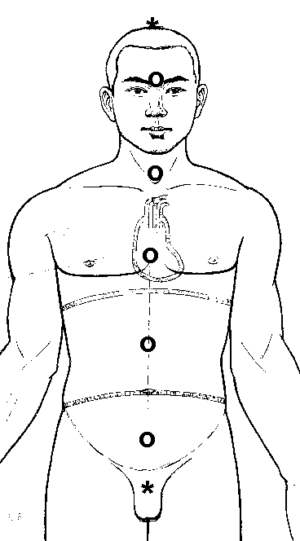  Crown  Anja  Throat  Heart  Solar plexus  Pubic  Root / Base

The characteristics of the seven main chakras can be seen from the following table. In addition, there are many more secondary chakras, important are especially the spleen chakra, one over the thymus gland and for energy transfer also those in the palms of the hands. Furthermore, each of the higher or finer energy bodies, such as the emotional or astral and the mental body have their own chakra system with different colors and other characteristics.
The corresponding chakras in the different bodies are interconnected. The more we spiritually develop, the greater becomes the exchange of energy between the different bodies, generally the energy flowing from the finer to the denser bodies. An excellent set of books on energy healing, energy bodies and the chakra systems are Hands of Light and Light Emerging by Barbara Ann Brennan (Bantam).
The Main Chakras or Energy Centers
Location & Name | Sanscrit Name | Associated Gland | Etheric Color | Spinal Location | Psychological & Energy Aspect
Root/Base | Muladhara | Adrenals | Red | Sacral 4 | Will to live, vitality, grounding
Pubic | Swadistana | Gonads | Orange | Lumbar 1 | Sexual energy, physical creativity
Solar Plexus | Manipura | Pancreas | Gold-yellow | Dorsal 8 | Emotional energy, feeling safe, protected
Heart | Anahata | Thymus | Green | Dorsal 1 | Spiritual feelings: love, compassion
Throat | Vishudda | Thyroid | Blue | Cervical3 | Communication, creating with words and sounds
Forehead or brow | Ajna | Pituitary | Indigo | Cervical 1 | Higher mentality & creativity, intuition, visualization
Crown | Sahasrara | Pineal | violet/white | none | Spirituality, connection to Higher Self and Divinity

You may experiment with two complementary methods of increasing your energy store. In one you imagine energy entering through the crown chakra while in the other you imagine that you retain the prana that you inhale with the air. With some practice you may even combine both exercises and do them at the same time. The main rule in all of this is that energy flow follows our awareness and intentions.

