HOW TO SURVIVE A HEART ATTACK ALONe;
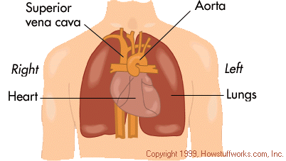
(from Rochester General Hospital)

If everyone who gets this sends it to 10 people, you can bet that we'll save at least one life.
The Scene:
Let's say it's 6:15 p.m. and you're driving home (alone of course), after an unusually hard day on the job. You're really tired, upset and frustrated. Suddenly, you start experiencing severe pain in your chest that starts to radiate out into your arm and up into your jaw.

Time is a premium:g
You are only about five miles from the hospital nearest your home; unfortunately you don't know if you'll be
able to make it that far. What can you do? You've been trained in CPR but the guy that taught the course
neglected to tell you how to perform it on yourself. Since many people are alone when they suffer a heart
attack, this article seemed to be in order.

Cough:
Without help, the person whose heart stops beating properly and who begins to feel faint, has only about
10 seconds left before losing consciousness. However, these victims can help themselves by coughing
repeatedly and very vigorously. A deep breath should be taken before each cough. The cough must be deep and
prolonged, as when producing sputum from deep inside the chest. And a cough must be repeated about every 2
seconds without let up until help arrives, or until the heart is felt to be beating normally again.

Oxygen:
Deep breaths get oxygen into the lungs and coughing movements squeeze the heart and keep the blood circulating. The squeezing pressure on the heart also helps it regain normal rhythm. In this way, heart attack victims can get to a hospital. Tell as many other people as possible about this, it could save their lives!

BE A FRIEND AND PLEASE SEND THIS ARTICLE TO AS MANY FRIENDS AS POSSIBLE.

