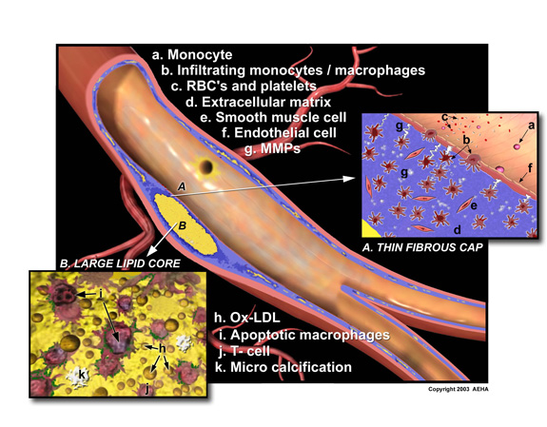
Myocardial fibrosis:

An exaggerated accumulation of fibrillar collagens type I and type III occurs throughout the free wall
and interventricular septum of animals and humans with arterial hypertension

. A rise in collagen content has been shown to raise myocardial stiffness and promote abnormalities of cardiac function that predispose to heart failure

. A number of previous experimental findings suggest that direct fibroblast stimulation by angiotensin II may be involved in myocardial fibrosis associated with arterial hypertension

Since myocardial cells cannot regenerate, necrotic myocardium is replaced by fibrous tissue. Fibrosis is, therefore, non-specific. Most commonly it is a result of ischemia, but may also result from myocarditis and cardiomyopathy.

The aim of the present study was to determine whether NO deficiency itself or rather the elevation of systolic blood pressure is responsible for the protein and structural remodeling of the heart during hypertension induced by long-term treatment by nitric oxide synthase inhibitor N^{G}-nitro-L-arginine methyl ester (L-NAME).
NO deficiency rather than hemodynamic changes appears to be crucially involved in collagenous protein and fibrotic tissue changes of the left ventricle in hypertension induced by L-NAME.

an MI, or myocardial infarction, describes a situation where the heart muscle is irreversibly damaged due to lack of sufficient blood (and thus oxygen) supply. Angina is a common symptom that is often perceived during episodes of insufficient blood supply to the heart muscle. However, a patient can experience many brief bouts of angina without suffering an MI. Basically, it takes prolonged angina to deprive the heart muscle of oxygen for a sufficient time to cause the irreversible injury.

Project 4: Role of Cytokines in Extracellular Matrix Modeling.
Abstract: Congestive heart failure is a disease of epidemic proportions with 4.6 million patients in the U.S. and in nearly half of these patients the etiology of their disease is unknown. It is generally viewed as a progressive disease in which initial myocardial damage is followed by cardiac remodeling and progressive dilation of the left ventricle. Cardiac compensation is followed by progressive de-compensation and patients present with worsening symptoms including fatigue, shortness of breath, and edema. Recent investigation has focused on the role of the proinflammatory cytokine TNF-alpha in the development of heart failure and in particular in the transition from compensated to decompensated heart failure. Although TNF-alpha can modulate the function of a group of potentially important cardiac proteins, recent evidence suggests that TNF-alpha modulates the expression of the two families of proteins that regulate the homeostatic balance within the extracellular matrix, the matrix metalloproteinases (MMPs) and the tissue inhibitors of metalloproteinases (TIMPs). Furthermore, transgenic mice harboring cardiac restricted overexpression of TNF-alpha develop matrix remodeling, progressive fibrosis, and collagen denaturation that are associated with up-regulation of MMP activity. Anti-TNF-alpha therapy using adenovirus-mediated gene therapy significantly inhibited MMP activity, prevented myocardial fibrosis and collagen denaturation. These preliminary studies led us to hypothesize that the development of end-stage heart failure is due in large part to cytokine-induced matrix remodeling and fibrosis, and that the development of fibrosis marks the irreversibility of the disease.

New Advances in Heart Failure Therapy: Potential for Fibrosis Regression
Jerusalem - In the first study of its kind, investigators here this week showed that fibrosis in the myocardium was significantly reduced following nine months of therapy with the angiotensin-converting enzyme (ACE) inhibitor, ramipril. Interstitial fibrosis is known to be a major mechanism associated with worsening heart failure. Some researchers also now feel that it is the antifibrotic and not the hemodynamic properties of an ACE inhibitor which protect patients best from deterioration of the myocardium and progressive heart failure. The antifibrotic properties of ramipril were theorized to be due to the intracellular penetration of ramipril and its effect on preventing bradykinin breakdown. The potentiation of bradykinin results in increased levels of nitric oxide (NO) resulting in cellular protection. A new way of measuring fractional volume collagen content noninvasively will give clinicians a chance to monitor the degree of fibrosis in heart failure patients without the need for myocardial biopsy.

The first suggestion that interstitial fibrosis may be reversed by treatment with an ACE inhibitor gives further hope that deterioration into worsening heart failure due to fibrosis may not be inevitable. "The major mechanisms behind progression of chronic heart failure are thought to be myocardial hypertrophy and interstitial fibrosis, triggered primarily by angiotensin II and other growth factors," said principal investigator, Dr. Kurt Schmailzl from the Ruppiner Clinic in Neuruppin, Germany, here this week.

"In my view, the chronification of heart failure is based upon ongoing fibrosis and it is this interstitial fibrosis that we have to stop or even more, to reverse, in order to prevent worsening heart failure," concluded Dr. Schmailzl.

Ischemic coronary disease is the leading cause of morbidity and mortality in the Western world. Most available therapeutic approaches aim either at relieving symptoms by reducing myocardial oxygen demand, preventing further disease progression by modifying risk factors, restoring flow to a localized segment of the arterial tree (angioplasty or bypass surgery
Acute Myocardial infarction (heart attack MI) results from occlusion of one of the coronary arteries of the heart by thrombus (blood clot) often superimposed on a ruptured plaque (atherosclerosis, blockage). It often starts with uncomfortable pressure, fullness, squeezing or pain in the center of the chest lasting more than a few minutes; Pain may spread to the shoulders, neck or arms. Chest discomfort may be associated with lightheadedness, fainting, sweating, nausea or shortness of breath, unexplained anxiety, weakness or fatigue, Palpitations, cold sweat or paleness). Immediate Medical Attention and prompt treatment with Aspirin, blood thinners, and either a clot busting (dissolving medicine) such as tPA, rPA, streptokinase, or immediate cardiac catheterization with primary angioplasty of the occluded artery to abort the heart attack. When available promptly (such as BIDMC), primary angioplasty improves the outcome of patients with heart attacks. Other medications used are beta blockers, nitroglycerine, and ACEinhibitors, and platelet inhibitors. Prompt treatment is essential to minimize the extent of damage to the heart.
Progressive systemic sclerosis (scleroderma) is a generalized disorder of connective tissue with thickening and fibrosis of the skin (scleroderma) as well as some involvement of heart, lungs, kidney and gastro- intestinal tract. Cardiac involvement has been recognized long before the advent of echocardio- graphy. (2-8) In the heart, any combination of vascular obliteration, fibrosis and inflammation may be present. (9-22) This patient had an extreme degree of left ventricular scarring with severe systolic dysfunction.
Scarring in the form of patchy myocardial fibrosis is present in as many as 81% of these patients. (23) Intermittent ischemia is presumed to be the cause since the histopathologic findings in scleroderma show evidence of myocardial contraction band necrosis. Contraction band necrosis is the pathologic hallmark of transient myocardial ischemia followed by reperfusion.

