Atherosclerosis:
Background—Coronary atherosclerotic disease remains the leading cause of death in the Western world. Although the exact sequence of events in this process is controversial, reactive oxygen and nitrogen species (RS) likely play an important role in vascular cell dysfunction and atherogenesis. Oxidative damage to the mitochondrial genome with resultant mitochondrial dysfunction is an important consequence of increased intracellular RS.

Conclusions—Mitochondrial DNA damage may result from RS production in vascular tissues and may in turn be an early event in the initiation of atherosclerotic lesions.

Composition and methods for the prevention and treatment of hypercholesterolmia, hyperlipidemia and atherosclerosis are described. Individual at a high risk of developing or having hypercholesterolmia and atherosclerosis undergoing conventional therapies may be treated with an effective dose of triperpene derivatives in limonoids, polyphenolic flavonoid compounds, tocotrienols or a combination of these agents.

**Myocardial infarction, known commonly as a heart attack, is a major cause of death, disability and healthcare expense in the U.S. and other industrialized societies. In most cases, its underlying cause is the development and rupture of soft atherosclerotic (vulnerable) plaques in the coronary arteries. While the build up of hard plaque may produce severe obstruction in the coronary arteries and cause angina, new clinical data demonstrate that the rupture of non-occlusive, vulnerable plaques causes the vast majority of heart attacks.
The 2002 Heart and Stroke Statistical Update, published by the American Heart Association, states that an estimated 1,100,000 Americans will have a new or recurrent heart attack (defined as a myocardial infarction). About 650,000 of these will be first attacks and 450,000 will be recurrent attacks. Over 45% of the people who experience a heart attack in a given year will die from it.

Atherosclerosis is the result of arterial narrowing (arteriosclerosis) as a result of atheroma, a porridge-like thickening of the arterial wall by a fatty deposit. The narrowing caused by atherosclerosis (stenosis) can result in the reduction of blood supply and oxygen to organs (ischemia). In addition these plaques alter the lining of arteries, which means they may act as a focus for blood clots that block off blood vessels (thrombosis and thromboembolism). The clinical manifestations of these phenomena include heart attacks (myocardial infarctions or MIs), sudden cardiac death, unstable angina, ischemic stroke and peripheral arterial disease (PAD).
It is thought that the process of atherosclerosis is initiated when lipoproteins accumulate in certain regions of arteries that are predisposed to such changes. These lipoproteins are trapped in the wall of the coronary artery and are subject to changes that result in these modified molecules being internalized by cells of the immune system called macrophages. As the lesion continues to collect lipid, it forms a lipid core, disrupting the cellular architecture of the intima and grossly thickening the arterial wall, although the lumen of the artery may still not be narrowed.
Treatment and five-year follow-ups for each heart attack survivor costs an estimated $50,000 in the US.
Recent research indicates that certain kinds of "vulnerable plaque," may trigger acute coronary events, creating demand for new diagnostic tools and therapeutics.
Traditional scientific wisdom holds that heart attacks originate from severe blockages created by atherosclerosis, the progressive build-up of plaque in the coronary arteries. The increase of lipids in the artery and ensuing tissue reaction lead to narrowing of the affected vessel, which, in turn, can result in angina and eventually coronary occlusion, sudden cardiac death, and thrombotic stroke. But research conducted in the past decade is leading to a shift in understanding of atherosclerosis. Scientists theorize that at least some coronary disease is an inflammatory process, in which inflammation causes plaque to rupture. These so-called "vulnerable plaques" don't block the arteries. Rather, much like an abscess, they are ingrained under the arterial wall, so that they are undetectable-they can't be seen by conventional angiography or fluoroscopy and they don't cause symptoms such as shortness of breath or pain. Yet, for a variety of reasons, they are more likely to erode or rupture, creating a raw tissue surface that forms scabs. Thus, they are more dangerous than other plaques that cause pain-and may be responsible for as much as 60-80% of all heart attacks.
Driving the interest is a problem with current therapies: balloon angioplasty and stenting improve quality of life but don't prolong it or ultimately prevent heart attacks. This disappointment has led some to think about new ways of dealing with in-stent restenosis, while it has led others to explore why plaque builds up in the first place. The result is an explosion of research on the role of inflammation in heart disease and the identification and characterization of plaques to predict which are the most thromobogenic and most likely to rupture.
Researchers are now finding that many people who have heart attacks do not have arteries severely narrowed by plaque. In fact, vulnerable plaque may be buried inside the artery wall and may not always bulge out and block the blood flow through the artery. That is when researchers began to look at how inflammation affects the arteries—and if inflammation could lead to a heart attack. What they found was that inflammation leads to the development of "soft" or vulnerable plaque. They also found that vulnerable plaque was more than just debris that clogs an artery, but that it was filled with different cell types that help with blood clotting.
What causes vulnerable plaque?
Researchers now think that vulnerable plaque is formed in the following way.
- Fat droplets are absorbed by the artery, which causes the release of proteins (called cytokines) that lead to inflammation.
- The cytokines make the artery wall sticky, which attracts immune-system cells (called monocytes).
- The monocytes squeeze into the artery wall. Once inside, they turn into cells called macrophages and begin to soak up fat droplets.
- The fat-filled cells form a plaque with a thin covering.
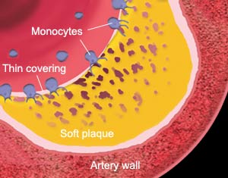
Inflammation can predispose the thin covering over the plaque to crack and bleed, spilling the contents of the artery into the bloodstream. The sticky cytokines on the artery wall capture blood cells (mainly platelets) that rush to the site of injury. When these cells clump together, they can form a clot large enough to block the artery.
Cardiologists have found that by measuring the level of a substance called C-reactive protein in the bloodstream, they can predict a person's risk of heart attack or stroke. C-reactive protein is a marker that doctors use to measure inflammation activity in the body. Two large studies showed that the higher the C-reactive protein levels in the blood, the greater the risk of a heart attack.
Coronary artery disease (CAD) is the most common form of heart disease. CAD and its complications, like arrhythmia, angina pectoris, and heart attack, are the leading causes of death in the United States. CAD most often results from a condition known as atherosclerosis, which happens when a waxy substance forms inside the arteries that supply blood to your heart. This substance, called plaque, is made of cholesterol, fatty compounds, calcium, and a blood-clotting material called fibrin. Doctors have found that there are 2 kinds of plaque: hard and soft.
If enough hard plaque builds up in an artery that supplies blood to your heart, the blood flow slows or stops. This lack of oxygen-rich blood increases your risk of heart attack. Sometimes, the narrowed artery is blocked by a blood clot that travels from another part of the body, causing a heart attack. Blood clots may also form at the site of soft or vulnerable plaque, which can rupture and cause a heart attack.
Heart attacks may be caused by
- A fatty buildup called plaque, which severely narrows or blocks a coronary artery. The blockage shuts off all blood flow to the section of heart muscle fed by the artery.
- A blood clot, which blocks an artery already narrowed by plaque. The blood clot may come from another part of the body, carried by blood flow through the narrowed artery. The blockage shuts off all blood flow to the section of heart muscle fed by the artery.
- A clot that forms at the site of "soft" plaque on the inside of the artery, because the plaque can crack and bleed. This plaque, which has a thin covering over it, is called vulnerable plaque. When vulnerable plaque ruptures, it can cause a blood clot to form. The clot can block the blood flow to the section of heart muscle fed by the artery
- A condition called coronary artery spasm, which means a coronary artery goes into spasm and the artery narrows. Because of this narrowing, less or no blood can reach parts of the heart muscle. Doctors do not know what causes coronary artery spasm, but it can happen in arteries with or without signs of plaque buildup.
Pathogenesis of Atherosclerosis
At one time, researchers believed that atherosclerotic plaque development in the coronary artery progressed over time, gradually causing symptoms and eventual CHD event. More recent studies have resulted in an improved understanding of the pathogenesis of the progression from atherosclerosis to CHD, and a shift toward the study of stable versus vulnerable plaque development. In the Framingham trial, as many as 50% of persons with CVD presented with MI or sudden death as their first “symptom.” Furthermore, in studies conducted throughout the 1980s and 1990s, many persons who presented with CHD symptoms had “normal” angiograms, and yet, experienced an acute CHD event with complete occlusion 3 to 6 months later. “These cases did not fit the profile of a gradual stenosis of the coronary artery, but implied a more sudden change from a small lesion to a moderate or large lesion or complete occlusion, perhaps in a single step,” said Dr. Ginsberg.
Further study has shown that the progression from atherosclerosis to CHD occurs when the artery wall is filled with lipids, followed by circulating cells, monocytes, and then T cells. The entire artery expands to accommodate this insult, even in the presence of smooth muscle proliferation, resulting in maintenance of the lumen at relatively normal size. “As part of this process, the lumen can progress rapidly from appearing apparently normal or minimally stenosed to being completely occluded and having an acute CHD event, after atherosclerotic plaque rupture and subsequent thrombosis,” Dr. Ginsberg explained. Indeed, a cross-section of a coronary artery via angiogram can appear apparently normal, while intravascular ultrasound shows significant atherosclerotic plaque and outward compensation by the vessel wall
Selected Articles | by Garry F. Gordon, M.D.,D.O.,M.D.(H)

Vulnerable plaque has come under scrutiny only very recently. It has not been noticed during traditional cardiovascular diagnostic testing because it builds up within the wall of the artery itself, extending outwards very little. It is made up primarily of soft cholesterol rather than the more crystalline form of obstructing plaque. This is contained by a fibrous cap that is thinner and weaker than obstructing plaque and so is much more easily ruptured. Further, the body tends to respond to vulnerable plaque as an infection. It sends defensive blood cells to the spots that attack and inflame the cap. This tendency to breakage is what gives vulnerable plaque its name. The interior of the plaque contains powerful coagulants that if released into the blood can create massive, lethal clots. This is what makes it so deadly.
blood clot (thrombus) completely blocking a small pulmonary artery in a human lung. The visible meshwork that forms the basis of this clot is made of fibrin. Fibrin is produced by the action of the enzyme thrombin on soluble fibrinogen (a protein) in the blood. Fibrinogen levels and clotting activities can be reduced using natural substances such as Vitamin E, garlic, gingko biloba, red algae, enzymes and EPA (an omega-3 essential fatty acid). This astonishing new breakthrough in cardiac research explains why there has never been a significant reduction in heart attacks or deaths in surgical patients. It also lends itself to a kinder, non-invasive, supplement-based protocol that can give men and women immediate protection against heart attacks and strokes.

Infections, Inflammation, Metabolism

The infection aspect of heart disease has been given added validation by means of a recent report published in JAMA showing that up to 55% of heart attacks appear to be prevented by treatment with proper antibiotics. In addition, evidence published in Science, February 1999, implicates an infectious bacteria known as Chlamydia. Ninety-five percent of us are exposed to Chlamydia during our lives. Cytomegalovirus (CMV) and Herpes (common retroviruses) have also been shown to be closely connected with heart attacks.
We do not have to wait for new blood-thinning drugs from the pharmaceutical companies. There are documented blood-thinning, anti-clotting, anti-platelet activities from substances like Vitamin E, garlic, gingko biloba, salmon oil (EPA) and red algae.
Garlic possesses the ability to reduce the tendency for unnecessary clotting to occur within the blood vessels. It appears to work on the 'stickiness' of blood platelets, reducing aggregation and inhibiting the release of clotting factors in the blood. This is thought to be a property of allicin, an unique thiosulfinate in Garlic, well known for its strong antibiotic and antifungal properties. An exciting new finding is that Garlic can work selectively, inhibiting the synthesis of enzymes involved in plaque formation whilst sparing the vascular synthesis of important prostaglandin's. This would make it a safe& effective anti-thrombotic agent. Following studies on the effect of raw Garlic on normal blood cholesterol level in men, the research scientists advocated its daily use in order to lower one's blood cholesterol. Traditional use of both Garlic and Onion in the treatment of hypertension are being supported by research. It was recently found that Onion oil contains a blood pressure lowering prostaglandin. Interestingly, the blood pressure normalizing and cholesterol lowering action of Garlic are not lost in cooking, whilst the anti-microbial effects appear to be.
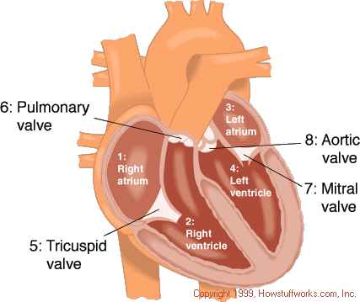
Each chamber has a sort of one-way valve at its exit that prevents blood from flowing backwards. When each chamber contracts the valve at its exit opens. When it is finished contracting the valve closes so that blood does not flow backwards.
- Tricuspid valve- is at the exit of the Right Atrium.
- Pulmonary valve - is at the exit of the Right Ventricle.
- Mitral valve - is at the exit of the Left atrium.
- Aortic valve - is at the exit of the Left Ventricle.
When the heart muscle contracts or beats (called systole) it pumps blood out of the heart. The heart contracts in two stages. In the first stage the Right and Left Atria contract at the same time, pumping blood to the Right and Left Ventricles. Then the Ventricles contract together to propel blood out of the heart. Then the heart muscle relaxes (called diastole) before the next heartbeat. This allows blood to fill up the heart again.
The right and left sides of the heart have separate functions. The right side of the heart collects oxygen-poor blood from the body and pumps it to the lungs where it picks up oxygen and releases carbon dioxide. The left side of the heart then collects oxygen rich blood from the lungs and pumps it to the body so that the cells throughout your body have the oxygen they need to function properly.

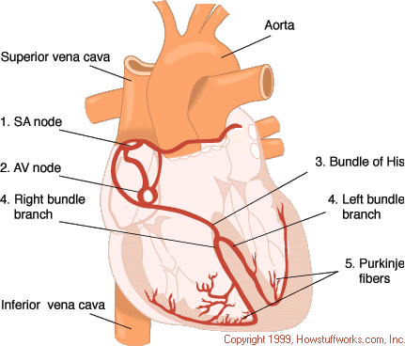
Each part of the tracing has a lettered name:
- P wave - coincides with the spread of electrical activity over the Atria and the beginning of it's contraction.
- QRS complex - coincides with the spread of electrical activity over the ventricles and the beginning of it's contraction.
- T wave - coincides with the recovery phase of the ventricles.
Electrical system abnormalities can range from minor premature beats (skipped beats) that do not require treatment, to slow or irregular beats that require an artificial pacemaker.

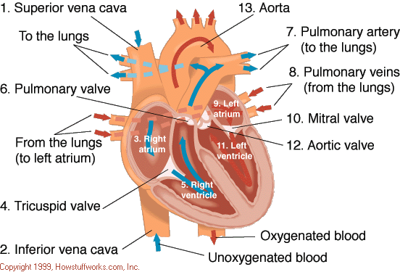

Blood supply
Coronary arteries are the ones that we try to keep clear by eating a healthy diet. If Coronary arteries are blocked a heart attack results.
The heart, just like any other organ, requires blood to supply it with oxygen and other nutrients so that it can do its work. The heart does not extract oxygen and other nutrients from the blood flowing inside it. The heart gets its blood from coronary arteries that eventually carry blood within the heart muscle. Approximately 4-5% of the blood output of the heart goes to the coronary arteries (7 ½ ounces/minute or 225 ml/min).
There are two main coronary arteries (figure 6) - The Left Main Coronary artery (1) and the Right Coronary Artery (2) which arise from the Aorta. The Left Main Coronary Artery divides into the Left Anterior Descending (3) and the Left Circumflex Arteries (4). Each Artery supplies blood to different parts of the heart muscle and the electrical system.
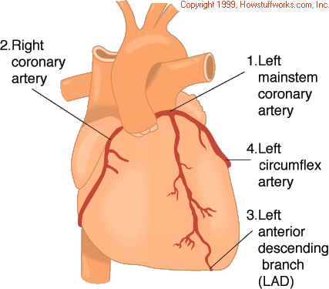
Figure 6
The heart also has veins that collect oxygen poor blood from the heart muscle. Most of the major veins of the heart (great cardiac vein, small cardiac vein, middle cardiac vein, posterior vein of the Left Ventricle, and oblique vein of the Left Atrium) drain into the coronary sinus which opens into the Right Atrium.
Coronary artery disease is caused by a blockage in one of the coronary arteries. When a coronary artery is partially blocked that artery cannot supply enough blood to the heart muscle to meet its needs during exertion. When someone with coronary artery disease exerts himself or herself, it causes chest pain. This is due to lack of blood and oxygen to that part of the heart muscle. This is called angina. If the angina worsens (more frequent angina episodes, with less exertion) a condition called unstable angina exists. A worsening of the obstruction causes this. A heart attack occurs when a coronary artery is completely blocked and no blood or oxygen is getting to the heart muscle served by that artery. This also causes chest pain and causes death to the heart muscle served by that artery.

