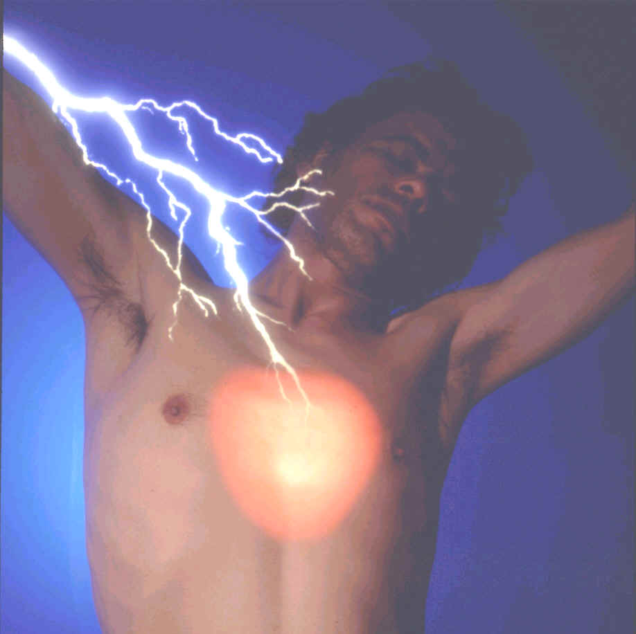
How to Keep From Having a Heart Attack:
Do Less Aerobic Exercise!

That title certainly runs against the grain of everything we've been conditioned (brain washed) to believe in the last 30 years! After 30 years of lowering cholesterol, avoiding salt, taking an aspirin a day and running, what have we got to show for it? Heart disease is still the #1 killer disease in America. Plus, we now have Alzheimer's, electrolyte depletion, renal damage, intestinal hemorrhage, and severely worn joints to show for our efforts! So if all this hasn't worked - what is the real culprit behind heart disease?

Harvard's' Framingham study in 1966 told the world that if you lowered cholesterol to below the then hallowed 244 mark everything would be all right. At the same time, one of their scientists was coming up with a different theory but since Framingham had taken so long to do and cost so much money, that particular Ph.D.'s findings were swept under the rug. In fact, they were so swept under the rug that he was fired for having the tenacity of insisting that he was right. What does a Ph.D. know when all of the learned MD's insisted they knew better? (Without getting into the turf fight between Ph.D.'s and MD's I'll simply say that it's the Ph.D.'s who tell the MD's what they can and can't do and what science really says).

Well guess what? It turns out that the Ph.D. was right after all. (Harvard has even quietly apologized to him but have they apologized to us for leading us down a wild goose chase the last 30 years?) Part of the reason his work was suppressed was that it was not likely to bring about the development of anti this or anti that drugs to combat the things Framingham said were wrong. Financial gain over physiological truth. Financial gain at the cost of peoples lives. Well, that's the way the system works.

OK, enough preaching - so what really causes heart disease and what can you do about it? Lately, medical statistics have admitted a trend.....Healthy, exercising "30 Something's" are having heart attacks. On examination their arteries were clear, no major blockages. Their cholesterol levels were picture perfect - just what the docs want them to be. By gosh these folks even did aerobic exercise several times a week! And still there they were in hospital beds and mortuary slabs; felled by heart disease. The lab work showed one common factor: Inflammation of the blood vessels.

For the last 30 years we've had the notion that it was only arterio sclerosis that blocked up our blood pathways. Those dams in our arteries were visible and removable either by surgery or chelation treatments. But there was an insidious culprit that could block off an artery as completely as the sclerotic plaque then disappear and not be found on examination. Inflammation. When blood vessels swell, the size of the opening that the blood has to flow through decreases. If this decrease is significant enough then whatever tissue that vessel feeds is cut off from life giving blood. If that swelling happened in one of the arteries feeding the muscle of the heart that area dies and we have an MI, Myocardial Infarction or heart attack.

It turns out that this inflammation is easily and cheaply dealt with. That's why the Framingham boys wanted to reject the inflammation study. It would produce no money for the drug companies in the form of patentable medicines. Several things are needed to reduce vascular inflammation:
Vitamin B 12
Folic Acid
Proteolytic Enzymes (Vitalzym)
Decrease in physical stress
Decrease in mental stress.

Also very helpful for heart health is:
Magnesium (the heart beats irregularly without it)
Potassium (the heart beats fast without enough)
CoQ 10
Vitamin E
Selenium

Lets quickly go over what these nutrients can do for you and get them into what the title lured you here for in the first place. Folic acid and B 12 were found to significantly reduce blood vessel swelling. The FDA has been hedging on granting vitamin companies the right to advertise this as it would hurt sales of the "patented" heart medications. Protein eating enzymes are superior ways of reducing inflammation, eating away at the fibrin that forms arterial plaque and reducing c-reactive protein levels (markers for inflammation). The anti oxidant nutrients listed above, Vitamin E, CoEnzyme Q 10, and the mineral Selenium keep the blood slick, the heart regular and prevent degeneration of tissues. Magnesium is super important because it regulates muscular relaxation and must serve as a counter ion to the calcium that causes muscular contraction. Calcium channel blockers drugs keep calcium from getting into magnesium sites of the heart and causing a Contraction - Contraction reaction instead of the usual Contraction - Relaxation reaction. Would it not make more sense to have enough magnesium in the first place so that the proper channels were filled with the proper minerals and the contractions would not go awry? What natural docs have been advocating for 30 years has now caught on. Our old friends at Harvard are now IV fast push injecting 2000 mg of Magnesium into heart patients during periods of irregular beating and guess what? The problem stops! (Don't let the MD's claim to have invented that one, as they have with nearly every natural therapy they have "Integrated" into their system).

Potassium keeps heart beat appropriate to the task; without it folks especially women, have episodes of rapid heart beat. Now stress reduction we've heard before so I won't beat that dead horse again. But heart disease as a result of exercise is a new one most people outside of cardiology or exercise physiology have not heard about.

When runners, especially marathoners, tell me that they are running to attain healthy hearts I sound off that "Jim Fixx is dead"! For those of you who may not be old enough to remember the high guru of the manic compulsiveness known as distance running; Fixx was a god. His leadership inspired millions to take to the roads running. His training recommendations were law and his advice the pronouncements of the running lord most high. Then one day something funny happened to him in the middle of a run - he keeled over and died! Of a heart attack no less!!! Running fanatics world wide were in shock. How could this happen; maybe he had some thing congenitally wrong with his heart; sure that it was something mechanically wrong with his heart from birth. But then other marathoners began to follow, a famous doctor from a renowned running magazine went plotz followed by so many runners that even the MD who popularized the term "Aerobics" and advocated distance running, Ken Cooper took notice.

All of the running aficionados thought more was better. The longer the workout...the healthier the heart. (They were actually making excuses for being compulsive but we won't go there). Dr. Cooper reworked his data, did more tests and low and behold what did he say: "The heart stops conditioning at about 24 minuets" and "anything over 3 miles- 3 times a week is done for reasons other than fitness". Other than fitness! Heresy; the running world was aghast, it could not be so! But so it is. Too much aerobic exercise of any type, causes the blood vessels to inflame from the overstress. This inflammation leads to scaring of the internal portions of the vessels and this scaring is where the fibrin begins to build, onto which accrue the other components of arterio sclerotic plaque. If the inflammation is serious enough in itself, from the exercise and combination of the other factors, then the decrease in the lumen (diameter) of the blood vessel from the swelling can in and of itself cause a heart attack. Let's work out the numbers as concerns aerobic exercise.

The true dean of cardiovascular exercise and father of cardiac stress testing was a Scandinavian exercise physiologist named Karvonen. (There go those uppity Ph.D.'s again)! His definitive work in the 50' and 60's showed that the heart began getting stronger (conditioning) after a mere 7 to 8 minutes worth of work. Cooper's early research also found that 8 minute mark. So we have 8 minutes as the minimum we can do cardio vascular (CV) exercise for and gain a positive training effect on the heart! The idea that we need 16 to 20 minutes plus to attain CV conditioning came from a mis reading of research done by Tom Cureton, Jr. Ph.D. (another giant in exercise science). That research found that the plaque in the arteries began to be worn down and the lipids (fats) therein used as fuel in between 16 to 20 minutes of aerobic work. The research did not mean that the heart did not condition before 12 minutes. But many non-experts in exercise field MD's, personal trainers and television stars with workout videos to sell), understood it to mean just that.
Dr. Coopers follow up research set the ceiling for CV conditioning at 24 to 26 min. After that he said the heart stopped getting an exercise effect from the work. We will add insult to injury here by relating the statistic that after 20+ years of the "aerobics" craze, the couch potatoes are living as long or longer than their marathoning cousins. Heart disease and severely suppressed immune systems are killing the runners.

So; with all of that said and done let's set the parameters for safe and productive aerobic exercise.
Remember we mean to strengthen our hearts, clear our vascular systems and build miles of new blood vessels to lower the blood pressure. We don't mean to reduce manic compulsiveness or other psychological needs by these exercises.

CV work - minimum 8 minutes, top off at 24 minuets. Do CV exercise no more than 3 times a week. Period. Recumbent cycles, semi recumbent cycles, orbital steppers and swimming produce less arthritis causing joint wear than the usual running, stair climbing, ski machines, dance or karate aerobics and rowing. For most, running should be out of the question as it destroys the knees, hips and lower back. Treadmills are actually worse than road running as it only mimics running and is producing a slew of lower back injuries. Think of it; in true running you are propelling yourself across a surface. In treadmill running you are trying to keep form falling on your nose. While the movement looks the same, biomechanically it uses the opposite muscles for different reasons and hence the injuries. Ski machines concentrate work primarily in the flexor muscles of the hip creating a lordotic or "ass backward" duck posture and creating the conditions for injuring the lower back.

When it comes to aerobic exercise less is more and when combined with the nutrients and lifestyle conducive to a healthy heart and a healthy mind then we have a complete package for a healthy life.


Daily recommended Intakes for the nutrients listed:
B 12, 1000 mcg.
Folic Acid 800 mcg.
Vitalzym 3 to 5 tablets 3 times a day in between meals.
Magnesium 1200 to 1600 mg.
Potassium 1000 mg.
CoQ 10 100 mg.
Vitamin E 800 IU.
Selenium 200 to 600 mg.

Many uninformed docs will tell patients that too much magnesium will make their hearts race, this is altogether not true as the new research work has shown. If excessive magnesium were truly dangerous then there would be millions of dead colonoscopy patients! What's one got to do with the other? Docs give colonoscopy patients a gallon of Magnesium Citrate, the most absorbable from of the mineral, equal to almost a half million milligrams of magnesium the day before the procedure! If magnesium were dangerous at high levels than all of those patients would be dead! Enough said.

