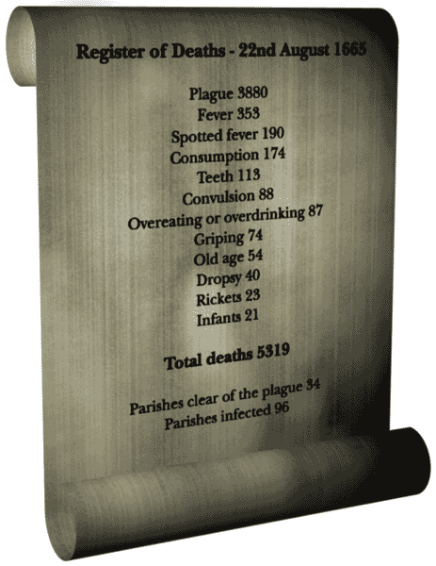
The Great Plague
The Great Plague of London (1664-1666) was an outbreak of bubonic plague that struck London and was particularly violent during the hot months of August and September of 1665. In one week, 7,165 people died of the plague. The total number of deaths was about 70,000. The disease was carried by fleas that lived on black rats. It was generally incurable, and its effects were terrible--fever and chills, swelling of the lymph glands, eventual madness and death.
People had no idea what caused the disease or how to control its rapid course. Victims of the plague were buried in large pits. Many people fled from London.
The Great Plague was an epidemic that devastated London and the south east of England between 1664 and 1666. The poor conditions in towns and cities were a major cause of the disease spreading quickly. The plague of the 1660s did not affect the wealthier areas as badly as the poor parts.
A cross was painted on the doors of those houses affected by the plague. Carts were driven around the empty streets with their drivers shouting 'bring out your dead', carrying the corpses to the burial pits. Those infected were either shut in their own homes with their families or carried to special 'pesthouses' and, once the cemeteries were filled, the dead were buried in mass graves. The epidemic was at its worst in the third week of September 1665 when the death toll was estimated at well over 10,000. A cold autumn reduced the toll to 900 deaths in the final week of November and the crisis had ended by the time the King returned to London on February 1st 1666.

