
Detox Foot Patches
Toxic accumulation can lead to disease
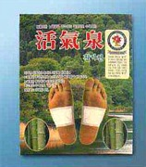
Life-force Detox Foot Patches assist do-it-yourself detoxification. As adults, we have around 400 to 800 man-made chemicals lodged in our bodies. Normal healthy body elimination processes do not remove all these chemicals. Foods, drinks, polluted air, medications, stress, metabolism, disease, products applied to skin, synthetics, home and workplace chemicals contribute to the body’s toxic load which accumulates daily and builds up over the years. For effective natural immunity which has evolved over countless centuries, the body needs to reach a balance between excretion of toxins and absorption of nutrients and water.
Toxins accumulate in the extremities
Eastern medical study, for hundreds of years, has held the view that toxins go downwards in the body during the day with gravity and pile up from the tips of the toes to the ankles. Eastern medicine also understands that toxic accumulation leads to many degenerative diseases. For example, painful rheumatism and arthritis are caused by acidic toxic fluid gathered in the joints. There is another Asian expression that says ageing comes from the foot.
Acupuncture points
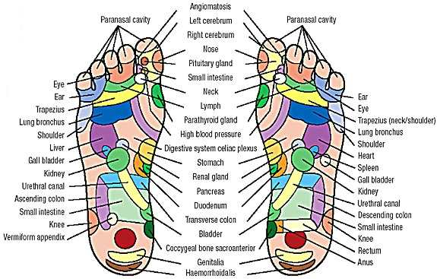

The feet are at the extremities from the heart. The heart has the hardest job of pumping blood carrying toxins back up to itself, the kidneys, lungs, liver and also out through the skin for detoxifying the body. In foot reflexology, the feet are considered a “second heart”, or an abbreviated version of the body, with 62 acupuncture points on the soles relating to the major organs in the body. Accumulated fluids and toxins can cause painful swelling around the ankles with poor blood circulation. Generally, the top third of the foot relates to the organs in the top third of the body, the arch relates to the organs in the centre of the body and the heel to the organs in the lower third of the body. When lying horizontally, the body fluids gather in the head and toes. Toxins that are heavier tend to sink to the lower part of the body when standing during the day and normally, due to gravity, accumulate around the feet. Skin colour of the feet of people with diabetes can be blue, with kidney problems it can be black and with cancer it can be a yellowish colour. Waste removal can assist to reduce fatigue, cold feet and pain, improve blood circulation, wellbeing and help prevent disease by lifting the body’s natural immunity.
An easy, non-invasive way to detox
The all-natural dry ingredients in the Life-force patches adhere like a big Band-Aid to the soles of the feet overnight, when the body detoxifies. Depending on the individual, the detox may be for two or three days to two or three weeks, or longer in the case of more severe disease or toxic build up. The Life-force patches warm up so as to open pores of the skin to draw out and absorb accumulated wastes via the skin under osmotic pressure from the blood and lymph systems. The effect of Life-force patches can usually be seen or felt sooner with more acute diseases, sometimes in a few days. It may however require a longer time to see the effect on less chronic diseases like lethargy and fatigue. Life-force patches can take longer to work on some people, especially if they have been on medication for a long time, but if the patches are still dry after use, they can be re-used. Life-force patches work well when placed on the soles of the feet to enhance blood circulation and improve sleep. They can be used at any time but preferably overnight as you sleep. Socks worn over the foot patches may prevent accidentally kicking them off during sleep.
Potent all-natural ingredients
Life-force patch ingredients include the Agaricus mushroom from the jungles of Brazil. The Agaricus mushroom contains ample amounts of Beta Glucans, the major ingredient in natural cancer controlling substances, a steroid that can regulate the increase of cancer cells. Dry powder in the patches also contains chitosan, bamboo sap, eucalyptus sap from trees over 100 metres, ionic (absorbable) tourmaline minerals that contain negative ions and far infrared rays which resonate with the same long wavelength of water in the body, saururus chenesis which was the first plant to grow at the atomic bomb site in Hiroshima, fermented adjusting starches and other potent plant ingredients. The dried tree saps in Life-force patches have a strong sterilizing power, detoxification, infiltration and absorption qualities. They can assist in treating many health concerns and disease prevention by reducing toxin levels. The original Asian study of the health, longevity and natural disease resistance of mature trees deep in forests with no human assistance led to the formulation of the ingredients for the foot patches. The trees’ ability to purify large amounts of ground water through the roots into high quality water transported into the trunk and leaves, as well as harnessing the absorbing and detoxifying power of the wood sap, made the sap a natural ingredient for human use. Tree and bamboo ingredients are processed with heat and then powdered, adding in other beneficial natural ingredients to make convenient detoxifying patches.

Benefits for other parts of the body
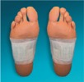
Life-force patches can be attached to other parts of the body and acupuncture points, where there are pains, health issues or swelling to remove toxins from the area, but at the same time they should be applied to the soles of the feet as well for maximum detoxification. There may not be as much moisture removed from other parts of the body. For knee problems, place patches on the back of the knee. For eye problems, place on the back of the ears or on the temple, but not on the eye. For those whose health condition is more critical, life-force patches can be placed on the back either side of the spine along the waistline and over the kidneys to boost the functions and excretion powers of the kidneys. For wounds and bruising (excluding cuts and eyes) Life-force patches can be used to help reduce inflammation and pain on the affected parts. Apply patches either side of the spine on the back of the neck underneath the ears but above the lymph nodes for mouth disorder or ear problems.
Directions for use:
Life-force patches are best applied at bedtime in the convenience of your own home. The box contains 30 dry white patches plus the 30 thin adhesive plasters to stick them on with. The patch contents start oxidizing after breaking the airtight plastic seal. Assess the used patches yourself in the morning – they can range from being not changed much to being brown, wet and sticky. In the case of extreme toxicity such as people with cancer, they may be black and soggy with considerable stench and pull out more moisture than the capacity of the patches to absorb. The darker the colour, the more fluid toxins are excreted. Progressively, the patches will become lighter and drier as the toxic load is reduced. Each individual is different. If the patches are not changing much, you can leave the rest in the box till some other time when you have a health issue or for regular use as a preventative detox. You decide how many and how often you will apply the patches, between one and six patches on the body at once. This is detoxifying without stress or the cost and possible side effects of more aggressive detox procedures. Since their release in 1998, foot patch detoxifiers now sell over four million boxes a month globally, mostly in Asia. Being for external applications, Life-force patches are safe to use with other health treatments.
USA FDA lab certification
The manufacturers of the South Korean Hwal Gi Cheon Life-force foot patches were tested and certified safe and with nondetectable heavy metals by USA FDA lab certification and California Department of Health (DOHS) in September 2002. ™

