CFSN - supplements
Cleansing Herb
Product Information Chanca Piedra (aka "Stone Breaker", latin "Phyllanthus Niuri") is found in tropical climates worldwide. It is used traditionally in India and china as a liver tonic for jaundice and hepatitis B. In South America for eliminating kidney stones, gall stones, soothing urinary tract infections and for kidney cleansing. Chanca piedra has been shown scientifically to significantly inhibit aggregation and kidney cell uptake of calcium oxalic acid. As a kidney cleanser and disperser of oxalic acid chanca piedra is beleived to work synergistically with supplements of magnesium and vitamin B6. The herb milled for this product is harvested from the Peruvian rain forest.

L-Histidine - 500 mg 1 bottle, 90 capsules - Mineral Regulation & Detoxification
Product Information
An amino acid essential in forming many metal/mineral bearing enzymes and compounds, including super oxide dismutase, ferritin, FUR, cerulplasmin, hemoglobin, metallothionein, and cysteine dioxygenase. Used to regulate essential trace minerals zinc, copper and to store and transport out of the body unwanted metals nickel, mercury, lead, and cadmium.

Glutathione Precursors 1 bottle, 120 vegetable capsules - Detoxication Enzymes
The same amino acid blend found in our "Defense" and "Advanced Defense" packets. These free form amino acids absorb into the bloodstream and readily form glutathione (GSH) inside of cells. GSH is the most abundant antioxidant enzyme inside of cells, essential for protection against free radicals, proper immune function and detoxification of xenobiotics such as mercury and drugs. By blending all three amino acids required for producing glutathione this blend avoids the common gastro-intestinal side-effects when only NAC is taken. These capsules can be taken as often as three times a day for extended periods of weeks and months as aggressive support for the body's immune and detoxification processes. For best results this amino acid formula should be taken along with daily B vitamins such as found in our "Cellular B™ formula" and Defense & Replenish formulas.
Each vegetable capsule contains: 257mg N-acetyl L-cysteine (NAC), 128mg L-glutamic acid, 64mg L-glycine, free form amino acids.

Glutathione Precursors - Cysteine Complement 1 bottle, 120 vegetable capsules - Detoxication Enzymes
For people with elevated plasma cysteine and intolerance of foods such as onions, garlic and broccoli. This formula "complements" (makes a whole with) the overabundance of cystiene to provide the three amino acids required to manufacture glutathione within the cell. These free form amino acids require no digestion, absorb from the GI into the bloodstream, absorb directly into cells, and are available as substrate for the intracellular enzymes that form glutathione (GSH). GSH is the most abundant antioxidant enzyme inside of cells. GSH provides essential protection against free radicals, detoxification of xenobiotics such as mercury and numerous drug metabolites, and is an essential resource for a properly functioning immune system. For best results this amino acid formula should be taken with B vitamins such as our "Cellular B™ formula".
Each vegetable capsule contains: 257mg L-glutamic acid, 153mg L-glycine, free form amino acids.

LDF - Lipoic Detoxification Formula - 1 bottle, 120 vegetable capsules - Detoxification Energy Formula
Lipoic acid is the metabolic antioxidant that can significantly increase cellular and whole body energy for those who are lacking in the nutrient. Lipoic acid is also a potent chelator of mercury and other heavy metals. Toxic persons should consult with their physicians to first remove toxin exposure sources, restore glutathione and other nutritional resources to the body before using this product to increase metal excretion rates. Milk thistle herb protects the kidneys and liver against toxic effects while supporting regeneration of functioning organ tissue. Rosemary is an antioxidant rich herb which protects the stomach and liver.
Each gelatin capsule contains: Pharmaceutical grade Alpha Lipoic Acid 50mg, Milk thistle seed standardized to 80% Silymarin 150 mg, Rosemary herb 300 mg
PH Release - 1 bottle, 120 capsules - Alkalizing Citrate Formula
120 capsules, 500mg
PH balance is essential to proper metabolism. Mineral buffers in this formula raise PH reducing acidity. Citrate carries 3 mineral atoms per molecule producing an extremely bioavailable delivery form. Alkalinity in the kidney accelerates the release of calcium oxalate and metals by detoxifying agents. This formula complements the excretion supporting actions of Glutathione Precursors, LDF and Chanca Piedra Tea.Ý
Suggested use: Take 1-2 capsules, 1-3 times a day or as directed. Best taken with 4-6 ounces of liquid.
Each vegetable capsule contains: 300mg potassium citrate, 200mg magnesium citrate
Defense Formula
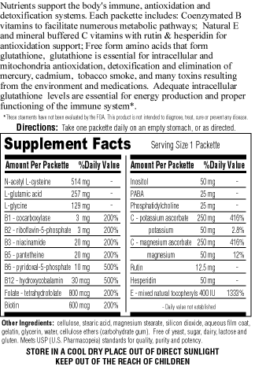
Reseller Program

CFS Nutrition is actively seeking resellers for it's food supplement programs.
We are not a multi-level marketing company, nor do we have intentions to become one. Our wholesale price list offers a generous discount for food supplement retailers, health care practitioners, and patient organizations placing bulk orders.
If you are interested in reselling CFS Nutrition supplement programs, send us an e-mail at sales@cfsn.com, please provide your name, business name, mailing address, type of reseller, or health care practice, or patient group you represent.
Or, mail your request on official stationary to:
CFS Nutrition
Attention: Reseller Program
P.O. Box 23911
Portland, OR 97281
USA

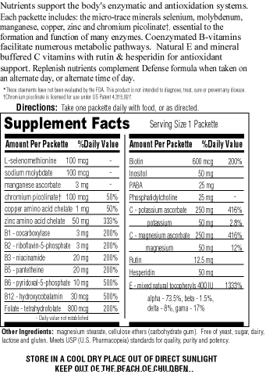


Jeff Clark

