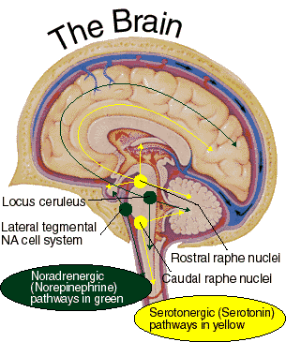
DEPREX is a Scientific Formulation of Natural Ingredients Including:
Hypericum Perforatum (St. John's Wort): Helps the body relax because of documented (1) MAO inhibiting properties, as well as (2) acts as a Serotonin re-uptake inhibitor, increasing the amounts of circulating Serotonin, and also (3) inhibits interleukin-6 (IL-6) and Cortisol, which cause anxiety and depression. St. John's Wort has demonstrated clear antidepressant effects in a number of double blind studies, and is recognized in Germany (Commission E) as an herbal antidepressant often prescribed by German physicians (66 million daily prescriptions in 1994 alone).
DL-Phenylalanine (DLPA): Has demonstrated superior antidepressant effects, when compared with a number of tricyclic antidepressants in double blind studies, by raising phenylethylamine (PEA) levels in the brain which increases the manufacture of Norepinephrine, and has demonstrated the ability to protect the integrity and lifespan of Endorphins, important neuroproteins involved with mood and pain regulation.
L-Tyrosine: The amine-neurotransmitter that is the direct precursor to Norepinephrine, working interactively with Serotonin.
L-Threonine: Low threonine levels have been noted in chronically depressed persons at Princeton's Brain-Bio Institute, and subsequent supplementation was found to lead some patients to control of their depression.
GABA: One of the major inhibitory neurotransmitters of the central nervous system, helping to relax muscle tissue and better regulate Cortisol release from the Adrenal Cortex via Corticotropin-Releasing Hormone production from the Hypothalamus, a problem which is known to affect 50% of all depressed individuals
Scutellaria Laterifolia (Skullcap): Helps to calm and relieve an overly sensitized "sensorium."
Verbena Officinalis: An ancient herb used for to relieve continuing sadness and unhappiness.
5-HTP: The natural immediate precursor to Serotonin and Melatonin, providing neurochemical balance during stress.
Supporting Amino Acids, Specifically Targeted Micro-Nutritionals & More: Provides electromagnetic instructions to further help the body naturally regulate Hypothalamic activity, balance the natural production of Serotonin and Norepinephrine and help restore clear sentient thinking and appropriate reality testing, as well as mood stabilization for potentially explosive and unpredictable mood swings

