Source Naturals
Hyaluronic Acid-60T

  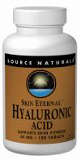
  Brand | Source Naturals
  Form | Tablet
  Size | 60 Tablets
  Serving Size | 2 Tablets
  Servings | 30
  UPC Code | 021078016250
  Top of Form
  Bottom of Form
  Bottom of Form
  Your Price: | $14.15
Ingredients
Supplement Facts
Amount per serving
Protein 1 g
Calcium 140 mg
BioCell Collagen II™ 1 g
Yielding:
Type II Collagen 600 mg
Chondroitin Sulfate 200 mg
Hyaluronic Acid 100 mg

