Mexi-Stim : The MexiStim unit is sold simply as a device that cycles between two battery powered polarities

In my travels and researches over the years, I have tried several electronic methods claimed to help the body to heal itself. None have given results that were measurable. Of course, no sane person will say outright that their method 'cures' anyone for fear of the wrath of the FDA, AMA or local medicos whose regular income depends on you remaining sick.

Wouldn't it be great to adapt the ancient Chinese method where you pay the physician as long as you are healthy, when you get sick, he pays you!

Don't read this as a slam against all medical practitioners, there are many fine doctors, nurses and medical technicians who do a great job in their fields, but so many aren't remotely open to the idea that any kind of alternative therapy beyond what they learned in school could possibly help anyone.

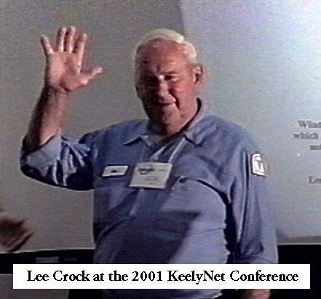
The machine I want to tell you about first came to my attention through several emails sent to KeelyNet asking if there was any information about a fellow in Caldwell, Ohio named Lee Crock who was using something called 'Aura Therapy' to get amazing results with sick or ailing people with varied conditions, some given up on as beyond hope.

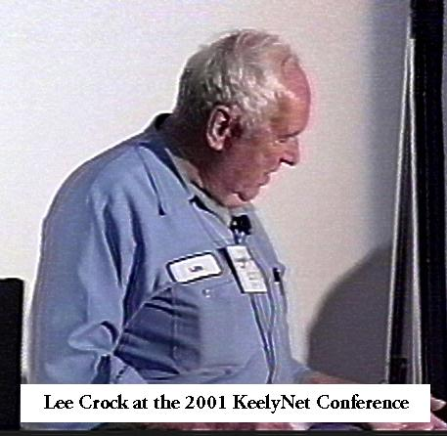
Some of the conditions this machine has been used to help resolve include all types of cancer, Altzheimers, rheumatism, arthritis, viruses, kidney, heart and lung failure, hearing loss, various physical pains, headache, epilepsy, Hodgkins disease, shortness of breath and other conditions as reported in testimonials seized and on file at the Noble County Courthouse in Caldwell, Ohio.

I had never heard of the guy and didn't actively began looking into his work until a couple of months later. I ended up calling Mr. Crock on several occasions and found him to be charming, personable and very informative about his method.

To put it mildly, Lee is a ball of fire and enthusiasm. He repeatedly told me he wanted to help as many people as possible with his discovery while he could.

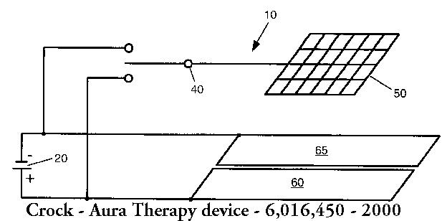
After speaking with him several times on the phone and after he sent me a copy of his patent, I wrote up a file on KeelyNet about the Crock machine.

In 2001, we had the first KeelyNet conference in Dallas which gave me the opportunity to fly Mr. and Mrs. Crock to Dallas to give a presentation and demonstrate his machines. We just happen to have a videotape of Lee should you be interested in obtaining a copy.

The original patent s slightly different from the current machines being sold. As you can see in the diagram, it shows two screens with the body sandwiched between them.

It has now been found unnecessary to use two screens since the body serves as a 'floating ground' for whichever polarity is in effect during a given 15 minute interval.

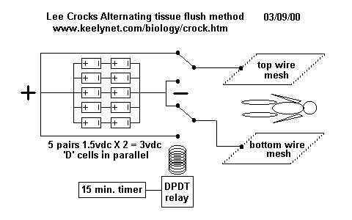
Meaning one screen has either positive OR negative applied to it and the body acts as the ground for whichever is in effect at the moment.

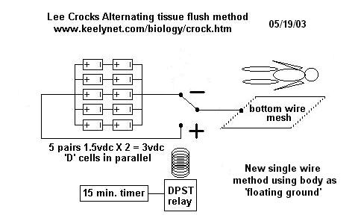
The one wirescreen is all that is necessary to couple with the body field and serve to complete the 'circuit.'

One schooled in formal electronics would think this can't possibly work or do anything useful unless it has a current path. How can a single wirescreen that doesn't even have to make contact with the body POSSIBLY do anything to help heal the body?

How can there be a circuit path between this screen and the body? Lee originally thought it was the aura and has taken photographs with a very expensive aura camera which shows the aura changing brightness and colors after exposure to his machine. That is why he called it 'Aura Therapy', thinking the screen somehow couples with the aura of the body to add energy.

It turns out there is an interesting effect called electro-poration, where the cells can be made to expand or contract depending on the polarity of current applied to them. That is what I think is going on in a weak fashion with Lee's machine, possibly occurring as part of a coupling to the aura, or what the Russians call the 'Bio-Plasmic field'.

New information has been released recently on work done by the husband and wife team of D. James and Dorothy Morre', who have worked on biological clocks since the 1960's and recently found a 12 minute expansion and a 12 minute rest cycle associated with proteins and cells. This is remarkably close to the 15 minutes Lee found by empirical observation as the optimum time between switching polarities for his machine.

Before the Conference, Lee kindly sent me one of his very early units as pictured here. You will note the corroded battery plate grids arranged for 3vdc output, use of an off-the-shelf AC timer and a single wire output for the pad. There is also a plus and minus port to measure battery power.

Lee brought about 6 of the new units (shown later in this article) to the KeelyNet conference which he let people examine and use.

These six devices also used the single wire pads which have proven superior to the dual pads as in the original patent.

The machine itself is remarkably simple, a combination of 10 'D' cell flashlight batteries connected to produce 3 volts DC.

A switching circuit set for 15 minute intervals alternates the polarity (negative or positive) sent to a wirescreen made of aluminum and available at any hardware store.

This wirescreen was held on or near the part of the body to be 'treated' though it appears to produce effects as long as it is held within about 6 inches of the body, thereby reinforcing the idea there might be some unknown aura coupling effect.

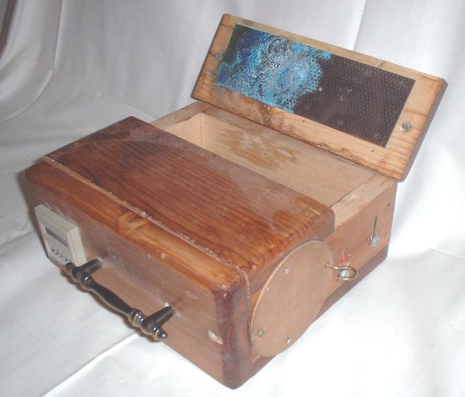
As an update since this article was written, an associate suggested using aluminized plastic Mylar film as a flexible pad substitute for the stiffer wirescreen. This is the material the metallic looking ballons are made of. You can buy it as an 'emergency' blanket for about $2-$3US at any camping or hiking store or in the camping section of WalMart. You can easily cut it to any size you want and it is perfectly conductive.

However, Tom Berryhill, who makes the Energy Cleaner machines for Lee Crock, reports they work fine as long as you don't flex them too much, which will damage conductivity. But you could cut them into pieces the size you want and simply replace when they begin to crack or lose conductivity over the larger part of the sheet.

I would like to bring in some other correlations which might further help to understand how this very simple machine could actually be assisting the body to heal itself.

It is my opinion that the aura of the body produces lines of force which actually 'write' the pattern of the aura into the physical matrix of the body. The aura, I believe, changes very slowly and is amenable to 'sustained' thought, meaning you can reprogram your aura with concentration and repetition.

According to Dr. Harold S. Burr of Yale University, all protein in the body is replaced approximately every 159 days (6 months), so why then do we not have a new body each 6 months?

Why do scars and aging appear in a body that is new? Because the aura IS the energy pattern which is written into the physical body and it holds the pattern of the scars as well as tallies up all the stresses we have encountered over our past, including the prior 6 months, all written into the flesh of our body.

One interesting claim that correlates is that of David Hudson who states that monoatomic gold is superconducting and when ingested will add energy to the body, increase psychic abilities and promote healing among other things.

David was with our group in Dallas for several days giving us the opportunity to spend a lot of time with him. I must say, the man is brilliant, with a mind able to span vast bodies of information and correlate relevant parts.


He kindly provided me with copies of two lab reports which showed that new, growing tissue was naturally superconducting, a condition he believes ingestion of monoatomic elements might induce artificially and a technique he suspects the Patriarchs and religious figures knew and used in the past to develop their 'powers.'

It was from David that I first heard the aura being described as a resultant of superconductivity. A term I like to use in describing the aura is based on Davids' ideas as 'a dynamic attenuating Meissner field.'

Dynamic because it is living and in slow motion giving the body time enough to 'write' the aura pattern into the reality of flesh.

Attenuating because it weakens with age and time, eventually becoming so weak that the transcription (copying) of the aura pattern to the body is so weak as to not be able to sustain the energy connection, thus resulting in death.

Meissner 'field' because the Meissner effect is experienced with superconductors as a repulsion of magnetic lines of force, no matter the polarity of the magnetic pole.

This effect is called 'diamagnetism' when both poles are simultaneously repelled. Scientists in Finland have succeeded in levitating living frogs, fruits and other 'non-magnetic' objects in a high density magnetic field, based on this diamagnetic repulsion effect.

Lee Crocks' Energy cleaner machine requires a 'steady state' DC field from the 10 batteries at low voltage (3 volts). Although there is no current flow that I know of or which has been measured between the wirescreen and the body or even the aura of a body, I think it provides an ambient pool of force from which the aura can extract energy.

I base this on natural law where nature always seeks equilibrium, so by immersing a low potential object into a high potential field, the low potential will necessarily be pulled up trying to come into equilibrium with the high potential field. Thus a weak aura or body energy field will be pulled up by absorbing energy from the wirescreen via a coupling to the aura.

David Hudsons' idea of ingesting the superconducting monoatomic elements would likewise increase the field strength of the aura, allowing for more perfect transcription to the physical, promoting healing and possibly inducing paranormal abilities.

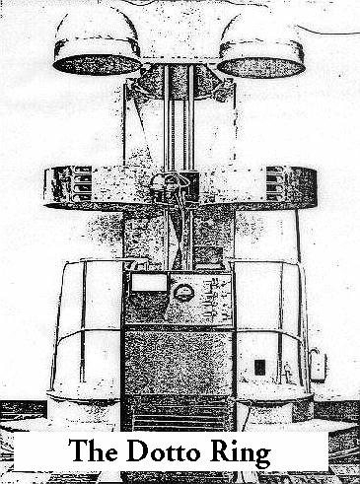
A similar background energy effect is that of Dr. Gianni Dotto who designed and built the famous healing machine known as the 'Dotto Ring' which produced an intense magnetic field using 30,000 amps at almost no voltage, which makes it 'almost superconducting', ergo, current without voltage in a supercold material has no resistance.

Reports were that Dottos' machines would levitate off the floor when in operation due to the intense magnetic field they produced.

This effect resulted from repulsion against the magnetic field lines of the earth.

This claim causes many to sneer and say it is impossible because the field lines of the earth's magnetic field aren't that strong.

However, about 3-4 years ago I received a couple of telephone calls from a young man in Atlanta, Georgia asking if I knew of a compact power supply that ran on gas or some other replaceable fuel.

Well yes, there are many power supplies that could fit that requirement, depending on how much power was required to be generated. He then proceeds to say he had built a three foot spherical model of the Wachspress levitating monopole magnet, connected with a power cable and which he flew around the room.

He wanted to expand this to a 6 foot model which would allow a pilot and needed a self-contained onboard power source. I was impressed by the claim, he swore it was true but that he could only fly it for about 20 minutes or so before the coils became too hot due to the very high current necessary to drive them, so he risked shorting them out.

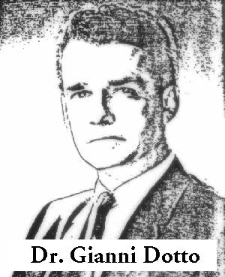
This young man was very paranoid and never contacted me again after the two phone calls, so I didn't have a name or any way to contact him. Granted it could have been a hoax but he sounded sincere and rather harried, like he was afraid of something.

His machine was based on a magnetic 'monopole' which is described in the 1989 patent by Herb Wachpress describing a toy based on a unique geometry that produced just such a 'monopole'.

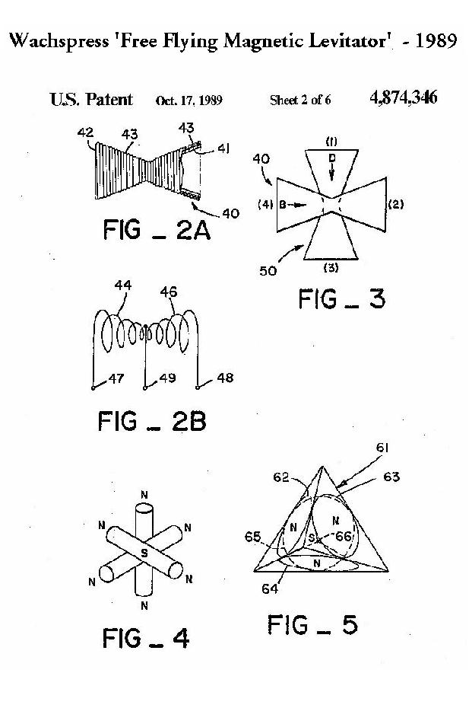
Basically, it consisted of 6 electromagnets all pointing with the same polarity towards a center so as to form a sphere.

Though with sufficiently strong small magnets, you should be able to make a purely magnet 'powered' monopolar sphere.

When measured around the surface of the sphere, it would appear as a monopole since only one polarity was facing outwards.

Using this, Wachspress made a table with electromagnets appropriately positioned and connected to a joystick, so that the magnetic monopolar sphere could be 'flown' in the air above the electromagnetic table.

This has no real bearing on the Crock machine or how it works, I just thought it might be interesting in light of the claims that the Dotto Ring machines levitated off the floor when in operation to produce the 30,000 amps and thus a very intense magnetic field.

It would be great to hear from anyone working along these lines, though I don't think I would want to ride in a flying machine with such a strong magnetic field density.

Another interesting correlation to the Crock machine is EEMAN relaxation screens, sometimes called biocircuits or Eeman screens. These were discovered by Leon Ernest Eeman in the early 1920s. After serious injuries in a plane crash, Eeman was deemed 100 percent disabled.

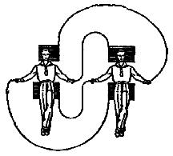
While hospitalized he recalled Jesus' admonition "Heal the sick by the laying on of hands." Eeman reasoned that this healing energy was the subtle energy of the life force itself.

Within two years after his release from the hospital he developed techniques using these screens that "restored him to better health than he had ever known."

These screens are passive devices that facilitate the flow of subtle bodily energy. A scientific, double blind study, that measured muscle tension and skin conductance as well as monitored EEG, found these screens to be superior for producing relaxation.

After all this preliminary material, now is a good time to repeat what Lee told me on the telephone in our numerous conversations and what he said at the KeelyNet Conference. By the way, we do have a videotape of Lee speaking at the conference if you are interested. Order Lee Crock Video.

Lee said he was fascinated by the 'laying on of hands' as reported to be used by Jesus, his disciples and other healers. His healing system stems from Reiki massage therapy which partially relies on the production of heat in the hands to heal the body.

The treatment takes from 3-5 days and is given at his Therapeutic Academy (now called EDK University due to legal reasons) in Caldwell, Ohio. They had 10 beds (at the time of the conference Lee reports 30 beds) and give treatments around the clock. For those too ill to care for themselves, they request that you bring a friend or helper.

If you cannot acquire a machine, by building or buying, it might be worth a brief 'vacation' to Caldwell to stay for a week. Meet Lee and his people, experience the machines, relax and take a break from your normal routine. If nothing else, you will get a vacation though it might help in other ways. Contact information for Lee and his University are included below.

Lee says a counter clockwise (CCW) motion is positive, discharges the cellular electrical energy and relieves pain within about 14 minutes.

As opposed to clockwise (CW) motion which is negative and refills the cells with energy.

The principle Lee describes as like emptying a bucket, filling it back up and emptying it again, over and over with the idea being to flush out any toxins.

He says an easy demonstration is to hold your hands flat against or close to the ailing organ or body of a subject, and move the palms of your hands in a CCW motion until you begin to feel a heating effect.

Once it achieves the maximum heat, you lay your hands on the area being treated, and let them cool down.

A CW motion will recharge the cellular energy and after about 30 hours of this CCW, then CW treatment, repeated over this 30 hour period in 15 minute intervals, the subject improves.

By using a relay of 4 or more people, doing this without the machine, you can continually flush and recharge the damaged cells continually over 24 hours for 3-5 days or as needed.

The machine Lee has developed apparently produces this same alternate CCW and CW motion without the need of a human operator to produce the same flushing and recharging effect.

One of the side effects is excess urination in people with very serious health issues, which Lee says is due to the body discharging the toxins that are being released as the tissues are being flushed out using this very simple method.

Lee says he and his volunteers have worked with over 10,000 people over a 3 year period with excellent success rates, with these people coming from 10 foreign countries and all 50 states.

He has been summoned into court, forced to change the name of his Therapeutic Clinic to Therapeutic Academy (now changed again to EDK University) and never claims outright to be able to heal or cure anything or anyone. His method simply assists the body to heal itself by flushing out the toxins that cause the problems.

Lee says his electronic device has one wire leading from it which is connected to a screen that is usually sealed in a pillow. The pillow can then simply be laid on the suspect organ and the bigger the screen, the more area is affected.

Lee says the CCW motion is like building a coil and since coils attract electricity, this energy coil will pull the electricity out of the cells which will carry the toxins with them.

He says the proof of it is the production of heat in the palms of the hand which can be felt with or without the machine and a less subjective proof is that the subject urinates often when being subjected to this bio-heating and cooling effect.

This sounds to the author like a version of iontophoresis, where charged ions can be used to introduce or remove elements or chemicals to or from the cells. Once these cellular contaminants are in the blood stream, they are detected as invaders or excesses and removed as waste, most easily via urination.

And yes, Lee says he has treated himself with the machine for months where he used a 4 foot by 8 foot wire mesh screen placed between the mattress and box spring of his bed, with his machine feeding this mesh screen so he would be treated while he sleeps.

He reports during this process, he would have to go to the bathroom 4-5 times a night and had to discontinue it due to dehydration where his body was flushing out all toxins. He also says after discontinuing this nightly treatment, he still has to go to the bathroom often to urinate but the effect is going away over time.

I take this comment as a great warning to not OVERUSE this technique, use it when you need it. Many would never have mentioned this for fear it might scare people away from the entire claim, and to my view that is a sign of Lee Crock's sincerity and integrity. Lee also provides a background for the basic effect and its' discovery as well as charging NOTHING for his treatments at his facility and is just there to help whoever he can. Look around and see how rare this attitude is these days.

Lee has an 'Aura Therapy' booklet which he does not sell, but gives away freely. He is generous to a fault and charges nothing for people to come to his academy to stay in one of the 30 beds for as long as necessary to get them better. He says to give him a call so he can find you an open slot in their schedule.

I asked if he was setup as a non-profit organization and he said yes, so they are in a position to accept donations, bequests, etc.. His call impressed me in that Lee didn't seem the least concerned with selling anything. His main concern is helping as many people as he can while he is here, another excellent sign of character.

Amazing results have been achieved with Altzheimers' because his system helps to flush aluminum from the tissue as well as arthritis and rheumatism which resolves as the excess calcium crystals are flushed. He says you can get a sample of the urine of the arthritic person and you will see tiny brown calcium crystals in the sample.

The treatment involves one of the screen embedded pillows which is laid over the person with the machine attached.

I asked him about muscular dystrophy and other such illnesses, he says they are nerve disorders and it depends on the degree of decay though it couldn't hurt. Also, since Lee has a great sense of humor I asked him if it helped hair growth or would act like electronic Viagra.

He said no, he didn't think it would help restore hair and he didn't know what Viagra was, I explained it and he said well, most of that is in the mind anyway, so he didn't think it would help......

One of the other discoveries is that you can have several people touch the pillow while the machine is on and the effect is greatly increased, as if the machine, producing its alternating CCW and CW fields absorbs additional healing energy from the people participating, which greatly intensifies the healing effect.

This is very similar to the claims of the Eeman screens where two wire mesh screens are laid next to each other and offset on the floor to be connected with one wire at the top and one wire at the bottom.

A healthy person lays on one mesh screen and a sick person lays on the other mesh screen opposite each other, so that the feet are on the end of each screen. The idea is that a bioelectric current will flow between the two and a form of induced empathic trans-sympathetic healing is produced.

Lee has many great stories about using the machines, one of them had to do with a woman who had lung cancer and was given up to death. In the hospital she was in an oxygen tent to assist her breathing. Since she was known to be a very religious woman, they thought about ways to smuggle the machine into the hospital to help her.

So they put the device in a suitcase and wrote 'anointing oils' on it, then took the pillow and the suitcase in. The pillow was placed on the womans chest and the single wire connected to the machine. The helpers all placed their hands on the pillow and put on quite a show when the nurse or doctors came in.

They went back every day and treated the woman for 2 hours at a time, within 3 days, she was taken off the oxygen tent, within 5 days released to go home. The cancer had 'disappeared' and was written off as a miracle due to spontaneous healing.

He has another great story about a priest who had been unknowingly using this healing technique by placing his right hand on the left shoulder of the faithful until he felt a heat, usually after about 6 minutes. He attributed this heat production to his faith and considered himself one of a gifted few.

The priest told Lee there were probably a total of 13 people in the world with this 'gift'. Lee told him that 6 of these people were with them today at the academy and if he'd give him a couple of hours, he'd call up the other 7.

He then did a demonstration and showed the priest what was really happening and how to speed it up with the CCW motions so he could help more people instead of just waiting for the flow to happen on its own.

I will tell you my experience with the machine. For some 23 years, I worked in three different photo-finishing labs running the Technical Support department. During that time I was exposed to chemicals which I blame for damaging my spleen and causing it to become enlarged. The spleen kills off old red blood cells among other functions, so when it is enlarged, it kills off many more red cells than it should, leaving the subject tired and needing sleep. That was my problem.

After 5 doctors, I was sent to a hemotologist who found an enlarged spleen to be the problem. My options were to have it removed and become susceptible to opportunistic infections where my only recourse was to take antibiotics, or take massive doses of cortisone. Either option would eventually damage other organs. Or I could just live with it. I chose to live with being tired and needing more sleep than normal but was always looking for something that might help my non life-threatening condition.

My red cell count when I was first tested was 7.9 and the doctor said I should not have enough energy to even be walking around. The normal red cell count for a healthy male is 12 to 16 according to the medical staff I consulted. They put me on massive doses of iron and folic acid which in the next test about a month later, only increased my count to 8.1.

That was their best and they expressed regret that they could not do more. That was in October of 2000. In the summer of 2001, we had the KeelyNet Conference and Lee loaned me one of his machines. I used it for approximately 3 months, with a 3 X 4 foot aluminum wirescreen under my mattress pad and the machine running unnoticed under my bed, all but forgotten.

In the 3rd month I began having trouble sleeping and would wake up with a lot of energy. I would have to get up to clean the house or do something to dissipate this extra energy so that I could sleep to make it in to work the next day. Finally I realized the only change I had made recently was the Crock machine under my bed, so I disconnected it and over the next 2 days, my sleep pattern was restored.

Around that time, I quit my job for my planned move to Mexico since the hemotologist warned me I was now subject to sudden heart attack. It scared me pretty badly so I decided to make a serious life change. Before I left Dallas for my exploratory trip to Mexico, I went back to the hemotologist to have another red cell count and this time it showed 8.9!!

I had taken NO iron and NO folic acid. The doctor and the nurses came to read this result and were amazed, asking me what I had been doing to cause such an increase when their best was 8.1. I tried to tell them about the Crock machine but all of them put their hands over their ears and said they didn't want to hear about any alternative health machine. So much for that. But I made them give me photocopies of the test from the 8.1 (my last best reading under their guidance) and this new 8.9 using ONLY the Crock machine.

Needless to say, it certainly gave me faith in the machine, I definitely had more energy and this test showed why, I simply had more blood. Now I don't know if the machine is helping to increase my red cell production or if it is healing my spleen. To tell you the truth, I don't CARE because I feel so much better.

Since moving to central Mexico in November of 2001, I have built my own version of the machine which I call the 'MexiStim' and have been using it under my bed with a wirescreen under my mattress pad. The machine is on all the time and sometimes I have to disconnect it due to too much energy preventing me from sleeping.

I have completely changed my diet and lost 4 pants sizes, further benefiting my health. Adding to my success, I also credit not having the temptations of fast food and the stresses of the computer call center job I was working that was adding to my health problems.

My goal here in central Mexico is to build an alternative science research center where the climate is 70-90 degrees year round, land is very reasonable, local labor is $15-$20US a DAY! I soon learned many of the horror stories about Mexico I had read on the Internet simply are not true.

We have many dozens of projects which have commercial potential and need one or more investors or partners to finance these various projects. The returns could be phenomenal and we could do much to quantify so many of the bogus claims in the alternative science arena. That includes many projects relating to free energy, gravity control, claims of health machines and rejuvenation systems. KeelyNet interests and technical information are both wide ranging and prolific in many areas. If you are interested in investing in or discussing this alternative research center, please Email me.

The new machines Lee uses necessarily require just 9 'D' cell batteries to get the 4.5vdc and require no outside power making them completely portable, a much desired feature for many situations and for travel.

These self-contained battery powered machines (shown here labeled as 'Energy Stimulator') are very well built by Mr. Tom Berryhill and you can contact Lee if you might wish to purchase one.

I would recommend you visit Lee Crocks' website at www.edkuniversity.com and read all the details they have provided, particularly the testimonials.

In experimenting with the machines, I notice with the 3vdc system, a heat sensation from the pad which I don't experience with the 4.5vdc system.

I thought this was just me until a fellow in Texas asked me to build him a machine.

When he got it, he wrote back saying he had also bought one of the 4.5vdc systems and he also felt heat from the 3vdc machine but not from the 4.5vdc. I don't know that this is critical as people have used and are using the 4.5vdc system and getting good results.

My red cell count increased and my lady friends rectal cancer dissolved, both usingone of Lees' newer 4.5vdc machines so it apparently doesn't make a difference. The resolved sarcoiditis cancer used the 3vdc system as in the MexiStim unit and it is the design for the machine I now use for myself.

Lee has an unusual way to sell the machines, using a 'lease with option to buy' system. The University where Lee allows people to come use the Energy Cleaner machines for free does cost money to operate. Many people cannot pay to stay there, so the money has to come from somewhere. Lee offers a money back guarantee where he charges $3,000 for a machine which you can use for a month.

On receipt of the money, a machine is overnighted to you with the cost of that shipping taken from the $3,000. If you send the machine back undamaged, you receive the $3,000 minus the overnight shipping cost. If you decide to keep the machine, the extra money helps to run his clinic and allows those who cannot pay an opportunity to benefit from the machines. In this way many can benefit from those who buy his machines, so I urge you to consider helping him to help many others less fortunate if you can possibly do so.

I understand his logic and applaud the money back guarantee but to me, that is a lot of money to have to put up front, even for a money back guarantee. Lee and I have discussed this and he knows my feelings about it.

Having met Lee Crock, I must say I am totally impressed with his discovery, the results he definitely gets in some cases that I am aware of (as in my case and the two cited above) and his genuine desire for his machine and technique to be used to help as many people as possible.

Many people, including me, have suggested to Lee that he lower the price of the machines and sell many more in volume without the money back option. It would let so many more people benefit from the machines. He resists this suggestion as the system has worked well thus far. The Energy Cleaner machine can be used for so many problems that many people choose to keep them and use it for their family and friends. As the saying goes with Murphys' law, "if it ain't broke, don't fix it."

You can build yourself a machine with some basic ability, the most difficult part is the timer. Some use an integrated circuit based on a 555 timer with a big capacitor, others use a 24 hour appliance timer which I believe gives you 12 cycles which would switch in 15 minute intervals for a total of 3 hours, yet others do the absolute simplest thing, they hook the wire from the batteries to the screen and watch the clock for 15 minutes, once 15 minutes has elapsed they move the wire to the opposite polarity and wait another 15 minutes. All the methods seem to work.

(The following Carbon battery comment is incorrect, ALKALINE batteries such as Duracell, Energizer, etc. can be used with excellent results.)

I think it critical to repeat something Lee was quite adamant about at the conference. Lee says use ONLY CARBON 'D' cell batteries, not lead acid, not alkaline, not NiCads, not rechargeables and not AC adapters because he tried all of them and didn't get the same feeling in his hands when testing the machine with 10 'D' carbon cell batteries wired for 3vdc. We had quite a discussion about carbon being key to life on this planet and why it was that carbon batteries are the best type to use. Some kind of sympathetic resonance connection through the carbon connection? Somewhat reminscent of Edgar Cayce and other bio-energy devices that use carbon. Who knows, it could lead to a new science.

At the conference and in our telephone conversations, Lee also says to use 10 batteries, not 9, not 11, but 10 which they found produces the identical heating and healing sensation he and his fellow practitioners feel in their hands. Since their new portable machine uses 9 batteries to produce the 4.5vdc, perhaps this recommendation has changed.

The one wirescreen method as diagrammed earlier in this article is the method currently in use for the machines Lee is providing and in the MexiStim machine I build by request.

Though you can cut a piece of wirescreen to whatever size you want, I use a 1 foot by 1 foot wirescreen for local application and a 3 foot by 4 foot wirescreen under my mattress pad for all night application. It makes sense that the smaller the pad, the more concentrated the energy should be.

This energy effect can be further increased by holding a hand on the pad to intensify the local energy field. Though it is my opinion that a large screen under the resting/sleeping body will still receive energy but at a slower rate since it is exposed to more surface area.

All you do is attach one corner of the wirescreen to the negative pole of the batteries and leave it for 15 minutes, then attach it to the positive pole and leave it for 15 minutes, repeat, or you can build a switching circuit that does it automatically, or buy one of the prebuilt and tested machines and save all the hassle.

Lee Crock and Tom Berryhill recently reported you can connect the output wire to a metal bathtub filled with water or just suspend it in the water, then sit for awhile to experience what Lee calls the 'Fountain of Youth'.

In the 1900s, people used 'galvanic baths' for medical treatments but this machine doesn't have a current path so it shouldn't be doing anything. Since the machine is battery powered I think it is perfectly safe due to such a low voltage and no current flow. The MexiStim I build has a completely separate battery system isolated from the AC adapter powered timer. I definitely plan to try this 'Fountain of Youth' claim.

Once again, if you want to read more about the Energy Cleaner machine, its history, testimonials, instructions for using it, etc., go to Lee Crocks website at www.edkuniversity.com.

Should you wish to contact Lee Crock, inquire about purchasing one of his Energy Cleaner machines or to make an appointment to visit his University to try out the machines (think of it as a mini-vacation), his mailing address and email address are herein provided;

For those who might not have the technical ability or patience to build one of these machines, I can build you a MexiStim unit for $250 plus shipping (without the 10 'D' cell batteries as they are too heavy to ship), which runs about $50 to ship FEDEX from Mexico to the United States and more for overseas. I cover any additional shipping costs to simplify payment.

This is not a big factory operation, each unit is hand built by me by request which is why I can keep the costs down very low. I build the machines in the sequence I get the orders so it might take 2 weeks to fully complete and test your machine. Then I ship FEDEX to non PO Boxes with an email to you of your TRACKING NUMBER.

Since I have been here in Mexico, I met a North American lady named Donna who wrote a best selling book on Anger Management and was invited as a guest on Oprah. Donna told me her +30 year old son had an incurable cancer called sarcoiditis. He was visiting here for a week so she took him around for aromatherapy, acupuncture and anything that might help him, none of which helped. I told her about the Crock machine and loaned him the unit I brought to Mexico. He said he could feel a heat coming from the pad so he used it the last 3 days he was here.

On his arrival back home, he had an MRI done and the doctors told him his cancer appeared to be 'melting', so he was eager to spend more time using the machine but could not afford the $3000. So impressed was he and his mother with the results of even a short exposure to the machine, his mother asked me to build him a MexiStim unit, I did and mailed it to him in Connecticut. This was in 2002.

Donna only stays here with her husband for about 6 months of the year, so they went back to the states and I forgot about the machine. About 2 months ago, around March 2003, she returned and was all effusive saying the machine I sent her son had healed his sarcoiditis cancer as proven by MRI and biopsy. They were both ecstatic, though the doctors claimed it was 'spontaneous remission.'

A lady friend in Dallas had rectal cancer and I loaned her one of the other Crock machines Lee had loaned us to let people use. My lady friend now reports she is cancer free and is now taking the machine to another friend who has many ailments, we are hoping it will help him.

I recently received an email from a medical practitioner in England who received one of my MexiStim units and he writes;

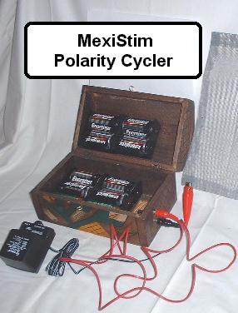
"Have my cancer patient on box and already getting positive feedback from her within an hour of using it her pain in the chest had reduced by 75%. The next morning her energy was also good as well so we'll see how she does as she has to have Chemo next week again. She only has a 10% chance of survival so this should prove interesting."

I have built several of the MexiStim machines at the request of people who visit KeelyNet.

My version uses the original 3vdc system with an AC adapter to power the custom switching timer circuit I build.

Though you can't see it in the photo, there are 10 batteries in my unit.

Also included with the MexiStim device;

the custom switching timer circuit board, a jack for the AC adapter power, the AC adapter as shown, a jack for the wirescreen connection, the cable for connecting to the approximate one foot square wirescreen and instructions, all of which come with the unit for $250 plus $50 FEDEX shipping from central Mexico.

Prior to shipping, each machine is tested over a period of several hours to verify correct operation.

The 10 'D' cell batteries are NOT included because of their weight for shipping.

If you'd like to order a MexiStim unit or have questions or comments, feel free to contact me at Jerry Decker or through www.keelynet.com or you can write to;

Jerry Decker
APDO Post 17 C.P.
Chapala, JAL, MEX 45900

I can take payments via the PAYPAL credit card option, through PayPal direct funds transfer as sent to my email address above or other options on the Order Page. See advertisement in Nexus for more details or click here to go to the ORDER page. The ORDER PAGE offers several options for payment other than PayPal.

Normally I am a big skeptic about healing machines mostly because I have tried several and didn't get any effects. Granted, I didn't have life threatening or serious illnesses which should ideally respond more easily to them if they really worked as claimed.

In the case of Lee Crocks' Energy Cleaner machine, I originally had my doubts as I just could not believe such a simple machine could possibly impact health in any way, positive or negative.

Yet I had extra energy plus my red cell count printouts showing the seriousness of my condition, had used the machine and forgot it was even there until I began trying to find the source of why I couldn't sleep, then when I got my next red cell count, my results amazed the doctor and staff, plus I had the printout verifiying an increase.

In other words, I was not fooling myself as do so many who 'want to believe' in an alternative therapy that seems to make them 'feel better.'

Before I knew about Lee Crocks' Energy Cleaner machine, I had friends die from failing to get proper medical tests when they became ill. Instead they chose alternative methods and believed they were better, though as time progressed, their illness progressed to a point of no return.

Several years ago, I knew an intelligent, beautiful young lady who found a lump on her breast. Rather than have conventional therapy for what was found to be a malignant tumor, she used a custom Rife type machine sold by a fellow named Robert Fox in the Dallas area. She believed she was better and became a spokeswoman for this machine.

Over time, her breast lump became seriously infected and she wound up in the hospital. They did what they could for her, but too much time had elapsed and she died as a result of massive infection from the cancer, all the while wanting to believe the claims of an alternative therapy and denying orthodox therapy.

This hit all her friends hard. Alas, no lesson was learned by any of us apparently, as my closest lady friend developed a shooting pain in her hip which she believed to be sciatica from a pinched nerve. Rather than have it formally tested, she tried various alternative medical approaches over an approximately six month period. She began with a limp, progressed to having to use a cane, then a walker, then a wheelchair.

All her friends urged her early on to PLEASE go see a real doctor and have Xrays done, instead, she had a very fuzzy Xray done by an alternative medical guy which showed nothing useful. Time progressed and we all watched helplessly as she went further down, despite our voiced concerns, she refused to allow anyone to take her to the doctor. Finally, she went to a hospital, by this time she was in a wheelchair and in horrible pain, taking morphine for suppressing the pain.

The Xrays showed her hip bone had been eaten away with only a sharp spike left. Additional Xrays showed massive scarring on her lungs from an earlier mastectomy. As time went on, her lungs became reinfected with cancer spreading from her diseased hip.

The doctors said there was nothing they could do as it had gone too far. She quickly ended up in the hospital, lung cancer ensued and her friends attended her in her last days, as she was given a morphine drip that had to be increased almost daily to compensate for the ever worsening pain.

Her closest friends were there at her passing and we all regretted immensely that we did not somehow force her to seek at least quantified tests much earlier. This woman, a brilliant biochemist, extremely intelligent, sparkling with life and interest, a friend and inspiration to many, was also very stubborn.

From this loss of a great and dear friend, I have learned; DO NOT TRUST YOUR FEELINGS! I can't and won't attempt to give any advice, but speaking for myself, if I have any ongoing medical problem which I cannot resolve in a reasonable period, I will most definitely have tests done to find out what is truly happening and what my options are. I will NEVER BELIEVE without proof just because I have tried an alternative system and seem to 'feel better.'

Excuse me, but that's just not good enough. And I would hope others learn from this sad story and spend the money to have real tests done. I like the idea of before, during and after tests but that can get expensive. For myself, I would want to know what IS NOW, then try my alternative for a reasonable period and if I 'felt better', then I would have comparable medical tests done to VERIFY the FACT. Not just trusting my feelings.

Hey, its YOUR life we are talking about here. Believe in alternative methods without quantifiable (measured) tests and take a chance of letting whatever it is get SO BAD there is no chance of recovery, or have the tests done and KNOW what your problem is and what options you have.

As for Lee Crocks' Energy Cleaner, I can for certain say it originally did help me, though I now use my 3 volt DC MexiStim version because I prefer the effects I get, more energy and a sensation of well being which the 4.5vdc system also gave me but I think not as intense as the 3vdc system.

I would love to report a further increase in my red cell count but when I was last in Dallas back in October 2002, the office of my hemotologist told me they no longer take cash, credit cards or checks, only group insurance as provided by companies. I even tried to bribe them (one learns this in Mexico, called a 'mordida' meaning little bite) to test my blood but they refused.

Despite my last test in Dallas that so surprised the medical staff, before I can be CERTAIN I am not fooling myself, I need to find a place here in Mexico where I can have more red cell counts done to verify the machine is continuing to help me get to a normal red cell level. The increased energy level could even be imaginary though I almost never think about the 'machine under my bed.'

For those who know me, they know what a skeptic I am for medical claims especially, it's a hard thing to say, but I have experienced proof of it myself and have the printouts to prove something positive is going on. I never intended to make and sell the MexiStim units, designed and built based on my version of Lee's current machine, only doing so when people wrote me asking that I build one for them for whatever reasons.

I rely on Lees' statement that he wants to see as many people helped with this discovery as possible and I share with him all information that comes in about the machines as well as forward questions and requests people make and address to me for him. I would hope people would write in with their successes or lack of them.

The more information we have, the more can be posted to help others. If you have experiences with this machine, whether one you build yourself, one you lease or buy from Lee, or one I build for you, do feel free to write me and I will compile your information into a 'testimonials page,' please include the condition you were trying to alleviate, how long you used it, where you used it, what kind of results you had and if you have had any formal testing to verify an improvement in your condition.

As you can see from the diagrams above, it is not a complicated high tech machine, the current and most effective version to date uses the single wirescreen for a pad with the body as the 'floating ground', so its really your choice as to whether you want to wire it up for 4.5vdc or 3vdc as in the original.

I want to thank Lee Crock for providing much of the information in this article, especially the technical details and wonderful anecdotes about experiences he has had with his machine and 'laying on of hands' technique. If you are having a conference or want an entertaining, informative speaker willing to demonstrate his technology, I most certainly recommend Lee Crock.

How many people would share something like this so freely? I can't say enough good things about Mr. Crock and the builder of his machines, Mr. Tom Berryhill.

One thing I want to write in closing, the machine uses batteries to power the wirescreen and so is perfectly safe to use. I can't see any way this machine could possibly hurt you unless you got tangled up in the cable leading from the machine to the wirescreen. There are SO MANY illnesses and conditions whose true cause is simply not known that this machine might help.

The idea of toxins in the cells causing irritation and various conditions makes much sense to me, and if this machine can help your body remove those toxins, so much the better.

The bottomline is, I am so glad I was made aware of Lee and his machine, then tried it and found such success that I would gladly recommend it to my friends to at least TRY.

As an example of how I think the machine has played a part in improving my life and realizing of course that there are many other factors involved, I want to show you a 'before' photo of me captured from a videotape taken at the 2001 KeelyNet conference in Dallas as compared to a photo a friend took in December of 2002, here in Mexico.

My god, I was almost too embarrassed to include it here, on looking at it, I couldn't believe I was so out of shape! But in the interests of information, I have to include this gordo photo and apologize for ever being on videotape!

As they say in Mexico, Las Cosas Cambien! - Things Change...

At 49 years of age, I will admit I tint my hair (for $5US here) which began turning salt and pepper some 6 years ago.

Since moving here to Mexico Lindo I had dental work done, lost over 4 pant sizes from 46 down to 38, working on size 36.

I sleep on a 3 foot by 4 foot aluminum wirescreen under my mattress pad which is connected to the first MexiStim unit I built, which I leave on day and night.

I bought my wirescreen at the local ferreteria (hardware store), cut it to size, then folded the edges in about an inch to minimize the rough edges.

I keep the wirescreen under my mattress pad and it is connected to my MexiStim machine which is under my bed with the AC adapter always plugged in. When I can't sleep from being too 'wired' I disconnect the machine for a couple of days.

On visiting my friends and family, everyone says I look and act years younger. I most certainly feel it.

They are amazed at the very positive health changes much of which I credit to Lee Crock because, speaking from my own experiences with the machine, I seem to have more energy than I've had in years from using his very simple yet effective technology.

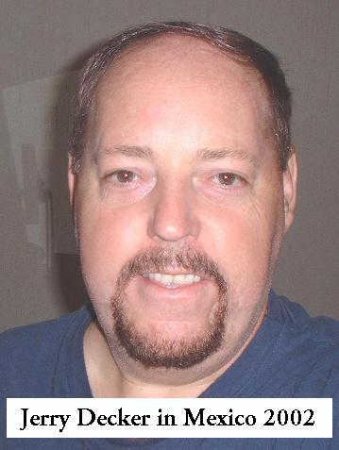
The weight loss I think was mostly facilitated by the easily obtainable fresh foods here in Mexico, no junk food, but I do think the 'perceived' energy I get from the machine really helped.

Delusional? Tell that to my hemotologist and try to ignore the printouts showing a MUCH higher red cell count than they could hope to get. From 7.9 to 8.1 is only 3 points, from 8.1 to 8.9 is 8 points, which is better?

At any rate, its great when people first meet me me these days and they guess I am 30 or 35 years old. I've had people say 28 but I think they need eyeglasses or maybe not so much tequila or cerveza. (I just turned 50 years old!)

Geez, if this is just using the machine under the bed, I really need to try Lees' 'fountain of youth' idea of connecting the machine to a tub of water and immersing in it.

All this said, I am sold on the Energy Cleaner 'technology' and very pleased to have the opportunity to report it to readers of Nexus, thanks for that goes to Duncan. For myself, I am 'livin la vida loca' in glorious Mexico but I DO wish Lees' machine grew hair!!!

If you can't afford to buy a machine, I really would recommend that you try to build one, even if its' where you have to switch the polarity wire by hand after waiting every 15 minutes. A few hours might make you tired doing this, but it might also give you an interesting and possibly beneficial experience.

Hasta Luego y Namaste!

