Cellular Respiration
Cellular respiration is the process of oxidizing food molecules, like glucose, to carbon dioxide and water. The energy released is trapped in the form of ATP for use by all the energy-consuming activities of the cell.
Index to this page
- Mitochondria
- The Citric Acid Cycle
- The Respiratory Chain
- Chemiosmosis in Mitochondria
- How many ATPs?
- Mitochondrial DNA (mtDNA)
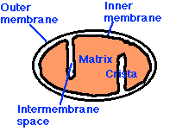
The process occurs in two phases:
- glycolysis, the breakdown of glucose to pyruvic acid
- the complete oxidation of pyruvic acid to carbon dioxide and water
In eukaryotes, glycolysis occurs in the cytosol. (Link to a discussion of glycolysis). The remaining processes take place in the mitochondria.

Mitochondria
Mitochondria are membrane-enclosed organelles distributed through the cytosol of most eukaryotic cells. Their main function is the conversion of the potential energy of food molecules into ATP. Mitochondria have:
- an outer membrane that encloses the entire structure
- an inner membrane that encloses a fluid-filled matrix
- between the two is the intermembrane space
- the inner membrane is elaborately folded with shelflike cristae projecting into the matrix.
- a small number (some 5-10) circular molecules of DNA

The Outer Membrane
The outer membrane contains many complexes of integral membrane proteins that form channels through which a variety of molecules and ions move in and out of the mitochondrion.

The Inner Membrane
The inner membrane contains 5 complexes of integral membrane proteins:
- NADH dehydrogenase
- Succinate dehydrogenase
- Cytochrome c reductase(also known as the cytochrome bc₁ complex)
- Cytochrome c oxidase
- ATP synthase

The Matrix
The matrix contains a complex mixture of soluble enzymes that catalyze the respiration of pyruvic acid and other small organic molecules. The enzymatic steps in the breakdown of pyruvic acid make up the citric acid cycle.

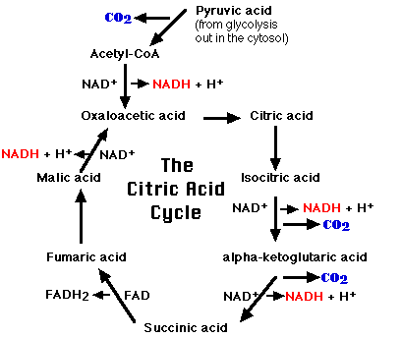
The Citric Acid Cycle
- pyruvic acid is decarboxylated resulting in a 2-carbon fragment of acetate
- this 2-carbon fragment is coupled to a molecule of oxaloacetic acid
- the resulting molecule of citric acid (which gives its name to the process) undergoes the series of enzymatic steps shown in the diagram
- the final step regenerates a molecule of oxaloacetic acid and the cycle is ready to turn again
Note these additional features of the citric acid cycle:
- each of the 3 carbon atoms present in the pyruvate that entered the mitochondrion leaves as a molecule of carbon dioxide (CO₂)
- at 4 steps in the cycle, a pair of electrons (2e⁻) is removed and transferred to NAD⁺ reducing it to NADH + H⁺
- At one step, a pair of electrons is removed from succinic acid and reduces FAD to FADH₂
The electrons of NADH and FADH₂ are transferred to the respiratory chain.

The Respiratory Chain
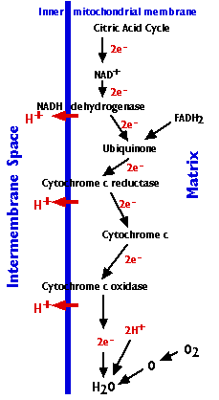
The four complexes of integral membrane proteins that make up the respiratory chain accomplish the following:
- the stepwise transfer of electrons from NADH (and FADH₂) to oxygen atoms to form (with the aid of protons) water molecules (H₂O)
- harnessing the energy released by this transfer to the pumping of protons (H⁺) from the matrix to the intermembrane space
- protons are pumped at 3 (of the four) complexes
  - the NADH dehydrogenase complex
  - the cytochrome c reductase complex
  - the cytochrome c oxidase complex
- an average of 3 protons are pumped out at each complex as each pair of electrons passes through it. Thus some 9 protons are pumped for each pair of electrons contributed to the respiratory chain by NADH; (6 for each pair contributed by FADH₂).
- the gradient of protons formed across the inner membrane by this process of active transport forms a miniature battery
- the protons can flow back down this gradient, reentering the matrix, only through another complex of integral proteins in the inner membrane, the ATP synthase complex.

Chemiosmosis in mitochondria
The energy released as electrons pass down the gradient from NADH to oxygen is harnessed by the
- NADH dehydrogenase
- cytochrome c reductase
- cytochrome c oxidase
complexes to pump protons (H⁺) against their concentration gradient from the matrix of the mitochondrion into the intermembrane space (an example of active transport). 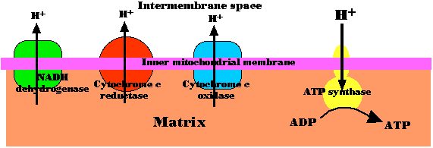
As their concentration increases there (which is the same as saying that the pH decreases), a strong diffusion gradient is set up. The only exit for these protons is through the ATP synthase complex. As in chloroplasts, the energy released as these electrons flow down their gradient is harnessed to the synthesis of ATP. The process is called chemiosmosis and is an example of facilitated diffusion.
One-half of the 1997 Nobel Prize in Chemistry was awarded to Paul D. Boyer and John E. Walker for their discovery of how ATP synthase works.

How many ATPs?
It is tempting to try to view the synthesis of ATP as a simple matter of stoichiometry (the fixed ratios of reactants to products in a chemical reaction). But (with 3 exceptions) it is not.
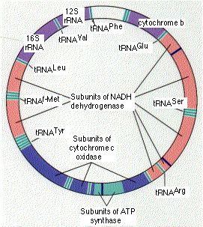
Most of the ATP is generated by the proton gradient that develops across the inner mitochondrial membrane. The number of protons pumped out as electrons drop from NADH through the respiratory chain to oxygen is theoretically large enough to generate, as they return through ATP synthase, 3 ATPs per electron pair (but only 2 ATPs for each pair donated by FADH₂).
With 12 pairs of electrons removed from each glucose molecule,
- 10 by NAD⁺ (so 10x3=30); and
- 2 by FADH₂ (so 2x2=4),
this could generate 34 ATPs.
Add to this the 4 ATPs that are generated by the 3 exceptions and one arrives at 38.
But
- The energy stored in the proton gradient is used for a number of other mitochondrial functions such as the active transport of a variety of essential molecules and ions through the mitochondrial membranes.
- NADH is also used as reducing agent for many cellular reactions.
So the actual yield of ATP as mitochondria respire varies with conditions. It probably seldom exceeds 30.

The three exceptions
A stoichiometric production of ATP does occur at:
- one step in the citric acid cycle yielding 2 ATPs for each glucose molecule. This step is the conversion of alpha-ketoglutaric acid to succinic acid.
- at two steps in glycolysis yielding 2 ATPs for each glucose molecule.

Mitochondrial DNA (mtDNA)
The human mitochondrion contains 5-10 identical, circular molecules of DNA. Each consists of 16,569 base pairs carrying the information for 37 genes which encode:
- 2 different molecules of ribosomal RNA (rRNA)
- 22 different molecules of transfer RNA (tRNA) (at least one for each amino acid)
- 13 polypeptides
The rRNA and tRNA molecules are used in the machinery that synthesizes the 13 polypeptides.
The 13 polypeptides are subunits of the protein complexes in the inner mitochondrial membrane, including subunits of NADH dehydrogenase, cytochrome c oxidase, and ATP synthase. However, each of these protein complexes also requires subunits that are encoded by nuclear genes, synthesized in the cytosol, and imported from the cytosol into the mitochondrion.

Mutations in mtDNA cause human diseases.
A number of human diseases are caused by mutations in genes in our mitochondria:
- cytochrome b
- 12S rRNA
- ATP synthase
- subunits of NADH dehydrogenase
- several tRNA genes
Although many different organs may be affected, disorders of the brain and muscles are the most common. Perhaps this reflects the great demand for energy of both these organs.
Some of these disorders are inherited in the germline. In every case, the mutant gene is received from the mother because none of the mitochondria in sperm survives in the fertilized egg. Other disorders are somatic; that is, the mutation occurs in the somatic tissues of the individual.

Example: exercise intolerance
A number of humans who suffer from easily-fatigued muscles turn out to have a mutations in their cytochrome b gene. Curiously, only the mitochondria in their muscles have the mutation; the mtDNA of their other tissues is normal. Presumably, very early in their embryonic development, a mutation occurred in the cytochrome b gene in a cell destined to produce their muscles.

Why do mitochondria have their own genome?
Many of the features of the mitochondrial genetic system resemble those found in prokaryotes like bacteria. This has strengthened the theory that mitochondria are the evolutionary descendants of a prokaryote that established an endosymbiotic relationship with the ancestors of eukaryotic cells early in the history of life on earth. However, many of the genes needed for mitochondrial function have since moved to the nuclear genome.
The recent sequencing of the complete genome of Rickettsia prowazekii has revealed a number of genes closely related to those found in mitochondria. Perhaps rickettsias are the closest living descendants of the endosymbionts that became the mitochondria of eukaryotes.
Further discussion of the evolutionary implications of mtDNA.

