Hormones:
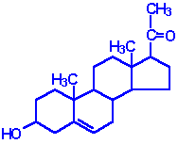 | Pregnenolone: produced directly from cholesterol, the precusor molecule for all C₁₈, C₁₉ and C₂₁ steroids
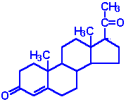 | Progesterone: a progestin, produced directly from pregnenolone and secreted from the corpus luteum, responsible for changes associated with luteral phase of the menstral cycle, differentiation factor for mammary glands
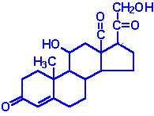 | Aldosterone: the principal mineralocorticoid, produced from progesterone in the zona glomerulosa of adrenal cortex, raises blood pressure and fluid volume, increases Na⁺ uptake
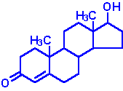 | Testosterone: an androgen, male sex hormone synthesized in the testes, responsible for secondary male sex characteristics, produced from progesterone
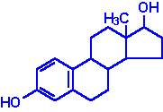 | Estradiol: an estrogen, principal female sex hormone, produced in the ovary, responsible for secondary female sex characteristics
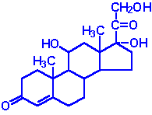 | Cortisol: dominant glucocorticoid in humans, synthesized from progesterone in the zona fasciculata of the adrenal cortex, involved in stress adaptation, elevates blood pressure and Na⁺ uptake, numerous effects on the immune system

Steroid Hormone Biosynthesis Reactions
The particular steroid hormone class synthesized by a given cell type depends upon its complement of peptide hormone receptors, its response to peptide hormone stimulation and its genetically expressed complement of enzymes. The following indicates which peptide hormone is responsible for stimulating the synthesis of which steroid hormone:
- Luteinizing Hormone (LH):
  - progesterone and testosterone
- Adrenocorticotropic hormone (ACTH):
  - cortisol
- Follicle Stimulating Hormone (FSH):
  - estradiol
- Angiotensin II/III:
  - aldosterone
The first reaction in converting cholesterol to C₁₈, C₁₉ and C₂₁ steroids involves the cleavage of a 6-carbon group from cholesterol and is the principal committing, regulated, and rate-limiting step in steroid biosynthesis. The enzyme system that catalyzes the cleavage reaction is known as P450-linked side chain cleaving enzyme (P450ssc), or desmolase, and is found in the mitochondria of steroid-producing cells, but not in significant quantities in other cells.
Mitochondrial desmolase is a complex enzyme system consisting of cytochrome P450, and adrenadoxin (a P450 reductant). The activity of each of these components is increased by 2 principal cAMP- and PKA-dependent processes. First, cAMP stimulates PKA, leading to the phosphorylation of a cholesteryl-ester esterase and generating increased concentrations of cholesterol, the substrate for desmolase. Second, long-term regulation is effected at the level the gene for desmolase. This gene contains a cAMP regulatory element (CRE) that binds cAMP and increases the level of desmolase RNA transcription, thereby leading to increased levels of the enzyme. Finally, cholesterol is a negative feedback regulator of HMG CoA reductase activity (see regulation of cholesterol synthesis). Thus, when cytosolic cholesterol is depleted, de novo cholesterol synthesis is stimulated by freeing HMG CoA reductase of its feedback constraints. Subsequent to desmolase activity, pregnenolone moves to the cytosol, where further processing depends on the cell (tissue) under consideration.
The various hydroxylases involved in the synthesis of the steroid hormones have a nomenclature that indicates the site of hydroxylation (e.g. 17a-hydroxylase introduces a hydroxyl group to carbon 17). These hydroxylase enzymes are members of the cytochrome P450 class of enzymes and as such also have a nomenclature indicative of the site of hydroxylation in addition to being identified as P450 class enzymes (e.g. the 17a-hydroxylase is also identified as P450c17).

Steroids of the Adrenal Cortex
The adrenal cortex is responsible for production of 3 major classes of steroid hormones: glucocorticoids, which regulate carbohydrate metabolism; mineralocorticoids, which regulate the body levels of sodium and potassium; and androgens, whose actions are similar to that of steroids produced by the male gonads. Adrenal insufficiency is known as Addison disease, and in the absence of steroid hormone replacement therapy can rapidly cause death (in 1--2 weeks).
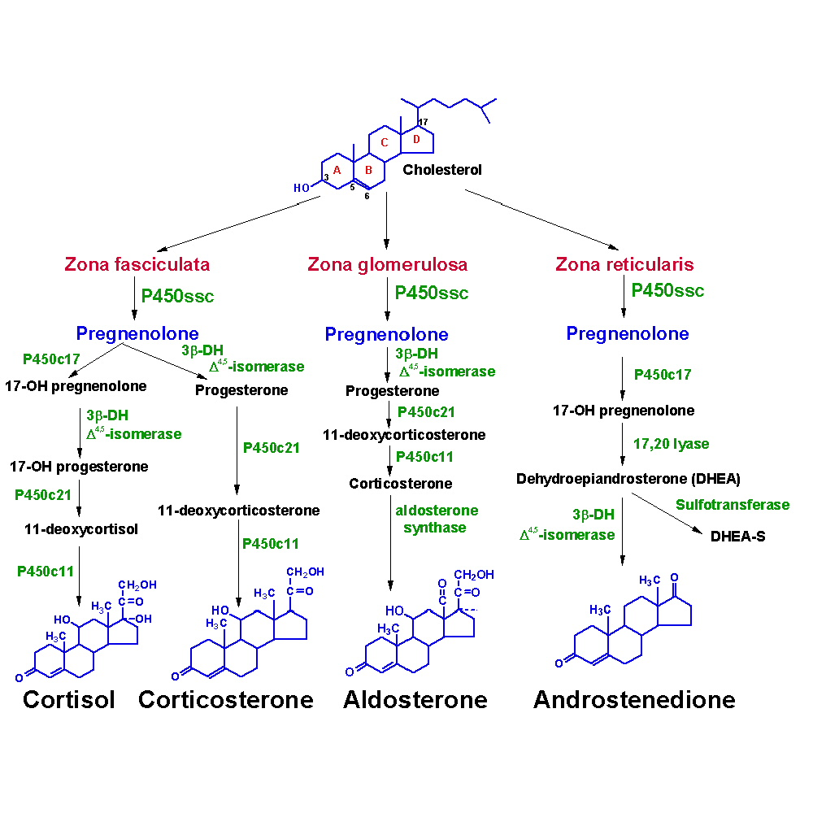
The adrenal cortex is composed of 3 main tissue regions: zona glomerulosa, zona fasciculata, and zona reticularis.
Testosterone
Testosterone is an anabolic steroid synthesized primarily by the testes in males, the ovaries in females, and adrenal glands in both sexes. Testosterone is synthesized from androstenedione, a product of dehydroepiandrosterone (DHEA) and progesterone, both of which are products of pregnenolone and cholesterol.
At puberty, and throughout most of the reproductive years, approximately 10-20 times more testosterone is synthesized in males than in females. In males at puberty, the much higher level of testosterone is responsible for the development of male external genitalia and secondary hair patterns, stimulation of spermatogenesis, stimulation of anabolic activity leading to increased muscle mass, and behavioral changes. In pubescent females, testosterone effects are more subtle but equally important for proper musculo-skeletal development, general anabolic activity, and libido. In both sexes, testosterone enhances aerobic metabolism and increases protein synthesis.
Testosterone decreases with age in both men and women. Testosterone replacement has been used to treat some postmenopausal symptoms, especially lack of libido in women who have received chemotherapy. It has also been used effectively in the treatment of anemia and the weakness and muscle wasting syndrome associated with AIDS. Recent research on the effects of testosterone on aging demonstrates a gain in lean body mass and a possible decline in bone loss when used in elderly patients.

