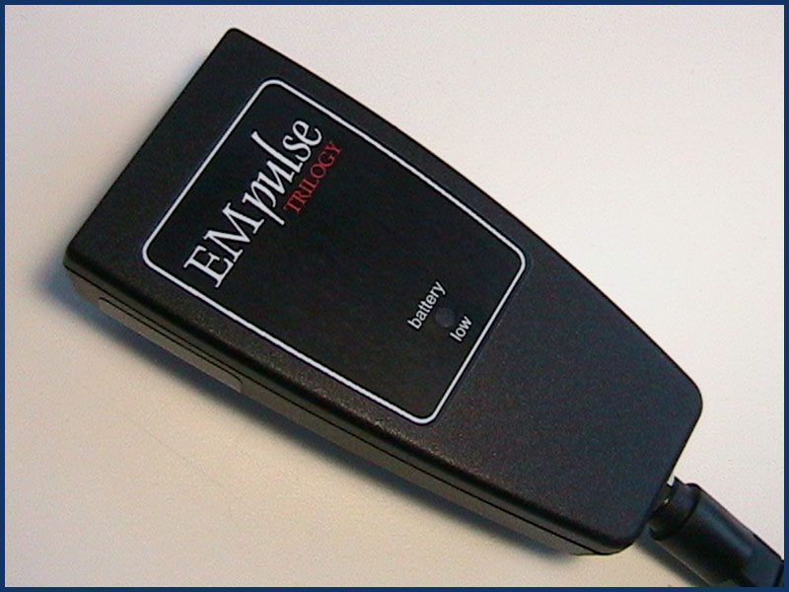
Em – pulse::
First in US to study Pulsed Electromagnetic fields and soft tissue injury in humans. (1980)

First investigators to describe the effects of Free Radicals in musculoskeletal pain and injury (1990)

First to describe the beneficial influence of pulsed electromagnetic fields on antioxidants and free radicals

Most portable, least expensive device in the world
First to describe the role of antioxidants and free radicals in “overuse” injuries such as low back pain, carpal tunnel disorder, and other injuries involving bones, muscles, and joints.
2003 - Proven effective by 4 year NASA study.
The following is for historical information only and does not constitute a recommendation for treatment of any conditions mentioned nor a warranty of result for any conditions mentioned.
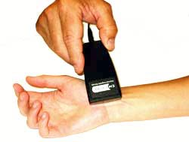
When I began using PEMF devices in late 1979 I saw results I'd never seen from a therapy device before. I questioned if something that could heal an injury so rapidly might not have an unforeseen sinister effect. Failing to understand the mechanism of its action, I considered discontinuing the use of PEMF devices. Fortunately for thousands of patients, I didn't follow that logic, mainly because nothing I read in the rather scanty literature of the day, nor any results in my then limited experience indicated the device was other than "what you see is what you get" in terms of results. In my humble opinion, they were spectacular. Some colleagues vigorously disagreed with that assessment, although few of them took the time to investigate the technology. In sports medicine I focused on track and field, eventually treating athletes from around the world at every level of achievement. Prior to the Los Angeles Olympics our clinic looked like the United Nations as numerous athletes who were training in this country faced the choice of returning home or being seen in my office to receive PEMF treatment. For several years coaches asked me to join their teams at the NCAA Track and Field Championships; while coaches and athletes loved it, the PEMF device created some interesting moments with a few meet doctors.
In 1984, at their request, I returned to FDA headquarters to discuss our findings with their scientists and investigators. None of us understood anything about the mechanism of action; some chided, "yes, it's free of side effects, but does it have any effect at all?" EM mechanism(s)- ah, sweet mystery of life!
Saw fractures hardly pause as they healed. After ten days, in disbelief, I sent one patient to the radiologist who had taken the original X-rays; he called to report, "no fracture apparent", then inquired, " what did you treat it with"?
Early in the course of our investigation, a physicist friend and open doubter of the device treated a running injury without success, which only confirmed his beliefs. You never win them all in life, not even some you should have. He continued seeing me as a patient, and remained a doubting friend. A couple of years later, after several weeks of failed treatment by his university's athletic trainer, he came to see me. After a rather intense discussion about our respective positions, he reluctantly agreed to try the device "one more time". Taking it home over the weekend, he treated himself Friday evening, then lay awake all Saturday night trying to understand why the device made him feel well enough to complete a run on Saturday and again on Sunday. Imagine the joy his lack of sleep elicited in me upon my anxious inquiry on Monday morning. Joining our research meetings after that, his insights most assuredly benefited us, albeit "me questions whose questions brought him there."
We won more than we lost with low back pain and sciatica. Never cured it, but frequently relieved the pain, without narcotics and minimal down time. Tennis elbow and groin injuries were a "crap shoot", some responded, some didn't, but those who did were happy campers indeed. Carpal tunnel syndrome was unresponsive unless treated very early, we rarely encouraged anyone to try EM-PROBE Technology with chronic CPT sydrome. Achille's tendinitis, unless acute, save your money. Helped some cases of plantar fasciitis, again very time sensitive. Acute stress fractures responded well, chronic stress fractures were iffy.
Top of Page
Please allow me to reiterate that our experiences are for your information only, not to serve as a treatment recommendation or implied warranty they might apply to you. Not everyone responds in the same manner to PEMF, therefore regardless of the condition, discuss it with your health care provider. We are happy to have you or any health care provider contact us with questions of a general nature or regarding our bibliography. If we can answer them, we most assuredly will, if we can't, we'll tell you why.
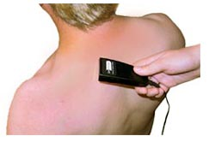
One patient with a unique specialty in marine welding traveled all over the world at the behest of shipping companies in need of his expertise. He grimaced into our clinic one day, walking with his head propped toward the wall in his contorted, tortured, gait, his hand firmly affixed to the middle of his low back. We treated him one time for 30 minutes. The next morning he walked in, apparently none the worse for his prior agony, and said, "I want one of those!" pointing to the PEMF device. I advised I couldn't sell him one, fearing some breach of the law. He said, "man, I'm Canadian". He paid for it out of pocket, and I never saw him again. I presume he's still traveling around the world, his welding stinger in one hand and the PEMF unit in the other. He'd been plagued for years with acute back flare-ups, and never wanted to be without that PEMF unit again.
The response we saw with acute peripheral nerve injuries in distance and cross country runners, along with our experience treating sciatica, made us hopeful we could positively impact acute spinal cord injuries. Our research group found an approved spinal cord injury model, then made an application to NIH for funding. NIH gave us fair consideration, but asked FDA scientists to referee the application and everything stopped.
We played that cat and mouse game several times and lost each time. Our hope for stopping the progression to quadriplegia in acute spinal cord injury lies untested, using a device with no reported side effects. It sometimes takes days for a spinal cord injury to progress from the original anatomic injury status to the final status as quadriplegia. Stopping the devastating chemical degradation of the cord with a device that requires no surgery and has no side effects seems reasonable to me. If it doesn't help them, it sure won't hurt them. That field is beginning to level out, and someday a youngster will be given that chance. I hope I'm alive to see it.
Lastly, I must share my own anecdotal experience with PEMF. I suffered my first heart attack when I was 38 years old. Scared the Boo out of half the people in town. I was in good shape and bingo, almost died. I was told I had 1, maybe 2 years to live; too much dead heart muscle. Ten years later, and not to be confused with a banana split, I had a "chest split" and a fist full of bypasses; then I became confused. What part of the chest pain was heart pain (angina)? It all gets worse if you keep exercising. I'm now 20 years after the surgery, outlived one of the guys that told me I was a goner in 1-2 years, but I still can't tell if it's angina or not; at least not with any accuracy. Because I was convinced some of this was arthritis in my ribs and sternum, I began using PEMF when I got pain, and I started sensing less pain, all of it.
Scientists have shown that angina is associated with, probably caused by, the immediate production of reactive oxygen species (ROS) or oxidants. I have proposed to the scientific community that PEMF helps "antioxidants" neutralize these destructive oxidant species (ROS). I neither can, nor would I tell you to treat your angina with a PEMF device, but you might want to give your health care provider a "heads-up". There are some pretty clever fellows in Europe and the US who are beginning to smell this one out (see bibliography). We scoff at the Russians, but they've been treating angina and other heart problems with PEMF since the 1970s. Perhaps our scoffing is justified; maybe they'll have the last laugh.

