Galvanic Skin Response Meters:
The Ability Meter Model 3a takes advantage of state-of-the-art electronics to provide the highest quality available in biofeedback instrumentation using the Galvanic Skin Response (GSR) principle. The Ability Meter is specially designed to assist in one-to-one (two hand-held electrodes) and solo (single hand double-electrode) psycho-therapeutic and personal development procedures. Indeed, there are many situations in which it is extremely helpful to be able to detect the presence of emotionally charged, suppressed mental content just below or at the borders of subconsciousness. This is a tremendous aid in assessing which of many specific topics is most relevant to be treated and at the same time, such material is also accessible and readily viewable by the subject. This can save many hours of wasted searching and discussion and when you have used an Ability Meter for a short time you will wonder how it is possible to be effective in developmental therapies without one!

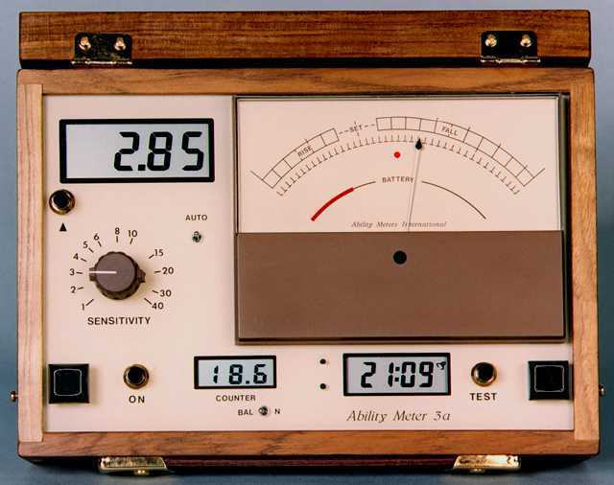
Price: 525 GBP NZ$`1440.00

The GSR & Bilateral Meter Course
A free on-line course teaching basic and advanced biofeedback monitoring skills in the context of transformational psychotherapy
The Ability Meter Model 3a takes advantage of state-of-the-art electronics to provide the highest quality available in biofeedback instrumentation.
The Ability Meter 3a was specially designed for solo (single hand double-electrode) use in psycho-therapeutic and personal development procedures. It can also be used for one-to-one (two hand-held electrodes) with a client. There are many situations in which it is extremely helpful to be able to detect the presence of emotionally charged, suppressed mental content just below or at the borders of subconsciousness. These can adversely effect a persons happiness and behaviour.
This is a tremendous aid in assessing which of many specific topics is most relevant to be treated and, at the same time, such material is also accessible and readily viewable by the subject. This can save many hours of wasted searching and discussion. When you have used an Ability Meter for a short time you will wonder how it is possible to be effective in developmental therapies without one!
The Clarity Meter:
The Clarity Meter is a revolutionary new biomonitor for use in the various modern processes of personal transformation.

Now, using the Clearing Biomonitor is easier than ever!
• Hands-off metering!
• Ultra-sensitive!
• Easy-to-see displays!
• All the information you need about session progress!
• Select "Fully Automatic" or "Reset on Demand"
The AutoReset™ is a long-awaited development, in response to practitioners, students and teachers of biomonitor-guided Clearing, who have sought a meter that does not require manual resetting of the range (TA) adjustment to compensate for changes in baseline range.

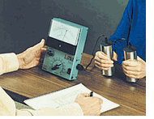
It is used for discovering and handling suppressed or repressed thoughts, memories and impressions which impact upon people's behavior and feeling of well-being. The utilization of the Clarity Meter can significantly enhance the speed and effectiveness of many kinds of developmental therapies, regression techniques and meditation procedures. Furthermore, its usefulness and versatility in the experimental exploration of the human thought process is unparalleled.

The Clarity Meter far surpasses other meters used for simple psychology demonstration purposes and clearing. It is the culmination of over fifty years of technical development in bio-monitors used in personal development techniques. It was designed to give the most premium performance, reliability and versatility available.
Special Features of the Clarity Meter include:
• Extremely Sensitive
• AutoSens and AutoReset
• Ultra-Modern Electronics

