The average frequency of the human body during the day time is between 62 and 68 cycles each second. If it drops below this rate the immune defense system will start to shut down. Cold symptoms appear at 58 cycles, flu at 57, candida at 55, glandular fever at 52, cancer at 42 cycles each second... Dr Young and Bruce Tainio. [Cheny University. WA. USA

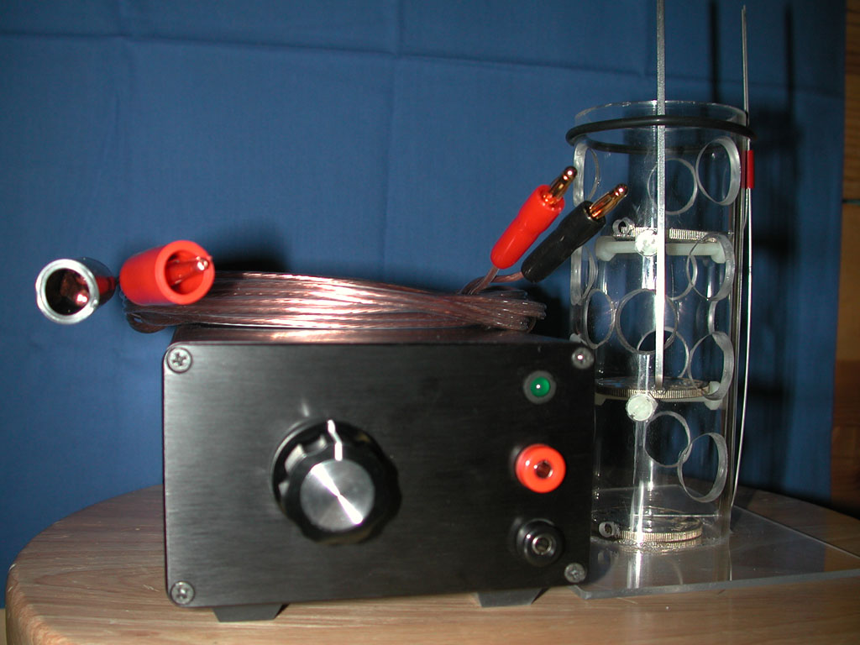
Hydro Chi:

Treat yourself to a Power Bath
and naturally vitalize your health!
The Hydro Chi is a DC bioenergy enhancer that is designed to boost your life force and energy levels in a 20-40 minute foot or full body bath using a quantum field. People who feel fatigued or tired are often suffering from a lack of bioenergy. This is sometimes called “Dead Battery Syndrome”. The HydroChi supplies this energy through water, charging the body’s electrolytes. Some people have trouble sleeping immediately after a bath because they are so “charged up”.It can be used in active or passive mode, that is bathing with theelectrodes in the water and energized or by charging the water first and removing the electrodes for the bath. It also assists the body in getting rid of toxins by openingthe pores of your skin.
Benefits for the user:
Affordable enough for home use
Two year warranty (except for electrodes)
Compact and lightweight with small cabinet footprint
Easy to operate
Body detoxification
Removal of Heavy metals
Microbes killed by ionized Silver
Increased Energy
Faster recovery time
Increased oxygenation in the body
Mental Clarity
Greater Sense of Well Being
Pain relief
Improved sleep
Reduced fluid retention
Headache relief
and much more...
Benefits for the Practitioner
Increase your bottom line
Easy set up and use
Built for heavy duty clinical use
Inexpensive, locally available replacement parts
Long life silver electrodes (approx. 40 hrs.)
Low price per session, typically $1 per minute
High client satisfaction
Repeat business
Usage Tip
Using a copper or stainless dish tub for a foot bath is nearly equal to a full body bath!
Improvements in the art
Most units of this type use stainless steel electrodes, and since the anode(s) of these devices erode as they do in electroplating processes, this results in a lot of nickel and steel particles in the water and I’m uncomfortable with that. Therefore my design uses silver for the main electrodes and a minimal amount of stainless to make the connection.
The electrodes are silver “rounds” of .999+ fine purity, one troy ounce, which can be found locally at coin shops anywhere. Ones with dents, scratches, etc. are fine and may be cheaper.They cost $6 - $10 each and only the anodes wear. They last 40 hours or more. Compare this with the 10-20 hours of use and $15-20 a set for the Q-2 and AquaChi.
I’d much rather be taking my bath in colloidal/ionic silver than colloidal steel/nickel! Wouldn’t you? Please let me know if you know of any microbe that can survive an ionic silver bath while the silver is being “cooked”.
In the course of studying (and repairing) the AquaChi and Q-2 B.E.F.E. devices , I have learned that they are different and each is best suited for different purposes. The Q-2 is best suited for detox and the AquaChi for energy boost. I have improved on the essential features of each and combined them into one unit that does both jobs better.
Specifications
Output is 24 volts DC, or pulsed DC, which is what the body responds best to. There are only two controls to operate, the mode switch and the pulse width/angle control. Mode switch down position is for detox and up for Power Bath. Special ramped waveform is adjustable in Power Bath mode.
Control starts at the off position of 12:00. Turning it to the 1:00 position outputs full power and maximum pulse width,and continuing to the 11:00 position of minimum power and pulse width. It’s like a volume control, but backwards. Bath should be started at maximum, turning it down as you wish.
There are no meters or indicators other than a power LED and an LED that varies in brightness with the current of the pulsed output signal. This is a cost effective substitute for meters and bargraphs found on the Q 2 B.E.F.E.™ and Aqua-Chi™ machines
Current is limited automatically to prevent premature electrodeburnout, which is the reason to monitor the current. It uses standard 120 volt AC power and has a grounded 3-wire cord for safety. High quality black anodized case will withstand dropping and abuse without functional damage.
The case is grounded and output is isolated from all AC wiring.
Electrode unit housing is acrylic plastic in a tower design. The water unit is therefore breakable if dropped. It is easily cleaned with a bottle brush. The silver is cleaned with a green scrubber - ScotchBrite.
Alternately, you can use CLR 50% solution.
A ten foot cord connects the power supply to the electrode unit giving plenty of flexibility for placing
the power supply in a place where it can’t fall into the tub. I find it convenient to place the power supply on the toilet seat when using it for a full body bath. For a foot bath, place the power supply on a convenient table or chair.
Special!
I am currently offering the machine to the public for $1377.77, which is the distributor price. You must
normally buy a machine at full retail ($1977) in order to become a distributor. I will drop ship for you if needed. Compare with B.E.F.E. or Aqua-Chi machines and see the value offered here! They use stainless steel... Q-2 is $2199. AquaChi is $1399.
The HydroChi performs the essential functions of both!
Researchers:
Another version is available for researchers for use with an external frequency generator also for experimental use.This allows using frequencies “targeted” for best results. This unit has a switch for selection of either the internal pulse generator or an external one via BNC connector.
Single frequency units are also available.
Keith Perry, P. O. Box 340711, Austin, Texas 78734
(512) 267-0099
Radionic Devices:
I have developed radionic interfaces for my Plasma devices that modulate the input frequency. They have a witness well and stick pad, modifiedfrom the designs of T. Galen Hieronymous. Homeopathics are easily broadcast.Further research is proceeding...
A psionic detector/amplifier is available for direct injection into the plasma. Pickup is piezo quartz for heart or ajna (third eye) chakra areas.
Stand alone units are available as well.
These devices are high-pass filtered for bad intent:
BAD signals are reflected back to sender like bad SWR.
So use only the best of intentions with these systems...
Pulsed Plasma Devices
(with wave injection)
Cold plasma devices enhanced with magnetic and scalar fields. I will literally “build to suit”. Call me with your needs or send specs. You choose the features that you want. Personally, I find that the plasma pulsed by magnets eclipses all the other modes.
Pricing will vary according to what features you want and if you have your own power supply, function generator, etc..
You can also choose the packaging, ranging from a plastic box to an “anvil” case, like mine. Cases are a major cost factor. I chose heavy duty packaging for mine so it could be shipped anywhere and could be backpacked into the jungle and be charged by solar cells if the need arises. Besides, I’m rough on my equipment. It IS an instrument.
An aluminum tool case is my favorite for “city use”. 19” rack mount enclosures are available.
I can also build in a case you provide. A basic pulsed cold plasma machine would include:a plasma tube with proprietary Ar/Ne mixture,switchable magnetic scalar pulser assembly,
AC power supply (50/60 HZ, 120/240 V),
12 volt operation is standard (includes car cord), external only frequency input capability.
Frequency counter/generator not included.In an aluminum tool case, this would cost $1495.
Options:
frequency injectors for pulsed plasma modulation higher quality aluminum briefcase or other case
battery for portable operation adjustable plasma/pad/piezo output external plasma tube output external magnetic coil /LED/laser output Plasma tubes with Xe, Kr, He, Ar, or Ne mechanical timer
LED emitter wands in the UV range as well as IR and visible colors Here is an example of a machine I built for a man in California:
Shown are four of the six plasma tubes and LED array.
Also not shown are laser probe, scalar magnetic pulser, scalar Mobius lcoils, tube pickup ring and probe.
A lab type generator is recommended for ease of use, such as the B&K 4011.( a separate generator and injector is needed for each frequency you wish to inject into the plasma) 1st(fundamental), 2nd, and 3rd harmonics are typically detectable at the tube with a frequency counter.
Cold Plasma research is a cutting edge, exciting field:…Plasma Weapons, Force Fields, Free Energy, Biological Defense, etc..Don’t get left behind!
Whether or not it’s the (bio)photons being affected by the magnetic field, who knows...but plasma (charged particles) are accelerated by magnetic fields. And plasmas affect other nearby plasmas. The sun (plasma) affects the Northern Lights.From microscopic (even subatomic) to macroscopic, plasmas affect other plasmas. 95% of “occupied” space is plasma.
It’s the photons, phonons, magnetic field (scalar), electric field, pressure wave, microwaves, acoustic waves, etc. in combination, working synergistically, in my opinion. They are effective individually,but together they multiply, rather than add. I don’t know... maybe it’s just a supercharged light and sound machine.But it works...better than a standard HV machine (as interactive art).
In my own experience and my wife’s, I can tell you that we can “feel” the emission more when the plasma tube is in front of the scalar assembly and even more so when it is pulsed (by a factor of about ten!). When the magnetic “beamers” are pulsed alone, there’s almost no effect felt and the frequency does not read out on the counter. But you can hearit (louder).
On the other hand, maybe we’re just hallucinating: there’s a lot of mold... ;) If it’s placebo effect, everyone who has tried it is also highly suggestible.Since my first test was blind, I don’t think that’s the case.
The device has erased a Palm III and floppy disks from 5-6 feet away. Fields detected by a Tri-Field meter are not strong enough to do this...

