


Code 1230 -- Price: $2,495.00
he importance of detoxification is a cornerstone of the naturopathic and emerging CAM communities, and is a frequent topic throughout the AO website. The ionCleanse® machine, which uses ionic exchange to draw toxins out of the body through the feet, is the latest is a series of machines to come out of Australia, Russian, and the U.S. The common feature that binds these machines together is ability to draw metals out of the body through the feet. (A number of laboratory reports, widely circulated on the internet, show rather substantial reductions in tissue and blood samples of toxic metals -- before and after treatment.)
Our interest in ionCleanse® was not so much any claims made by the manufacturer as it was the reliability of testimonial inputs we were getting from users who happened to be our own customers. Once we confirmed that these reports of pain relief (similar to reports we regularly get about the Prologue from Russia), reduction in liver and age spots and other dermatological signs of toxification, etc., were valid -- and not emanating from some overzealous multi-level marketing promoters, we investigated further.
The inventor of ionCleanse® openly proclaims that the idea is not original. His desire was to improve upon the Q2 B.E.F.E. Water Energy System (see Wolfe Clinic). B.E.F.E. is short for "Bio Electric Field Enhancement" -- see explanation of operation. This machine carries similarities to the Aqua-Chi machine, and the Q2 Energy Spa, now also sold widely in Australia.

Keepin' it Real ...
We hate to resort to freshly minted vernacular cliches -- this one currently overpopulating the "hip hop" scene, well vested in its contempt for any pretense to show mastery of the English language ... but forgive us. It fit. We are always perplexed when a company, or even group of competing companies, develop a technology that has real potential in the alternative health care community, and then trash it with unnecessary hyperbole.
The pictures above (showing Q2) are in circulation on the internet to show "how much toxic residue will be removed from your body." And it would be pretty impressive if this, or any other similar device, were removing the quantity of toxic metals and organic materials that these and other pictures suggest. Here's the problem --- most of the visuals are supplied by the interaction of the water with salt (added to increase conductivity) and the metal plates that feed microcurrent into the water. If you do your own experiment and KEEP YOUR FEET OUT OF THE WATER and run a "footless" session, you will see for yourself. If you purchase the ionCleanse® machine, do so because the reported health benefits appear to be real, cost of operation is minimal, reported side effects are non-existent, and you can afford it. Keep the visuals out of the picture. The yardstick you should use to measure the value of this technology in your own life is what it does for you. That's what we did, and it's why we decided to carry the ionCleanse®.
We feel that many of the claims concerning this general area are overplayed. (It is hard to imagine, for instance, what kind of quantitative measure you would use to prove that your machine was mimicking the medicinal quality of the famous waters at the Lourdes in France.) Nonetheless, both clinicians and frequent users would do well to investigate this area thoroughly. There are too many earnest people who are reporting tremendous results. (The maker's own site has a respectable list of earnest testimonials.) And no one appears to be reporting any side effects.
And this is precisely why we decided to add it to our line.

What You Purchase
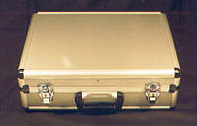
All but the array (the component that goes into the water next to your feet) come in an attractive, highly organized carrying case.
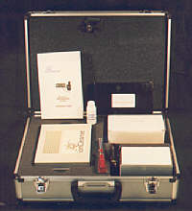
The case stores the control panel (or "main box"), the power supply, a 50 minute VCR tape ("ionCleanse® Product Demonstration"), a 23 page booklet ("ionCleanse® Electronic Detoxification System - Instruction Guide"), the brochure in PDF format, and two product samples from the ionCleanse® company. You also get an extra array set (the metal parts of the array wear out after about 50 thirty-minute sessions). The video tape shows you step-by-step how to replace the heart of the array, though anyone mechanically inclined will be able to do it intuitively.
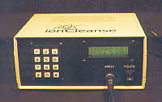
The control panel is the brains behind the product. You use this device to program positive and/or negative ion generation by the array, the duration of a session, check conductivity of your water in terms of amperage, etc. If it sounds confusing, it isn't. The Instruction Guide is very organized and easy to understand.
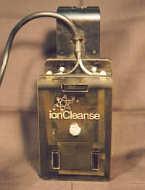
The array generates the ions from current sent by the control panel. The model above is worn from many uses performed by our staff in experimenting with the unit. It is of solid construction, requiring only the occasional replacement of the metal plates. (The process is demonstrated in the video).
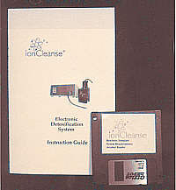
The literature provided takes the guesswork out of running the machine. The digital brochure on disk is in PDF format. We reproduce it here for your convenience, though it will take considerable time to download (at 885k) if you don't have a broadband connection. This digital brochure is beautifully done, with testimonials and a general description. However, at just two pages, remember that it is still just a brochure. You will still need your Instruction Guide for all the meaty instructions.
