Living From Vision
Personal Growth / Consciousness / Alternative Health
Personal Growth  Alternative Health  Contact us (Click here) | The SE-5 Plus  Intrinsic Data Field Analyzer  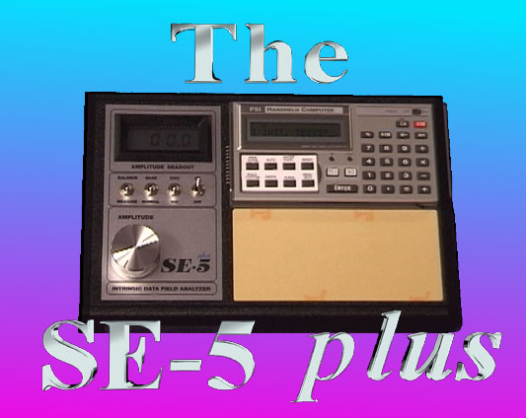  What you will recieve when you order your SE-5 plus:
  Home
  Living From Vision
  Self Study Course
  Books, Music,
  Guided Imagery Tapes
  Video tapes about dolphins
  Bob Beck Instruments
  The SE-5 plus
  Tuned Geometrics and Other Related Products
  Links to Other Websites

The SE-5 plus comes with a computer ( a calculator type computer). The PSI computer has many programs built in (36 programs) and you can make 17 custom programs that you can make yourself.
The best information (most complete) is in the book Regaining Wholeness Through the Subtle Dimensions by Don Paris.
Regaining Wholeness
Through the Subtle Dimensions

Top of Form
Qty.
Bottom of Form
Regaining Wholeness Through the Subtle Dimensions
$15.95
( Click here to read Regaining Wholeness online FREE)
The SE-5 plus is an experimental research instrument and no claims can be made to its effectiveness.
The SE-5 comes with a book of 14,000 Tunings. (The software for IBM has about 17,000 Tunings in it.)
The purchase of the SE-5 plus comes with 2 hours of personal training (phone) .
Warranty is 1 year, parts and labor.
The SE-5 plus and accessories sells for $2695.00 in the US.
The cost of shipping is about $50.00 in the U.S. and $90-150 outside the U.S.
Shipping will be billed seperately depending on your location.
The SE-5 plus package comes with the following:
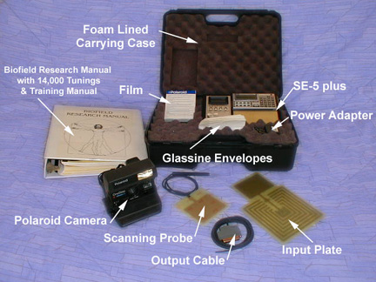
- SE-5 plus instrument
- B4 program (Health analysis program)
- Affirmations Program
- Mineral Program
- Subtle Balance Program (chakras, aura, tissue salts etc.)
- Agriculture Program
- Organ IDF Balance Program
- Pathogen IDF Balance Program
- 17 Custom Programs (that you design)
- Carrying case
- Camera and film
- Input Probe
- Output Cable
- Input Plate
- A/C Power adapter (USA version)
- Training manual
- Training video
- Book of Tunings (aprx. 14,000 Tunings)
- Instruction book
Also included: 2 hours of telephone time for personal training.
SE-5 Plus and accessories
$2695.00
Top of Form
Qty.
Bottom of Form
The optional IDF software for IBM or Mac allows you to make an infinite number of custom programs and keep track of all your subjects etc. Software is $550.00 for IBM Compatible and $600.00 for MAC software.
IDF Software (IBM)
$550.00

