Rife frequencies:
It is always best to give a first time client all the top 18 frequencies. Although they may come to you with a diagnosis from a lab or a health care provider of this parasite or that bacteria, that diagnosis may be incorrect or incomplete. At worst, they will spend a few more minutes sitting back reading a book, or taking a nap while they are being 'Rifed'. At best, they will be rid of a set of infections that they never knew about which were lowering their vitality.
Parasites | 72 |  | Rubella | 787
Parasites | 95 |  | Tuberculosis | 800
Parasites | 120 |  | E. Coli | 802
Lyme Disease | 432 |  | Streptococci | 880
Candida | 465 |  | Herpes | 1552
Common cold | 660 |  | Typhoid | 1865
H. Pylori | 676 |  | Sarcoma | 2008
Staphylococci | 727 |  | Carcinoma | 2128
Diphtheria | 776 |  | Arthritis | 2489

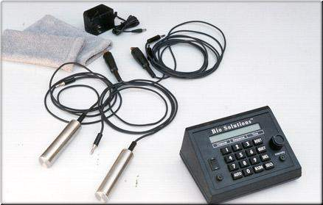
BioSolutions - Model E Bio-Active Frequency Generator
Frequency Healing will be the "Medicine of the Future"
THE FUTURE IS HERE NOW at WellnessTools!
Some of the great geniuses of this century, such as Rife, Tesla, and Lakhovsky have opened the door for further development in the field of bioenergetic healing through the use of frequency generators. Though this technology was suppressed in the 1930's and 1940's in the U.S., because of its threat to the pharmaceutical industry, it has resurfaced with an explosion of interest throughout the world!
Royal Rife, one of the greatest medical minds in history, found that he could cure diseases by shattering the membranes of viruses, bacteria, fungi, and parasites through the use of frequencies. He proved over and over, that by destroying these pathogens quickly and without side effects, he could eliminate the disease associated with it. He created the blueprint of the frequency generators which we have today. "Microbes can be killed with frequencies instead of drugs and chemicals."
Great engineering minds and advanced technology have made the latest generation of frequency generators extremely high quality.
What does a frequency generator do?
When connected to a living organism (plant, animal, or human), it can transmit a specific frequency from a very large range of frequencies. What researchers are discovering today is that every bacteria, virus, fungus, and parasite has its own frequency which can be identified. Once a frequency of a pathogen is known, it can be destroyed by an increased amplitude of its own frequency. The membrane walls are shattered and the pathogen soon dies.
What can this mean for mankind? Well, it means that any disease which is caused by a pathogen, can be reversed by destroying the pathogen and restoring the individual back to wellness. The best part is that the healthy cells will not be affected, since they function on a different frequency. "There is coming a time in the near future when all diseases will be irradicated, most by the use of frequency devices and others by as yet to be discovered means."
The Rife generators of the 1930's are much improved today, through the use of solid-state circuitry and the accuracy of the frequency selection. They are no longer hard to find and expensive. Some of these generators were over $5000 dollars and now they can be purchased for under $2000.
One such frequency generator is the BioSolutions Model E Bio-active Frequency Generator. It is compact, very accurate, holds its frequencies and is easy to use. It is so simple, anyone can use one. It is a superior Rife Frequency Generator and unlike other generators, holds 574 pre-programmed sequences of conditions. Each sequence holds up to 32 frequencies each, along with an adjustable time control for each sequence. It has over 12 years of clinical trials attributed to it and comes with an easy-to-read manual. At a price of $1990.00, it is a bargain for a highly accurate frequency generator that practically runs itself. It is light-years ahead of the other frequency generators which we have intensively researched. This one is highly recommended!!!

Rife Clark and Crane
There is a great deal of confusion regarding the various frequency lists. To explain there are three.
The Crane frequencies are from 20 to 10,000 hertz
The Clark frequencies are from 80,000 to 800,000 hertz.
The Rife frequencies are from 500,000 to 13,000,000.
Which to use?
The higher the frequency the faster and more effective the session so use Rife first, Clark second and Crane last. In some cases the microorganism you want to kill may only be known in one range and not the other, so use what is available.
Only machine to do all three
Our device is the only machine on the market that will give you access to all three sets of frequencies, so you don't have to worry that the frequency you need won't be available.
What are the Real Rife Frequencies
When Rife isolated the virus that caused cancer (carcinoma) , the frequency he used was 11,780,000 hertz. We know this because we now have Rife's original lab notes and we can see what frequencies he used.
Click here to see a page from Rife's lab notes showing this frequency
So, how is it that all the other machines on the market are using frequencies from 0 to 10,000 hertz?
To understand how this happened, we need to go back to the beginning where it all started
Rife kills cancer virus with radio waves
In the 1930's Dr. Rife discovered that radio waves could destroy viruses and bacteria. He used frequencies from 160,000 to 12,830,000 hertz. We know this because we have access to his original lab notes. In addition, rather then writing letters, Rife dictated his correspondences to other physicians onto reel to reel tapes which we also have access to.
The tapes confirm what his lab notes indicate. That is that he used one frequency at a time, and the frequencies were 160,000 hertz and higher. He made a point to say that these frequencies were NOT in the audible range (0 to 18,000 hertz.)
Rife is attacked
When it became clear to the medical establishment that Rife did not want to sell his invention to them, they began to harass him. His lab was burnt to the ground more than once, and they dragged him through the courts. Unable to take the pressure, Rife turned to alcohol and became a broken man.
Crane takes over
At this time, Rife had an engineer who worked with him named John Crane. Mr. Crane made his own machine which put low frequencies (audio range) through the body with electricity.
Since by this time Rife was no longer making Rife machines, these Crane machines were all that was available. These Crane machines were being sold as Rife machines to an unsuspecting public, and are still being sold to this day.
Virtually all of today's so called Rife machines are really Crane machines.
Crane machines with transmission
A few years ago people began to do some research on Rife and found out that Rife never touched to body with electrodes, but rather he transmitted the frequencies from an antenna. Thus, the newest incarnation of machines were built. These utilized a gas tube antenna like Rife had.
These devices are an improvement on the traditional Crane machines in that they could now send the signals through the entire body, not just the tissue between the electrodes. Devices which are in this category are Bio-Ray, Beam-ray, Biotec-2000 and the Rife-Bare devices.
Of course, they still missed the boat. While these devices did transmit, they were transmitting the Crane frequencies.
Rife frequencies versus Crane frequencies
The Rife frequencies are much more powerful than the Crane frequencies. This is because the are faster. The Crane frequency for cancer is 2008 to 2127 while the Rife frequency for cancer is 11,780,000. In physics, the faster the wave the more power it has.
When you read about how Rife had a 100% success rate with cancer, remember that he only used his machine for 3 minutes every third day, and had complete remissions in 6 weeks.
With a Crane machine you need to use the machine 2 hours every day for months. Even after this time, the cancer may only slow down. This is again due to the power of these different machines.
Our machine is also used for only a short period of time. The first exposure should be limited to 3 minutes.
We know from Rife's research that his 11.78 million hertz frequency was used to destroy the BX virus that he proved caused cancer. How the Chrane frequency works is still a mystery. Does it attack the cancer directly, affect the virus, turn on the P53 aptosis gene? That the Chrane frequency works is clear, how it works is not

Cancer Frequency Compact Disk
Technical Considerations:
These compact disks and wire kits are a very cost effective way to apply Rife technology. The frequencies are pure square waves generated mathematically in a computer and then burned onto CD's that can be played in any standard CD system. The wire kit taps the amplifier from the headphone jack and sends the frequencies to 2 metal electrode plates as a low level square wave electrical signal. These plates are placed apart on the body or sat on.
Unlike the original Rife generators, which can cost up to $5,000, this system works with any good CD stereo with 120-150 watts of power (60-75 W per channel). If one doesn't own one, they can be purchased for under $260.00 or less at most discount outlets, such as Best Buy, Circuit City, Costco, etc. It can also be used to listen to music when not being used for treatments.
There are companies manufacturing Rife Generators that produce frequencies electronically (using oscillators) but end by transmitting them through the body in the same way as our system does: as a low power square wave electrical signal. One advantage the generators have is a virtually unlimited frequency generation range, meaning they can produce frequencies like 31,000 Hz, 31,750 Hz and 34,750 Hz which are the high frequencies used by the Mexican Clinic for AIDS treatment. A CD is limited to frequencies between 20 Hz and 20,000 Hz, the sound spectrum, so frequencies outside of this range may not be transmitted via this system.
Fortunately, most of the useful frequencies are between 20Hz and 10,000 Hz. In the original Rife literature we have, there is only one frequency outside these limits, which is 10 Hz. All the others are the result of more recent research. The entire objective of CD music technology was to improve sound quality and purity. This gives our disk system an advantage since it uses "off the shelf" technology and the cleanest (most noise free) amplifiers available. The oscillators used in some types of Rife Generators have a good chance of producing noise along with the frequencies. There can be other problems like frequency drift (inaccuracy) especially with less expensive Rife Generators.
The times of treatments are specific. Hepatitis C, for instance, uses 8 frequencies for 45 seconds each. Some Cancer frequencies are so specific they call for 3 minutes every 3 days. Most other frequencies are 5 minutes per day. (The time between treatments is a recommendation to allow the body to clear itself of dead viruses through normal waste elimination processes.) With most Rife generators, you must manually change frequencies at the proper time until you are done, although some other types are "automatic". With the CD's, each cut is the exact length of time recommended for each frequency treatment! So you simply start the CD, set the volume properly, restart it (so you get the full time the first cut) and go to sleep, if you wish, letting the CD play straight through and then shut off. (Do NOT set it for repeat settings!)
This electrotherapy will not interfere with any known "conventional" therapy (e.g. chemotherapy, radiation, etc.) and has no known side effects. One caution is for Diabetes sufferers. Even one treatment with this system using the diabetes frequencies can reduce your body's need for medication, or possibly induce too low a blood sugar. So if you use a disk treatment, make sure you test yourself before medicating again.
Since this is electrical in nature, you should be careful about the volume of your stereo. It should be turned to zero and gradually increased while the disk is playing until the point where the vibrations become uncomfortable and then turned back a bit. Remember that with resonance, volume is not the only important factor; proper frequency and time are just as important.
It's important to remember that unless you have the viruses or bacteria that the frequencies are designed to kill, the treatment will do nothing. There are no side effects, such as there is with chemotherapy or radiation. The human body has no crystalline parts that will be damaged by these frequencies and normalcells are resilient to the frequencies.
The suggested retail price for the CANCER CD, instructions and a set of electrodes is $499, plus $9.95 S/H. We are discounting it by $110 to $389, plus S/H. If you follow the instructions for application and are not 100% satisfied, we will refund $350 of this fee if materials are returned any time within 120 days of receiving them. However, in order to get documented reports of results, we have the following limited time offer:
George L. Schmidt, O.D.
Email: doc@i-care.net
The Ultimate B3 with RF and Sine Wave Capibility
Precision Model 2.4MHz Sweep / Function Generator
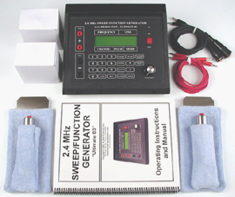
The Ultimate B3 - The most advanced frequency generator ever built! We know many, many others make that claim also - but just compare
for yourself as we did. Remember - "At ProgressiveDoctors.com we do our homework so you don't have to!" We have tried them all.
Having over 3500 pre-programmed automatic channels and capable of running up to 8 frequencies simultaneously makes it up to 8 times faster than any other generator. No other generator on the market has this advanced capability!
“The Ultimate B3 ” has both Sine AND Square wave capabilities and is the only generator on the market today that has two pre-set square wave duty cycle modes (50% or 90% for greater capibility and flexibility) and can modulate all frequencies on a built-in 2.4 MHz sine wave carrier frequency!
It has 21,800 Crystal controlled frequencies that can be accessed with a touch of a button. Because The Ultimate's frequencies are crystal controlled its accuracy is guaranteed not to drift. Just enter a frequency and that is the exact frequency you get!
The Ultimate B3 frequency generator contains over 3500 preprogrammed Auto Channels in the memory. An Auto Channel remembers up to 48 different frequencies, depending on what you want to potentially experiment with. This generator is so easy to use that anyone can run it. If you’re one of the many people wishing to experiment with frequency generators - The Ultimate B3 is the one to choose.
We are only able to sell this state of the art machine in the U.S. for your own personal investigation into the effects of frequencies.
A complete list of experimental frequencies for over 900 different conditions is provided in the most extensive manual ever published.
You will be very surprised and amazed when you buy this machine to experiment for yourself!
Includes: (see picture below)
1. One Ultimate B3 Function Generator (portable, approx. 5lbs.);
2. Accessories - Two (2) stainless steel hand cylinders (w/ teri cloth covers), Two (2) stainless steel foil strips (w/ teri cloth covers) for feet or specific body part; Four (4) heavy duty extension cables (2 pos. & 2 neg.) for simultaneous whole body capability;
3. Power Supply - Two (2) ac-dc outlet plug-in UL listed power adaptors.
4. Extensive Operational Handbook / Manual;
5. Free personal educational video;
6. * **Free personal educational discussions with Dr. Dixon, MD regarding his opinion of The Ultimate B3 as test equipment and various experimental modalities;
7. 1 year Factory Parts and Labor Warranty and 30 DAY MONEY BACK GUARANTEE (less $150.00 restocking fee).
Please look and compare our features with the features of other generators.
It would take 8 or more other frequency generators to match the experimental capabilities of The Ultimate B3. We did our homework, and this is the winner.
The Ultimate B3 incorporates the best of frequency generator research, which has spanned over 80 years, with the most advanced electronic technology for a truly superior design. MADE IN THE USA.
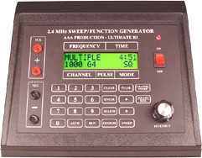
See additional advantages below and large close-up view
at bottom of page.
The Ultimate B3 / Advantages
1. Runs either single or multiple frequencies (up to 8 frequencies simultaneously)!
2. Is up to 8 times faster for each use!
3. Can connect to hands and feet at the same time (for whole body)!
4. Features: Sine, Square, Sweep and Pulse output!
5. Allows you to choose either 50% or 90% duty cycle for greater capibility and flexibility!
6. Has a mutant feature!
7. Can use in foreign countries with adapter!
8. Convenient, portable size.
9. Personal educational video.
Other Generators: price: US$1895
1. Can only run one frequency at a time.
2. Experiments take up to 8 times longer.
3. Cannot connect to hands and feet at the same time -
(can only experiment with half the body at one time).
4. Only some have the sweep feature.
5. None have the mutant feature.
6. Cannot change duty cycle (50% or 90%).
The Ultimate B3 Advantages / Number of frequencies
1. Has 2.4 MHz carrier frequency.
2. Has 21,800 crystal-controlled frequencies with perfect accuracy.
(.33 - 21,800 Hz.)
3. Can access all known Rife frequencies in Hz.
4. Can access experimental tissue frequencies for life-extension experiments.
5. No hidden codes for frequencies.
Other Generators
1. Some have as few as 3 to 250 frequencies claiming those are all you
need and limiting your ability to make use of available frequencies for new experiments.
2. Many are not crystal-controlled, claim high accuracy but are off by almost 1 Hz.
3. Some list code numbers rather than actual frequencies used.
The Ultimate B3 Advantages / Automatic Channels
1. Contains over 3500 pre-programmed automatic channels for experimentation on over 900 conditions.
2. Over 3 times as many pre-programmed channels as any other generator.
3. Pre-programmed channels can be run in 3 easy steps.
4. Each channel holds up to 48 frequencies.
5. Has 25 custom channels available for user programming.
Other Generators
1. Only two other models to date come pre-programmed and they do not have even 1/3 as many pre-programmed channels to choose from!
The Ultimate B3 Advantages / Personal Experimental Material
1. Complete and detailed - listing over 900 conditions using health care definitions.
2. Provides you with all necessary information to assist in selecting the appropriate pre-programmed channels for experimentation.
Other Generators
1. Usually, most other generators come with a few pages of operating instructions but limited health care terminology, making it hard to choose the correct experimental condition and greatly reducing your chance of satisfaction.
The Ultimate B3 Advantages / Affordability
1. List price $1895.00 + Free Shipping, Handling & Postal Insurance.
"We wanted to make it affordable for everyone".
Other Generators
1. Typically, other similar generators are nearly 2 to 5 times more expensive with less than half the features.
Customer Satisfaction
ProgressiveDoctors.com sets the standard for frequency generators and customer satisfaction. Look and compare. Check out the competition. First—just try and get in touch with them. They all fall short in every critical category.
**Government regulations require the following disclaimer:
All Information about "The Ultimate B3" on this website or otherwise is provided for personal educational purposes only and is not intended to be construed as medical advice nor are we intending to practice medicine or to lead anyone away from a doctor.
This 2.4 MHz sweep/function generator is test equipment. We cannot take any responsibility for those who use this equipment for personal experimentation into the effects of frequencies. Individual results
may vary; therefore, we make absolutely no claims of any cure for
any disease.
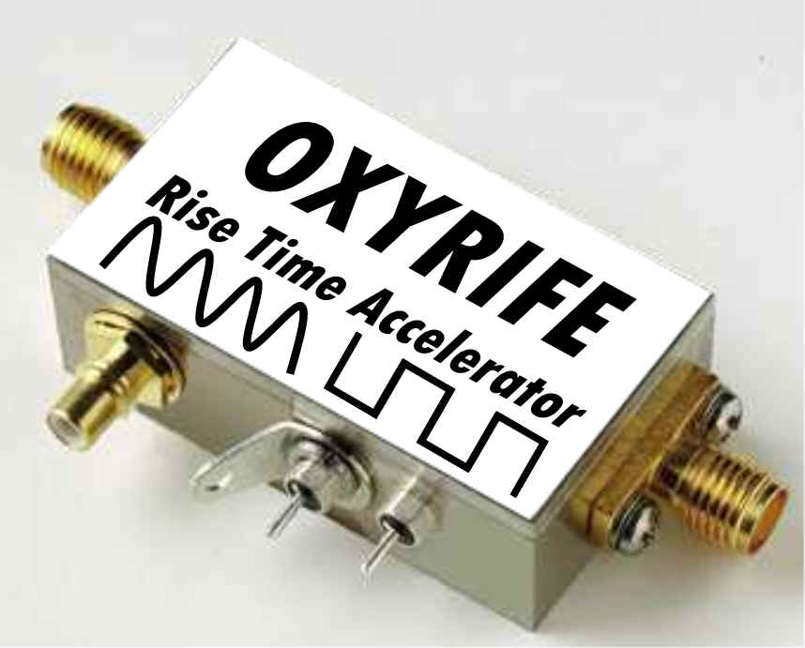
Our specially designed "Rise time accelerators" can turn almost any Rife machine into a SUPER Rife machine. The limiting factor in all Rife machines is in the transmitter which limits the rise time. Rise time refers to the amount of time it takes for the Rife wave to go from off to on. As an analogy, compare a car hitting a brick wall at 1 mile an hour to a car hitting a brick wall at 100 miles an hour. Although the car and the wall were the same, the effect is quite different. It is the same with Rife machines, the faster you can deliver the force to the pathogen, the more powerful the effect.

Most rife machines have a minimum rise time of 11.25 microseconds( millionths of a second).
This is because most Rife machines use equipment (like a CB radio) designed to transmit the human voice, not rife frequencies.
The human ear cannot hear frequencies with a rise time faster than 11.25 microseconds, so for voice transmitters, faster rise times were an unnecessary expense, and not designed into the circuitry. If your rife machine uses a voice transmitter (like a CB radio) you are unlikely to get a faster rise time than 11.25 microseconds. Often, a voice transmission rife machine will not even pass that.
With our "Rise time accelerators" you can increase the rise time, to 8.28 nanoseconds (billionths of a second) This is over a 1,300 fold increase in speed over the 11.25 microsecond rate, and more than a 12,000 fold increase in speed over the chart seen here. Our Rise time accelerators can be added on to any Rife-Bare system, and of course are available on our own Rife machines.
Because of the tremendous increase in rise time, the time spent in front of a rife machine will be greatly reduced, and the effect will become much more powerful. Please take this into consideration when designing protocols.

