The EPRT devices are non-invasive, therapeutic devices invented by Australian born, Keith Wendell, Ph.D. The devices have been shown in clinical studies to have the ability to stimulate regeneration of tissues as well as reduce the chemicals that aid the aging process in the body. When tissue regeneration occurs on the cellular level, healing occurs in every aspect of the body. The devices are designed to propagate an ultra-low frequency electrical current, using the body to complete the circuit. These ultra-low microcurrents behave like a steady stream, low concentration electron generator.
From what we know about the effects of free radicals and the mechanism of antioxidants in neutralizing them, we can see a remarkable similarity in the action of the ultra-low currents. The steady flow of electrons in a relatively low concentration appears to act exactly as one would expect from any antioxidant. The fact that these electrons are focused on a small region of the body may explain why healing changes appeared so rapidly. The actual regeneration of the tissue, coupled with the absence of the age factor in healing and the concomitant improvements noticed in the patients' general condition, all point to a highly potent antioxidant effect on the local tissues as well as generally.
Water is utilized as a conductive medium in order to conduct the current through the body. This is achieved by applying a moist conductive foam wrap to the parts of the body between which the current is to be channeled. A small electrode is then attached to the wrap. Most patients feel nothing, but sometimes a slight tingling sensation may be experienced. The devices are safe, easy to use and free of side effects.
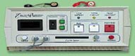 | 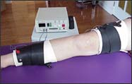
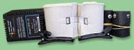
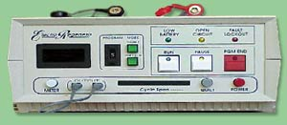
EPRT Devices For Pain and Wound Healing:
EPRT Device Accessories:

