The Syncrometer / zincrometer by Hulda Clark:
The Syncrometer is an electronic device developed by Dr. Hulda Clark to allow for the rapid and accurate detection of various substances in the human body. Based on her research into the causes of human diseases, Dr. Clark has discovered that all diseases are caused by only two things: Parasites and Toxins. If you eliminate either or both of these in the human body (or animals, too), disease can be eliminated. Unfortunately, although eliminating diseases such as cancer or AIDS from the body is relatively easy, rebuilding the damage they have done can be time consuming and difficult. I have read that for every year you are ill with a particular disease, it can take a month of doing everything right to regain normal health. Whether this is true or not, I'm not sure, but it sounds about right. The problem is, how many people are able to do everything right for even a few weeks, much less a few months! I do know it can take a long time to rebuild health that has been going downhill for years, so give health the time it needs and don't get in too big of a hurry.
To get back to the main subject, the Syncrometer is a wonderful device that can be built at home from parts that you can find at just about any Radio Shack, with a few parts from your local hardware store. The cost, depending on how you build the device, can be anywhere from roughly $15.00 up, typically about $40 - $50. It only takes a few hours to actually build one and anyone with even a basic ability to use a soldering iron can do a decent job. The hard part is in learning to use the Syncrometer after it has been built. (See the QuickSync Test Method) It is a very difficult device to master for most people, but, the rewards are outstanding for those willing to devote the time needed.
The Syncrometer works on the principle of matching resonance frequencies within the body. Everything in the universe vibrates at a particular frequency (usually multiple frequencies or a range of frequencies) that can be used to both identify a particular substance and, in the case of a biological organism, to kill or devitalize it. You can assemble a fairly large number of toxic substances for use in testing from items you already have in your kitchen, bathroom, garage, etc. This will enable you to test for a great deal more than you can ever imagine. What would it do for you to know that the particular brand of cereal you eat every day has benzene in it? How about Salmonella in the cottage cheese and milk in the refrigerator? Kids getting fussy and going off the deep end too often lately? Maybe they have a problem with Ergot or Aflatoxin from the bread and peanut butter they are eating. Now, with the Syncrometer, you can find out.
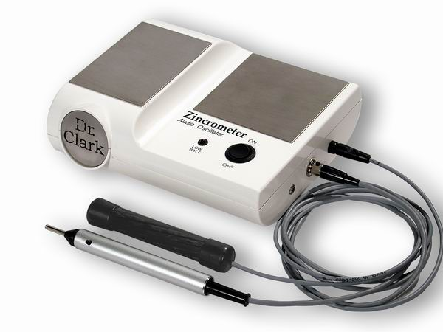
I have personally been using the Syncrometer on a regular basis since 1996 and have many, many stories I could tell about the value of doing home testing. The biggest problem, once you get to testing, is that there are way too many toxins in too many foods! It is definitely overwhelming when you actually find this out for yourself. The good news is that you can do something about it. Read Dr. Clark's books to find out more about the connection between toxins, parasites, and disease, and the ability of the Syncrometer to show you what is going on. Check out the info on the Zapper and the Bob Beck devices for the best ways to quickly eliminate the parasites. An online version of Dr. Clark's book "The Cure for All Cancers" is available for reading
Zincrometer:
Dr. Clark’s latest
“EAR PHONE” ZINCROMETER

PRATICAL, COMPACT DESIGN
INCORPORATED AKKU-PACK 6V (NIMH)
RECHARGER FOR POWER SUPPLY
PRECISE TEST PROBE WITH FINGER
PUSH BUTTON
HI-TECH CARBON HANDLES
SOCKET FOR EAR PHONES
WITH CONTINUOUSLY ACTIVE SPEAKER
COMPATIBLE WITH REGULAR EAR PHONES
(OPTIONAL).
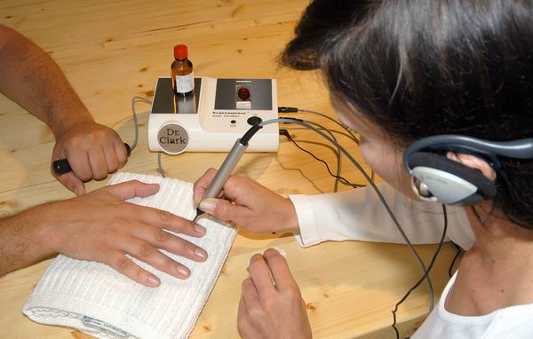

The ear phone outlet allows the use of all available earphones. The resonance tones are readily and more precisely perceived. The tested person can follow the procedure through the speakers. A push button which switches the right plate on (instead of foot pedal). (slightly elevated) The left plate picks up, according to Dr. Clark, the organ samples or their homeopathic potentates. The right plate, which is turned on with the finger push button, is for the parasite slides and their derivates. The Hi-Tech carbon handles also for the transmits an excellent contact and can be used solely with slightly dampend hands and without the use of wet paper. The handles are washable and alcohol-resistant. |  |  |  |  |  | 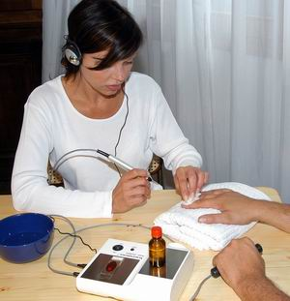
Info |  | ***NEW*** POWER ZAPPICATOR incl. Connection Cable
  $ 149,00
  quantity:
 |  | Food Zappicator as per Dr. Clark's latest |  |  |  | Info | ***NEW*** LCD Super Zapper DeLuxe 2004
  $ 189,00
  quantity:
 |  |  |  |  |  |  | Most up to date, most versatile zapper
 | Zincrometer |  |  | Syncrometer Science Laboratory Manual
  $ 309,00
  quantity:
  $ 20,00
  quantity:
 | Dr. Hulda Clarks Screening Unit |  |  | NEW!

