Livral Complex TM
The Alternative Hope
For Hepatitis C and Cirrhosis
Ingredients
The liver can often perform its essential functions in spite of serious damage. It also has more ability to self-repair than do most other organs. It is important to give the liver the nutrients it needs to function and be able to regenerate and detoxify it.
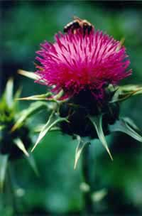
Milk Thistle Also known as milk thistle and variegated thistle, it is a common weed of pastures in Eastern Australia as well as in Europe and North America. It is regarded as the standard amongst hepatoprotective herbs and remains the most well studied (up to 50 studies and clinical trials). Constituents: Flavonolignans
These are unusual polyphenolic compounds referred to collectively as silymarin. Actions and use: Early studies conducted by Vogel and others demonstrated the dual effect of the flavonolignans from Silybum on the liver, i.e.. a membrane stabilizing effect (protecting liver cells from destruction from toxins) via anti-oxidant action, and protein synthesis enhancing effect, whereby the protected cells act as regeneration centres for new cells. The studies on silymarin conclusively show its effectiveness in protecting the liver against a wide range of toxins, from carbon tetrachloride to ethanol. It even prevents poisoning from the deadly Amanita or death cap mushroom if administered quickly enough. Thistle seed preparations are ideal for chronic and post-acute stages of hepatitis, rapidly bringing an improvement in appetite and well-being. It is also used in fatty degeneration and even cirrhosis of the liver. The seeds can be gathered (use gloves!) and made into decoctions, or ground up and used quite safely as foods. Avoid gathering in areas where chemical sprays are used.
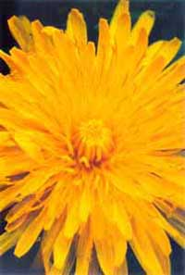
Dandelion, Research is reveling that the plants many constituents including Taraxacin, Taraxacoside, Inulin, Phenolic acids, Sesquiterpene lactones, Triterpenes, Coumarins, Catortenoids and Minerals, mainly Potassium and calcium, are very valuable in curing a number of disorders and illnesses. Dandelion is very nutritious, having more vitamins and minerals than most vegetables. An infusion of the root encourages the steady elimination of toxins from the body. It is a powerful diuretic but does not deplete the body of potassium like many diuretics. The whole plant is used as a medicinal herb internally and externally. Having such medicinal qualities as antibacterial, antiviral, aperient, cholagogue, depurative, diuretic, hepatic, laxative, stomachic, tonic. Being used for the treatment of gall bladder, kidney and urinary disorders, gallstones, jaundice, cirrhosis, hypoglycemia, dyspepsia with constipation, oedema associated with high blood pressure and heart weakness, chronic joint and skin complaints, gout, eczema and acne…
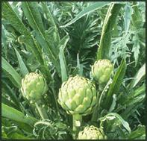
Globe artichoke is a popular food originating in Europe which can be easily cultivated in Australia. It has a long history of use as a bitter digestive herb and is a major remedy for liver and gall bladder disorders. It is the leaf that contains these properties. Constituents: Cynarin and other phenolic acids; sesquiterpene lactones; flavonoids; inulin. Minerals, vitamins and enzymes. Actions and use: Choleretic; digestive tonic; diuretic; hypocholesterolemic; hepatoprotective. A safe and reliable herb for all liver disturbances including hepatitis. Helps lower cholesterol (made in the liver) and assists weight reduction. It can be made into a leaf decoction and take alone or in combination with the above two remedies.
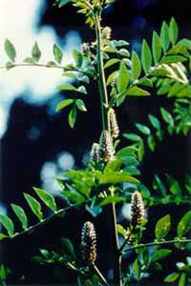
Licorice is one of the most widely used herbs throughout the world, liquorice is regarded by herbalists as a harmoniser or balancing agent. It certainly improves the flavour of herbal compounds but its properties extend much further than flavouring. Constituents: Glycyrrhizin, a triterpenoid saponin; isoflavones. Actions and use: Demulcent; expectorant; antiulcer; tonic; antiviral; antiinflammatory; hepatoprotective. Chinese teaching hospitals found its effective rate in treatments of chronic HVB over 70%. The herb has a mineralcorticoid effect and can cause oedema and hypertension in some people. The popular liquorice stick candies are of little use therapeutically, since the percentage of liquorice is small while the sugar content is high. Pure liquorice root can be obtained in bulk , it has a distinct yellow colour due to its flavonoid content. Manufacturers use thick liquorice concentrates which are included into a wide range of products. Liquorice should not be used over long times unless under supervision of a practitioner.
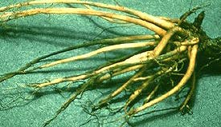
Black Roots contain volatile oil, extractive, tannic acid, gum, resin, a crystalline principle, a saccharine principle resembling mannire, and a glucoside re-sembling senegin. Both the crystalline principle and the impure resin obtained by precipitating with water a tincture of the root have been called Leptandrin and is said to be the active principle. The properties are extracted by both water and alcohol. An ester of p-methoxycinnamic acid, a phytosterol verosterol, and some dimethoxy-cinnamic acid are also obtained.
Medicinal Action and Uses: The fresh root is a violent cathartic and may also be emetic. The dried root is milder and less certain. Leptandrin excites the liver gently and promotes the secretion of bile without irritating the bowels or purging. As it is also a tonic for the stomach, it is very useful in diarrhoea, chronic dysentery, cholera infanturn, and torpidity of the liver.
The accounts of its use are conflicting, perhaps owing to the difference in the action of the root in its dry and fresh states. There appears to be a risk of the fresh root producing bloody stools and possibly abortion, though a decoction may be useful in intermittent fever. It has been stated that the dried root has been employed with success in leprosy and cachetic diseases, and in combination with cream of tartar, in dropsy.
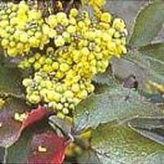
Oregon grape has been used for hundreds of years to treat infections because of its powerful antibiotic properties. In fact, Oregon grape may be substituted for golden seal since they have similar properties. Oregon grape enhances the glandular system, focusing its action on the thyroid and liver, detoxifying and cleansing both the lymphatic system and liver. Oregon grape improves circulation and provides the body additional nourishment. Oregon grape contains alkaloids that are beneficial for fighting infection, strengthening the immune system, purifying the blood and treating a variety of skin problems. In addition, Oregon grape may be used to improve digestion, stimulate the appetite and lower blood pressure.
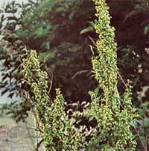
Yellow Dock is a good Iron source and Builds Strength and Stamina A wonderful blood purifier which be of use in most skin problems. High in digestible iron, it helps tone the entire system. It is useful for ulcers, constipation, and rheumatism and in addition is used to build strength and endurance. Yellow Dock is an excellent blood cleanser, tonic and builder. It works through increasing the ability of the liver and related organs to strain and purify the blood and lymph system. Yellow Dock has one of the highest iron content in nature so is effective in working with anemia. It is used to treat skin diseases, liver disorders and iron deficiency and will also nourish the spleen. It can be used externally applied to bleeding hemorrhoids and wounds. Yellow Dock is an excellent cleansing herb for the lymphatic system. It is a great endurance builder and balances body chemistry with its high mineral content. It nourishes the glands and helps build the immune system.
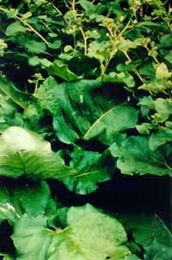
Burdock, latin name Arctium lappa, is a carrot-like root from the plant Arctium lappa, a biennial herb grown in China, Europe and the United States. Burdock is widely utilized by herbal practitioners in the treatment of liver problems, gallstones, flu, and to support the kidneys in filtering acids from the blood stream. Studies of burdock show that it is high in minerals, being a good source of iron. Data also indicate that the burdock root is a good source of the carbohydrate inulin, which can account for 45% of the plant mass.
Bupleurum is an adaptogenic herb used in traditional Chinese medicine. It is used for emotions of irritability, anger, frustration, and mood swings. Bupleurum is anti-inflammatory, anti-spasmodic and anti-pyretic. It is also used to improve energy, treat fever, dizziness, indigestion, gas in the system, inflammation of the abdomen, liver function, colds, coughing, and chills.
Schizandra herb is highly prized by Chinese women as a sexual enhancer and youth tonic. Schizandra is believed to preserve beauty and to be a mild sedative. Schizandra is also reputed to be tonic for men. Until recently coveted by the wealthy, and a favorite among the Chinese emperors, Schizandra is also considered an adaptogen and, similar to ginseng, it is believed to increase stamina and fight against fatigue. In Asia, the schizandra adaptogenic property is said to stimulate immune defenses, balance body function, normalize body systems, help surgery recovery, protect against radiation, optimize energy in times of stress, increase stamina, protect against motion sickness, normalize blood sugar, blood pressure, and high cholesterol, shield against infection, improve the health of the adrenals, energize RNA-DNA molecules to rebuild cells and produce energy comparable to that of a young athlete.
Studies conducted on Schizandra effects have noted that it has a stimulating effect in low doses, but this effect disappeared with larger doses. The compounds thought responsible for the liver-protective effects of Schizandra are lignans composed of two phenylpropanoid. More than 30 of these have been isolated in Schizandra and some 22 of which were tested in 1984 by the Japanese scientist H. Hikino for their ability to reduce the cytotoxic effects of carbon tetrachloride and galactosamine on cultured rat liver cells. Western herbalists commonly recommend Schizandra for the lungs, liver and kidneys, and to help with depression due to adrenergic exhaustion. In Russia, Schizandra is used to treat eye fatigue and increase acuity.
Astragalus (Astragali) is considered an adaptogenic herb. A 1988 experiment indicated astragalus increased the ability of interleukin-2 to kill cultured tumor cells. A more recent study at the Hiroshima University School of Medicine in Japan showed that a water-based astragalus, when incubated with mouse spleen cells, had several immunopotentiating effects. It increased B cell growth, T cell activity, and interleukin-6, tumor necrosis factor and antibody production Astragalus is included in a Chinese herbal medicine referred to as 10 significant tonic decoction or SQT (Shi-Quan-Da-Bu-Tang). It is a 10-herb combination recommended in conjunction with cancer therapy to protect the body from drug toxicity and increase immunity. According to Chinese research, astragalus prevents the adverse effects of the anti-cancer drugs mitomycin C and cisplatin as well as stimulates the immune system. The herb is more commonly used in Asia as an adjuvant to cancer treatments.
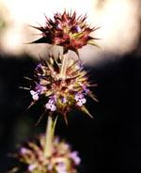
Gentian is an excellent bitter which stimulates appetite and digestion through a general stimulation of the digestive juices, increasing the production of saliva, gastric juices and bile. It also accelerates the emptying of the stomach. It is indicated wherever there is a lack of appetite, dyspepsia or flatulence. The general toning effect of bitters give this herb a role to play in treating debility, anorexia and exhaustion.
Salvaie promotes blood circulation to remove blood stasis: For cardiodynia, hypochondriac pain, abdominal pain, stomachache, dysmenorrhea, amenorrhea, lochiorrhea and trauma with blood stasis. It has recentlt been used for ischemic apoplexy, disseminated intravascular coagulation, chronic hepatitis, cirrhosis, etc.
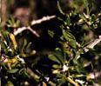
Lycium, for thousands of years, people in Asia have used lycium and licorice to help maintain good health. Lycium is a Chinese herb that helps improve vision and prevent headaches and dizziness caused by liver and kidney deficiencies. Also lycium also has been shown effective in mild forms of diabetes. Lycium contains both conventional nutrients and phytonutrients (nutrients from plants), including vitamins, minerals, beta carotene, polysaccharides and amino acids. The herb lycium is good for the following body meridians: Liver; Kidney and Lung.
Peony is usually used for yin-deficiency or blood-deficiency related to hyper-activity of yang and sthenia of liver-yang syndrome such as headache, dizziness, insomnia and irritability. It also can be used together with Radix Rehmannia and Radix Angelica Sinensis to treat for yin deficiency and blood deficiency syndrome such as menalgia, menoxenia, leucorrhagia.
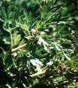
Under the name bai shao, white peony root is used in many diverse Chinese herbal formulas. It is considered a herb with strong blood-toning characteristics, used to treat the imbalance of blood in the body, cooling and providing nourishment to the blood and activating circulation. More specifically, red peony root is used to treat heat rash, to correct poor circulation and to stop hemorrhages. White peony root is used for irritability and muscle cramping, vaginal discharges, excessive menstrual bleeding, and excessive sweating. It is also given to treat a large variety of gynecological disorders and to avert miscarriage.
In the databases developed by the Agricultural Research Service of the United States Department of Agriculture, white peony root (from both Paeonia albaflora and subspecies Paeonia albaflora trichocarpa) has been shown to have chemical properties that restore the normal functioning of the digestive system; act as a laxative; relieve pain; reduce or stop spasms or seizures; lower blood pressure by dilating arteries; and improve the nutrition of blood. Peony root appears to have some positive effects in treating anemia, some types of cancer, convulsions, gastritis, hypertension, and some gynecological problems. It can also be used as an emmenagogue, which means that it can bring on a woman's menstrual period.
Wild Yam is helpful to the liver and the endocrine system. It is also used in regulation of the female system, particularly during menopause and menstrual distress, as well as used in treating infertility. Used with chaste berry and dandelion it is an effective treatment for morning sickness. Usually found wild in the eastern half of North America, it is a perennial plant that is a low creeper, and occupies average to poor soils and full sun. Wild Yam contains a multitude of hormone-like compounds that have been used to effectively treat a variety of medical problems.
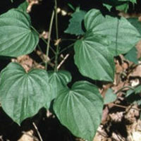
Researchers have long believed that certain species of the Dioscorea plant (wild yam) have powerful medicinal uses due to the existence of specialized phytochemicals called "hormone precursors". Hormone precursors assist in the body's production of prohormones, such as DHEA and Pregnenalone. These substances help regulate the body's metabolism. Unfortunately, the body's natural levels of prohormones begins to decrease in the 20's. Research has shown a direct correlation between this drop in prohormone levels and obesity, lethargy, and other degenerative health conditions such as rheumatoid arthritis and osteoarthritis.
The British Herbal Pharmacopoeia recognizes Dioscorea as a spasmolytic, mild diaphoretic, anti-inflammatory, anti-rheumatic, and it is listed for use in the treatment of the following: intestinal colic, diverticulitis, rheumatoid arthritis, osteoarthritis, muscular rheumatism, cramps and ovarian & uterine pain.

