BIOGRAPHY OF EDMOND BORDEAUX SZÉKELY

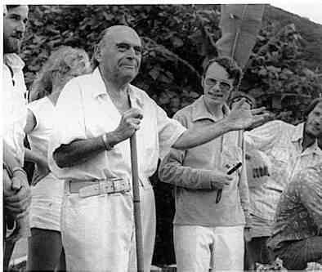
Professor Székely: "Life always begins again"
Grandson of Alexandre Szekely, the eminent poet and Unitarian Bishop of Cluj; a grandson of Csoma de Koros, Transsylvanian traveler and philologist who, more than a century ago, compiled the first grammar of the Tibetan language, an English-Tibetan dictionary, and wrote his unsurpassed work, "Asiatic Researches". He was also Librarian to the Royal Asiatic Society in India. Dr. Bordeaux earned his Ph.D. degree from the University of Paris and other degrees from the Universities of Vienna and Leipzig. He also held professorships of Philosophy and Experimental Psychology at the University of Cluj. A well-known philologist in Sanscrit, Aramaic, Greek and Latin, Dr. Bordeaux spoke ten modern languages. In 1928, he co-founded the International Biogenic Society with French Nobel-Prize winning author Romain Rolland. His most important translations , in addition to selected texts from the Dead Sea Scrolls and the Essene Gospel of Peace (over a million copies in 26 languages) are selected texts from the Zend Avesta and from pre-colombian codices of ancient Mexico. His last works on the Essene Way of Biogenic Living have attracted worldwide interest. He is the author of more than 80 books on philosophy and ancient cultures published in many countries. Professor Székely was also the founder of Archeosophy.
Edmond Bordeaux Székely's youth and Studies.
Edmond Bordeaux Székely was born in the first decennium of the twentieth century, (See p.29-30, the Discovery of the Essene Gospel of Peace) his mother was French and Roman Catholic and his father was a Hungarian Unitarian. So, in a spirit of conciliation, they decided about his education that he would first be educated in a Catholic monastery of the Piarist order, which specialized in classical education, with the emphasis on Greek, Latin and Ecclesiastic literature. Then after graduating from the Piarist school, he would go to the University of Paris, completing his education at the Sorbonne for his doctorate in philosophy. After that, it was up to him to choose what profession and what religion he would choose for himself. And so he began his scholastic life with the Piarist order; it was at first difficult for him to get used to the austerity of Piarist life after the luxuries of his affluent home (his father owned large estates both in transsylvania and France). Click on the picture under here to read more about young Edmond's dog: Nuage.
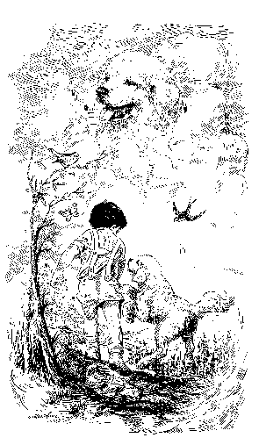
When Edmond was eighteen years old, he was speaking classic Greek and Latin fluently and graduated magna cum laude, becoming the valedictorian of his class. At the same time, he prepared his obligatory thesis for graduation , with the title: "Let St. Francis Sing in your Heart." Right after his graduation, he was called to the office of the Headmaster, Msgr. Mondik, the Prior of the Monastery, who offered him a chance to continue his research on St.Francis at the Vatican, where an old schoolmate of his was then the Prefect of the Archives, and even supplied a letter of introduction.
Discovery of the Essene Gospel of Peace in the Secret Archives.
After Edmond Székely, during his studies in the archives of the Vatican and the convent of Monte Cassino, had found the scriptures by Plinius about the Essenes, and the Gospel of Peace of the Essenes, (this is described in "The Discovery of The Essene Gospel; The Essenes and the Vatican", see I.B.S. booklist), in which could be found many things that nowadays cannot be found in "The Bible"anymore, especially concerning the actual mental and physical healings by Jesus (descriptions can be found of how Jesus instructed people to heal themselves) (again, see I.B.S. booklist:The Discovery of the Essene Gospel), he started to distribute (privately at first) the EsseneGospel of Peace in French, and giving lectures on it.

The First Essene Church.
From then on, since the 30's, more and more people wanted to establish an alternative to the institutionalized "Christian" churches that had laid down the rules up till then... Click on the bible below to read more on these First Essene Churches that spontaneously sprung up, and still do!
Edmond meets his memorable friend, Jean Pierre.
About three weeks after the French translation of the Gospel of Peace had been edited, Edmond received a letter from someone who would play a very important role in the propagation of the Essene traditions and philosophy and in the foundation of the first Essene church in the south of France. The letter came from Jean Pierre Weiller, who lived in Tourette sur Loup, a war hero pilot from the First World War, who survived the crash following his last fight for which he became a Chevalier de la Legion d'Honneur, but remained deaf since and became a changed man since the experience he had during his crash, from then on dedicating his life to spiritual pursuits, study of mysticism, study of philosophy, exploration of many branches of all-sided knowledge; a very wealthy and very eccentric man, who ever since meeting with Edmond gave all the support he could to the Essene revival. Together, they founded a "literary Spa"in Aspremont, where among the guests were important writers like George Bernard Shaw, Maurice Materlinck and André Gide (who woulf later become Nobel Prize Winner in 1947).
Zarathustra in the Twentieth Century.
When Edmond became interested in investigating the Zend Avesta of Zarathustra, Jean Pierre Weiller introduced him to a friend of his, Jules Costes, who possessed a rare edition of the original translation of the Zend Avesta by the elusive and enigmatic Anquetil-Duperron, who deserted from the Foreign Legion to spend his life in Persia pursuing the near-impossible task of translating this least-known but most universal and profound of all the holy scriptures of antiquity. It turned out, when Edmond looked him up in a suburb not far from Paris, that he actually lived in Zarathustrian style too. His house and garments, all were in authentic ancient-Persian style. He said to Edmond: "My friend, the Zend Avesta is not just an archaic museum piece, it is a world in itself. It contains information about how to live, how to eat, how to meditate, how to grow a garden and so much more I could not begin to describe - and you theoretical, scholastic people, you never do anything about it." That was when Edmond decided he WOULD definitely do something about it, and answered: "M. Costes, I do not know yet what I will do about it, but I feel I will do something - I feel there is very important knowledge in that book." In answer to that M. Costes exclaimed: "Of course there is important knowledge! It is the most ancient sacred book of mankind and it is an encyclopedia! It has everything we ever need to know!"
M.Costes gracoiusly adopted the Gospel of Peace of The Essenes, though he was swift to point out several passages of the Zend Avesta in which the Essene traditions could be traced from the avestic culture of ancient Persia. He proved unmistakably that the Essenes had their roots in ancient Persia and Sumeria, and they both admitted that probably the avestic traditions themselves went back much farther than that. M. Costes, his grandchildren and their spouses all enthusiastically embraced the Gospel of Peace. Of course, it was basically the same philosophy they were following anyway, but they liked very much the spiritual atmosphere of the Essene Gorpel. They formed a little nucleus which became a center for theEssene teachings.

The little Essene Brotherhood in the south of France.
While he was attached to the Paris Sorbonne-University,Professor Székely also got in touch with a number of young, enthusiastic idealists, that had heard his lectures and decided to, for the first time after so many ages, start an Essene community again, in the south of France, exactly as described in the Essene sources and in the account of Plinius, that Professor had found in the convent of Monte Cassino, also using his book "La Vie Biogenique" as a very useful contemporary manual (Read about this in the story: "The little Essene Brotherhood in the South of France" from part 1 of Professor's biography: Search for the Ageless, 1).

1).
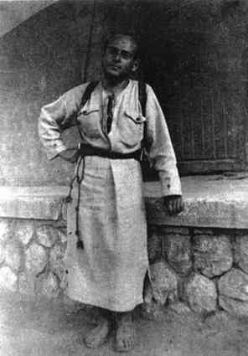
Professor on expedition in the Karpathian Mountain Region
Expeditions to the Hunza and the Carpathians.
Professor also went on many expeditions, often to very remote regions, for his studies, such as his expedition to the region where the Hunza's lived, in the Altaï-Mountains, where people living in harmony with nature became very old in remarkably good health. Time and again these studies proved how much the way of life of such people had in common with the general principles of living in harmony with the Laws of Nature and Cosmos, as observed by the Essenes. These travels can also be found, vividly described, in the Trilogy "Search for the Ageless" (Professor's biography, see I.B.S. booklist).
During these expeditions, Professor proved the descent of the Hunza's from soldiers of Alexander the Great, and the descent of the Rumanians of upper Transylvania from the surviving Roman Legionnaires and native Dacian women. For which he earned the gratitude of the President of Albania, who would later give him much support by granting him the right to fly the Albanian flag from his ship in the Caribbean, thus granting him immunity.
African Interlude: a complete failure.
Edmond Székely was given an opportunity, during his studies at the Paris Sorbonne-University, to actually try out the ancient Essene methods of healing in Africa. (See the story "African Interlude" from part 1 of Professor's biography: Search for the Ageless,Vol. 1, also on the I.B.S. Booklist ).

Tahiti and the South Seas.
After this, Professor went to Tahiti and the South seas to study the possibility of curing leprosy with Essene methods. In this he succeeded in Orofara on the Island of Tahiti, but the authorities there (the French Navy) were not pleased by his activities (actually curing people, but putting others out of business who were selling the bad, canned food from France that kept the lepers in their condition of illness) and wanted to run him off the island, threatening to actually blast his ship out of the water with a naval gunboat. He succeeded to escape this situation unharmed by genial tactics...
...
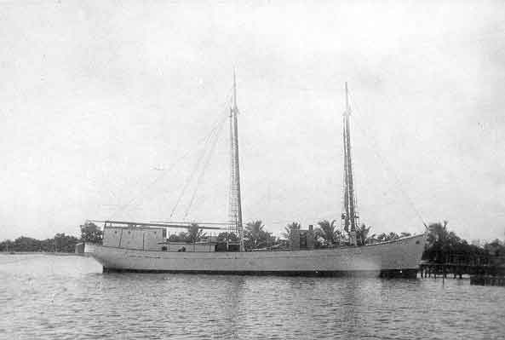
The Marihini, Professor's Ship
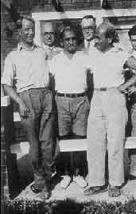
Within two months of Professor's stay in Tahiti, there was a serious Essene movement there, not only because of the succesful use of the Essene methods of healing, but also because great interest was aroused by the few copies of the Essene Gorpel of peace that were given to friends and which were circulating all over. This is how Professor met Fred Marchal, who had a health problem, but was cured by the Essene methods.
. The strange adventures of Purcell Weaver.
Purcell Weaver, attorney, and the adopted son of Sir Stafford Cripps (left, front on photo above) was a close personal English friend of Professor and was, by Professor's Essene methods, cured from an illness that had been pronounced "incurable" while Professor was staying on Tahiti. Purcell also translated into English the book Professor was writing then: "Cosmos, Man and Society," that was also edited in England afterwards. He stayed with professor from then on and drove him around in his Ford for the very successful pre-war seminars in the U.S. in 1936, and later in England too, in 1937 . Fred Marchal, (middle, front on photo above) had abandoned his job as manager of the Tahiti branch of the Banque de l'Indochine to become Professor's secretary.
The first edition of the Essene Gospel of Peace (before the second world war) had been in French, an English translation was first made by Purcell Weaver (edited by the C.W.Daniel Company, London, 1937). The Editors W.C.Daniel Company also edited other books in English, (long before the I.B.S. moved to the U.S./Canada, in the 70's) from the shorthand of the lectures, which were given in French and Esperanto, but translated litterally, after each sentence, into English by Purcell Weaver. Among those titles are: Cosmos, Man and Society, Medicine Tomorrow, The Living Buddha, The Future of Humanity and several others. Three other books were published by Geoffrey L.Rudd: Cottage Economy, Sermon on the Mount and Genesis - an Essene Interpretation.
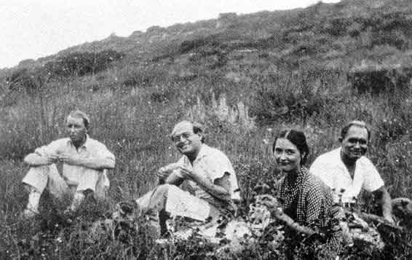
At Lake Elsinore, left to right : Purcell Weaver, Professor, Deborah Shainman (Professor's first wife, who became mother of his two children: Livia and Alex) and Fred Marchal
Southern California: The Essene beginnings in America.
After leaving the South seas, in 1936, the three of them went to Lake Elsinore, where Purcell's English followers were to join them. Via the Universal Esperanto Association, Professor was invited to hold a lecture in Los Angeles about the migration of the Maoris from Polynesia (in Esperanto, Purcell Weaver translating every sentence into English). Then preparations were made for a summer seminar at Lake Elsinore.
Among the followers who came from England to participate in the seminar was Mrs. Florence Mahon, who later became resident manager of the International Health and Education Centre in Leatherhead, Surrey (England), where Professor would later hold a memorable summer seminar organized by Purcell under the auspices of his adopted father, Sir Stafford Cripps, later Chancellor of the Exchequer.
At this time, the Essene Gospel of Peace appeared in San Francisco, and the First Essene Church was established in San Francisco.
Lectures at the Baha'i Summer-Seminar in Geyserville.
Also, a lecture was given at the Baha'i summer seminar in Geyserville, where the chairman was Mr. Bosch from Switzerland. It seemed "Abdul-I-Baha" had told the Baha'is that fruit, herbs and vegetables were the food of the future, and the Boschs followed his example and ate only these things. Most of the modern Baha'is, however, interpreted his statement to mean that while fruits and herbs were the food of the future, they were living in the present and could go on eating cooked foods, meat, etc. Luckily, toward the end of the course, the great majority of the students made the spirit of "Abdul-I-Baha" very happy and adopted the food of the future...
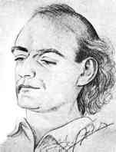
Portrait of Edmond Bordeaux Székely, sketched en route to England.
Afterwards, the Seminar at Lake Elsinore was continued, producing more and more material. Meanwhile, the Essene Gospel of Peace had a second and even a third edition in San Francisco and Cosmos, Man and Society was also selling very well in England. As reaction to these books grew, many letters were also received from young medical doctors, osteropaths, chiropractors and naturopaths. They all asked Professor the same question: when and where can we meet you for a seminar about the Essene teachings, especially regarding the health aspects? They seemed to be inflamed with a desire to use those methods immediately in their healing arts, to cure the ill effectively, and then teach them how to stay cured, something physicians always talk about but rarely do. So as Professor read letter after letter, he became slowly convinced that he should indeed give such a seminar. Thus, preparations were made for the seminar at Rio Corona.
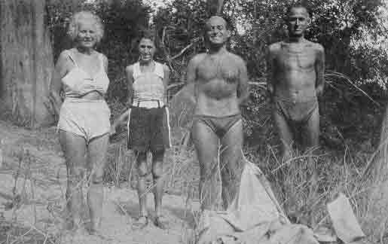
Professor (center) with three patients at Rio Corona
The Seminar in the mahogany woods at Rio Corona, Mexico.
Dozens of participants came from all over the globe. They came with tents and sleeping bags, in their knapsacks a copy of the Essene Gospel of Peace or Cosmos, Man and Society. Also quite a number of doctors and some professors attended; they were young and old, men and women, established physicians in different fields, business men and housewives, young students - including a few from England - all intelligent, all alert and seeking - all eager to learn and apply the medicine of the future to health problems of the present day. Also at this seminar were the Shainmans, a New York family who had met Professor in Tahiti where they went to live during the depression, and who later followed Professor to Mexico. Their son, little Joseph Shainman, went to fetch the mail each morning riding a little donkey. After the lectures were ended, the material of this seminar was gathered, sifted and organized into a publication which would be published in Los Angeles under the title of Medicine of the Future.
Around this time, reports began to come from Purcell, who had already left to England, that the movement had grown to such an extent that he was imploring Professor to come to England and conduct a seminar for the British and European followers. So Professor decided to postpone his archeological work and leave for England.
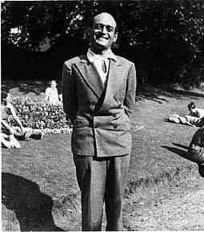
The Summer Seminar in England.
The photograph above was taken during the Seminar at the Lawrence Weaver House, of the International Health and Education Centre in Leatherhead, Surrey in England, a magnificent estate erected to the memory of Sir Lawrence Weaver, the architect, Purcell's late father. Professor travelled there sailing to England from Tampico on a Dutch passenger liner called De Leerdam, where his portrait, shown above, was made.
Shipwreck and survival in the Gulf of Mexico.
After surviving a shipwreck in 1938 (read the story "Our Jovial Boat disintegrates in the storm") something he managed to do making use of Essene methods (as Professor had read in a description by Plinius), somewhere in the Carribean, just before the start of the second world war, he had to start all over again from scratch (all his personal possessions, including identity papers and clothing, were lost in the shipwreck and all family possessions were in then occupied France, where it definitely was not safe for him to return; the Nazi's certainly did not like his Essene ideas) and, from nothing, managed to eventually build a colony, called Rancho La Puerta, in Mexico, where from 1938 the Essene methods of meditation and healing were succesfully put into practice, curing people who, according to regular medicine, were incurable, given up...

The Great Experiment: Rancha La Puerta.
At first, all volunteers that started La Puerta lived in tents; they all knew each other from the previous tours and seminars by Edmond B. Székely. Professor then got married to his first wife, called Deborah Shainman, who at the time was just 17. Her mother, Rebecca Shainman, was a registered nurse and naturopath. She was very important for the success of this "experiment," and always there when needed. Professor and Deborah got two children: a daughter called Livia and a son called, after his father, Alex. Deborah from the outset of La Puerta took over the shopping, bookkeeping, practical business correspondence and finances of the little cooperative.
Mind you: apparently those Essene methods, like fasting and also living on a "spiritual diet" that was just as important as a physical diet, mainly consisting of fresh raw vegetable and fruit food, and "sprouts" (freshly germinated seeds), were actually already known thousands of years before we ever heard of people like Bircher-Benner, Waerland, Nolfi, Oshawa or Moerman... And besides, all of this was even researched scientifically at the very place of Rancho La Puerta, because several scientists who had become interested got no permission at any university to do this; it obviously was not in their best interest. A detailed account of these scientific results can be found in "Search for the Ageless Vol.3: "The Chemistry of Youth"

Norma Nilsson: actress, pianist, musicologist, writer and "The Swallow" of La Puerta.
In the early spring of 1960 a young girl, just turned 22, arrived at Rancho La Puerta, who had been a professional actress and pianist since the age of five: Norma Jean Nilsson who eventually became professor's assistant and took over the leadership of many activities at La Puerta. She was in so many places at once, that Professor gave her the name of "the Swallow." Together they took up the job of geting all Professor's books published or re-published.
Mountain of a thousand Meditations: Mille Meditations
After Professor Székely eventually retired from La Puerta, he moved to the United States, started organizing yearly seminars in San Diego (the first one there took place in 1975) and elsewhere and by then with powerful assistance of his faithfull assistent Swallow (Norma Nilsson, the later Norma Székely) the immeasurable knowledge from his photographic memory was written down in book form (pet answer of Professor to certain questions: "Ask Norma, I never read my books!"), so that we nowadays may still benefit by making use of it.
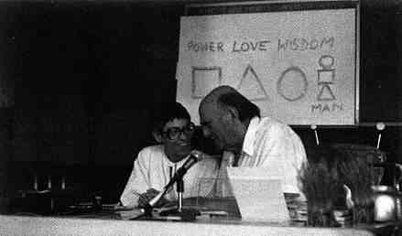
The Biogenic Revolution: the Seminar of 1977
Seminar: Professor explains the Pictograms of Zarathustra
Norma continues the work.
Since Professor exchanged the temporary with the eternal in 1979, Norma Székely (Swallow) has kept the biogenic revolution going, and she now manages the distribution of all the books on the I.B.S. list and has even taken up the big task of giving all the books (that had been originally made with one of the first computers for lay-out) a whole new lay-out. She also continues to give regular seminars (be it not every year).
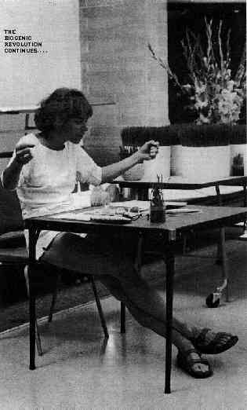
Norma continues the work: explaining Biogenic Meditation
Professor Székely did not only teach and write about the Essenes, such as about the Communions with the Angels and the Sevenfold Peace, but also about the origin of all that in the "Original" philosophy it sprung from, as becomes clear by reading the following quote from the preface to "The Art of Asha":
(This book is also on the I.B.S. booklist)
In the years between 1966, when The Art of Asha was first published, and 1979, when Edmond Bordeaux Székely died, his interpretation of Zarathustrian cosmology and cosmogony underwent a profound transformation. He had always spoken of the art of Asha as the spiritual ancestor of the Essene Tree of Life; and in his lectures he often emphasized the importance of studying the Art of Asha as a foundation for true understanding of the Essene philosophy. But in his last years, at his Seminars and in his writings, he gave greater and greater importance to the teachings of Zarathustra, not only as a basis of study of other great World Pictures, but as the very keystone, the central point, the most vital and important of all spiritual revelations of history. He often said that "intelligence is the ability to adapt ourselves adequately to unexpected changes in the environment," and as the seventies drew to a close he concluded that a thorough knowledge and active use of the Art of Asha was the most effective use dealing with those unexpected changes.

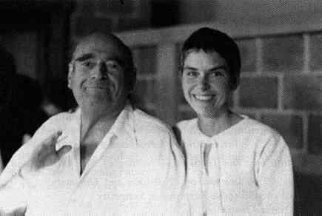

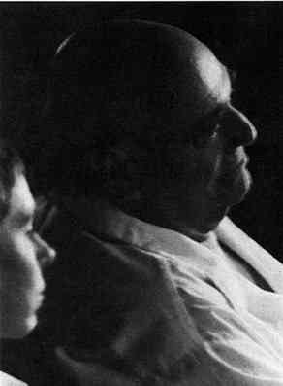
EDMOND BORDEAUX SZÉKELY
"In giving the spiritual treasures of his rich life to millions,
He can never die,
Even when his days have reached their end.
Shedding his earthly remains,
He becomes a life-giving spirit.
And even as he fades away in time and space
He survives:
Pure Light, Eternal and Endless..."


