Mark Purdey
His biography and eco-detective journeys to the centre of scientific truth.
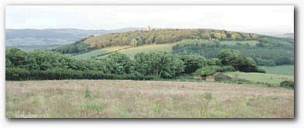
Read about the current ecological imbalance of ultra violet radiation, manganese, copper, organophosphate chemicals, dioxins, geomagnetism, low frequency infrasound, radar, silver, magnesium molydenum and many more factors in our modern environment. Discover how these prerequisites interact and combine to bring about some of the mystery free radical based illnesses that blight our modern times, most particularly, BSE.


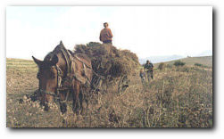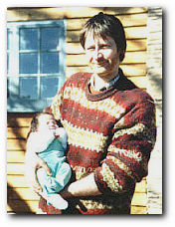
Hi, I'm Mark Purdey and I live on a remote rural ranch on the back of the Brendon Hills in West Somerset. I have a passion for environmental science and the arts, music - playing the saxophone, flute and double bass in jazzfunk/celtic bands.
I have eight amazing children who have the habit of suddenly appearing in unexpected places, including on these pages!
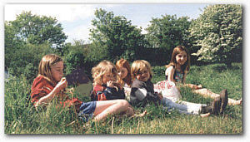
I would like to introduce you to my new website which features the scientific insight that I have gleaned from twenty years worth of unconventional, eco-detective adventures to isolated out-backs around the world - select regions where clusters of modern diseases have suddenly erupted.
By strong reliance on straight forward field observation, local intelligence and comparative analyses of soils, water, atmospheres, vegetation, etc, in the disease / disease-free locations, I build up an overall understanding of the bio-mechanisms at work in a specific illness. By scanning the scientific scenery of each cluster location, I attempt to pinpoint the aetiological needle in the causal haystack.
The purpose of these journeys has been to unearth the causal riddle of various industrially induced conditions, such as Creutzfeldt Jacob disease, scrapie, multiple sclerosis, amyotrophic lateral sclerosis, alzheimers disease, myalgic encephalomyelitis, glioma brain tumours, cot death syndrome, psychoses, teratogenic defects etc.
Although discarded by Establishment bodies, the phenomena of the disease cluster provides an ideal research tool for identifying the true environmental causes of a given illness; which, in turn, paves the way for identifying the best means of eradicating, preventing, and even curing that disease. But, sadly, the unilateral research direction of the multinational-ministerial grand alliance is purely designed to develop the most effective means of suppressing symptoms of disease through formulation of pharmaceuticals, gene manipulation, etc; Such an approach fails to deal with the root cause.
My work focuses on the biological impact of the increasing cocktail of environmental oxidizing agents in our modern environment; eg, ultra violet radiation, systemic insecticides, low frequency infrasonic radiation, radar, microwaves, etc. I am studying the oxidative impact that these agents exert upon various transition metals in the brain - manganese, silver, etc - and how they are transformed into pathogenic 3+ or 4+ species which carries a lethal oxidative capacity that is capable of initiating a self perpetuating free radical mediated neuro degeneration.
My technique of " total ecosystem analyses " has identified several environmental prerequisites which could be involved in the origins of some diseases , most particularly my discovery of high levels of silver or manganese in combination with low levels of copper in spongiform diseases. I have also observed molybdenum and serotonergic toxicity in multiple sclerosis, silver toxicity in glioma tumours, a high manganese/ low magnesium induced mutation in Machado-Josephs disease, etc.
The political perspectives of my work first came into the news in 1984, when I successfully quashed the UK government's compulsory warble fly eradication scheme in the high courts; exempting my farming business from treating my organic cattle with high doses of "systemic" organo-phosphate insecticides - chemicals derived from military nerves gases, which, amongst a myriad of toxicological effects, disturb the crucial balance of metals in the brain. I believed that BSE reared its ugly head in the UK cattle herd as a direct legacy of this exclusive "high dose" UK government mandate.
I have found myself at odds with the reductionist mindset of UK government "experts" ever since, and consequently found myself subjected to a steady derisory trickle of ridicule and dirty tricks. Like many heretics before me, I have found myself forced into operating as an "underground scientist"; tramping a lone journey to the Ends of the Earth, sampling exotic corners of Colorado, Iceland, Calabria, Slovakia, Japan, Australia, etc, where high incidence clusters of various neuro degenerative diseases have erupted.

Set against a backdrop of flamboyant and sometimes threatening scientific scenery , my journey has spontaneously taken me up many surprise avenues. With limited funds, I often find myself sleeping rough and thrown into the hands of fate, bumping into a series of unusual characters who end up providing the crucial evidence/assistance in establishing the key milestones of the mission - a Hell's Angel, an Aboriginal elder, a Slovak 'au pair' girl, the Icelandic government's chief vet, a taxidermist, Amish farming family........
The BSE debacle represents the mere tip of the iceberg of Establishment ineptitude and socio-eco-irresponsibility. It represents a clear cut example of the far reaching extent to which the 'talons' of multinational monopolies can stretch to protect their global master plan on the fast expanding 'Health and Food chain Industry'. Can we afford to allow this insidious mode of food chain control to continue unregulated and unabated ?
There is an increasing groundswell of public unease concerning the unknown effects that are polluted environment is exerting on our health and long term survival. Public suspicion is mounting towards the transparent array of so called independent scientific experts and medical spin doctors who are called to advise governments and address the public on all aspects of the impact of chemical pollutants on our food chain
This website returns us to the lessons that can be learnt from the intuitive wisdoms of the people on the "ground" . At the same time it will alert us to both the insidious and unscientific techniques which the incestuous clique of official experts employ to marginalize and discredit those who dissent from the totalitarian line. It will show us the ill conceived basis on which the positions of the Establishment are truly based, along with the woeful degree of administrative complacency over issues which, in most cases, are matters of life and death for normal people.
