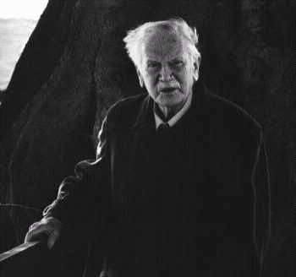
Richard st. barbe baker:
The Man of the Trees-
Almost from birth, Richard St Barbe Baker, founder of The Men of the Trees, showed a love of trees and the outdoor life. He continued a vigorous, worldwide pursuit of both until his 92nd year.
St Barbe Baker was born on 9 October 1889 and grew up in England, the son of a clergyman/nurseryman from whom he first learned his love of forestry. He planted his own garden at the age of two and could propagate trees by the time he was four. On leaving school, he headed for the wilds of Canada and a life of horse-breaking, lumber camps and studies at the newly founded University of Saskatchewan. Four years later he returned to England to begin a degree in divinity at Cambridge University, according to the family custom.
But his studies were interrupted by the 1914-1918 War. He was badly wounded twice. Recuperating in London, St Barbe Baker lent his support to the foundation of a new, centralised Ministry of Health, before returning to Cambridge. This time, however, he studied forestry, paying his way by manufacturing his invention, a caravan, from surplus aircraft parts.
In 1921 he journeyed to Kenya as Assistant Conservator of Forests. He found its lands turning arid, its tribesmen unable to support themselves. With insufficient government funds, in 1922 St Barbe Baker and Chief Josiah Njonjo appealed to the Kikuyu people to raise and plant trees to make their land fertile again; together they founded the first branch of The Men of the Trees.
Richard St Barbe Baker felt keenly the need for humans to be stewards of the earth and foresaw the need for global forest conservation, irrespective of political boundaries. A good mixer, uninhibited by class or social distinctions, he had a great ability to withstand ridicule and scepticism. He spent the next sixty years travelling the world, teaching the importance of trees and inspiring people in many countries to form branches of The Men of the Trees.
St Barbe Baker wrote over a dozen books to support his cause. They were translated into many languages and, in some cases, used as text books.
As early as 1929 he was campaigning to save the Californian redwoods. He came to the notice of US President Roosevelt, who consulted him on unemployment during the Depression. The resulting Civilian Conservation Corps gave employment to over six million people in the dark days of the thirties and left a heritage of parks still enjoyed today.
He helped found the Friends of the Sahara and the Sahara Reclamation Project. In 1952 he travelled 40,000 kilometres around and across the desert on an ecological survey. He supported the Chipko people in India and led tree-awareness programmes in Australia and New Zealand, where he lived for many years. In 1982 he launched The Decade of the Trees in Brazil in an effort to stem the wholesale destruction of the Amazon rainforest and to alert the peoples of that country that they must plant trees for the future.
By the time he died in 1982, the "Man of the Trees" had been responsible for the planting of 27,000 million trees worldwide.
"Tree cover is nature's most important means of maintaining and regulating the flow and quality of water . . . upon how well the tree-cover is managed depends, not only the availability of water but also whether rain and snow on the mountains will be a blessing or a curse - whether it will gently percolate into the soil . . . or carry everything before it in devastating floods."
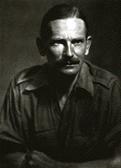
"Is it too much to hope that the Iron Curtains of the world will give place to the Green Front and the scars in the earth as well as the scars in people's hearts may be healed by tree planting?"
"We wish you
The health of the pines
The strength of an Oak
And the endurance of a Redwood Tree."
(To George Bernard Shaw, a Life Fellow of MOTT)
Richard St. Barbe Baker was a world-famous environmentalist who began what may have been the first international conservation movement, "The Men of The Trees". St. Barbe Baker homesteaded at Beaver Creek, just outside of Saskatoon, which fed his love of nature. He moved to Saskatoon to become one of the first 100 students at the University of Saskatchewan. He said that although he worked for conservation around the globe it was here in Saskatchewan that he developed his commitment to conservation.
He was working for environmental conservation as early as 1920 in Kenya. He worked on every continent except Antarctica and his was an early voice warning the world about the spread of the deserts and speaking about the need to maintain rather than destroy the world's forests. It was his suggestion that led to the formation of the Civilian Conservation Corps that provided work for about six million people during the depression.
Richard St. Barbe Baker truly loved trees. He was given his nickname "The Man of the Trees" by the American writer Lowell Thomas, who said that it wouldn't surprise him if St. Barbe Baker didn't one day marry a tree.
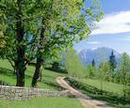

On World Environment Day, June 5, 1982 he was in Saskatoon to plant the last of the millions of trees he helped to plant and protect though out his life. The tree he helped plant that day was a poplar planted close by the gravesite of John G. Diefenbaker, on the University of Saskatchewan campus. He died a few days later at 92 years of age.
As a member of the Bahá'i religious faith, Richard St. Barbe Baker was buried in Saskatoon where he died. Religious belief of the Bahá'i religious faith require that the burial take place within an hour's travel time from the place of death and, as it was in Saskatoon that he died, though a world traveller, it was in Saskatoon that he would be buried.

