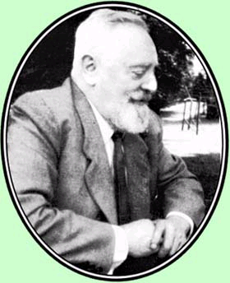
Viktor Schauberger
Landscape healer and inventor of environment-friendly technology, Viktor Schauberger vividly described how our disdain for Nature's ways will bring only environmental catastrophe. His vision - humanity working within Nature's laws - is the path we must rediscover, if we are to survive.

Viktor Schauberger (1885 - 1958) was a natural scientist whose ideas were way ahead of the time. As a young man he worked as a 'forest-master' in the Austrian Alps when they were still a true wilderness. His remarkable observations of Nature-in-the-raw were to influence his entire life's work.
Schauberger's insights into Nature's ways pivoted around the essential characteristics of water as a living substance that energises all life, both organic and inorganic. He frequently asserted "water is a living organism" - an idea to which poets and philosophers have subscribed, but which has escaped conventional science.
He was passionate about trees, and natural forests as the cradle of water. He warned how deforestation would deplete the world of water and destroy fertility, causing deserts and climatic chaos. He argued that when the natural eco-systems are in balance and diversity rules, there is great creativity and the evolution of higher and more complex life forms, but there is also order and stability.
When humanity walked lightly on the Earth, we cooperated with Nature. Although we are still part of Nature, we behave as though we are not, but above it, dominating and exploiting it. Viktor warned that the more we continued to go against Nature, the whole eco-system would become sick, the climate destructive, and human society would break down, with extreme violence, greed and pandemic illnesses.
"How else should it be done", he was asked. His answer was straightforward and uncompromising -- "Exactly in the opposite way that it is done today!"
Viktor Schauberger's discovery of the enormous energy potential contained in living water led him to develop the technology of implosion (the opposite to explosion) with radical new forms of propulsion and an appliance that converted lifeless water into healing water with the vitality of a mountain spring. His insights about vortex energy and implosion have made possible the development of a new range of products that give us sustainable and healing energy, and show the way to healing our environment.
Viktor Schauberger; a brief biography:

1885 Viktor Schauberger born in Holzschlag, Upper Austria, into a family with a long tradition of caring for the unspoilt Alpine forests.

1914-18 Soon after the birth of his son Walter, Viktor was enlisted in the Kaiser's army.
1919 Appointed forest warden and gamekeeper.
1920 Became head warden ('forst meister') in Brunnenthall-Steyerling, the property of Prince Adolph van Schaumburg-Lippe.
1922 Radical designs of new log flume at Steyerling, which greatly reduced cost of bringing trees out of inaccessible mountains, with no damage to the timber.
1924-28 National consultant for timber flotation, building successful flumes in Austria, Bavaria and Yugoslavia.
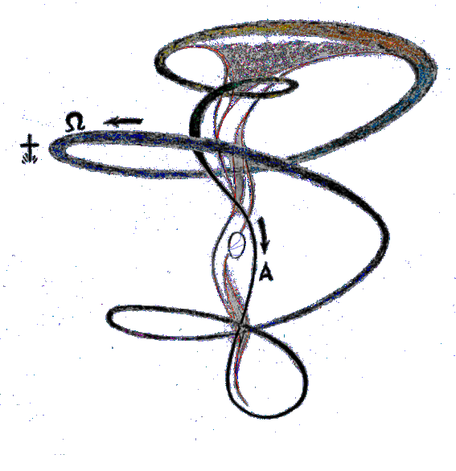
1929 First patent applications for water engineering and turbines. This was a very creative time, and for the next few years he did a lot of writing.
1930-32 Experiments with producing electrical energy directly from water, converting degraded into pure water and the prototype of the 'trout turbine' based on his observations of a trout's behaviour in a fast flowing stream. Study of comparative agricultural methods in Bulgaria, sanctioned by King Boris.
1933 Publication of his only book, Unsere Sinnlose Arbeit "Our Senseless Toil - The Cause of the World Crisis"; subtitled 'Growth through Transformation, not Destruction, of the Atom'. Meeting with Hitler to discuss Viktor's ideas about power generation and agricultural methods.
1936-7 Arnold Hohl made detailed records of his visits to Viktor Schauberger, with contemporary writings, letters, notes and comments which were published in 1993 in a special edition of Mensch und Technik - naturmass (Humanity & Technology - in accordance with Nature).
1938 Constructs with his son Walter a replica of Lord Kelvin's Falling Water Experiment of capillary research, generating a voltage of 20,000 volts.
1940 The first Repulsine (flying saucer) built first in Berlin and then in Vienna, where the prototype broke from its mooring and smashed through the factory's ceiling. Heinkel steals Viktor's copyright and builds his Schriever 'Flying Top' in his Rostock factory.
1943 Himmler gives the SS the task of producing secret weapons. Viktor gets sucked into the Nazi machine against his will.
1944 Schauberger drafted into the SS and ordered (on pain of death) to develop an improved Repulsine and a submarine engine for Germany's war effort, at the Mathausen concentration camp. All prototypes and working models of the Repulsine subsequently ordered by Field Marshall Keitel to be destroyed on the collapse of the German armies.
1945 Invading Russian intelligence team removes Viktor's research papers and his models from his Vienna flat. Held for a month in 'protective custody' by American forces in Austria who decided he was not to be deported to the USA, as were countless other German atomic scientists, engineers and physicists. Viktor starts work on his Klimator, for domestic air conditioning.
1945-50 Focuses on research to increase soil fertility and agricultural production.
1950 Patent application for his radical 'golden plough'. Viktor's son Walter invited by St. Barbe Baker to go on a top universities lecture tour in England. British scientists impressed, but admitted to St. Barbe afterwards that, though his implosion theories were unchallengeable, their adoption would mean 'rewriting all the textbooks in the world'.
1952 The experiments carried out at the Department of Hygiene at the Stuttgart University of Technology by Prof. Franz Pöpel, on the investigation of friction in helicoids pipes with various forms of wall structure. This independent investigation was to vindicate Viktor's theories of how to reduce (even to a negative value) the friction of liquids in pipes.
1956 A Canadian aerospace company offers to buy a propulsion system for their Avrocar disc from Schauberger, which he declined because it was likely to be used for military purposes. Another offer of $3 million by an American company he turned down for the same reason.
1958 In April, Viktor agrees go with his son Walter to Texas to develop radical power technology with an American consortium. Disagreement ensues as to the purpose of the research, and after refusing to cooperate, they were allowed to go home only on condition that Viktor surrendered to the Consortium all his patents past, present and future. Viktor dies, a desolate man, five days after returning home.
1966 Dr. Evgeny Podkletnov, a Russian scientist admits to Jane's Defence Weekly editor that his father was given Schauberger's papers, from which he was able to develop an anti-gravity device which, in 2002, was introduced into the Boeing Aerospace programme.

