Return to Table of Contents
Return to Minor Surgery Table of Contents

INFORMED CONSENT
Informed Consent should include:
- The reason for the procedure
- Tx options, including alternatives
- Possible complications of the procedure
- Possible complication from not having the procedure
Include a copy of the consent form in the chart
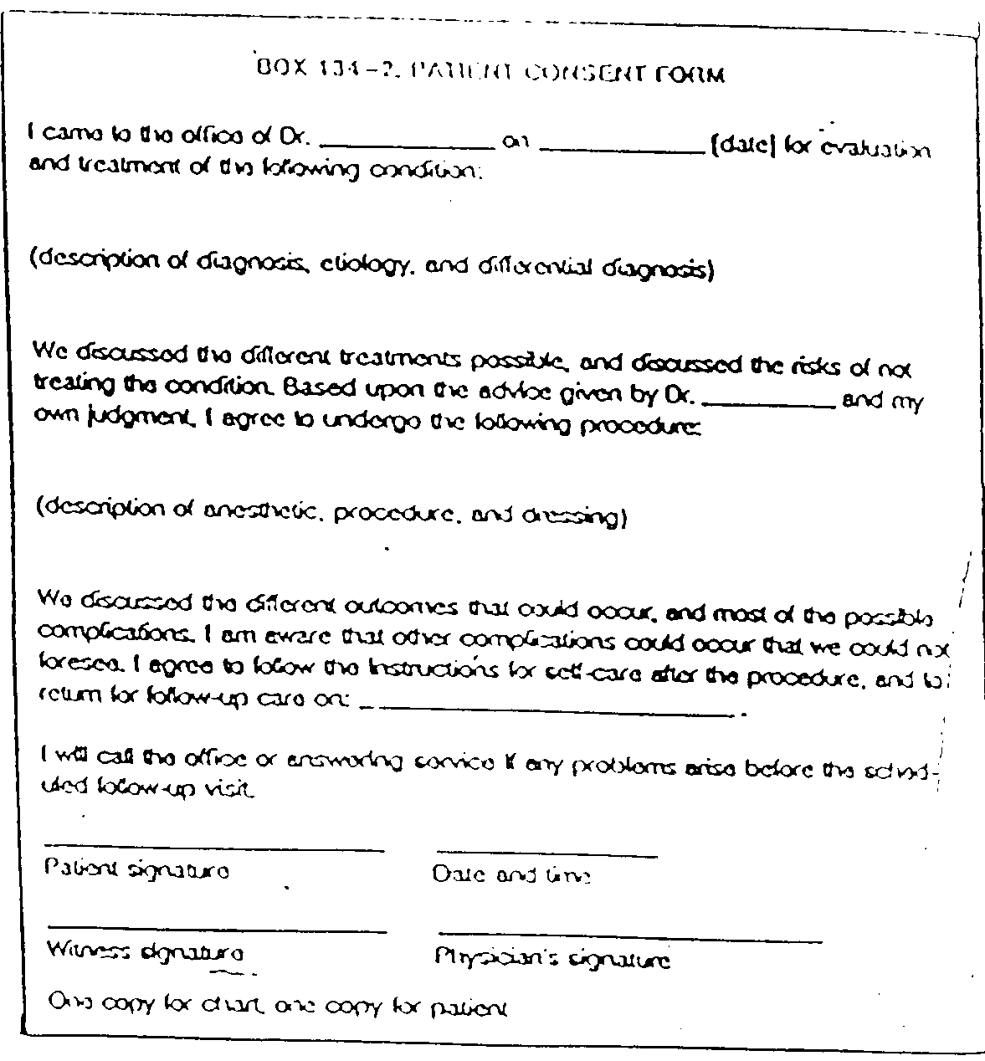

DOCUMENTATION
- Rationale:
- Continuity of care
- Liability and L&I for patient
- Protection in malpractice suits

What should be charted:
S// 7 attributes including age, how and when wound sustained or age of lesion, recent lesion changes, prior Tx, tetanus status
+ Meds/Supplements
+ PMHx: allergies, other conditions, keloids, nutrient status, lifestyle (water, sleep, diet, elimination systems)

O// vitals and general condition
Evaluation before anesthesia
wear gloves and mask
r/o referrals
describe:
size, shape, color, surface, superficial vs. deep, tidy vs. untidy (note flaps), clean vs. contaminated
type of lesion (puncture, abrasion…)
photograph if possible, especially work related injuries, dog bites, fights
distal neurovascular status and tendon function
Evaluation after local anesthesia → detailed exam + other pertinent PE

A// Be as specific as possible with probable or suspected underlying etiology, include problem list as it applies to lesion etiology, healing
and overall wellbeing

P// Informed consent
Chart the following:
Anesthesia (complete PE as necessary): type, batch #, concentration, amount
Irrigation (approx 1 liter): i.e. NL saline
Prep around wound (betadine or chlorhexadine) and drape;
Ensure adequate numbing: Lidocaine w/ epi is instant; procaine takes a few minutes
Debride if indicated;
Inspect, technique of removal; suture, stitch; repair;
Antiseptic wash and dress;
Tetanus or Abx as indicated;
Verbal and written wound care and follow-up;
Specimen sent to path/culture as indicated

