Glutathione:
Glutathione (abbreviated GSH) is a tripeptide composed of glutamate, cysteine and glycine that has numerous important functions within cells. It serves as a reductant, is conjugated to drugs to make them more water soluble, is involved in amino acid transport across cell membranes (the γ-glutamyl cycle), is a part of the peptidoleukotrienes, serves as a cofactor for some enzymatic reactions and as an aid in the rearrangement of protein disulfide bonds.
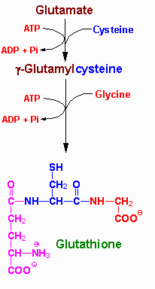 | 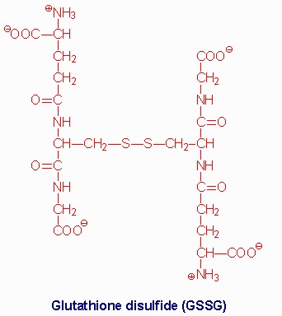
Synthesis of glutathione (GSH) | Structure of GSSG

The role of GSH as a reductant is extremely important particularly in the highly oxidizing environment of the erythrocyte. The sulfhydryl of GSH can be used to reduce peroxides formed during oxygen transport. The resulting oxidized form of GSH consists of two molecules disulfide bonded together (abbreviated GSSG). The enzyme glutathione reductase utilizes NADPH as a cofactor to reduce GSSG back to two moles of GSH. Hence, the pentose phosphate pathway is an extremely important pathway of erythrocytes for the continuing production of the NADPH needed by glutathione reductase. In fact as much as 10% of glucose consumption, by erythrocytes, may be mediated by the pentose phosphate pathway.

Several mechanisms exist for the transport of amino acids across cell membranes. Many are symport or antiport mechanisms that couple amino acid transport to sodium transport. The γ-glutamyl cycle is an example of a group transfer mechanism of amino acid transport. Although this mechanism requires more energy input, it is rapid and has a high capacity. The cycle functions primarily in the kidney, particularly renal epithelial cells. The enzyme γ-glutamyl transpeptidase is located in the cell membrane and shuttles GSH to the cell surface to interact with an amino acid. Reaction with an amino acid liberates cysteinylglycine and generates a γ-glutamyl-amino acid which is transported into the cell and hydrolyzed to release the amino acid. Glutamate is released as 5-oxoproline and the cysteinylglycine is cleaved to its component amino acids. Regeneration of GSH requires an ATP-dependent conversion of 5-oxoproline to glutamate and then the 2 additional moles of ATP that are required during the normal generation of GSH.

