Magnetic therapy:

Susan Bucci, writes the following summary or her own experiences with magnets:

"Susan Bucci is a holistically trained nurse who has spearheaded the development of magnetic healing products. "Magnets oxygenate tissues and allow cell walls to absorb more oxygen," she explains. "They promote mental acuity and normalize pH balance by increasing alkalinity. Restorative sleep is enhanced. Therapeutically, they stop pain, fight infection, and reduce inflammation and fluid retention. Over time, fatty and calcium deposits dissolve and the circulatory system opens up. Put that all together and you've got healing from A to Z. Take that a step further: If you achieve optimal well-being, you can actually live a long, productive life."

In addition to promoting overall well-being, magnets can eliminate many specific signs and symptoms of old age. Bucci reports these antiaging benefits from her own use of magnetic healing techniques: "My energy level has increased. I used to have chronic fatigue in the worst way, but now that's gone. My immune system is functioning much better, so my susceptibility to viruses and colds has decreased dramatically. Allergies are basically gone, and there are no more killer sinus headaches. My circulation has improved so that I withstand weather a whole lot easier. Wounds heal quickly, and my spider veins have disappeared. Also, I was headed for an early menopause, but now my menstrual cycle is very much on track, very regular.

"Hair skin, and nails have definitely improved. My hair grows faster and has a much better quality to it. Within two weeks of using magnets on a daily basis, I was able to see new, thick, dark hair growing. My grays started falling out and disappearing. I was going to color my hair about four years ago, and I still haven't touched it with an ounce of anything. My skin definitely looks and feels younger. And my nails grow so well that if I break one, it doesn't upset me. I know that it will grow right back."

How can magnets do so much? Simply stated, magnets confer a wide range of benefits because we are magnetic beings who derive energy from the earth's magnetic field. Bucci explains: "One reason we get sick is that the earth has lost a good deal of its magnetism, which leaves the body in an unbalanced state. Additionally, we are bombarded by unhealthy energies." Magnets create overall benefit by restoring internal harmony.

It is important to realize that not just any old magnet will do. The negative pole restores health and good energy to the system, while exposure to the positive pole is detrimental. This has been proved repeatedly in studies where a variety of creatures, from earthworms, mice, and chickens to larger animals, live twice as long as untested control groups when exposed to negative field magnets, and half as long when exposed to positive fields. Bucci recommends unipolar magnets, marked by the Davis and Rawls system with an "N" or the word "negative" and a green label. "That's the healthy side, and that's the one we face toward the body." Negative field ions support biological systems, which help the body to heal itself "The body is an amazing machine with a remarkable capacity to cure itself," Bucci says. "Give it a boost in the right direction and it does the rest on its own. The negative field is completely safe and risk-free."

Bucci finds that magnets work best when worn on a daily basis. During the day she wears a magnet over her heart to improve circulation and oxygenation. "It keeps the heart open and flowing and sends all that wonderful oxygen throughout my body," she says. At night, she takes the magnet off and sleeps with her head on a magnetic mattress pad. She does this because the most important benefit while sleeping is increased melatonin production from the brain's pineal gland: "People are running out to buy melatonin, but guess what? We can encourage our own melatonin production.

"People ask me how long magnets should be worn. Generally speaking, the longer you wear them, the more healing takes place. You can wear them all night and during the day. Generally, the body will tell you when it has had enough. It also will tell you when a condition has healed, although you should check with a physician just to make sure."

My investigations found that the best magnets, as suggested by Susan above, were ceramic unipolar magnets used in sports therapy. (Don't even try this with ordinary magnets, you can get none or just the opposite effect from what you desire.) I obtained a neck magnet wrap-around band then removed six of the magnets from inside the ends of the band, leaving six still inside the front part of the band under the "Champ" logo.

logo.

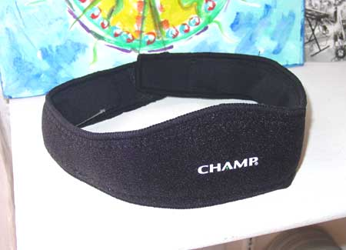

I found that the wrap-around fit perfectly and comfortably as a head band, with the magnets perfectly positioned over the frontal lobes, or higher up for hair-therapy (!). See the top photo.

The remaining magnets I fashioned into a pendant to be used as Susan Bucci suggested to be worn during the day. I used two pieces easily cut out of neoprene foam rubber sheet, into which I punched three holes.

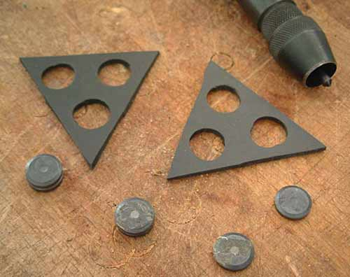

I then used contact cement to double layer the foam sheet, then inserted two layered magnets, which clung together from magnetic force, into each hole.IT IS IMPORTANT TO NOTE THAT THE NEGATIVE SIDE OF THE MAGNET- INDICATED BY THE DOT ON THAT SIDE OF THE MAGNET- FACES THE BODY. KEEP TRACK OF THIS IF YOU MAKE ONE YOURSELF.

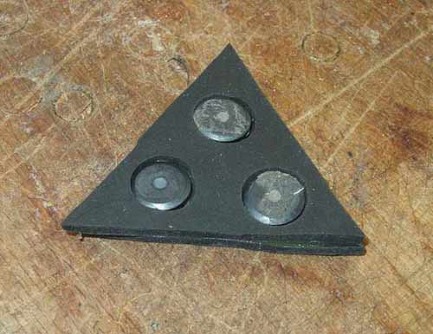

Next, I taped the magnets into place and secured a soft string. I sandwiched the string to come out the sides as so to prevent the pendant from accidentally flipping over, and rendering the thing useless. Remember, the negative side faces the body- note the negative indicator dots showing through the tape.

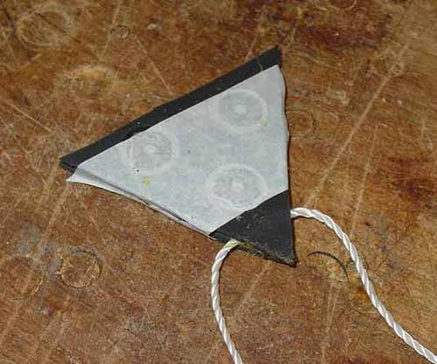

And finally, covered with some nice crushed velvet.

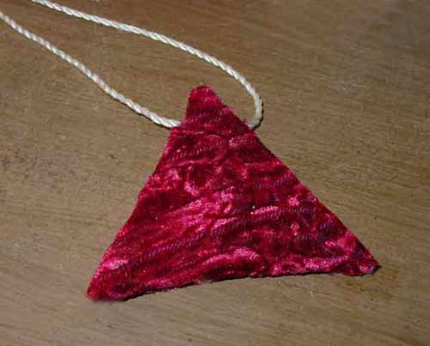

Shown here outside shirt-- However, best worn under shirt to avoid looking like you are stuck in 1969.

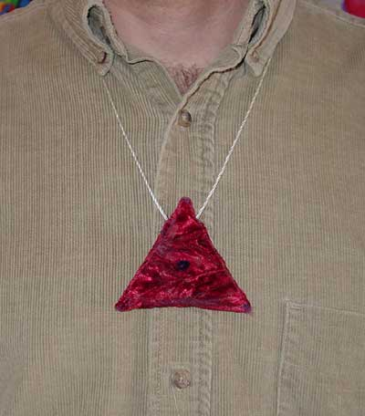

I also found a magnetic pillow pad using the same kind of ceramic unipole magnets and will use this in the evening as Susan recommends

This is a very informal trial, but I'll post any discoveries and results on this page. Low level magnetic therapy may be just another New Age hocus pocus thing with little merit. I am NOT recommending this, and this could be a ridiculous waste of money (little as it is).

But it may not- I have before pictures of my hair line saved now- we shall see.....!

looks.
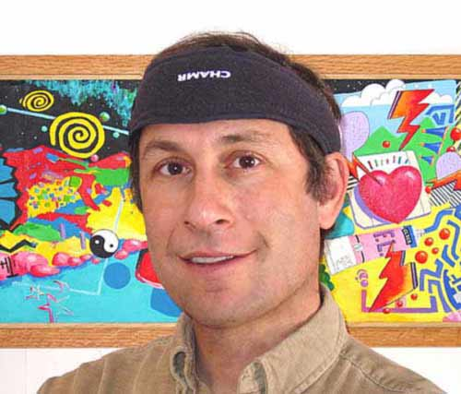

KEY
by Keven Allen Cotter

I found a key inside of me,
It looked funny at first,
I thought, it won't fit.
But this key inside you see,
Could quench my thirst,
Every bit.
My thirst for love,
It fit quite well.
My thirst for truth,
My lips to tell.
My thirst for knowledge,
Best of all.
My thirst for freedom,
I now stand tall.
This little key inside of me,
I soon found out it had a mate.
To my astonished mind you see,
Quite a twist of neato fate.
And I soon discovered with my twin keys,
I could open any gate.
Little keys almond shaped,
Right behind my eyes.
Keys to all of time and space,
Always there and ready to FLY!

Humanity? by Rawone

Humans do the darndest things
It makes me shake my head
Most will claim religion
But practice hate instead
Most say they want freedom
Then give away their power
To those who practice dominance
Each and every hour.
We say we have compassion
For our fellow man
But do we feed the hungry
And shelter those we can?
We claim to love our children
To whom we've given birth
Then we seek destruction
By killing Mother Earth
I'm not sure how it got this way
Maybe it's genetics
Anyone observing us
Must think we're schizophrenics!

